|  |  |  |  |
| --- | --- | --- | --- |
| **Course Name:** | **Elements of Electrical and Electronics Engineering** | **Semester:** | **I** |
| **Date of Submission:** | **8 /01 / 2022** | **Batch No:** | **C1** |
| **Faculty Name:** | **Sonia Joshi** | **Roll No:** | **16010121157** |
| **Faculty Sign & Date:** |  | **Grade/Marks:** | **/ 20** |

**Internal Assessment: 1**

**Brief Report on**

1. Electrical power Generation and distribution systems:

List the Electrical power generation methods in India. Explain using block diagram how electricity reaches at your home from generating station. Explain in brief the stages of conversion of Voltages and role of transformer.

Answer:

There are 8 types of electrical power generation methods in India. They are listed below:

* COAL POWER GENERATION
* THERMAL POWER GENERATIONS
* NUCLEAR POWER GENERATION
* HYDRO-POWER GENERATION
* GEOTHERMAL POWER GENERATION
* WIND POWER GENERATION
* TIDAL POWER GENERATION
* SOLAR POWER GENERATION

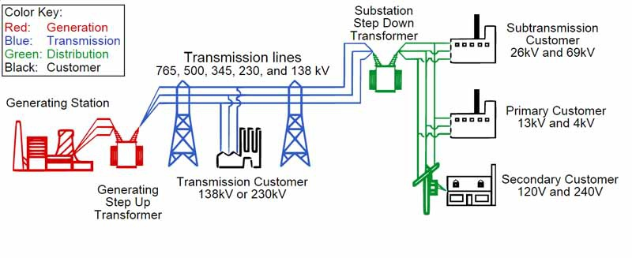

When an input voltage is applied to the primary winding, alternating current starts to flow in the primary winding. As the current flows, a changing magnetic field is set up in the transformer core. As this magnetic field cuts across the secondary winding, alternating voltage is produced in the secondary winding.  
 The ratio between the number of actual turns of wire in each coil is the key in determining the type of transformer and what the output voltage will be. The ratio between output voltage and input voltage is the same as the ratio of the number of turns between the two windings. A transformers output voltage is greater than the input voltage if the secondary winding has more turns of wire than the primary winding. The output voltage is stepped up, and considered to be a "step-up transformer". If the secondary winding has fewer turns than the primary winding, the output voltage is lower. This is a "step-down transformer".

Transformers have two windings, being the primary winding and the secondary winding. The primary winding is the coil that draws power from the source. The secondary winding is the coil that delivers the energy at the transformed or changed voltage to the load. Usually, these two coils are subdivided into several coils in order to reduce the creation of flux.

2. List the possible electrical Hazards inside a home??

Answer:

1. **Faulty or Damaged Wiring**
2. **Overloading Circuits**
3. **Use of Extension Cords**
4. **Water Spill on Electrical Devices**
5. **Improper Grounding**
6. **Incorrectly placed Electrical Cords**
7. **Loose Fitting Plugs**
8. Handling electrical appliances with wet hands
9. Light Bulbs with the Wrong Wattage
10. Heavily covered electrical cords and wires causing heat to form

3. Electrical safety essentials: List and brief about Products for a safer home such as Circuit barkers, MCBs, Switch Fuse Unit (SFU, ELCB, MCCB. (Note: Students can add photographs of safety devices)

Answer:

## ****FUSES-****

Fuses are built as a safety measure if there is too much current flowing through a circuit. Fuses have a thin metal strip (usually made of copper or zinc) that keeps the connection open. However, if an electrical current exceeds the maximum current allowed within that fuse it will overheat and cause the metal strip to melt. The destroyed metal strip breaks the connection and stops electricity flowing through.

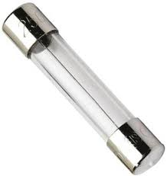The main difference between fuse switch and switch fuse is **that the switch can break the circuit and provide over current protection to the installation**.

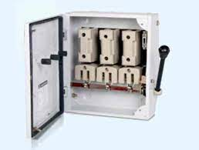

**ELCB-**

An **Earth-leakage circuit breaker** (ELCB) is a safety device used in electrical installations with high Earth impedance to prevent shock. The main purpose of ELCB is **to detect Earth leakages and prevent injury to human beings from electrical shocks** and prevent electrical fires that are caused by short Circuit. It detects small stray voltages on the metal enclosures of electrical equipment, and interrupts the circuit if a dangerous voltage is detected.

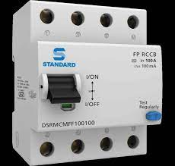

**MCB/MCCB-**

“MCB” stands for “Miniature Circuit Breakers”, while **“MCCB” is “Molded Case Circuit Breaker**.”

MCB is **mainly used for low Breaking capacity requirement mainly domestic**. MCCB is mainly used for both low and high Breaking capacity requirements mainly industrial. A moulded case circuit breaker (MCCB) is a type of electrical protection device that is used to protect the electrical circuit from excessive current, which can cause overload or short circuit. With a current rating of up to 2500A, MCCBs can be used for a wide range of voltages and frequencies with adjustable trip settings. These breakers are used instead of miniature circuit breakers (MCBs) in large scale PV systems for system isolation and protection purposes. It is helpful in **Protection against overload , Electric fault protection and in Switching the circuits on and off**

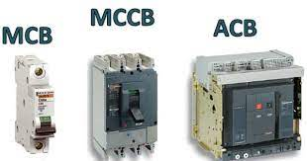

4. What are Types of Wires and Cables used for electricity distribution?

* Live wire ( Red colour)
* Neutral wire(Black colour)
* Earth wire (Green colour)
* [**Jumper wires**](https://www.jameco.com/c/Wire-Cable.html#/filter:ss_category:Wire$2520$2526$2520Cable$253EAssortments$253EJumper$2520Wires)
* [**Magnet wire**](https://www.jameco.com/c/Wire-Cable.html#/filter:ss_category:Wire$2520$2526$2520Cable$253EBulk$2520Wire$253EMagnet$2520Wire)
* [**Wire-wrap**](https://www.jameco.com/c/Wire-Cable.html#/filter:ss_category:Wire$2520$2526$2520Cable$253EBulk$2520Wire$253EWire-Wrap)
* muscle wire
* Coaxial cable – used for radio frequency signals, for example in cable television distribution systems.
* Communications cable.
* Direct-buried cable.
* Flexible cables.
* Heliax cable.
* Non-metallic sheathed cable (or non metallic building wire, NM, NM-B)
* Metallic sheathed cable

5. Importance of Earthing.

Earthing is one of the main factor in electrical systems to protect the humans from getting electric shock. Earthing is used in alomst every equipment. Earthing is system in which the part of the equipment is connected to the earth with the help of the wires or cables. Earthing is also known as the grounding system.

Earthing is **used to protect you from an electric shock**. It does this by providing a path (a protective conductor) for a fault current to flow to earth. It also causes the protective device (either a circuit-breaker or fuse) to switch off the electric current to the circuit that has the fault.

6**.** Explain in brieffluorescent, CFL, LED operations and typical power ratings.

**Fluorescent-**

Fluorescent light bulbs are a specific type of gas-discharge light (also known as a high intensity discharge, HID, or arc light. Fluorescent bulbs produce light by converting ultraviolet emissions with a fluorescent coating on the inside of the tube. UV radiation is generated in the first place by an electrical charge that is run through the inert mercury glass internal to the bulb. The gas is excited by the electricity and releases ultraviolet radiation as a consequence. Fluorescent lights require ignition, which is typically provided by a voltage pulse or a third electrode (an additional metal part) internal to the bulb. Starting is relatively simple with small tubes but can require significant voltage with larger lights. *The typical luminous efficacy of fluorescent lighting systems is****50–100 lumens per watt.***

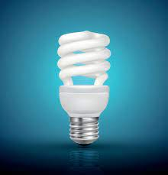

**CFL-**

CFL is an acronym that stands for *compact fluorescent light*. CFLs are much smaller than fluorescent bulbs. They are still tubes but they are, as the name implies, “compact.” CFLs were designed to replace standard applications for incandescent bulbs as they are both more efficient and longer lasting. *CFLs provide 50-60 lumens per watt*.

*LED-*

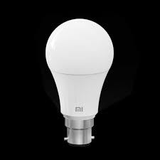LED stands for light emitting diode. A diode is an electrical device or component with two electrodes (an anode and a cathode) through which electricity flows - characteristically in only one direction (in through the anode and out through the cathode). Diodes are generally made from semi-conductive materials such as silicon or selenium - solid state substances that conduct electricity in some circumstances and not in others (e.g. at certain voltages, current levels, or light intensities). When current passes through the semiconductor material the device emits visible light. **It is very much the opposite of a photovoltaic cell .**  LED provide **80-90 Lumens per watt** .