| **Course Name:** | **Elements of Electrical and Electronics Engineering** | **Semester:** | **I** |
| --- | --- | --- | --- |
| **Date of Submission:** | **01/ 02/ 2022** | **Batch No:** | G3 |
| **Faculty Name:** | Seema Talmale | **Roll No:** | 16010421063 |
| **Faculty Sign & Date:** |  | **Grade/Marks:** | **/ 20** |

# Internal Assessment: 2

**Case study on Electricity consumption and billing of a home**

1. **What is electrical power and energy? What are their units?**

1) Electric power is the rate, per unit time, at which electrical energy is transferred by an electric circuit Or Electric power is the rate at which work is done or energy is transformed into an electrical circuit.

2) The SI unit of power is the watt, one joule per second. Electrical energy is energy derived from [electric potential energy](https://en.wikipedia.org/wiki/Electric_potential_energy) or [kinetic energy.](https://en.wikipedia.org/wiki/Kinetic_energy) When used loosely, electrical energy refers to energy that has been converted from electric potential energy.

3) This energy is supplied by the combination of [electric current](https://en.wikipedia.org/wiki/Electric_current) and [electric potential](https://en.wikipedia.org/wiki/Electric_potential) that is delivered by an [electrical circuit](https://en.wikipedia.org/wiki/Electrical_circuit) . Once converted from potential energy, electrical energy can always be called another type of energy.

4) Electrical energy is usually sold by the [kilowatt-hour.](https://en.wikipedia.org/wiki/Kilowatt_hour) Units of Electric Power are Watt (SI Unit), VA, kW, Joule per second, Horsepower(1HP=746 W)etc.

5) A body is said to have the power of 1 watt if it does work at the rate of 1 joule in 1 s. Electrical energy is the energy derived from electric potential energy or kinetic energy of the charged particles. In general, it is referred to as the energy that has been converted from electric potential energy. We can define electrical energy as the energy generated by the movement of electrons from one point to another. The movement of charged particles along/through a medium (say wire) constitutes current or electricity.

6) The basic unit of electrical energy is the joule or watt-second. An electrical energy is said to be one joule when one ampere of current flows through the circuit for a second when the potential difference of one volt is applied across it. The commercial unit of electrical energy is the kilowatt-hour (kWh) which is also known as the Board of trade unit (B.O.T).

1 kwh = 1000 × 60 × 60 watt – second 1 kwh = 36 × 10^5 Ws or Joules

Generally, one kwh is called one unit.

1. **What is 1-unit electrical energy?**

1 unit of electrical energy is equal to 1 kWh. For example, if an electrical appliance of power 1000 watt is operated on mains for 1 hour, it will consume 1 unit of electricity. It is commercially known as ‘unit’. It is also called B.O.T. (Board of Trade Unit).

1kWh = 1000Wh.

1kWh = 1000 x 60 x 60 W second.

1kWh = 3600000 W second.

1kWh = 3.6 x 106J.

1kWh = 3.6 MJ.

1. Estimate the electricity consumption of your home for two months (units/month) **December 2021 & January 2022. (Following table is applicable as per actuals)**

**December 2021-**

| Sr.  No. | Appliances | Power Rating (watts/appliance) (a) | No of appliances (b) | Utilization in Hours per day  (c) | Energy in Wh/1000  (units)/day  (d=axbxc)/1000 | Energy units/month dx30 |
| --- | --- | --- | --- | --- | --- | --- |
| 1 | Lights | 38 | 2 | 6 | 0.456 | 13.68 |
| 2 | Lights | 15 | 4 | 6 | 0.36 | 10.8 |
| 3 | Fans | 75 | 4 | 8 | 2.4 | 72 |
| 4 | Air conditioner  s | 940 | 2 | 1 | 1.88 | 56.4 |
| 5 | Washing  Machine | 300 | 1 | 1 | 0.3 | 9 |
| 6 | Electric water heaters  (Geysers ) | 2000 | 1 | 0.3 | 0.6 | 18 |
| 7 | Mixer | 700 | 1 | 0.3 | 0.21 | 6.3 |
| 8 | Electric Iron |  |  |  | 0 | 0 |
| 9 | Microwave Oven | 1350 | 1 | 0.3 | 0.405 | 12.15 |
| 10 | Television | 80 | 1 | 3 | 0.24 | 7.2 |
| 11 | Freeze | 250 | 1 | 24 | 6 | 180 |
| 12 | Computer | 30 | 2 | 8 | 0.48 | 14.4 |
| Total energy (Units/month) | | | | | | 399.93 |

**January 2022-**

| Sr.  No. | Appliances | Power Rating (watts/appliance) (a) | No of appliances (b) | Utilization in Hours per day  (c) | Energy in Wh/1000  (units)/day  (d=axbxc)/1000 | Energy units/month dx30 |
| --- | --- | --- | --- | --- | --- | --- |
| 1 | Lights | 38 | 2 | 6 | 0.456 | 13.68 |
| 2 | Lights | 15 | 4 | 6 | 0.36 | 10.8 |
| 3 | Fans | 75 | 4 | 0.3 | 0.09 | 2.7 |
| 4 | Air conditioner  s | 940 | 0 | 1 | 0 | 0 |
| 5 | Washing  Machine | 300 | 1 | 1 | 0.3 | 9 |
| 6 | Electric water heaters  (Geysers ) | 2000 | 1 | 0.3 | 0.6 | 18 |
| 7 | Mixer | 700 | 1 | 0.3 | 0.21 | 6.3 |
| 8 | Electric Iron |  |  |  | 0 | 0 |
| 9 | Microwave Oven | 1350 | 1 | 0.3 | 0.405 | 12.15 |
| 10 | Television | 80 | 1 | 3 | 0.24 | 7.2 |
| 11 | Freeze | 250 | 1 | 24 | 6 | 180 |
| 12 | Computer | 30 | 2 | 8 | 0.48 | 14.4 |
| Total energy (Units/month) | | | | | | 274.23 |

**Plot a bar Graph showing appliances on x-axis and energy (units/month/appliance) on Y –axis. Draw the graph for both the months (Use can Microsoft Excel to plot graphs)**

**e.g.**

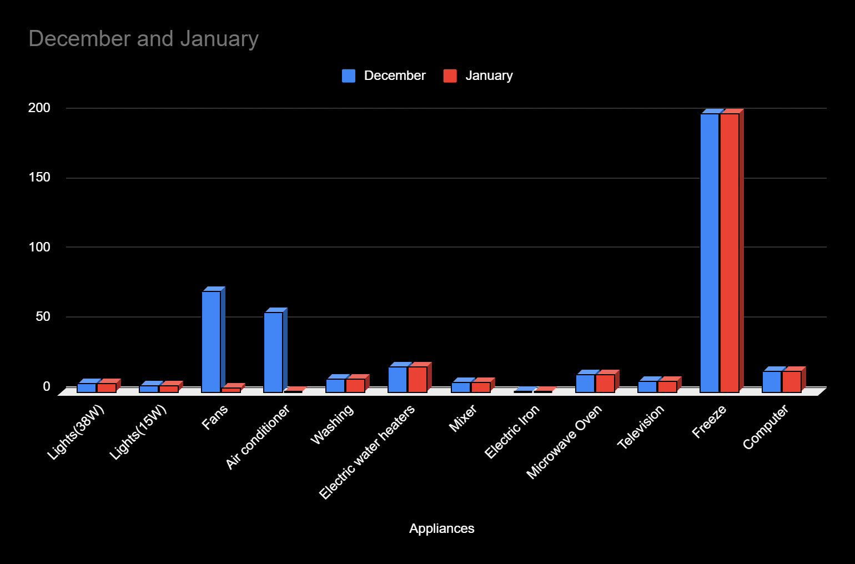

1. **Compare actual electricity units and bills (Rupees) with your estimation (Use electricity bill of the recent month of your home. Attach copy of the same with assignment)**

**December 2021-**

| Energy consumption | Energy  units/month | Billing Rate  Rs./Unit | Total  (Rs) |
| --- | --- | --- | --- |
| Estimated | 399.93 | 10.25316456 | 4100.54810248 |
| Actual | 395 | 10.25316456 | 4050 |

**January 2022-**

| Energy consumption | Energy  units/month | Billing Rate  Rs./Unit | Total  (Rs) |
| --- | --- | --- | --- |
| Estimated | 274.23 | 10.25316456 | 2811.72531729 |
| Actual | 270 | 10.25316456 | 2768.35443 |

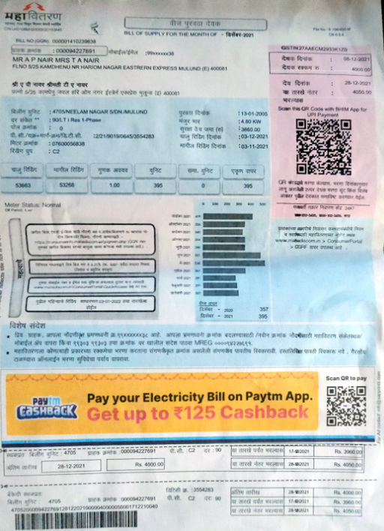

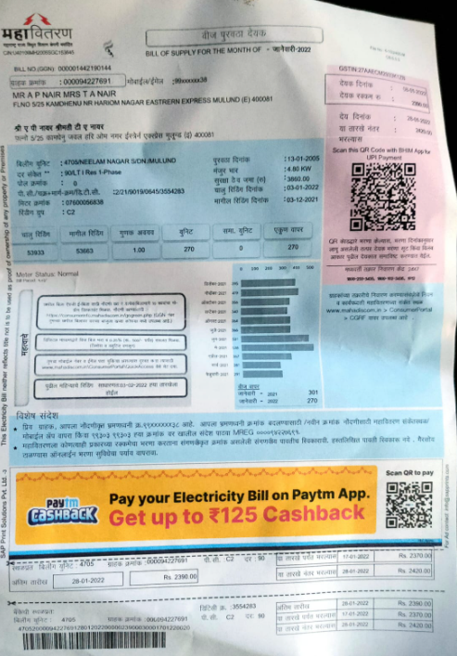

1. **How can you reduce the electrical energy consumption of your home? Alternatives methods**

**e.g. use of energy efficient lights….. Use of Gas water heater instead of electric water heater… etc.**

Ans-

1. Unplug your appliances when they’re not in use
2. Make a switch to energy-efficient lighting
3. Make use of energy monitors
4. Swap old, inefficient appliances for their eco-friendly versions
5. Use smart power strips
6. Use natural light
7. Use battery-operated devices like laptops instead of desktops
8. Instead of using dryers try drying stuff naturally.
9. Movement activated lights
10. Try to go for 5 or 4 star appliances.
11. Estimation of electrical energy consumption after alternate methods suggested in step-5.

| Sr.  No. | Appliances | Power Rating (watts/appliance) (a) | No of appliances (b) | Utilization in Hours per day  (c) | Energy in Wh/1000  (units)/day  (d=axbxc)/1000 | Energy units/month dx30 |
| --- | --- | --- | --- | --- | --- | --- |
| 1 | Lights | 38 | 2 | 3 | 0.228 | 6.84 |
| 2 | Lights | 15 | 4 | 4 | 0.24 | 7.2 |
| 3 | Fans | 75 | 4 | 8 | 2.4 | 72 |
| 4 | Air conditioner  s | 940 | 2 | 1 | 1.88 | 56.4 |
| 5 | Washing  Machine | 300 | 1 | 1 | 0.3 | 9 |
| 6 | Electric water heaters  (Geysers ) | 1500 | 1 | 0.3 | 0.45 | 13.5 |
| 7 | Mixer | 700 | 1 | 0.3 | 0.21 | 6.3 |
| 8 | Electric Iron |  |  |  | 0 | 0 |
| 9 | Microwave Oven | 1200 | 1 | 0.3 | 0.36 | 10.8 |
| 10 | Television | 80 | 1 | 3 | 0.24 | 7.2 |
| 11 | Freeze | 250 | 1 | 24 | 6 | 180 |
| 12 | Computer | 30 | 2 | 8 | 0.48 | 14.4 |
| Total energy (Units/month) | | | | | | 383.64 |

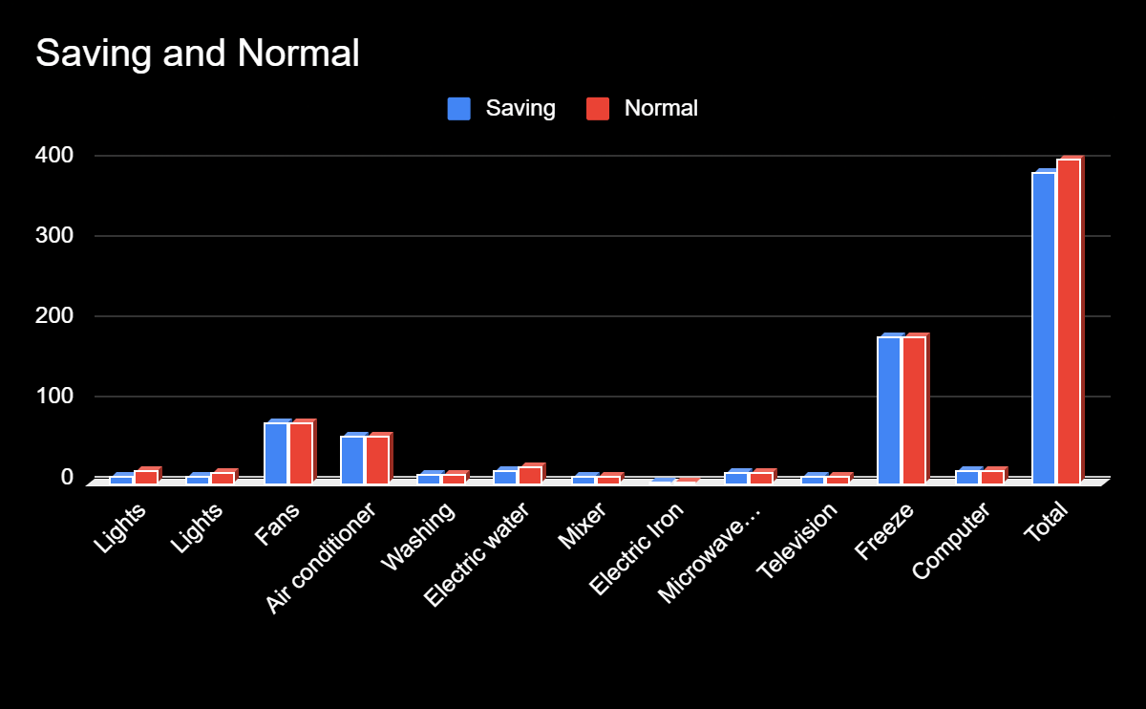

1. Energy saving units/month and expenses in Rs/month (after implementation of alternative method suggested in step

|  | Units | cost per unit | price |
| --- | --- | --- | --- |
| Normal | 399.93 | 10.25316456 | 4100.548102 |
| With Saving method | 383.64 | 10.25316456 | 3933.524052 |

**Savings- Rs.167.0240507**

