

| **TITLE:**  Application Oriented Program |
| --- |

**AIM:** To develop any application based program.

**______________________________________________________________________**

**Expected OUTCOME of Experiment:**

**C01: Formulate a problem statement and develop the logic (algorithm/flowchart) for its solution.**

**C02: Apply basic concepts of C programming for problem solving.**

**C03: Illustrate the use of derived and structured data typessuch as arrays, strings, structures and unions**

**C04: Design modular programs using functions and demonstrate the concept of pointers and file handling.**

**_____________________________________________________________________**

**Books/ Journals/ Websites referred:**

1. Programming in C, second edition, Pradeep Dey and Manas Ghosh, Oxford University Press.
2. Programming in ANSI C, fifth edition, E Balagurusamy, Tata McGraw Hill.
3. Introduction to programming and problem solving , G. Michael Schneider ,Wiley India edition.
4. [**http://cse.iitkgp.ac.in/~rkumar/pds-vlab/**](http://cse.iitkgp.ac.in/~rkumar/pds-vlab/)

**_____________________________________________________________________**

**Problem Definition:**

Consider the marble rolling toy as shown in figure:

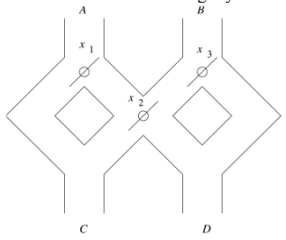

A marble is dropped at A or B. Levers x1,x2 and x3 cause the marble to fall either to the left or to the right. Whenever a marble encounters a lever, it causes the lever to reverse the direction after the marble passes, so the next marble will take the opposite branch. Write a C program to accept an input sequence and generate the appropriate output sequence.

**Flowchart:**



**Implementation details:**

| #include<stdio.h>  int main() {  int x1=0,x2=0,x3=0; //Initialising zero for position '/'  printf("Number of Marbles you want to put: ");  int n;  scanf("%d",&n);  char inp;  for (int i=0;i<n;i++)//Running a for loop for each marble  {  printf("Marble in A or B: ");  scanf(" %c",&inp);  if (inp=='A')  {  if(x1==0){//if lever is bent towards right it will directly go into C  printf("Marble fell in: C\n");  x1=1;//changing lever position  }  else if(x1==1){  x1=0;//changing lever position  if(x2==0){//if lever is bent left it will go into C  printf("Marble fell in: C\n");  x2=1;//changing lever position  }  else if(x2==1){//if lever is bent right it will go into D  printf("Marble fell in: D\n");  x2=0;//changing lever position  }  }  }  else if (inp=='B')  {  if(x3==1){//if is bent towards right it will directly go into D  printf("Marble fell in: D\n");  x3=0;//changing lever position  }  else if(x3==0){  x3=1;//changing lever position  if(x2==0){//if lever is bent left it will go into C  printf("Marble fell in: C\n");  x2=1;//changing lever position  }  else if(x2==1){//if lever is bent left it will go into D  printf("Marble fell in: D\n");  x2=0;//changing lever position  }  }  }  } } |
| --- |

**Output(s):**

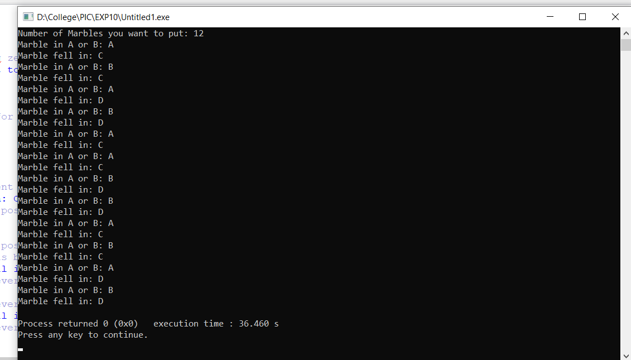

**Conclusion:**

Successfully solved the marble problem statement.

**Date: _____________ Signature of faculty in-charge**