**Batch: Roll No.:**

**Experiment / assignment / tutorial No. 10**

**Grade: AA / AB / BB / BC / CC / CD /DD**

**Signature of the Staff In-charge with date**

|  |
| --- |
| **TITLE:**  Application Oriented Program |

**AIM:** To develop any application based program.

**______________________________________________________________________**

**Expected OUTCOME of Experiment:**

**_____________________________________________________________________**

**Books/ Journals/ Websites referred:**

1. Programming in C, second edition, Pradeep Dey and Manas Ghosh, Oxford University Press.
2. Programming in ANSI C, fifth edition, E Balagurusamy, Tata McGraw Hill.
3. Introduction to programming and problem solving , G. Michael Schneider ,Wiley India edition.
4. [**http://cse.iitkgp.ac.in/~rkumar/pds-vlab/**](http://cse.iitkgp.ac.in/~rkumar/pds-vlab/)

**_____________________________________________________________________**

**Problem Definition:**

Consider the marble rolling toy as shown in figure:

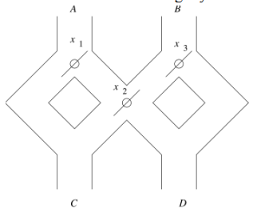

A marble is dropped at A or B. Levers x1,x2 and x3 cause the marble to fall either to the left or to the right. Whenever a marble encounters a lever, it causes the lever to reverse the direction after the marble passes, so the next marble will take the opposite branch. Write a C program to accept an input sequence and generate the appropriate output sequence. Example: input : “BAA” Its equivalent output sequence is “ CCD” i.e. three marbles are dropped sequentially at B, A and A. First marble will find its way through C, second through C and third through D.

**Flowchart:**

**Implementation details:**

#include<stdio.h>

int x1=0,x2=0,x3=0;

char ansx2()

{

char ans=(x2==0)?'C':'D';

x2=(x2==0)?1:0;

return ans;

}

int main()

{

char s[20];

char ans[20];

scanf("%s",s);

for(int i=0;s[i]!='\0';i++){

if(s[i]=='A'){

ans[i]=(x1==0)?'C':ansx2();

x1=(x1==0)?1:0;

}

else{

ans[i]=(x3!=0)?'D':ansx2();

x3=(x3!=0)?0:1;

}}

printf("%s\n",ans);

return 0;

}

**Output(s):**

**Conclusion:**

Successfully executed Experiment 10 based on application oriented program.

**Date: _____________ Signature of faculty in-charge**