

| **TITLE:**  Menu driven program. |
| --- |

**AIM:** Write a menu driven program for following option

a.To find whether a number is palindrome or not. (e.g. 1221 is palindrome)

b. To calculate the sum of the Fibonacci series up to ‘n’ terms(use do-while loop only)

c. To find the numbers and sum of all integer between 100 and 200 which are divisible by both 3 & 5.(use for loop only)

______**________________________________________________________________**

**Expected OUTCOME of Experiment:**

CO2:Apply Basic concepts of C programming for problem solving

**_____________________________________________________________________**

**Books/ Journals/ Websites referred:**

1. Programming in C, second edition, Pradeep Dey and Manas Ghosh, Oxford University Press.
2. Programming in ANSI C, fifth edition, E Balagurusamy, Tata McGraw Hill.
3. Introduction to programming and problem solving , G. Michael Schneider ,Wiley India edition.
4. [**http://cse.iitkgp.ac.in/~rkumar/pds-vlab/**](http://cse.iitkgp.ac.in/~rkumar/pds-vlab/)

**_____________________________________________________________________**

**Problem Definition:**

The program accepts a choice from the user using a switch case statement and generates output accordingly.

**Choice a**: The program checks whether a given number by the user is palindrome or not.If a number remains the same, even if we reverse its digits then the number is known as a palindrome number. For example, 12321 is a palindrome number because it remains the same if we reverse its digits.

**Choice b:** Sum of Fibonacci series up to n terms will be generated. Fibonacci series is a series in which each number is the sum of the last two preceding numbers. The first two terms of a Fibonacci series are 0 and 1.(use while loop only)

**Example:**

Input: n = 5

Output: 7

tExplanation: 0 + 1 + 1 + 2 + 3 = 7

**Choice c:** To find the numbers and sum of all integer between 100 and 200 which are divisible by both 3 & 5.(use for loop only)

**Algorithm:**

**Step-1:Take option from user(a/b/c)**

**Step-2:Switch statement to navigate to the correct code**

**Step-3.a- Palindrome checker**

**Step-3.a.1- Run a for loop to check if ith element from beginning and the end is same**

**Step-3.a.2-If the elements are the same print-{number} is palindrome. Else print- Not a palindrome**

**Step-3.b- Fibonacci Sum**

**Step-3.b.1- Run a for loop n number of times**

**Step-3.b.2- Find the next number in fibonacci series**

**Step-3.b.3- Add the fibonacci number to the variable sum**

**Step-3.b.4- After the loop is finished display sum.**

**Step-3.c- Divisible Sum**

**Step-3.c.1-Run a for loop to iterate through every element in between 100 and 200**

**Step-3.c.2- If the number is divisible by 3 and 5 print the number and add it to sum**

**Step-3.c.3- Print the value of sum after loop is finished**

**Step-4 - Program Stop**

**Implementation details:**



| #include<stdio.h>  void palcheck() {  //function to check palindrome  char num[16];  //Getting values from user  printf("Enter your number: ");  scanf("%s",&num);   int i=0,j=strlen(num)-1;  //do-while loop to iterate through elements of string  do  {  if (num[i++]!=num[j--])//to check is if numbers are not same from the both ends  {  printf("Not a palindrome");  return;  }   }while(j>i);  //Giving user the answer  printf("%s is a palindrome",num);  return; }  void fibonacciSum()//function to check fibonacci sum {  //Getting number of terms from user  printf("Enter the number of terms whose sum you desire: ");  int n,sum=0,x=0,y=1,z,i=0;  scanf("%d",&n);  //loop to find fibonacci numbers and add them to sum  while(i<n)  {  sum=sum+x;  z=x+y;  x=y;  y=z;  i++;  }  //giving user the same  printf("Sum upto is %d",sum); }  void divisionSum() {  int s=0, i;  //loop to iterate through values between 100 and 200  for (i=100;i<200;i++)  {  if (i%3==0 && i%5==0)//to check if divisible by 3 and 5  {  printf("%d\n",i);  s=s+i;  }  }  printf("Sum is: %d",s); }  int main() {  char choice;  //Getting the correct choice from the user  printf("Choice a:Palindrome Checker\nChoice b:Sum of fibbonaci upto n\nChoice c:To find the numbers and sum of all integer between 100 and 200 which are divisible by both 3 & 5\n\n Enter the appropriate option as per your requirement from the option above:");  scanf("%s",&choice);  //switch case for calling the right function for the respective choice of user  switch(choice)  {  case ('a'):  case ('A'):  palcheck();  break;  case ('b'):  case ('B'):  fibonacciSum();  break;  case ('c'):  case ('C'):  divisionSum();  break;  default:  printf("Incorrect input");  break;  } } |
| --- |

**Output(s):**

Choice A:

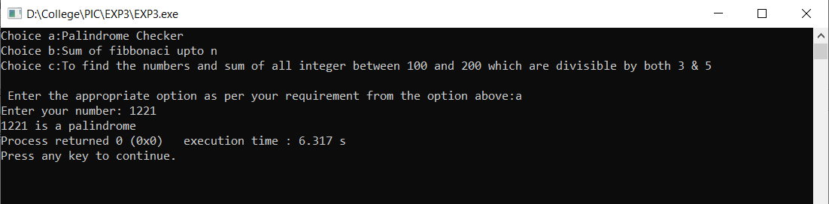

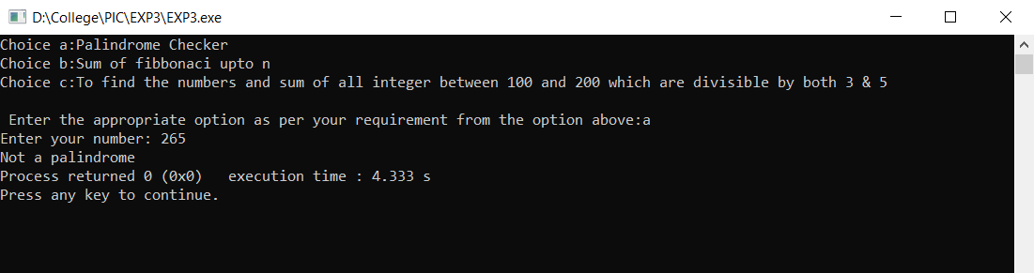

Choice B:

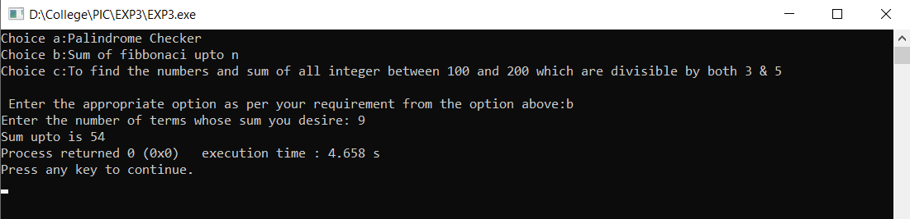

Choice C:

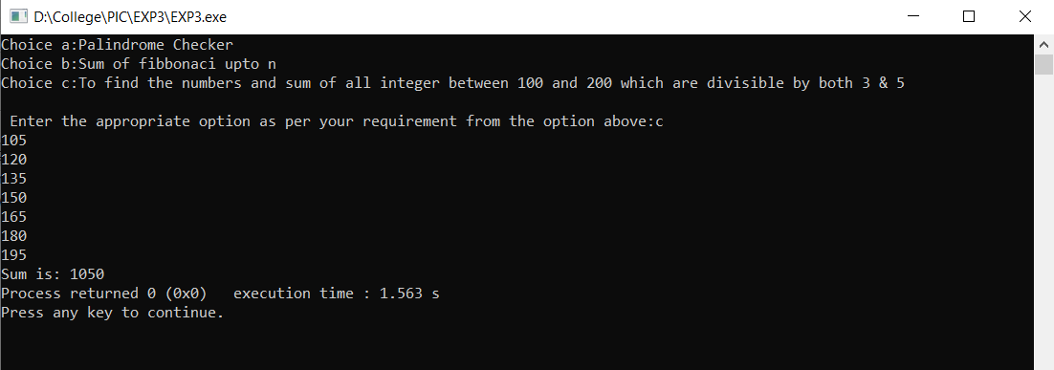

**Conclusion:**

In this experiment we used switch case, for loop and while loop to create a menu driven thus giving the user choice of the output.

**Post Lab Descriptive Questions**

**Write menu driven code for the following:**

The program allows a user to enter five numbers and then asks the user to select a choice from a menu. The menu should offer the following options –

1. Display the smallest number entered

2. Display the largest number entered

3. Display the sum of the five numbers entered

4. Display the average of the five numbers entered.

5. Exit

ANS:

| #include<stdio.h> #include<limits.h>  int main() {  int opt;  int values[5];  printf("Enter 5 numbers: ");  for(int i = 0; i < 5; ++i) {  scanf("%d", &values[i]);  }   printf("1. Display the smallest number entered\n2. Display the largest number entered\n3. Display the sum of the five numbers entered\n4. Display the average of the five numbers entered.\n5. Exit\n");  printf("Enter the option you chose(1/2/3/4/5): ");  scanf("%d",&opt);  switch (opt)  {  case 1:  {  int min=INT_MAX;  for(int i=0;i<5;i++)  {  if(min>values[i])  {  min=values[i];  }  }  printf("%d",min);  break;  }  case 2:  {  int max=0;  for(int i=0;i<5;i++)  {  if(max<values[i])  {  max=values[i];  }  }  printf("%d",max);  break;  }  case 3:  {  float sum=0;  for(int i=0;i<5;i++)  {   sum+=values[i];   }  printf("%f",sum);  break;  }  case 4:  {  int sum=0;  for(int i=0;i<5;i++)  {   sum+=values[i];   }  float avg=sum/5;  printf("%f",avg);  break;  }  case 5:  return 0;    }  return 0; } |
| --- |

**Date: _____________ Signature of faculty in-charge**