

| **TITLE:**  Program to print patterns |
| --- |

**AIM:** Program to print patterns for ‘n’ rows using nested loop **______________________________________________________________________**

**Expected OUTCOME of Experiment:**

CO2: Apply Basic concepts of C programming for Problem solving

**_____________________________________________________________________**

**Books/ Journals/ Websites referred:**

1. Programming in C, second edition, Pradeep Dey and Manas Ghosh, Oxford University Press.
2. Programming in ANSI C, fifth edition, E Balagurusamy, Tata McGraw Hill.
3. Introduction to programming and problem solving , G. Michael Schneider ,Wiley India edition.
4. [**http://cse.iitkgp.ac.in/~rkumar/pds-vlab/**](http://cse.iitkgp.ac.in/~rkumar/pds-vlab/)

**_____________________________________________________________________**

**Problem Definition:**

The program is to print a pattern as given by the user. The program makes use of a nested loop to print a pattern of characters, numbers or alphabets.

**Example:**

Input: number of rows = 4, number of columns = 4

Output: 5

             4    5

         3   4   5

    2   3   4   5

1  2   3   4   5

**Algorithm:**

**Step-1 - Enter number or ‘rows’**

**Step-2 - Run a for loop for row number of times(i)**

**Step-3 - Inside the bigger for loop insert two for loops**

**Step-4 - First for loop for the number of blank spaces required**

**Step-5 - Second for loop to get the desired numbers.**

**Step-5.1 - we run the second loop (row-i)times**

**Step-6 - After each iteration we add a new line**

**Step-7 - After loop is finished Program Stops**

**Implementation details:**

| #include<stdio.h> //Code by Arya Nair int main() {  int rows;  printf("Enter Rows: ");  scanf("%d",&rows);  for(int i = rows; i >= 1; i--)  {  for(int j = 1; j < i; j++)  {  printf(" ");  }  for(int j =i; j <= rows; j++)  {  printf("%d ", j);  }  printf("\n");   } } |
| --- |

**Output(s):**

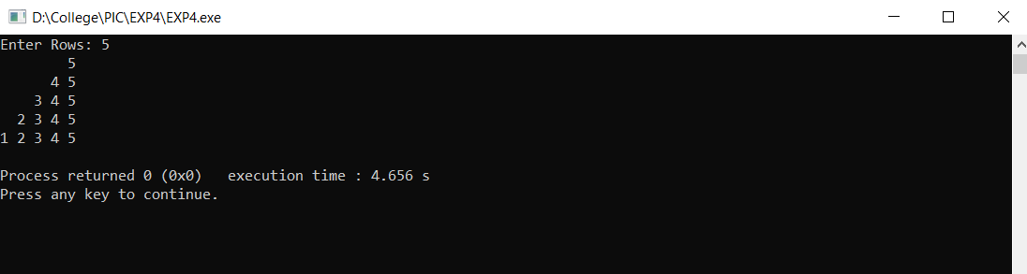

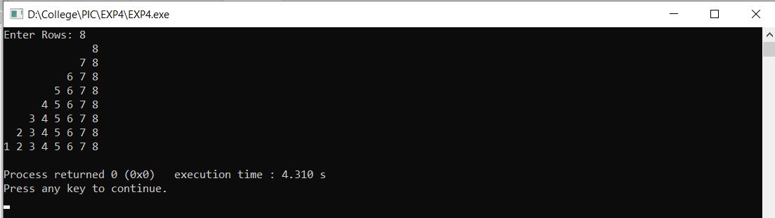

**Conclusion:**

By using basic concepts of C programming we are able to create the required output.

**Post Lab Descriptive Questions**

Write a program to print the following:

1

2 4

3 6 9

4 8 12 16

5 10 15 20 25

6 12 18 24 30 36

7 14 21 28 35 42 49

8 16 24 32 40 48 56 64

9 18 27 36 45 54 63 72 81

10 20 30 40 50 60 70 80 90 100

| #include <stdio.h> //Code by Arya Nair int main() {  int row = 10;  for(int i = 1; i <= row; i++)  {  for(int j = 1; j <= i; j++)  {  printf("%d ", i * j);  }  printf("\n");  }   return 0; } |
| --- |

**Date: _____________ Signature of faculty in-charge**