

| **TITLE:**  Program to sort array |
| --- |

**AIM:** Program to sort the 1D array in the ascending or descending order and then accept the element from user and insert in the same array at its correct place by keeping array sorted **______________________________________________________________________**

**Expected OUTCOME of Experiment:**

CO3: Illustrate the use of derived and structured data types such as arrays, strings, structures and unions.

**_____________________________________________________________________**

**Books/ Journals/ Websites referred:**

1. Programming in C, second edition, Pradeep Dey and Manas Ghosh, Oxford University Press.
2. Programming in ANSI C, fifth edition, E Balagurusamy, Tata McGraw Hill.
3. Introduction to programming and problem solving, G. Michael Schneider ,Wiley India edition.
4. [**http://cse.iitkgp.ac.in/~rkumar/pds-vlab/**](http://cse.iitkgp.ac.in/~rkumar/pds-vlab/)

**_____________________________________________________________________**

**Problem Definition:**

The program takes a 1D array and sorts it in the specified manner. The user enters an element and the same has to be inserted at the correct place in the sorted array.

**Flowchart:**



**Implementation details:**

| #include<stdio.h> //Code By Arya Nair float sort(float arr[], int n)// Parameters- float data type array and int n {  float temp;  for (int i = 0; i < n; ++i)  {   for (int j = i + 1; j < n; ++j)  {   if (arr[i] > arr[j])  {   temp= arr[i];  arr[i] = arr[j];  arr[j] = temp;   }   }   }  }  int main() {  int n,i,j,temp;  //Asking user to enter number of elements  printf("How many elements are there: ");  scanf("%d",&n);  //Asking user to enter the elements  printf("Enter %d elements: ",n);  //Declaring an array with size+1 to accommodate the new element later  float arr[n+1];  for ( i=0;i<n;++i)  {  scanf("%f",&arr[i]);  }  //sorting the array  sort(arr,n);  //Showing user the sorted array  printf("Sorted Array: ");  for (int i=0;i<n;++i)  {  printf("%f ",arr[i]);  }   // Asking user for another element which he/she/they want to add  printf("\nEnter the element you want to insert: ");  scanf("%f",&arr[n]);   //Sorting the new array  sort(arr,n+1);   //Displaying the Array to the user  for (int i=0;i<=n;++i)  {  printf("%f ",arr[i]);  } } |
| --- |

**Output(s):**

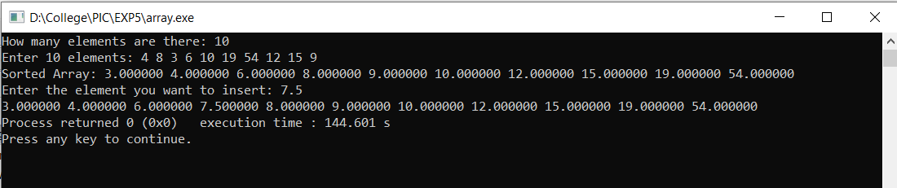

**Conclusion:**

We successfully learnt and applied the concept of 1D array

**Post Lab Descriptive Questions**

Write a program to enter n numbers, store them in an array and rearrange array in the reverse order.

| #include<stdio.h> //Code by Arya Nair float sort(float arr[], int n)// Parameters- float data type array and int n {  float temp;  for (int i = 0; i < n; ++i)  {  for (int j = i + 1; j < n; ++j)  {  if (arr[i] < arr[j])  {  temp= arr[i];  arr[i] = arr[j];  arr[j] = temp;  }  }   }  }   int main() {  int n;  //Asking user to enter number of elements  printf("How many elements are there: ");  scanf("%d",&n);  //Asking user to enter the elements  printf("Enter %d elements: ",n);  float arr[n];  for ( int i=0;i<n;++i)  {  scanf("%f",&arr[i]);  }  //sorting the array in reverse order  sort(arr,n);  //DIsplaying the reverse sorted array  for (int i=0;i<n;++i)  {  printf("%f ",arr[i]);  } } |
| --- |

**Date: _____________ Signature of faculty in-charge**