

| **TITLE:**  Array of Structures. |
| --- |

**AIM:** Program to declare an array of structure `players` having data members (name, total matches played, best bowling figure). Program should do the following operations using functions.

1. **Insert Minimum 5 player data in array of structure**
2. **Sort and display this data in descending order of their best bowling figure (if wickets are same then consider less run conceded as priority) and in proper tabular form**
3. **Delete the data for any one player.**
4. **Search for a particular player using its name.**

**______________________________________________________________________**

**Expected OUTCOME of Experiment:**

CO4:Design modular programs using functions and demonstrate the concept of pointers and file handling.

CO3: Illustrate the use of derived and structured data types such as arrays, strings, structures and unions

**______________________________________________________**

**Books/ Journals/ Websites referred:**

1. Programming in C, second edition, Pradeep Dey and Manas Ghosh, Oxford University Press.
2. Programming in ANSI C, fifth edition, E Balagurusamy, Tata McGraw Hill.
3. Introduction to programming and problem solving , G. Michael Schneider ,Wiley India edition.
4. [**http://cse.iitkgp.ac.in/~rkumar/pds-vlab/**](http://cse.iitkgp.ac.in/~rkumar/pds-vlab/)

**_____________________________________________________________________**

**Problem Definition:**

Create an array of structured ‘players’ which store information about multiple players having different data members such as name, total matches played, best bowling figure.

Program should read choice from the user and perform following function:

Choice 1: Insert data in an array of structure.

Choice 2: Sort and Display

Choice 3: Delete a player

Choice 4: Traverse and search a player with a given name.

**Algorithm:**

1. Create a structure which contains names, matches played, wickets and runs.
2. Get the value from the user about how many player names the user wants to input.
3. Make an array of structure of that size.
4. Take values such as names, matches played, wickets and runs by traversing through the structure and assign the value given by the user
5. Give user a choice-
   1. Sort the players according to wickets
   2. Delete one of the player data
   3. Search for the data of one of the players
   4. Exit the program
6. If user chooses sort , then by using bubble sort we will sort the array and display the data
7. If the user chooses delete, then ask the user the name of the user you want to delete. Then compare the user entered value and the elements of the array. If both string matches then delete the particular array element
8. If the user chooses to search, then ask the user the name of the user they want to search for. Compare the user entered value and the elements of the array. If both strings match, display the elements of the array.
9. If user chooses Exit, just exit the code by writing “return 0;”

**Implementation details:**

| #include<stdio.h> //CODE by Arya Nair  struct players {  char name[20];  int matches_played;  int wickets;  int runs; };   int main() {  int n;  printf("Enter number of players(n>=5): ");  scanf("%d",&n);  struct players arr[n];  printf("Enter data: \n");  for (int i=0;i<n;i++)  {  printf("Enter name of player: ");  scanf("%s",&arr[i].name);  printf("Enter matches played: ");  scanf("%d",&arr[i].matches_played);  printf("Enter wickets and runs conceded: ");  scanf("%d%d",&arr[i].wickets,&arr[i].runs);  }   int choice;  do  {  int choice;  printf("\n1. Sort and display player data");  printf("\n2 Delete data for any one player");  printf("\n3. Search for a player using name");  printf("\n4. Exit the program");  printf("\nEnter your choice: ");  scanf("%d",&choice);  switch(choice)  {  case (1):  {  printf("\nName\t Matches Played\t Bowling Figure");  printf("\n----------------------------------------------------");  struct players temp;  for (int i=0;i<n;i++)  {  for (int j=i+1;j<n;j++)  {  if (arr[i].wickets<arr[j].wickets)  {  temp=arr[i];  arr[i]=arr[j];  arr[j]=temp;  }  if (arr[i].wickets==arr[j].wickets)  {  if (arr[i].runs>arr[j].runs)  {  temp=arr[i];  arr[i]=arr[j];  arr[j]=temp;  }  }  }  }  for (int i=0;i<n;i++)  {  printf("\n%s\t\t %d\t\t %d/%d",arr[i].name,arr[i].matches_played,arr[i].wickets,arr[i].runs);  }  printf("\n-----------------------------------------------------");  break;  }  case (2):  {  char name1[20];  printf("\nEnter the name you want to Delete for: ");  scanf("%s",name1);  for (int i=0;i<n;i++)  {   if (strcmp(arr[i].name,name1)==0)  {  for (int j=i;j<n;j++)  {  arr[j]=arr[j+1];  }  n=n-1;  }  }  break;  }  case (3):  {  char name1[20];  printf("\nEnter the name you want to search for: ");  scanf("%s",name1);  printf("\nName\t Matches Played\t Bowling Figure");  printf("\n----------------------------------------------------");  for (int i=0;i<n;i++)  {   if (strcmp(arr[i].name,name1)==0)  {   printf("\n%s\t\t %d\t\t %d",name1,arr[i].matches_played,arr[i].wickets);  }  }  printf("\n-----------------------------------------------------");  break;  }     case (4):  return 0;  }   }while(choice!=4);  } |
| --- |

**Output(s):**

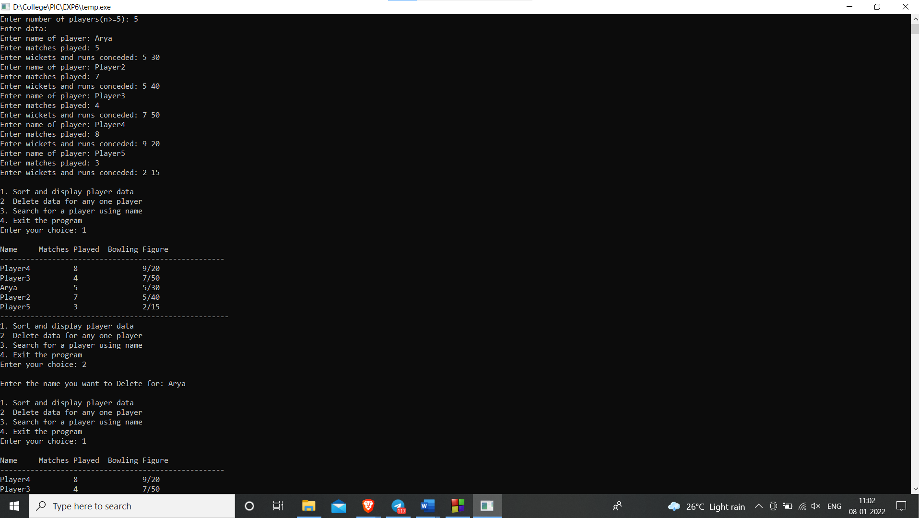

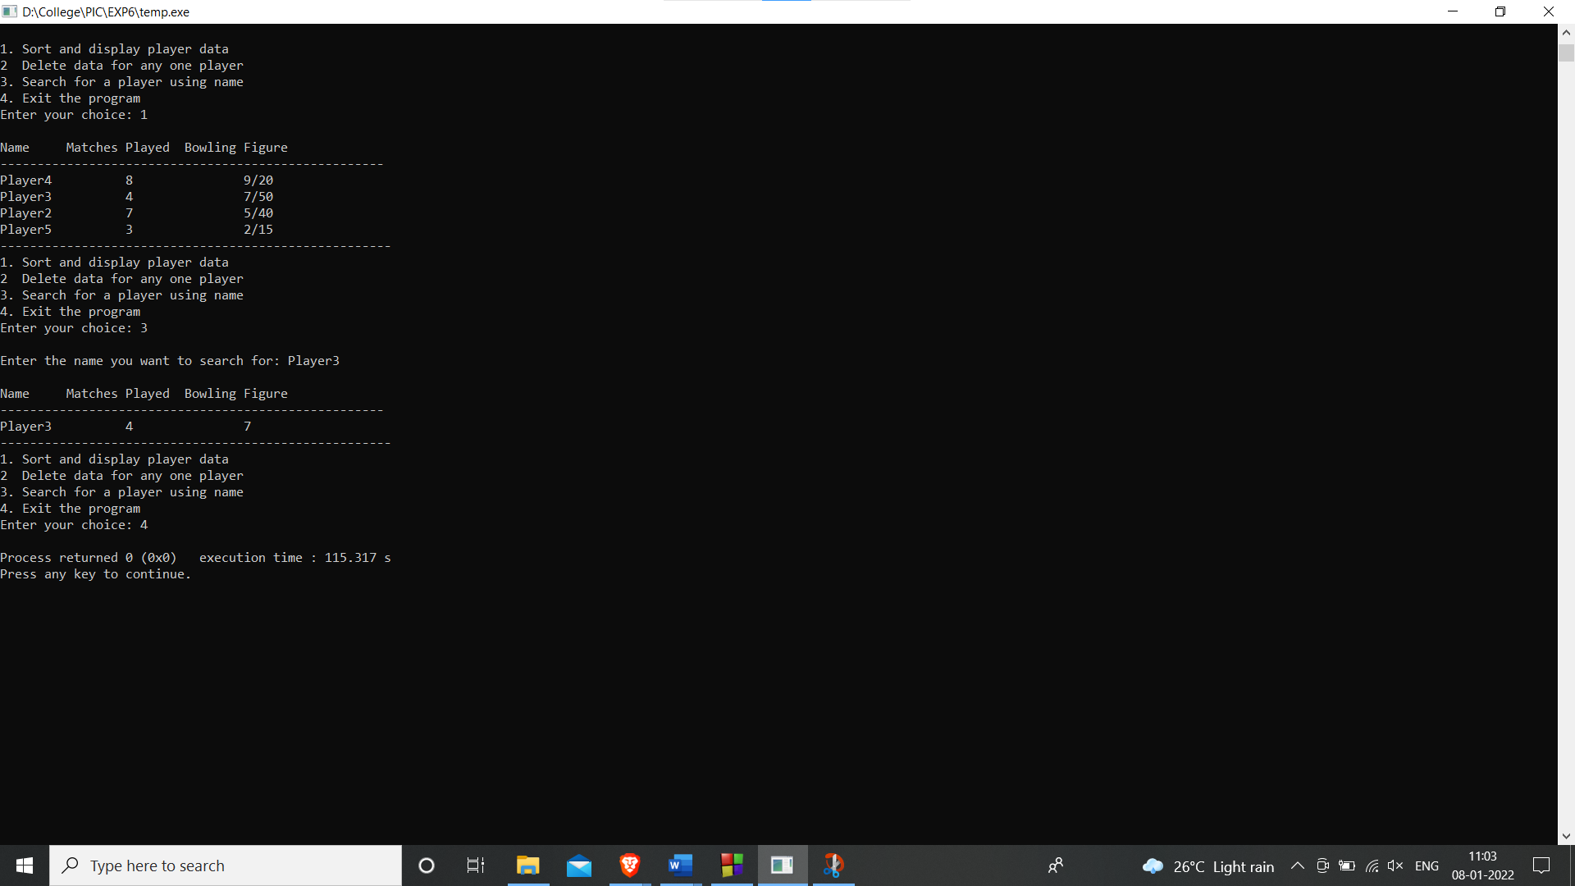

**Conclusion:**

**We successfully wrote a program which used an array of structures. Also implemented sorting, searching and deleting algorithm on that**

**Post Lab Descriptive Questions**

1. **Comment on the output of the following C code.**

#include <stdio.h>

struct temp

{

int a;

int b;

int c;

};

main()

{

struct temp p[] = {{1, 2, 3}, {4, 5, 6}, {7, 8, 9}};

}

**And- There will be no output as there is no output function (printf(),putchar(),puts()).**

1. **Consider the following C code. What will be the output?**

#include<stdio.h>

struct st

{

int x;

struct st next;

};

int main()

{

struct st temp;

temp.x = 10;

temp.next = temp;

printf("%d", temp.next.x);

return 0;

}

(A) Compiler Error

(B) 10

(C) Runtime Error

(D) Garbage Value

**Ans- A)Compiler Error**

1. **Difference between Structure and Union.**

| **Structure** | **Union** |
| --- | --- |
| The keyword Struct is used to define a structure | The keyword Union is used to define a union |
| When a variable is associated with a structure, the  the compiler allocates the memory for each member. The  size of structure is greater than or equal to the sum of  sizes of its members | when a variable is associated with a union, the compiler  allocates the memory by considering the size of the  largest memory. So, size of union is equal to the size  of largest member |
| Each member within a structure is assigned unique  storage area of location. | Memory allocated is shared by individual members of  union. |
| Altering the value of a member will not affect other  members of the structure. | Altering the value of any of the member will alter other  member values. |
| Individual members can be accessed at a time. | Only one member can be accessed at a time. |
| Several members of a structure can initialize at once. | Only the first member of a union can be initialized. |

**Date: _____________ Signature of faculty in-charge**