

**(To be filled by Candidate)**

| **Course:** | **Programming In C (PIC)** | | |
| --- | --- | --- | --- |
| **Candidates’ NAME:** | Arya Nair | | |
| **Candidates’ ROLL NO (In Figure):** | 16010421063 | | |
| **Year/ Sem:** | **FY B-Tech / I** | **Branch / Batch:** | G3 |

**PROGRAM 1 CODE: (Copy your program below)**

| #include<stdio.h> //Code by Arya Nair int main() {  int num;  printf("Decimal Number: ");  //Getting decimal value from User  scanf("%d",&num);  printf("Converted to HexaDecimal: %X",num);//Using %X format specifier to print HexaDecimal  return 0; } |
| --- |

**PROGRAM 1 OUTPUT/ ERROR: (Copy your output or error below)**

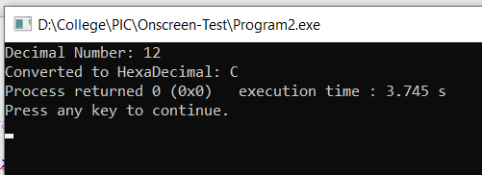

**PROGRAM 2 CODE: (Copy your program below)**

| #include<stdio.h> #include<stdlib.h> #include<string.h> //Code by Arya Nair int main() {   FILE *fp;//Declaring pointer to a file  FILE *fp2;  char ch;  char str[100]="Hey my name is Arya";  int i=0;  fp2=fopen("Arya.txt","w");//creating a file  fputs(str, fp2);  fclose(fp2);  fp = fopen("Arya.txt","r");//Opening file in read mode   if(fp == NULL)//If file is not found  {  printf("File not found");  exit(0);  }   fscanf(fp,"%[^\n]",str); //Storing in single string until we don't get a new line character  printf("Original String: %s\n",str);  printf("Reversed String: %s",strrev(str));//using string.h library to reverse the string  fclose(fp);  return 0; } |
| --- |

**PROGRAM 2 OUTPUT/ ERROR: (Copy your output or error below)**

