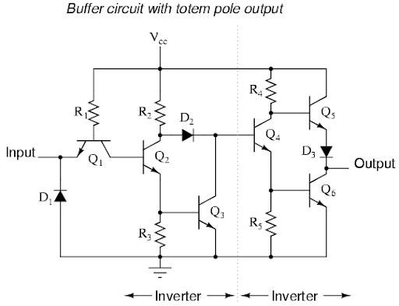

**Draw schematic diagram and design PCB layout of above diagram.**

**Schematic Diagram:**

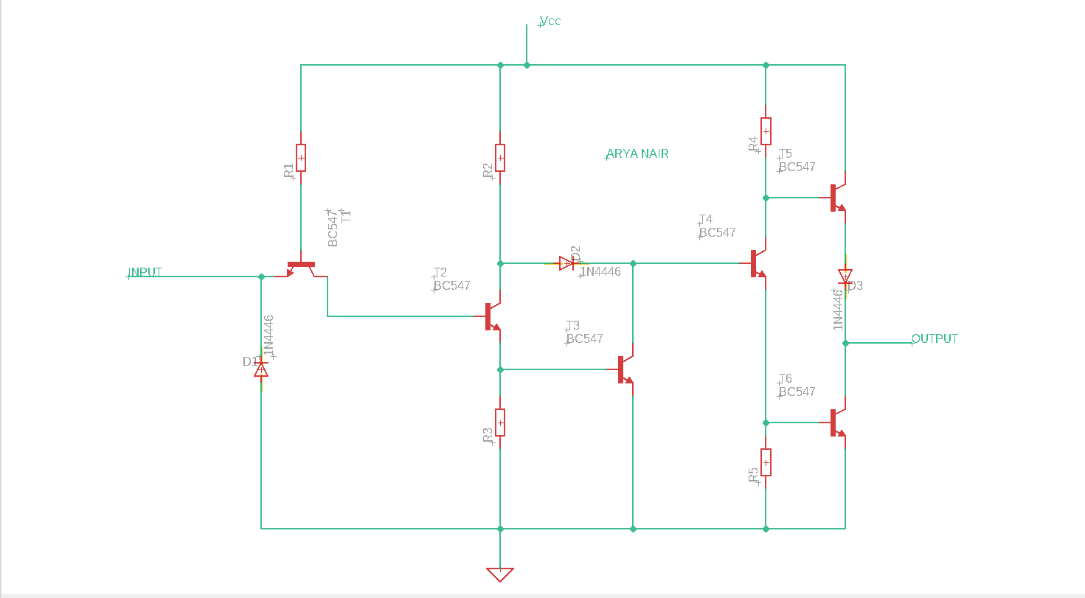

**PCB Layout:**

