Batch: G3 Roll No.: 16010421071

Experiment / assignment / tutorial No. 2

Grade: AA / AB / BB / BC / CC / CD /DD

Signature of the Staff In-charge with date

TITLE: Write a program to accept 3 numbers from the user and find the largest of the 3 numbers using,
1) If, else if, else, and
2) Ternary operator.

AIM: Write a program to accept 3 numbers from the user and find the largest of the 3 numbers using,
1) If, else if, else, and
2) Ternary operator.

Expected Outcome Of The Experiment: Apply basic concepts of C programming for problem solving. The problem being finding the largest number out of three. The program will help one find that using if else statements and also by ternary operators.

Books/ Journals/ Websites referred:
- Programming in C, second edition, Pradeep Dey and Manas Ghosh, Oxford University Press.
- Programming in ANSI C, fifth edition, E Balagurusamy, Tata McGraw Hill.
- Introduction to programming and problem solving, G. Michael Schneider, Wiley India edition.
- http://cse.iitkgp.ac.in/~rkumar/pds-vlab/

Problem Definition:
Ask user to input three numbers; Compare three numbers to find the largest of them using:
- Nested if else statement, and
- Using ternary operators.

Flowchart:
START

INPUT Num1, Num2, Num3

NO
YES
A > B
NO
NO
A > C
B > C
YES
YES

PRINT B

PRINT C
PRINT A

STOP

Implementation Details:

- Using If-Else Statements:

#include <stdio.h>
#include <stdlib.h>
// Hiral Patel
int main ()
{
float num1;
float num2;
float num3;
printf("Enter First Number: ");
scanf("%f", &num1);
printf("Enter Second Number: ");
scanf("%f", &num2);
printf("Enter Third Number: ");
scanf("%f", &num3);
if (num1 > num2 && num1 > num3) {
printf("The Largest Number is: %0.2f.", num1);
}
else if (num2 > num1 && num2 > num3) {
printf("The Largest Number is: %0.2f.", num2);
}
else{
printf("The Largest Number is: %0.2f.", num3);
}

return 0;
}

- Using Ternary Operators:

#include <stdio.h>
#include <stdlib.h>
// Hiral Patel
int main()
{
float num1;
float num2;
float num3;
float maximum;
printf("Enter First Number: ");
scanf("%f", &num1);
printf("Enter Second Number: ");
scanf("%f", &num2);
printf("Enter Third Number: ");
scanf("%f", &num3);
maximum = (num1 > num2 && num1 > num3) ? num1 : (num2 > num1 && num2 > num3) ? num2 : num3;
printf("The Largest of Three:%0.2f", maximum);

return 0;
}

Output(s):

For If-Else Statements:
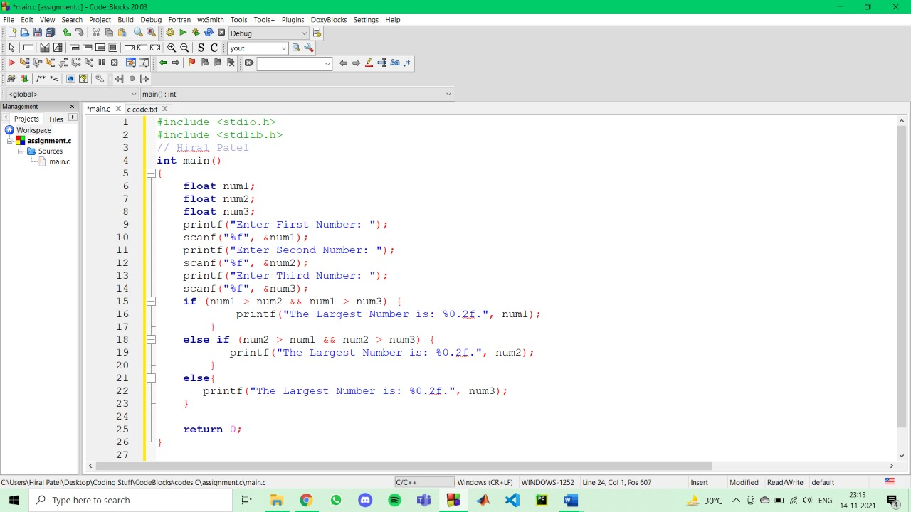
Input^
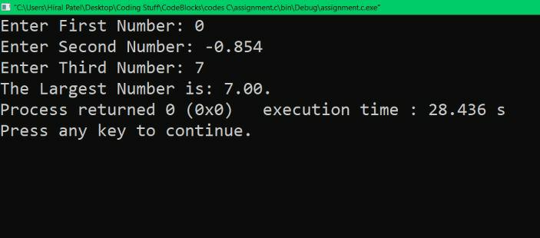
Output^

Ternary Operators:
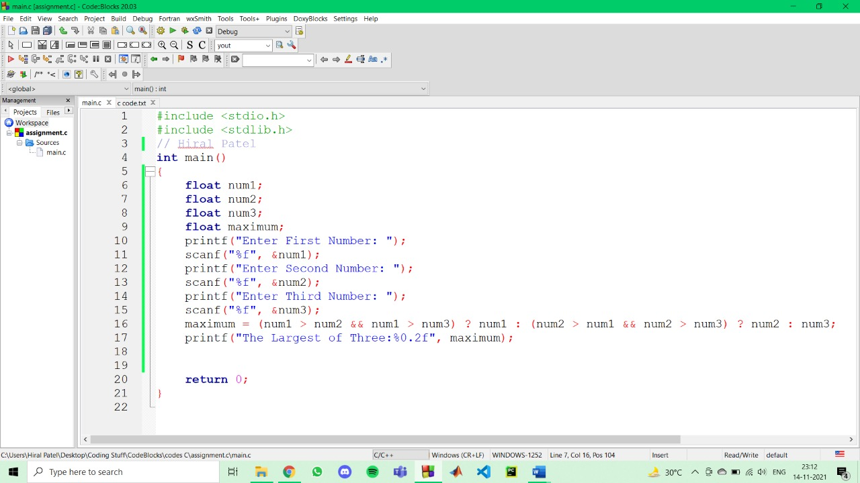
Input^
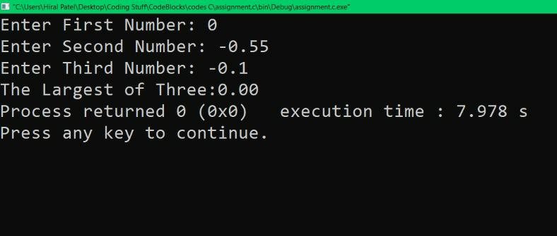
Output^

Conclusion:
Use of if else statements and ternary operators is completely understood, and so is the difference between them. The largest of the three numbers was found with the help of both the methods.

Post Lab Descriptive Questions:

- Explain bitwise operators with examples.
Answer: Bitwise operators are characters that represent actions to be performed on single bits stored inside the computer language. These operators are used to perform bit operations. Decimal value is converted into binary values which are the sequence of bits and bitwise operators work on these bits. As we perform mathematical operation using mathematical operators like ‘And’, ‘Or’, etc. The same way to perform bit level operations in C programming language we have bitwise operators. The examples of bitwise operators are:
OPERATORS | MEANING
& | Bitwise And
| | Bitwise Or
^ | Bitwise Exclusive Or
- | Bitwise Complement
<< | Shift Left
>> | Shift Right

- Write a code snippet to perform left shifting of bits by some positions.
Answer: Left shift operator shifts all the bits towards left by a certain number of specified bits mentioned while using the operator. The bit positions that have been vacated by the left shift operator are filled with 0. The symbol of the left shift operator is <<.

#include <stdio.h>
#include <stdlib.h>
// Hiral Patel
int main()
{
int num;
int i;
printf("Enter a Number: ");
scanf("%d", &num);

for (i=0; i <= 5; ++i) {
printf("Left shift by %d: %d\n", i, num << i);
}

return 0;
}

- Write associative rules and precedence table of various operators.
Answer: The precedence of operators helps determine which operator is executed first if there is more than one operator in an expression. The associativity of operators determines the direction in which an expression is evaluated.
ASSOCIATIVITY | OPERATOR | DESCRIPTION
left to right | ( )  [ ]  .  ->  + + - - | Parentheses/Function call  Brackets  Dot  Arrow Operator  Postfix Increment/Decrement
right to left | + + - -  + -  ! ~d  (type)  *  &  size of | Prefix Increment/Decrement  Unary plus and minus  not operator and bitwise complement  type cast  dereference operator  Address of operator  Determine size of bytes
left to right | + -  * / % | Addition and Subtraction  Multiplication, Division and Modulus
left to right | << >>  < <= > >=  = = ! =  &  ^  |  &&  | | | Bitwise left shift and right shift  Relational less than/less than equal to  Relational greater than/greater than equal to  Relational equal to and not equal to  Bitwise And  Bitwise exclusive Or  Bitwise inclusive Or  Logical Or  Logical Or
right to left | ? : | Ternary Operator
right to left | =  += -=  *= /=  %= &=  ^= |=  <<= >>= | Assignment Operator  Addition/Subtraction Assignment  Multiplication/Division Assignment  Modulus/Bitwise And Assignment  Bitwise Inclusive/Exclusive Or Assignment  Bitwise Shift Left/Right Assignment
left to right | , | Comma Operator

- What are different storage class specifiers in C?
Answer: A storage class is used to represent additional information about a variable. Storage class represents the scope and lifespan of a variable. It also tells us as to who can access a variable and from where. A storage class is used to describe the following things:
- The variable scope.
- The location where the variable will be stored.
- The initialized value of a variable.
- A lifetime of a variable.
- Who can access a variable?
Auto, extern, register, static are the four storage classes in 'C'. Details:
- Auto is used for a local variable defined within a block or function.
- Register is used to store the variable in CPU registers rather memory location for quick access.
- Static is used for both global and local variables. Each one has its use case within a C program.
- Extern is used for data sharing between C project files.

Date: _____________ Signature of faculty in-charge

