Batch: G3 Roll No.: 16010421071

Experiment / assignment / tutorial No. 3

Grade: AA / AB / BB / BC / CC / CD /DD

Signature of the Staff In-charge with date

TITLE: Menu driven program.

b. To calculate the sum of the Fibonacci series up to ‘n’ terms. (use do-while loop only)
AIM: Write a menu driven program for following option
a. To find whether a number is palindrome or not. (e.g., 1221 is palindrome)
c. To find the numbers and sum of all integer between 100 and 200 which are divisible by both 3 & 5. (Use for loop only)
______________________________________________________________________
Expected Outcome of the Experiment: Apply basic concepts of c programming for problem solving a menu driven program.
_____________________________________________________________________
Books/ Journals/ Websites referred:

- Programming in C, second edition, Pradeep Dey and Manas Ghosh, Oxford University Press.
- Programming in ANSI C, fifth edition, E Balagurusamy, Tata McGraw Hill.
- Introduction to programming and problem solving , G. Michael Schneider ,Wiley India edition.
- http://cse.iitkgp.ac.in/~rkumar/pds-vlab/

_____________________________________________________________________
Problem Definition:

The program accepts a choice from the user using a switch case statement and generates output accordingly.

Choice A: The program checks whether a given number by user is a palindrome or not. If a number remains same, even if we reverse its digits then the number is known as palindrome number. For example, 12321 is a palindrome number because it remains same if we reverse its digits.

Choice B: Sum of Fibonacci series up to n terms will be generated. Fibonacci series is a series in which each number is the sum of the last two preceding numbers. The first two terms of a Fibonacci series are 0 and 1. (Use while loop only)
Example:
Input: n = 5
Output: 7
Explanation: 0 + 1 + 1 + 2 + 3 = 7

Choice C: To find the numbers and sum of all integer between 100 and 200 which are divisible by both 3 and 5. (Use for loop only)
Algorithm:
Implementation details:
#include <stdio.h>
#include <stdlib.h>
#include<conio.h>
// Hiral Patel
int main()
{
char choice;
int palindrome; // case A
int result_a = 0; // case A
int remainder; // case A
int n; // case A
int fibonacci; // case B
int num1; // case B
int num2; // case B
int num3; // case B
int result_b; // case B
int x; // case B
char yn; // case C
int lower = 100; // case C
int upper = 200; // case C

printf("Welcome to the Program!\n");
printf("A. To check if the Number you enter is a Palindrome or no.\nB. To check the sum of the Fibonacci Numbers up to the Number you enter.\nC. To find the Numbers and Sum of all Integer between 100 and 200 which are Divisible by Both 3 and 5.\n");
printf("Select one of the Options given Above: ");
scanf("%s", &choice);

switch(choice){
case 'A':
case 'a':
printf("Welcome to the Palindrome Program!\n");
printf("Enter a Number that you want to find is a Palindrome: ");
scanf("%d", &palindrome);
n = palindrome;
while(n != 0)
{
remainder = n % 10;
result_a = (result_a * 10) + remainder;
n = n / 10;
} if(result_a == palindrome){
printf("%d is a Palindrome.", palindrome);
} else{
printf("%d is not a Palindrome.", palindrome);
}
break;
case 'B':
case 'b':
printf("Welcome to the Fibonacci Sum Program!\n");
printf("Enter a Number till which you want to find the Fibonacci Sum till: ");
scanf("%d", &fibonacci);
num1 = 0;
num2 = 1;
printf("Fibonacci Series: ");
/* // for loop Fibonacci code
for (int i = 1; i <= fibonacci; i++){
printf("%d ", num1);
result_b = num1 + num2;
num1 = num2;
num2 = result_b;
}
printf("\nThe Sum of %d terms of the Fibonacci Series is %d", fibonacci, result_b); */
printf("%d %d ", num1, num2);
x = fibonacci;
x = x - 2;
while(x){
num3 = num1 + num2;
printf("%d ", num3);
num1 = num2;
num2 = num3;
x = x - 1;
}
printf("\nThe Sum of %d terms of the Fibonacci Series is %d", fibonacci, num3 + num2 + num1 - 1);
break;
case 'C':
case 'c':
printf("Welcome to the Program that helps you find the Numbers and the Sum of all Integer between 100 and 200 \nwhich are Divisible by Both 3 and 5.");
printf("\nEnter 'y' to continue and 'n' if you don't want to: ");
scanf("%s", &yn);
if (yn == 'y'){
printf("Let's proceed with the Program.\n");
} else if (yn == 'n'){
printf("Re-run the program to edit the numbers.\n");
} else {
printf("Invalid Operator, Re-run the program.\n");
}
printf("Welcome to the Program User!\n");
for (int i = lower; i <= upper; i++){
if(i % 3 == 0 && i % 5 == 0){
printf("%d ", i);
}
}
printf("\nThank You for using the Program User!");
break;
default:
printf("Invalid Option, Re-run The Code.");
}
return 0;
}
/* For Case A: Any number divided by 10, gives last digit as the remainder and the first two digits as the quotient. example: 712 / 10 gives 2 as the remainder and 71 as the quotient.
Even when it divides 5562, 2 is the remainder and 556 would be the quotient.
For Case B: If we want to find out the sum of first 5 terms, the terms are: 0 1 1 2 3. So, 0+1+1+2+3 = 7, that's one less than the next-to-next term. So, for 10 terms: 0 1 1 2 3 5 8 13 21 34
So, it gives 88, one less than the next-to-next term. It keeps on repeating. So, If we take 17, It'll give 2583, one less than the next to next term, 2584.
*/
Output(s):
Case A:
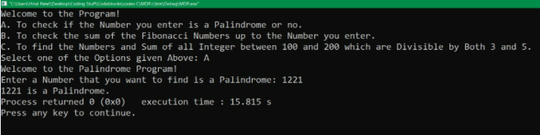

Case B:
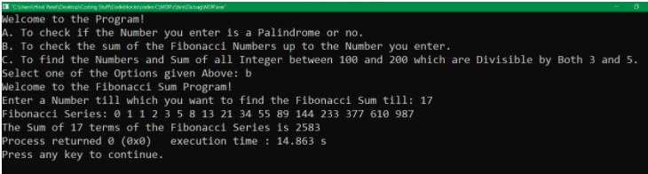

Case C:
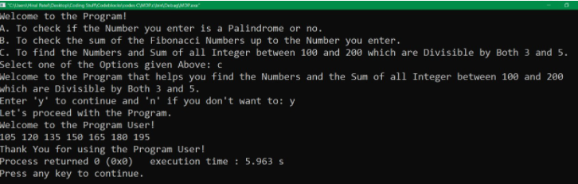

Default:
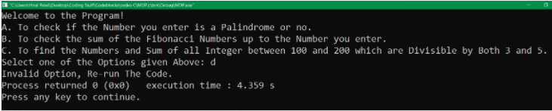

Conclusion:
Use of menu driven programming was understood using switch case. The concept and the use of Palindrome and Fibonacci series was understood and used in the program and assignment. Clear use of Loops was cleared.

Post Lab Descriptive Questions:

Write menu driven code for the following:

The program allows a user to enter five numbers and then asks the user to select a choice from a menu. The menu should offer the following options:
1. Display the smallest number entered;
2. Display the largest number entered;
3. Display the sum of the five numbers entered;
4. Display the average of the five numbers entered; and
5. Exit.

Answer:
#include <stdio.h>
#include <stdlib.h>

int main()
{
float num1;
float num2;
float num3;
float num4;
float num5;
char yn;
char choice;
printf("Enter any five numbers of your choice with a space in between: ");
scanf("%f%f%f%f%f", &num1, &num2, &num3, &num4, &num5);
printf("User, your numbers are: \n1) %0.1f\n2) %0.1f\n3) %0.1f\n4) %0.1f\n5) %0.1f\n", num1, num2, num3, num4, num5);
printf("If your numbers are correct type 'y' and if not then 'n': ");
scanf("%s", &yn);
if (yn == 'y'){
printf("Let's proceed with the Program.\n");
} else if (yn == 'n'){
printf("Re-run the program to edit the numbers.\n");
} else {
printf("Invalid Operator, Re-run the program.\n");
}
printf("Welcome to the Program User!\nA)Smallest Number.\nB)Largest Number.\nC)Sum.\nD)Average.\nE)Exit Program.\n");
printf("Choose one of the following option to run according to your number input: ");
scanf("%s", &choice);
float sum = num1 + num2 + num3 + num4 + num5;
float average = sum * (0.2);
switch(choice){
case 'A':
case 'a':
if(num1 <= num2 && num1 <= num3 && num1 <= num4 && num1 <= num5){
printf("Smallest Number: %0.1f", num1);
} else if(num2 <= num1 && num2 <= num3 && num2 <= num4 && num2 <= num5){
printf("Smallest Number: %0.1f", num2);
}else if(num3 <= num1 && num3 <= num2 && num3 <= num4 && num3 <= num5){
printf("Smallest Number: %0.1f", num3);
}else if(num4 <= num1 && num4 <= num2 && num4 <= num3 && num3 <= num5){
printf("Smallest Number: %0.1f", num4);
}else if(num5 <= num1 && num5 <= num2 && num5 <= num3 && num5 <= num4){
printf("Smallest Number: %0.1f", num5);
}else{
printf("Any two or more Numbers are Equal.");
}
break;
case 'B':
case 'b':
if(num1 >= num2 && num1 >= num3 && num1 >= num4 && num1 >= num5){
printf("Largest Number: %0.1f", num1);
} else if(num2 >= num1 && num2 >= num3 && num2 >= num4 && num2 >= num5){
printf("Largest Number: %0.1f", num2);
}else if(num3 >= num1 && num3 >= num2 && num3 >= num4 && num3 >= num5){
printf("Largest Number: %0.1f", num3);
}else if(num4 >= num1 && num4 >= num2 && num4 >= num3 && num3 >= num5){
printf("Largest Number: %0.1f", num4);
}else if(num5 >= num1 && num5 >= num2 && num5 >= num3 && num5 >= num4){
printf("Largest Number: %0.1f", num5);
}else{
printf("Any two or more Numbers are Equal.");
}
break;
case 'C':
case 'c':
printf("The Sum of all your Input Numbers is: %0.1f", sum);
break;
case 'D':
case 'd':
printf("The Average of all your Input Numbers is: %0.1f", average);
break;
case 'E':
case 'e':
printf("User, You Exited the Program.");
break;
default:
printf("Invalid Option, Re-run The Code.");
}
return 0;
}

Date: _16 / 11 / 21_ Signature of faculty in-charge

