Batch: G3 Roll No.: 16010421071

Experiment / assignment / tutorial No. 4

Grade: AA / AB / BB / BC / CC / CD /DD

Signature of the Staff In-charge with date

TITLE: Program to print patterns

Expected OUTCOME of Experiment:
AIM: Program to print patterns for ‘n’ rows using nested loop ______________________________________________________________________
Apply basic concepts of C programming for problem solving. Printing the different types of patterns for understanding about different types of loops in C.
________________________________________________________________
Books/ Journals/ Websites referred:
- Programming in C, second edition, Pradeep Dey and Manas Ghosh, Oxford University Press.
- Programming in ANSI C, fifth edition, E Balagurusamy, Tata McGraw Hill.
- Introduction to programming and problem solving, G. Michael Schneider, Wiley India edition.
- http://cse.iitkgp.ac.in/~rkumar/pds-vlab/
_______________________________________________________
Problem Definition:

The program is to print a pattern as given by the user. The program makes use of a nested loop to print a pattern of characters, numbers or alphabets.
Example:
Input: number of rows = 4 and number of columns = 4;
Output: 5
4 5
3 4 5

2 3 4 5
1 2 3 4 5
Algorithm:
STEP 1: Start.
STEP 2: Enter ‘rows’ where rows = number of rows as well as columns.
STEP 3: Using For loop where variable ‘a’ is equal to number of rows where row is variable ‘rows’.
STEP 4: Using first inner loop where the iteration variable ‘b’ represents spaces and displays space.
STEP 5: ‘b’ is assigned the value 1 and displays space till its condition “b < a” is fulfilled if the condition does not match the loop execution stops and the compiler goes to STEP 6.
STEP 6: Using second inner look where the iteration variable ‘c’ is equal to ‘a’ then the value displayed is ‘c’.
STEP 7: Increment of ‘c’ by 1, if ‘c’ becomes greater than the column where column is variable ‘i’ the loop breaks and compiler goes to STEP 8.
STEP 8: Print new line.
STEP 9: Decrement of ‘a’ by 1 if ‘a’ becomes equal to zero the loop condition fails and the compiler goes to STEP 10.
STEP 10: Stop.
Implementation details:

#include <stdio.h>
#include <stdlib.h>
// Hiral Patel
int main()
{
int a;
int b;
int rows;
printf("Enter The Number Of Rows: ");
scanf("%d", &rows);
for(a = rows; a >= 1; a--){
for(b = 1; b < a; b++){
printf(" ");
}for(b = a; b <= rows; b++){
printf(" %d", b);
}
printf("\n");
}
return 0;
}

Output(s):

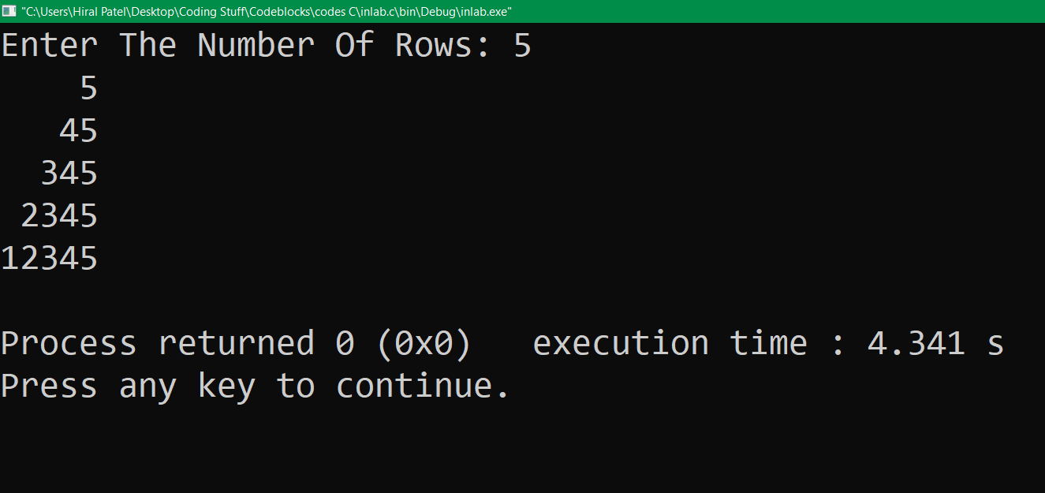

Conclusion:
The above code for printing different patterns is achieved by applying the basic concept of C programming for solving the problem. Use of different type of loops was understood. The code was successfully executed.

Post Lab Descriptive Questions:
Question: Write a program to print the following;
1
2 4
3 6 9
4 8 12 16
5 10 15 20 25
6 12 18 24 30 36
7 14 21 28 35 42 49
8 16 24 32 40 48 56 64
9 18 27 36 45 54 63 72 81
10 20 30 40 50 60 70 80 90 100

Answer:

#include <stdio.h>
#include <stdlib.h>
// Hiral Patel
int main()
{
int x = 10;
int a = 1;
int b;
for(a = 1; a <= x; a++){
for(b = 1; b <= a; b++){
printf("%d ", a * b);
}
printf("\n");
}

return 0;
}

Date: __30 / 11 / 21__ Signature of faculty in-charge

