**Batch: A3**

**Roll Number: 16010421075**

**Experiment Number: 1**

**Name: Tirth Patel**

**Title of the Experiment:**  Networking commands

**Output:**

**1)ping**

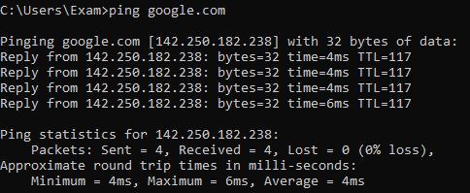

**2)ipconfig**

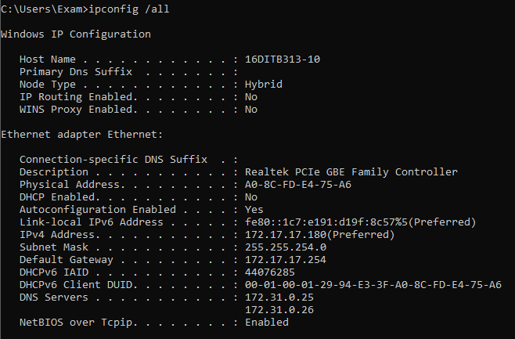

**3)tracert**

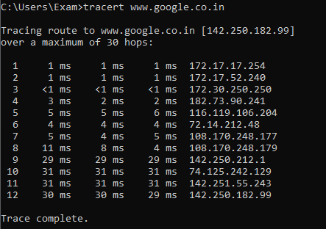

**4)arp**

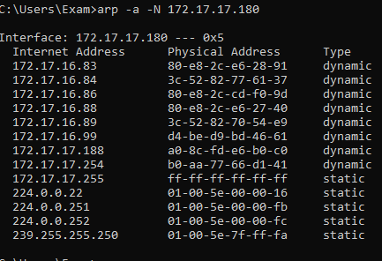

**5)netstat**

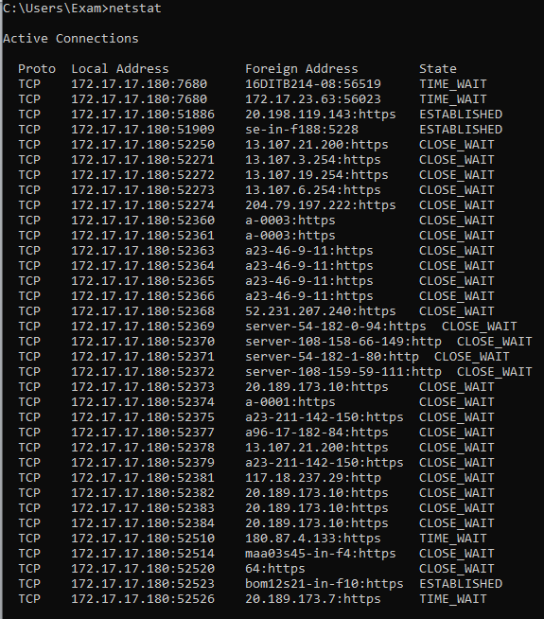

**6) nslookup**



**7)pathping**

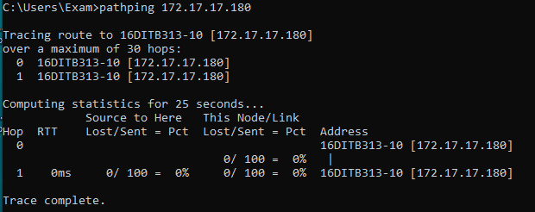

**Post Lab Question- Answers (If Any):**

1. ICMP is used in _________

a) Ping

b) Traceroute

c) Ifconfig

d) Both Ping & Traceroute

2. __________ command is used to manipulate TCP/IP routing table.

a) route

b) Ipconfig

c) Ifconfig

d) Traceroute

3. Select the false statement from the following.

a) Nslookup is used to query a DNS server for DNS data

b) Ping is used to check connectivity

c) Pathping combines the functionality of ping with that of route

d) Ifconfig can configure TCP/IP network interface parameters

**CO: Understand the data communication system, network topologies and network devices.**

**Conclusion:**

**We learned that ping is based on ICMP protocol and is used to determine:**

**If there is connectivity between your machine and another machine on the network.**

**It’s used to measure the “speed” or latency time. Also came to know about Routing tables to meet our network interfaces and its outputs.**