**Batch: A3**

**Roll Number:16010421073**

**Experiment Number: 1**

**Name: Keyur Patel**

**Title of the Experiment: Study of various networking commands**.

**Output:**

**1)Ping:**

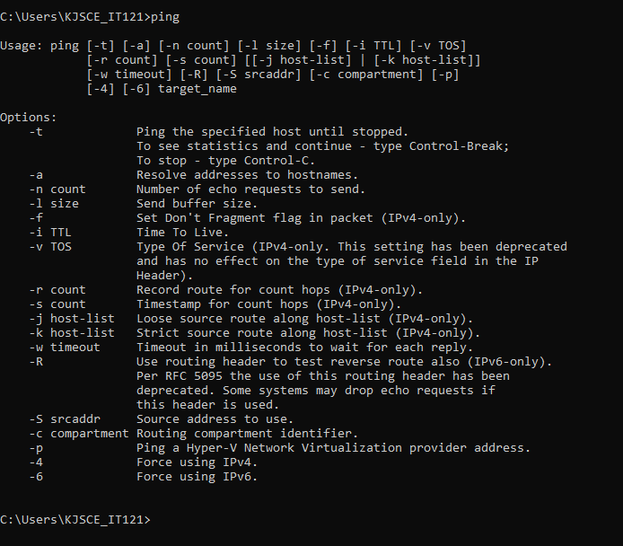

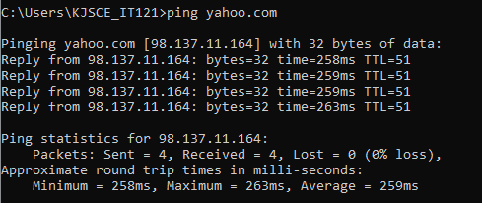

**2)ipconfig**

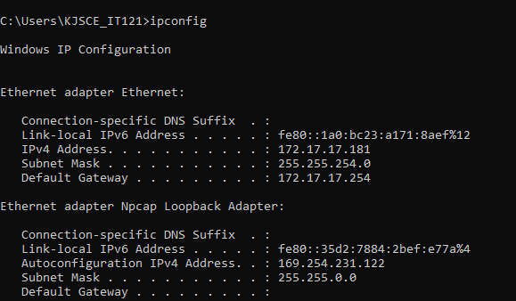

**3)tracert**

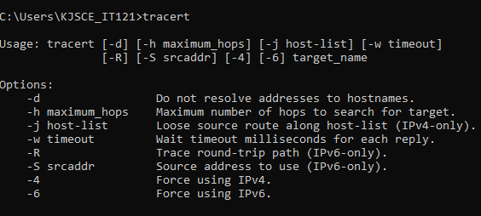

**4)arp**

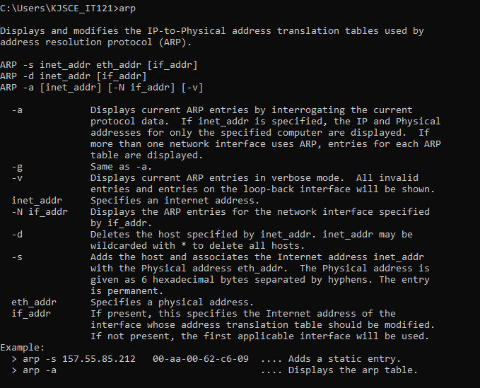

**5)netstat**

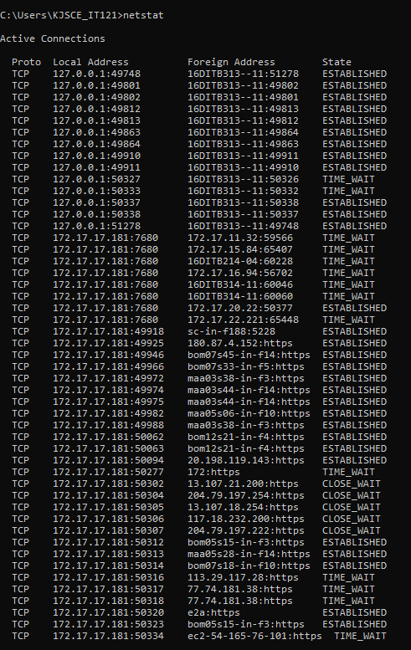

**Output:**

**6) pathping**

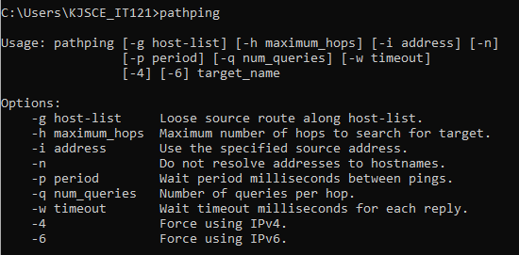

**7)** **Route:**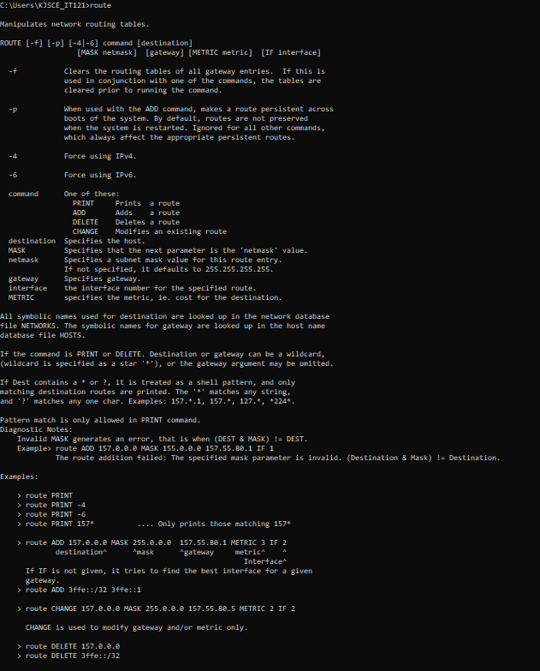

**Post Lab Question- Answers (If Any):**

Questions

**1. ICMP is used in _________**

a) Ping

b) Traceroute

c) Ifconfig

d) Both Ping & Traceroute

**2. __________ command is used to manipulate TCP/IP routing table.**

a) route

b) Ipconfig

c) Ifconfig

d) Traceroute

**3. Select the false statement from the following.**

a) Nslookup is used to query a DNS server for DNS data

b) Ping is used to check connectivity

c) Pathping combines the functionality of ping with that of route

d) Ifconfig can configure TCP/IP network interface parameters. _____________________________________________________________

**CO:** Understand the data communication system,network topologies and network devices.

**Conclusion:**

**In this experiment we learned about**

* **Use of ping command for getting the connectivity between two hosts.**
* **Use of Ipconfig command which is used to display all current TCP/IP network configuration , DHCP and DNS settings.**
* **Use of Tracert command to diagnose path related programs and its options like –d,-h etc.**
* **Use of Arp to send IP packets .**
* **Use of command which displays active connections, ports on which the computer is listening, Ethernet statistics, the IP routing table, and IP statistics.**