

**Experiment No. 4**

**Title:** TCP Header implementation

# Batch: A3 Roll No.: 16010421073 Experiment No: 4

**Aim:** To write a program to implement TCP header

**Resources Used:** Java /C/C++/Python

# Theory:

The transport service is implemented by a transport protocol used between the two transport entities. Transport protocols resemble the data link protocols. Both have to deal with error control, sequencing, and flow control, among other issues. Differences are due to major dissimilarities between the environments in which the two protocols operate. The Internet has two main protocols in the transport layer, Connectionless protocol: UDP Connection-oriented protocol: TCP TCP (Transmission Control Protocol) was designed to provide a reliable end-to- end byte stream over an unreliable internetwork .

**The TCP Protocol:** Every byte on a TCP connection has its own 32-bit sequence number. Separate 32-bit sequence numbers are used for acknowledgements and for the window mechanism. The sending and receiving TCP entities exchange data in the form of segments. A TCP segment consists of a fixed 20-byte header (plus an optional part) followed by zero or more data bytes. Two limits restrict the segment size. Each segment, including the TCP header, must fit in the 65,515-byte IP payload. Each network has a Maximum Transfer Unit, or MTU, and each segment must fit in the MTU. In practice, the MTU is generally 1500 bytes (the Ethernet payload size) and thus defines the upper bound on segment size. A segment that is too large for a n/w can be broken into multiple segments by a router. The basic protocol used by TCP entities is the **sliding window protocol**. When a sender transmits a segment, it also starts a timer. When the segment arrives at the destination, the receiving TCP entity sends back a segment (with data if any exist, otherwise without data) bearing an acknowledgement number equal to the next sequence number it expects to receive. If the sender's timer goes off before the acknowledgement is received, the sender transmits the segment again.

**The TCP Segment Header:** The **Source port** and **Destination port** fields identify the local end points of the connection. A port plus its host's IP address forms a 48-bit unique end point (TSAP). The **Sequence number** defines the number of the first data byte contained in that segment and **Acknowledgement number** specifies the next byte expected, not the last byte correctly received. Both are 32 bits long. The **TCP header length** tells how many 32-bit words are contained in the TCP header.



# Activity:

Write a program to accept the input in the hexadecimal form (continuous string) and display the value of each field of TCP header.

# Program:

# Code

list =(input("Enter your hexadecimal value that you want to write : \n"))

if len(list) == 40:

    print("The input is valids....")

else:

    print("input is invalid....")

mylist6 = []

mylist7 = []

tcp_1 = list[0:4]

print("Your source port address is: \n", tcp_1)

tcp_2 = list[4:8]

print("Your destination port address is: \n", tcp_2)

tcp_3 = list[8:16]

print("Your sequence number is: \n", tcp_3)

tcp_4 = list[16:24]

print("Your acknowledgemnt number is: \n", tcp_4)

tcp_5 = list[24:25]

print("Your HLEN number is: \n", tcp_5)

tcp_6 = list[25:28]

for i in range(25,28):

    mylist6.append(list[i])

for j in range(0,3):

    mylist7.append("{0:04b}" .format(int(mylist6[j])))

print(mylist7)

str_1 = " "

str_2 = str_1.join(mylist7)

print(str_2)

print("Your Reserved number is:",str_2[0:6])

print("Your Flag number is:",str_2[6:12])

tcp_7 = list[28:32]

print("Your Window size number is: \n", tcp_7)

tcp_8 = list[32:36]

print("Your check sum number is: \n", tcp_8)

tcp_9 = list[36:40]

print("Your urgent pointer number is: \n", tcp_9)

**Output:** 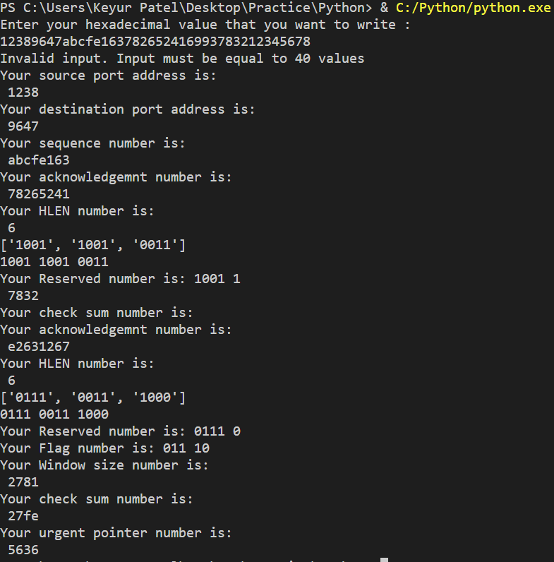

# Questions:

1. The unit of data transfer between two devices using TCP is called **data segment.**
2. Which type of addressing is used at Transport Layer?
   1. Port addressing
   2. Logical addressing
   3. Physical Addressing
   4. None of the Above
3. What is the difference between TCP and UDP?

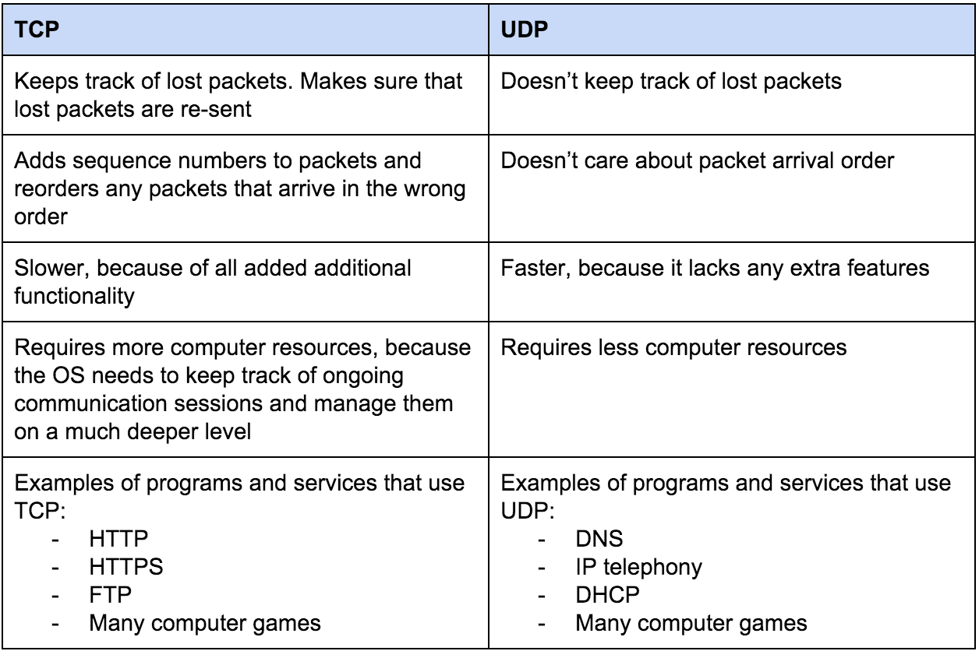

# Outcomes:

CO2: Enumerate the layers of the OSI model and the TCP/IP model, their functions and protocols

**Conclusion:**

**We understood about the different layers of the TCP model and also wrote a program to show values of each TCP header.**

# Grade: AA / AB / BB / BC / CC / CD /DD

**Signature of faculty in-charge with date**

# References:

**Books/ Journals/ Websites:**

* Behrouz A Forouzan, Data Communication and Networking, Tata Mc Graw hill, India, 4th Edition
* A. S. Tanenbaum, “Computer Networks”, 4th edition, Prentice Hall