KJSCE/IT/SYBTECH/SEM-III/DMS/2017-18

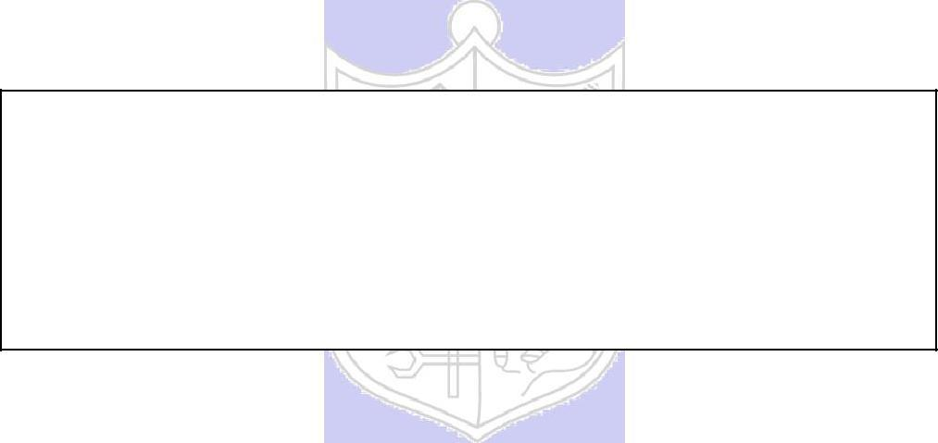

**Experiment No.: 02**

**Title:** To Map EER diagram drawn in experiment no.1to relational model.

(Autonomous College Affiliated to University of Mumbai)

KJSCE/IT/SYBTECH/SEM-III/DMS/2017-18

**Batch:A3** **Roll No.:16010421075** **Experiment No.: 02**

**Aim:** To Map EER diagram drawn in experiment no.1 to relational model.

**____________________________________________________________________**

**Resources needed:** MS-office

**____________________________________________________________________**

**Theory:**



The relational model uses collection of tables to represent both data and the relationships among those data. Each table has multiple columns and each column has a unique name. The relational model is an example of record-based model. Each table contains records of a particular type. The columns of the table correspond to the attributes of the record type. The relational model is the most widely used data model.

**__________________________________________________________________________**

**Procedure / Approach /Algorithm / Activity Diagram:**

**Steps for Reducing EER model into relational model**

1. Any strong entity set E having attributes a1, a2,…,an is reduced into a relation schema called E with n distinct attributes i.e. a separate relation with name E and n distinct columns.
2. Any weak entity set A having attributes a1, a2,..n and a strong entity set B on which A depends, having primary key attributes as b1, b2, …, bn is reduced into a relation schema called A with one attribute for each member of set

{ a1, a2,…, an} U {b1, b2, ……. , bn}

1. Any relationship set R having a1,a2,…,an as a set of attributes formed by union of the primary keys of each of the entity sets participating in R and b1, b2,….,bn as set of descriptive attributes is reduced into a relation schema called R with one attribute for each member of the set {a1, a2, …. ,an} U {b1, b2, …., bn}

(Autonomous College Affiliated to University of Mumbai)

KJSCE/IT/SYBTECH/SEM-III/DMS/2017-18

**Primary key of relationship set is decided as follows**

For **binary many to many relationships** the union of primary key attributes from the participating entity sets is primary key.

For **binary one to one relationship set** the primary key of either of the participating entity set can be chosen as the primary key.

For **binary many to one or one to many relationship set** the primary key of the entity set on the many side of the relationship set serves as the primary key.

For **n-ary relationship sets without any arrows on its edges**, union of the primary key attributes of participating entity sets is a primary key.

For **n-ary relationship sets with an arrows on one of its edges**, union of the primary key attributes of participating entity sets is a primary key.

To remove redundancy we generally make separate relation schema for many to many relationship set with primary key and other attributes as mentioned above.



For one to one we combine relation schema of relationship set with relation schema of either sides of entity sets relation schema.

For one to many and many to one we combine relation schema of relationship set with relation schema of entity set on many side entity set.

We don’t make separate relation schema for identifying relationship set.Every composite attribute A having subparts a1, a2,…,an is represented by separate column for each subpart in relation schema of the associated entity set.

For **multivalued attribute** separate schema is form having columns as attributes of primary key of associated entity set and a column for multivalued attribute

For **overlapping generalization/specialization** create separate relation schemas for higher level as well as lower level entity sets.

Also include the foreign key constraint in lower level entityset for the primary key attributes of higher level entity set.

For **disjoint generalization/specialization** create separate relation schemas only for every lower level entity set(higher level entity set’s attributes are inherited so add columns for same) and not for higher level entity set.

No separate relation is required to represent the **aggregation** the relation created from the defining relationship is used instead (design schema for relationship set treated as entity set carefully)

**___________________________________________________________________________**

(Autonomous College Affiliated to University of Mumbai)

KJSCE/IT/SYBTECH/SEM-III/DMS/2017-18

**Results: (Document printout/handwritten)**

1. **Relational model For Hotel management system**

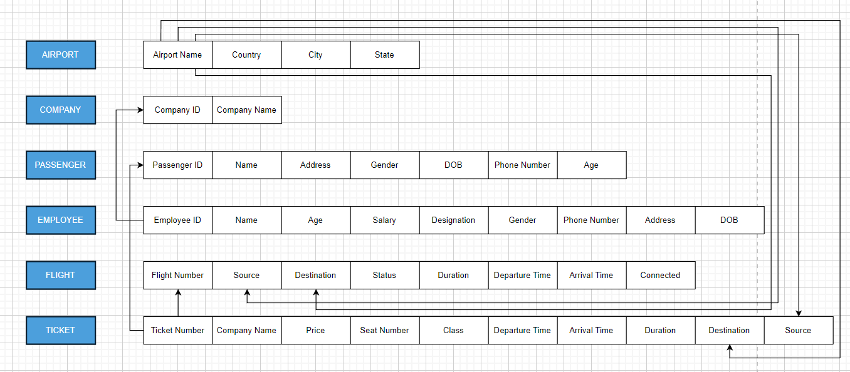

1. **ER diagram**

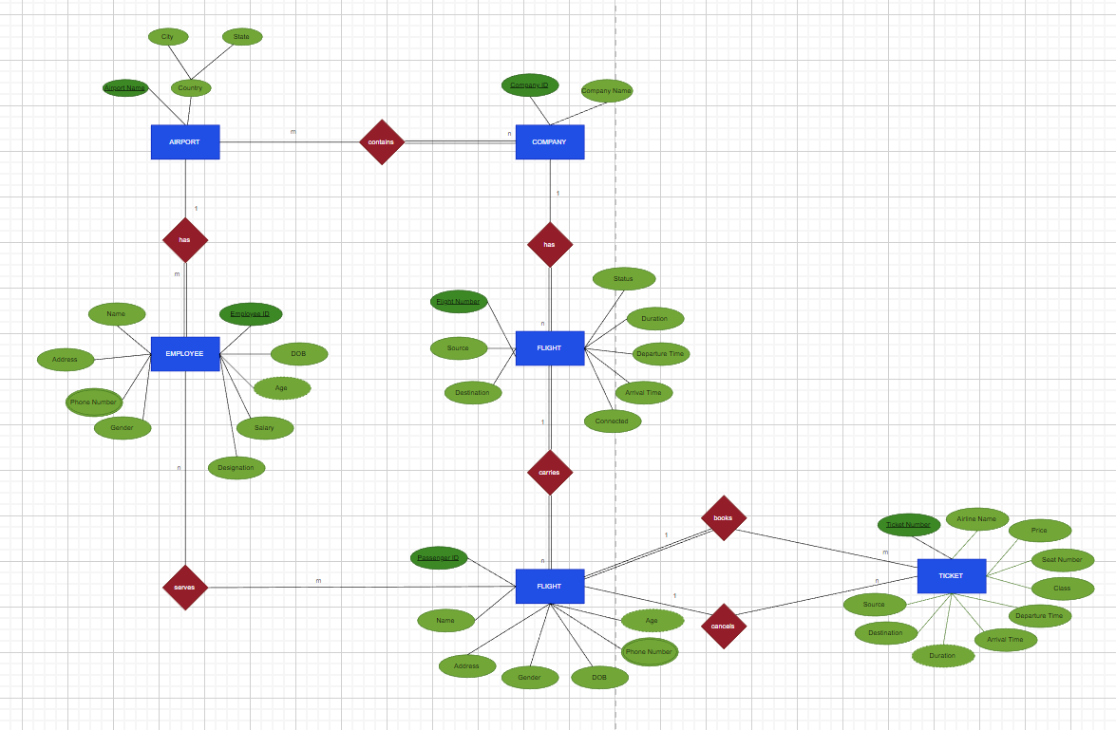

**Example:**

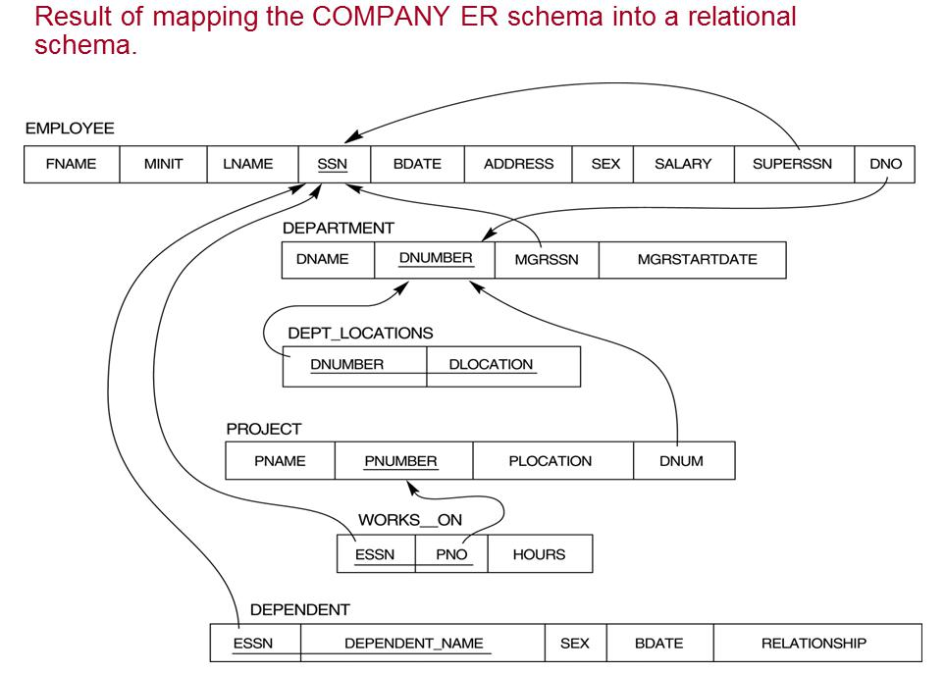

(Autonomous College Affiliated to University of Mumbai)

KJSCE/IT/SYBTECH/SEM-III/DMS/2017-18

**______________________________________________________________________**

**Outcomes:**

**CO2 :Realize the features of Relational database management systems and data models.**

**___________________________________________________________________________**

**Questions:**

**Q1 Explain generalization and specialization with example**

**Ans:**

**Generalization** is a bottom-up approach in which two lower level entities combine to form a higher level entity. In generalization, the higher level entity can also combine with other lower level entity to make further higher level entity.

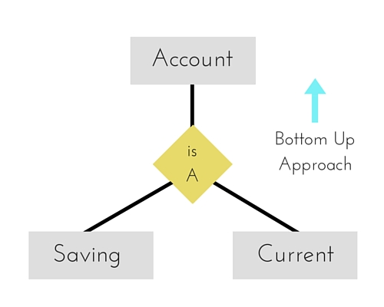

**Specialization** is opposite to Generalization. It is a top-down approach in which one higher level entity can be broken down into two lower level entity. In specialization, some higher level entities may not have lower-level entity sets at all.

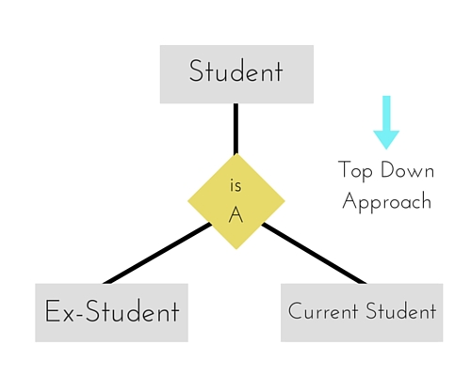

**Q2 what is physical and logical data independence in DBMS.**

**Ans:**

**Data Independence**

A database system normally contains a lot of data in addition to users’ data. For example, it stores data about data, known as metadata, to locate and retrieve data easily. It is rather difficult to modify or update a set of metadata once it is stored in the database. But as a DBMS expands, it needs to change over time to satisfy the requirements of the users. If the entire data is dependent, it would become a tedious and highly complex job.

**Logical Data Independence**

Logical data is data about database, that is, it stores information about how data is managed inside. For example, a table (relation) stored in the database and all its constraints, applied on that relation.

Logical data independence is a kind of mechanism, which liberalizes itself from actual data stored on the disk. If we do some changes on table format, it should not change the data residing on the disk.

**Physical Data Independence**

All the schemas are logical, and the actual data is stored in bit format on the disk. Physical data independence is the power to change the physical data without impacting the schema or logical data.For example, in case we want to change or upgrade the storage system itself − suppose we want to replace hard-disks with SSD − it should not have any impact on the logical data or schemas.

**__________________________________________________________________________**

**Conclusion:**

We have thus learnt to convert the ER model to Relational model by following tools:-

* 1-1 relationships  
  Depending on the optionality of the relationship, the entities are either combined or the primary key of one entity type is placed as a foreign key in the other relation.
* 1-m relationships  
  the primary key from the `one side' is placed as a foreign key in the `many side'.
* M-n relationships  
  a new relation is created with the primary keys from each entity forming a composite key. And many more tools.
* The relational model uses collection of tables to represent both data and the relationships among those data.
* Each table has multiple columns and each column has a unique name. The relational model is an example of record-based model. Each table contains records of a particular type.
* The columns of the table correspond to the attributes of the record type. The relational model is the most widely used data model.

**Grade: AA / AB / BB / BC / CC / CD /DD**

**Signature of faculty in-charge with date**

**___________________________________________________________________________**



**Reference books:**

1. Elmasri and Navathe, “Fundamentals of Database Systems”, 6th Edition, Pearson Education
   1. Korth, Slberchatz,Sudarshan, :”Database System Concepts”, 6th Edition, McGraw –

Hill

.

(Autonomous College Affiliated to University of Mumbai