

(Autonomous College Affiliated to University of Mumbai)

# Batch:A3 Roll No.:16010421075 Experiment No.: 03

**Aim:** To implement database for relational model in experiment no. 2 using DDL statements (Virtual Lab).



**Resources needed:** PostgreSQL PgAdmin3



# Theory:

The Data Definition Language (DDL) is used to create and modify the relational schema. Also it is used to add various constraints to the table like the primary key, foreign key, check constraint, not null constraint and unique constraint.

The DDL statements are: CREATE

DROP ALTER

PostgreSQL supports the standard SQL types int, smallint, real, double precision, char(N), varchar(N), date, time, timestamp, and interval for creating tables.

# Procedure:

**Create Database and use it:**

$ createdb mydb

$ psql mydb

**Delete a database:** $ dropdb mydb

# Create table:

CREATE TABLE my_first_table ( first_column text,

second_column integer

);

CREATE TABLE products ( product_no integer,

name text, price numeric);

# Drop Table:

DROP TABLE my_first_table; DROP TABLE products;

# Default Value:

CREATE TABLE products ( product_no integer,

name text,

price numeric **DEFAULT 9.99** );

# Constraints:

1. **Primary Key**

CREATE TABLE products ( product_no integer **PRIMARY KEY**, name text,

price numeric );

Primary keys can also constrain more than one column. CREATE TABLE example (

a integer, b integer, c integer,

# PRIMARY KEY (a, c)

);

# Check Constraint

CREATE TABLE products ( product_no integer,

name text,

price numeric **CHECK (price** > **0)** );

# Not Null Constraint

CREATE TABLE products ( product_no integer **NOT NULL**, name text **NOT NULL**,

price numeric );

1. **Unique Constraint** CREATE TABLE products ( product_no integer **UNIQUE**,

name text,

price numeric );

# Foreign Key Constarint

CREATE TABLE products ( product_no integer PRIMARY KEY, name text,

price numeric );

CREATE TABLE orders ( order_id integer PRIMARY KEY,

product_no integer **REFERENCES products (product_no)**, quantity integer );

Here a foreign key constraint in the order table references the products table.

# Modifying table:

**Adding column**

ALTER TABLE products ADD COLUMN description text;

# Removing column

ALTER TABLE products DROP COLUMN description;

# Adding Constraint

ALTER TABLE products ADD CONSTRAINT some_name UNIQUE (product_no); ALTER TABLE products ADD FOREIGN KEY (product_group_id) REFERENCES product_groups;

# Removing Constraint

ALTER TABLE products DROP CONSTRAINT some_name;

# Adding Not Null Constraint

ALTER TABLE products ALTER COLUMN product_no SET NOT NULL;

# Removing Not Null Constraint

ALTER TABLE products ALTER COLUMN product_no DROP NOT NULL;



# Results: (Queries printout with output)

# Query output(Airline Management System)

**CREATE TABLE AIRPORT(**

**Airport_Name text PRIMARY KEY NOT NULL,**

**Country text NOT NULL,**

**City text NOT NULL,**

**Statee text NOT NULL**

**);**

**drop table AIRPORT**

**select*from AIRPORT**

**CREATE TABLE COMPANY(**

**Company_ID text PRIMARY KEY NOT NULL,**

**Company_Name text NOT NULL**

**);**

**drop table COMPANY**

**select*from COMPANY**

**CREATE TABLE PASSENGER(**

**Passenger_ID INT PRIMARY KEY NOT NULL,**

**Passenger_Name text NOT NULL,**

**Passenger_Age int NOT NULL,**

**Passenger_Address text NOT NULL,**

**Passenger_Gender char(1)**

**CHECK (Passenger_Gender='F' or Passenger_Gender='M'),**

**Passenger_DOB text NOT NULL,**

**Passenger_Phone_Number char(10) NOT NULL**

**CHECK (Passenger_Phone_Number like '[0-9][0-9][0-9][0-9][0-9][0-9][0-9][0-9][0-9][0-9]')**

**);**

**drop table PASSENGER**

**select * from PASSENGER**

**CREATE TABLE EMPLOYEE(**

**Employee_ID INT PRIMARY KEY NOT NULL,**

**Employee_Name text NOT NULL,**

**Employee_Age int NOT NULL,**

**Employee__Address text NOT NULL,**

**Employee_Gender char(1)**

**CHECK (Employee_Gender='F' or Employee_Gender='M'),**

**Employee_DOB text NOT NULL,**

**Employee_Salary int NOT NULL,**

**CHECK (Employee_Salary>0),**

**Employee_Designation text NOT NULL,**

**Employee_Phone_Number char(10) NOT NULL,**

**CHECK (Employee_Phone_Number like '[0-9][0-9][0-9][0-9][0-9][0-9][0-9][0-9][0-9][0-9]')**

**);**

**drop table EMPLOYEE**

**select * from EMPLOYEE**

**CREATE TABLE FLIGHT(**

**Flight_Number text PRIMARY KEY NOT NULL,**

**Sourcee text NOT NULL,**

**Destination text NOT NULL,**

**Status text NOT NULL,**

**CHECK(Status='Departed' or Status='Arrived' or Status='Delayed' or Status='Cancelled'),**

**Duration TIME NOT NULL,**

**Departure_Time TIME NOT NULL,**

**Arrival_Time TIME NOT NULL,**

**Connected char(1) NOT NULL,**

**CHECK(Connected='Y' or Connected='N')**

**);**

**drop table FLIGHT**

**select * from FLIGHT**

**CREATE TABLE TICKET(**

**Seat_Number VARCHAR(20) PRIMARY KEY NOT NULL,**

**Ticket_Number VARCHAR(20) NOT NULL,**

**PASSENGER_NAME VARCHAR(20) NOT NULL,**

**Company_NAME VARCHAR(20) NOT NULL,**

**Price INT NOT NULL,**

**Classs VARCHAR(5) NOT NULL,**

**Departure_Time TIME NOT NULL,**

**Arrival_Time TIME NOT NULL,**

**Duration INT NOT NULL,**

**Destination VARCHAR(20) NOT NULL,**

**Sourcee VARCHAR(20) NOT NULL**

**);**

**drop table TICKET**

**select * from TICKET**

**CREATE TABLE CONTAIN(**

**Airport_Name VARCHAR(20),**

**Company_ID text PRIMARY KEY NOT NULL,**

**FOREIGN KEY (Airport_Name) REFERENCES AIRPORT(Airport_Name),**

**FOREIGN KEY (Company_ID) REFERENCES COMPANY(Company_ID)**

**);**

**drop table CONTAIN**

**select * from CONTAIN**

**CREATE TABLE HAS(**

**Employee_ID INT PRIMARY KEY NOT NULL,**

**Airport_Name VARCHAR(20),**

**FOREIGN KEY (Airport_Name) REFERENCES AIRPORT(Airport_Name),**

**FOREIGN KEY (Employee_ID) REFERENCES EMPLOYEE(Employee_ID)**

**);**

**drop table HAS**

**select * from HAS**

**CREATE TABLE SERVES(**

**Employee_ID INT,**

**Passenger_ID INT,**

**FOREIGN KEY (Employee_ID) REFERENCES EMPLOYEE(Employee_ID),**

**FOREIGN KEY (Passenger_ID) REFERENCES PASSENGER(Passenger_ID)**

**);**

**drop table SERVES**

**select * from SERVES**

**CREATE TABLE BOOKS(**

**Passenger_ID INT NOT NULL,**

**Seat_Number VARCHAR(20),**

**FOREIGN KEY (Passenger_ID) REFERENCES PASSENGER(Passenger_ID),**

**FOREIGN KEY (Seat_Number) REFERENCES TICKET(Seat_Number)**

**);**

**drop table BOOKS**

**select * from BOOKS**

**CREATE TABLE CANCELS(**

**Passenger_ID INT NOT NULL,**

**Seat_Number VARCHAR(20),**

**FOREIGN KEY (Passenger_ID) REFERENCES PASSENGER(Passenger_ID),**

**FOREIGN KEY (Seat_Number) REFERENCES TICKET(Seat_Number)**

**);**

**drop table CANCELS**

**select * from CANCELS**

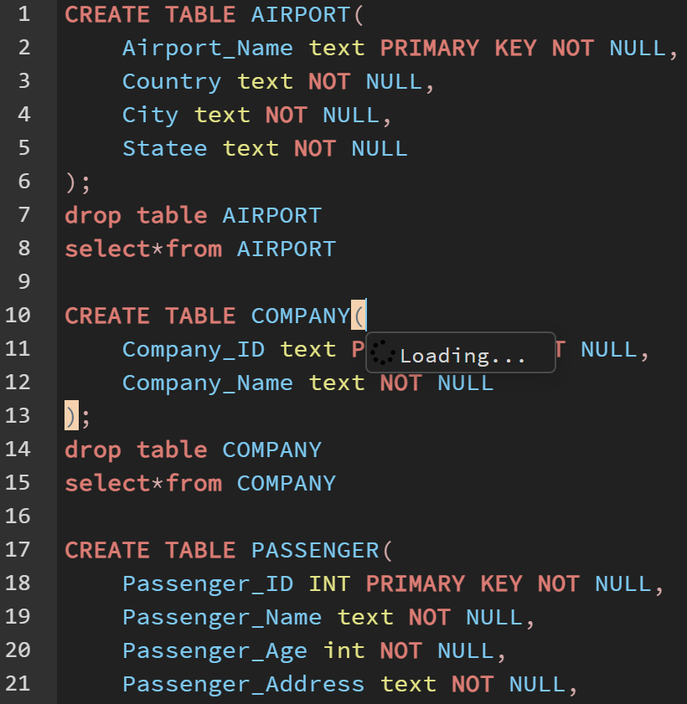

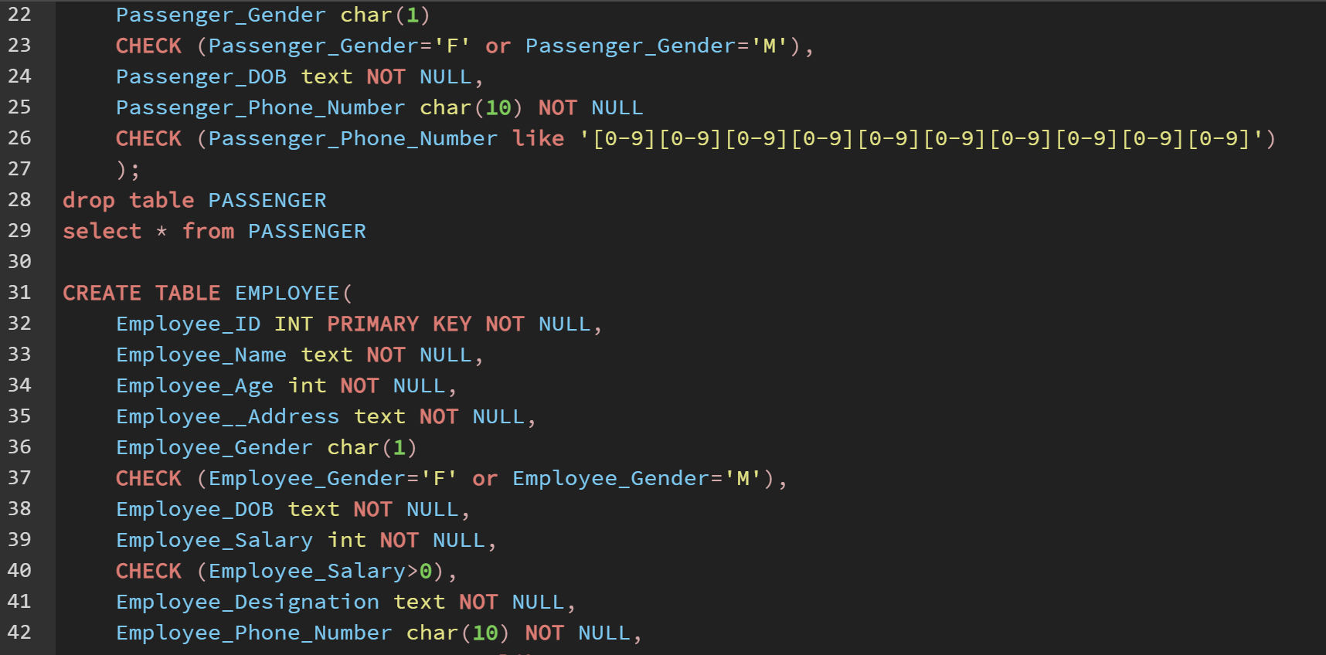

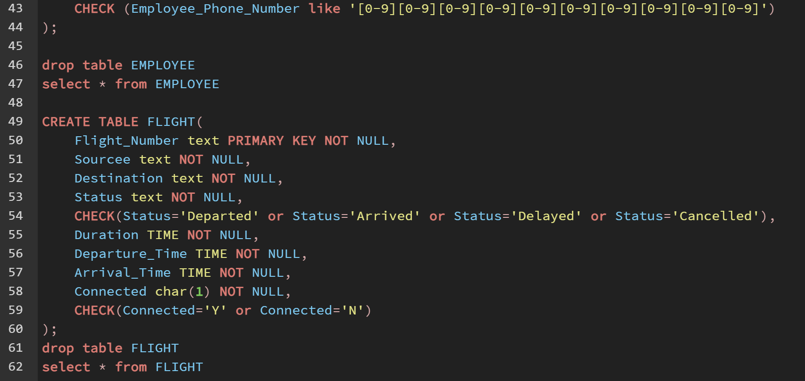

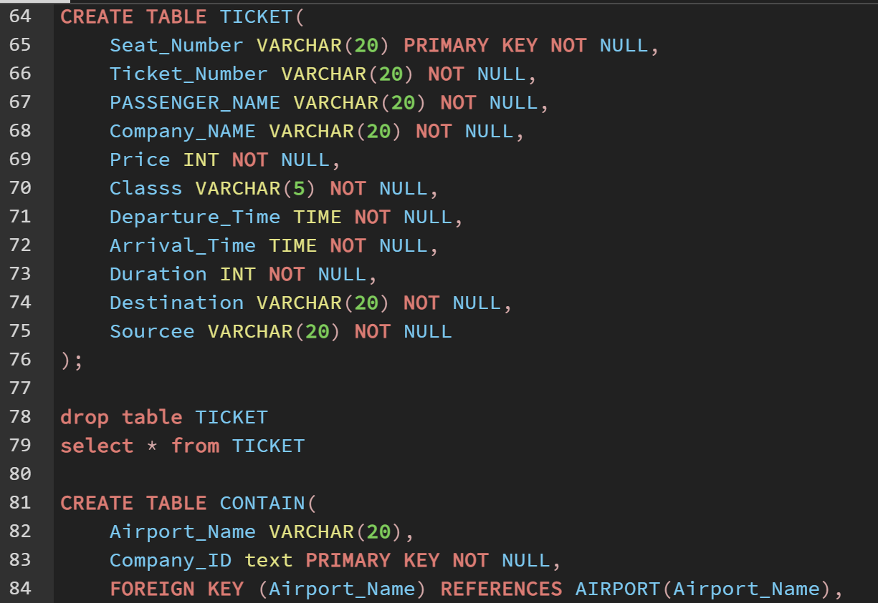

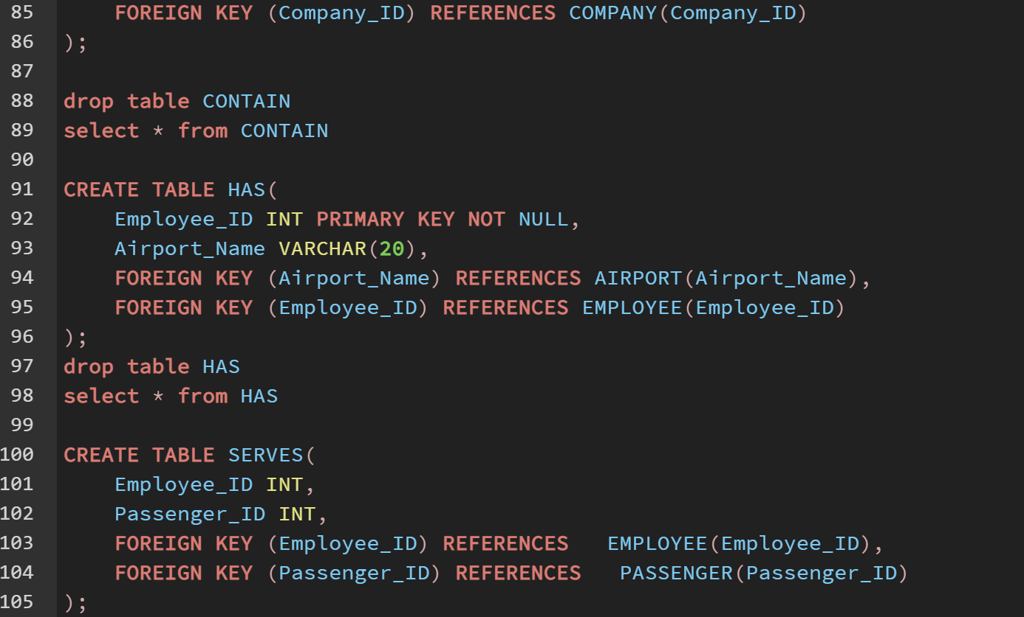

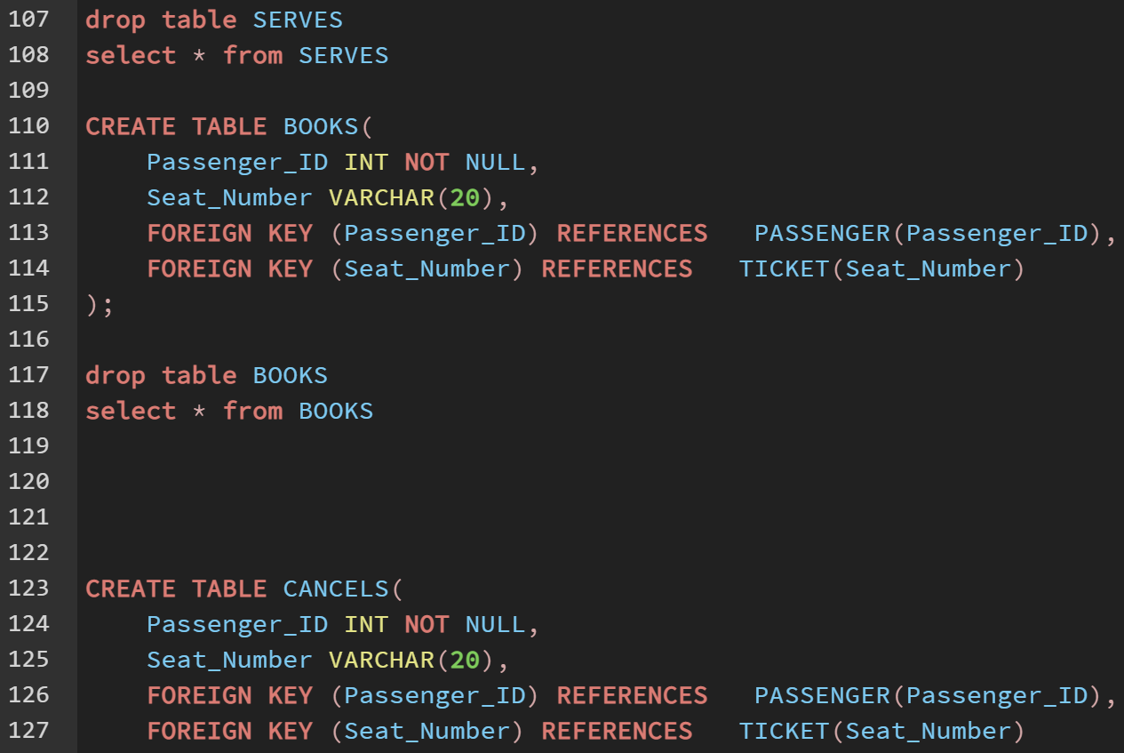

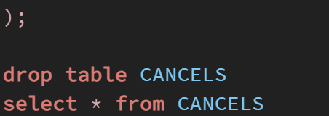

# OUTPUT

# 

# 

# 

# 

# 

# 



**Outcomes:**

**CO3:** Illustrate the concept of security, Query processing, indexing and Normalization for Relational database.



**Questions:**

**Q1 what is difference between Truncate, Drop and delete? Explain with example**

The DELETE command is used to remove some or all rows from a table. A WHERE clause can be used to only remove some rows. If no WHERE condition is specified, all rows will be removed.

TRUNCATE removes all rows from a table. The operation cannot be rolled back and no triggers will be fired. As such, TRUNCATE is faster and doesn't use as much undo space as a DELETE.

The DROP command removes a table from the database. All the tables' rows, indexes and privileges will also be removed. The operation cannot be rolled back.

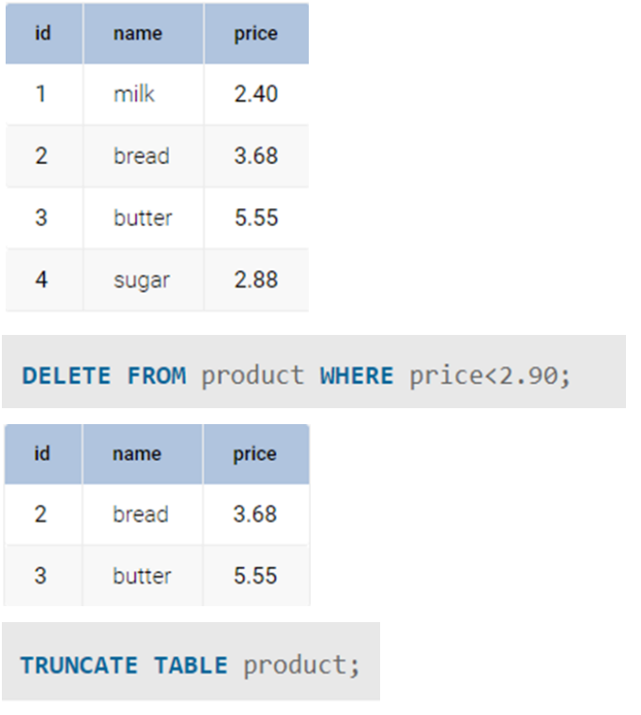

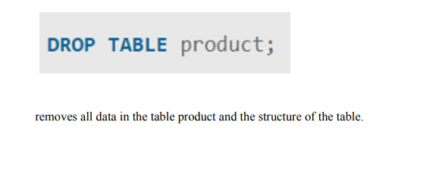



**Conclusion:**

**We learned about how to create and modify the relational schema and also to add various constraints to the table like the primary key, foreign key, check constraint, not null constraint and unique constraint by implementing various DDL statements like create,drop and alter.**

**Grade: AA / AB / BB / BC / CC / CD /DD Signature of faculty in-charge with date**

**Reference books:**

(Autonomou of Mumbai)

1. Elmasri and Navathe, “Fundamentals of Database Systems”, 6th Edition, Pearson Education
2. Korth, Slberchatz,Sudarshan, :”Database System Concepts”, 6th Edition, McGraw – Hill.

# WebSite:

1. <http://www.tutorialspoint.com/postgresql/>
2. <http://sage.virtual-labs.ac.in/home/pub/21/>

(Autonomous College Affiliated to University of Mumbai)