

**Experiment No.: 03**

**Title:** To implement database for relational model in Experiment no. 2 using DDL statements.

(Autonomous College Affiliated to University of Mumbai)

# Batch:A3 Roll No.:16010421073 Experiment No.: 03

**Aim:** To implement database for relational model in experiment no. 2 using DDL statements (Virtual Lab).

**Resources needed:** PostgreSQL PgAdmin3

# Theory:



The Data Definition Language (DDL) is used to create and modify the relational schema. Also it is used to add various constraints to the table like the primary key, foreign key, check constraint, not null constraint and unique constraint.

The DDL statements are: CREATE

DROP ALTER

PostgreSQL supports the standard SQL types int, smallint, real, double precision, char(N), varchar(N), date, time, timestamp, and interval for creating tables.

# Procedure:

**Create Database and use it:**

$ createdb mydb

$ psql mydb

**Delete a database:** $ dropdb mydb

# Create table:

CREATE TABLE my_first_table ( first_column text,

second_column integer

);

CREATE TABLE products ( product_no integer,

name text, price numeric);

# Drop Table:

DROP TABLE my_first_table; DROP TABLE products;

# Default Value:

CREATE TABLE products ( product_no integer,

name text,

price numeric **DEFAULT 9.99** );

# Constraints:

1. **Primary Key**

CREATE TABLE products ( product_no integer **PRIMARY KEY**, name text,

price numeric );

Primary keys can also constrain more than one column. CREATE TABLE example (

a integer, b integer, c integer,

# PRIMARY KEY (a, c)

);

# Check Constraint

CREATE TABLE products ( product_no integer,

name text,

price numeric **CHECK (price** > **0)** );

# Not Null Constraint

CREATE TABLE products ( product_no integer **NOT NULL**, name text **NOT NULL**,

price numeric );

1. **Unique Constraint** CREATE TABLE products ( product_no integer **UNIQUE**,

name text,

price numeric );

# Foreign Key Constarint

CREATE TABLE products ( product_no integer PRIMARY KEY, name text,

price numeric );

CREATE TABLE orders ( order_id integer PRIMARY KEY,

product_no integer **REFERENCES products (product_no)**, quantity integer );

Here a foreign key constraint in the order table references the products table.

# Modifying table:

**Adding column**

ALTER TABLE products ADD COLUMN description text;

# Removing column

ALTER TABLE products DROP COLUMN description;

# Adding Constraint

ALTER TABLE products ADD CONSTRAINT some_name UNIQUE (product_no); ALTER TABLE products ADD FOREIGN KEY (product_group_id) REFERENCES product_groups;

# Removing Constraint

ALTER TABLE products DROP CONSTRAINT some_name;

# Adding Not Null Constraint

ALTER TABLE products ALTER COLUMN product_no SET NOT NULL;

# Removing Not Null Constraint

ALTER TABLE products ALTER COLUMN product_no DROP NOT NULL;

# Results: (Queries printout with output)

# Query output(Hotel Mangement system)

**CREATE TABLE** ROOMS(

Room_ID int **PRIMARY KEY**,

Room_Type text,

Room_No int **NOT NULL**,

Room_Cat text,

**check** (Room_No <= 1000 )

);

**SELECT * FROM** ROOMS;

**DROP TABLE** ROOMS;

**CREATE** **TABLE** BOOKING(

Booking_ID int **PRIMARY KEY**,

Book_Type text **NOT** NULL,

Start_Date DATE **NOT** NULL,

End_Date DATE **NOT** NULL

);

**SELECT * FROM** BOOKING;

**DROP TABLE** BOOKING;

**CREATE TABLE** PAYMENT(

Pay_ID int **PRIMARY KEY**,

Pay_Cust_ID int **UNIQUE NOT** NULL,

Pay_Amt int **NOT** NULL

);

**SELECT * FROM** PAYMENT;

**DROP TABLE** PAYMENT;

**CREATE TABLE** SERVICES(

Service_ID int **PRIMARY KEY**,

SVCS_Type text,

SVCS_Desc text,

SVCS_Name text,

Room_ID int **REFERENCES** ROOMS(Room_ID)

);

**SELECT * FROM** SERVICES;

**DROP TABLE** SERVICES;

**CREATE TABLE** LOGIN(

Log_ID int **PRIMARY KEY**,

Log_Name text **NOT** NULL,

Log_Pass text **NOT** NULL,

Mob_no int,

Add_ress text,

Email text

);

**SELECT * FROM** LOGIN;

**DROP** TABLE LOGIN;

**CREATE TABLE** Customer(

Cust_ID int **PRIMARY KEY NOT** NULL,

Cust_Usr text **NOT** NULL,

Cust_Pass text **NOT** NULL,

Cust_Name int,

Cust_Mob_No text **NOT** NULL,

Cust_Email text,

Cust_Add text **NOT** NULL,

Room_ID int **REFERENCES** ROOMS(Room_ID),

Booking_ID int **REFERENCES** BOOKING(Booking_ID),

Pay_ID int **REFERENCES** PAYMENT(Pay_ID),

Service_ID int **REFERENCES** SERVICES(Service_ID),

Log_ID int **REFERENCES** LOGIN(Log_ID)

);

**SELECT* FROM** Customer;

**DROP TABLE** Customer;

**CREATE TABLE** HOTEL(

Hot_ID int **PRIMARY KEY NOT** NULL,

Hot_name text **NOT** NULL,

Hot_Add text **NOT** NULL,

Hot_Rent int,

Hot_Desc text,

**check** (Hot_ID <= 1000),

Room_ID int **REFERENCES** ROOMS(Room_ID),

Booking_ID int **REFERENCES** BOOKING(Booking_ID),

Pay_ID int **REFERENCES** PAYMENT(Pay_ID),

Service_ID int **REFERENCES** SERVICES(Service_ID),

Log_ID int **REFERENCES** LOGIN(Log_ID),

Cust_ID int **REFERENCES** Customer(Cust_ID)

);

**SELECT* FROM** HOTEL;

**DROP TABLE** HOTEL;

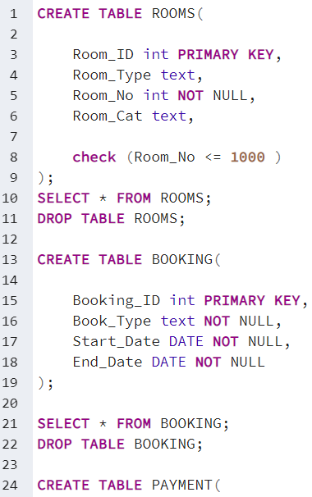

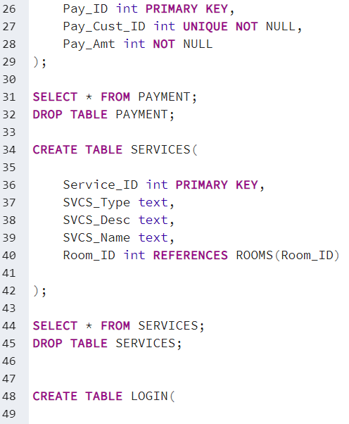

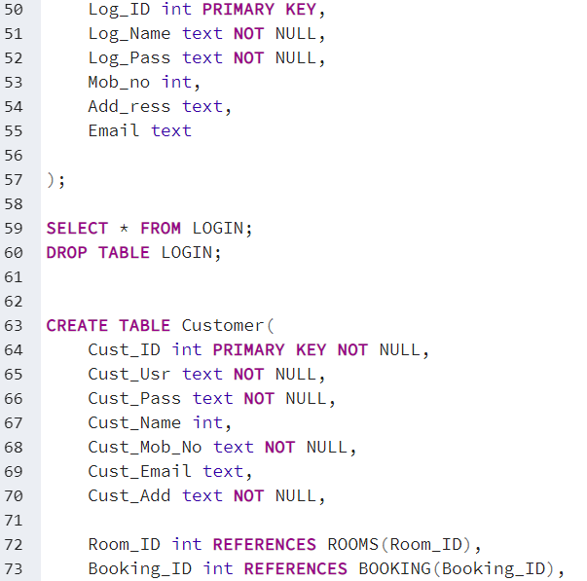

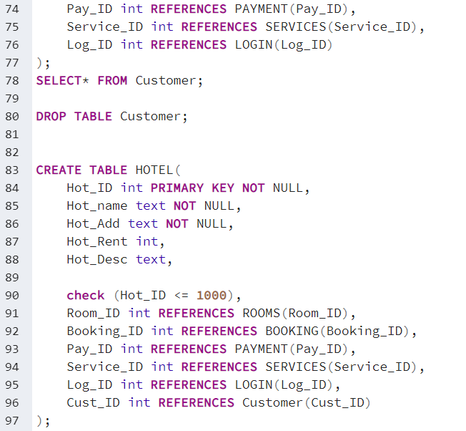

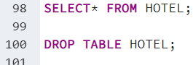

# OUTPUT

# 

# 

# 

# 

# 

# 

# 

**Outcomes:**

**CO3:** Illustrate the concept of security, Query processing, indexing and Normalization for Relational database.

**Questions:**

**Q1 what is difference between Truncate, Drop and delete? Explain with example**

The DELETE command is used to remove some or all rows from a table. A WHERE clause can be used to only remove some rows. If no WHERE condition is specified, all rows will be removed.

TRUNCATE removes all rows from a table. The operation cannot be rolled back and no triggers will be fired. As such, TRUNCATE is faster and doesn't use as much undo space as a DELETE.

The DROP command removes a table from the database. All the tables' rows, indexes and privileges will also be removed. The operation cannot be rolled back.

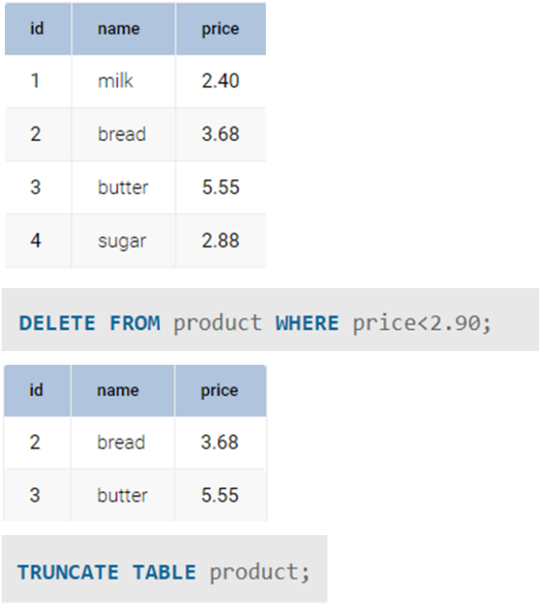

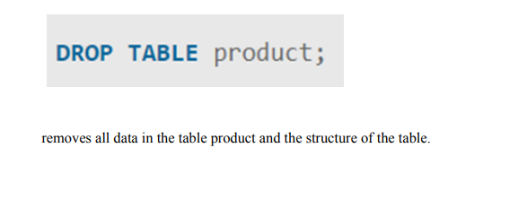

**Conclusion:**

**We learned about how to create and modify the relational schema and also to add various constraints to the table like the primary key, foreign key, check constraint, not null constraint and unique constraint by implementing various DDL statements like create,drop and alter.**

**Grade: AA / AB / BB / BC / CC / CD /DD Signature of faculty in-charge with date**

**Reference books:**

(Autonomou of Mumbai)

s College Affiliated to University

1. Elmasri and Navathe, “Fundamentals of Database Systems”, 6th Edition, Pearson Education
2. Korth, Slberchatz,Sudarshan, :”Database System Concepts”, 6th Edition, McGraw – Hill.

# WebSite:

1. <http://www.tutorialspoint.com/postgresql/>
2. <http://sage.virtual-labs.ac.in/home/pub/21/>

(Autonomous College Affiliated to University of Mumbai)