

Experiment No.: 04

Title: To use DML operations and SQL queries to
Populate the database

Batch:A3 Roll No.: 16010421073 Experiment No: 04

Aim: To use DML operations and SQL queries to populate the database .

___________________________________________________________________________

Resources needed: PostgreSQL PgAdmin4

___________________________________________________________________________
Theory:

The Data Manipulation Language (DML) is used to populate the table with values, modify the table values and remove the rows of the table.

The DML statements are: SELECT

INSERT
UPDATE

DELETE

__________________________________________________________________________
Procedure:

CREATE TABLE products ( product_no integer,

name text, price numeric );

Let us consider the above products table

Inserting rows:
The INSERT command requires the table name and column values

INSERT INTO products VALUES (1, ’Cheese’, 9.99);

If we don’t have values for all the columns, you can omit some of them. In that case, the columns will be filled with their default values. For example:

INSERT INTO products (product_no, name) VALUES (1, ’Cheese’)

Updating the values:
The UPDATE command requires three pieces of information:

- The name of the table and column to update
- The new value of the column
- Which row(s) to update
UPDATE products SET price = 10 WHERE price = 5;
UPDATE products SET price = price * 1.10;

Deleting rows:

The syntax of the DELETE command is similar to the UPDATE command. DELETE FROM products WHERE price = 10;

Retrieving values:

The general syntax of the SELECT command is SELECT select_list FROM table_expression SELECT * FROM table1;
SELECT * FROM products WHERE price=10;
SELECT product_no, name FROM products WHERE price=10;

Example:

insert into department values('IT', 101, 'mumbai');
insert into department values('COMP', 102, 'mumbai');
insert into department values('ETRX', 103, 'delhi');
insert into department values('EXTC', 104, 'chennai');
insert into department values('account', 105, 'mumbai');

insert into employee values('anita','m','sharma','emp0001',20000,'mumbai',101);
insert into employee values('nita','g','patil','emp0004',10000,'mumbai',101);
insert into employee values('krupita','v','jetali','emp0003',20000,'delhi',103);
insert into employee values('juhi','r','verma','emp0002',15000,'delhi',104);
insert into employee values('anita','m','sharma', 'emp0005',20000,'mumbai',104);

insert into project values( 1, 'mumbai','website',101);
insert into project values( 2, 'chennai','coding',101);
insert into project values( 3, 'mumbai','testing',102);
insert into project values( 4, 'delhi','documentaion',103);

insert into works_on values(1,'emp0001', 12);
insert into works_on values(1,'emp0002', 10);
insert into works_on values(2,'emp0001', 6);
insert into works_on values(3,'emp0004', 2);

insert into dependent values(‘emp0001’, ‘sunita’,’sister’);
insert into dependent values(‘emp0001’, ‘nita’,’mother’);
insert into dependent values(‘emp0002’, ‘kamal’,’brother’);
insert into dependent values(‘emp0004’, ‘krishna’,’father’);

select * from employee;
select * from department;
select * from project;
select * from dependent;
select * from works_on;

1) employee

fnamemnamelnamessn salary ecitydno
---------------------------------------- ------------------------------ ----------------------------------
anita m sharma emp0001 20000 mumbai101
juhi r verma emp0002 15000 delhi 104
krupita v jetali emp0003 20000 delhi 103
nita g patil emp0004 10000 mumbai 101
anita m sharma emp0005 20000 mumbai104

2) department

dnamednodlocation
------------------------------ ----------- -----------------------------------
IT 101 mumbai
COMP 102 mumbai
ETRX 103 delhi
EXTC 104 chennai
account 105 mumbai

4) project
pnoplocationpnamedno
----------- ---------------------------------------- -------------------- -----------
1 mumbai website 101
2 chennai coding 101
3 mumbai testing 102
4 delhidocumentaion 103

5) dependents

ssndepname relation
-------------------- ------------------------------ ------------------------------
emp0001nita mother
emp0001sunita sister
emp0002kamal brother
emp0004krishna father

6) woks_on

pnossnno_of_hrs
----------- -------------------- -----------
1 emp0001 12
1 emp0002 10
2 emp0001 6
3 emp0004 2

__________________________________________________________________________

Results: (Queries printout with output as per the format)
- Write 10 queries using ‘from’ and ‘where’ clause.

Example:

- To extract the name and ssn of all the employees:
Select fname, mname, lname, ssn from employee;

fnamemnamelnamessn
---------------------------------------- ---------------------------------------- -----------------------------
anitasharmam emp0001
juhiverma r emp0002
krupitajetali v emp0003
nitapatil g emp0004
anitasharma m emp0005

- To select names and city of the employees earning salary more then 10000:
Select fname, mname, lname, ecity from the employee where salary>10000;

fnamemnamelname ecity
---------------------------------------- ------------------------- ----------------------------------------
anitasharmam mumbai
juhivermar delhi
krupitajetaliv delhi
anitasharma m mumbai

- TO get the details of the cities of the employees in our company:
select distinct ecity from employee;
ecity
------------
delhi
mumbai

- To find the name of the department located in Mumbai and with department number 101:
select dname from department where dlocation=’Mumbai’ and dno=101;
dname
--------------

- To delete all dependent whose relation is mother with employee:
delete form dependent where relation=’mother’;
ssndepname relation
-------------------- ------------------------------ ------------------------------
emp0001sunita sister
emp0002kamal brother
emp0004krishna father

- Update relation employee to increment salary of all employees working in Department 101 by Rs. 10000:
update employee set salary=salary+10000 where dno=101;
fnamemnamelnamessn salary ecitydno
---------------------------------------- ------------------------------ ----------------------------------
anita m sharma emp0001 30000 mumbai101
juhi r verma emp0002 15000 delhi 104
krupita v jetali emp0003 20000 delhi 103
nita g patil emp0004 20000 mumbai 101
anita m sharma emp0005 20000 mumbai104

___________________________________________________________________________

Outcomes:
QUERY:(Insert)
CREATE TABLE ROOMS
(
Room_ID int PRIMARY KEY,
Room_Type text,
Room_No int NOT NULL,
Room_Cat text,
check (Room_No <= 1000 )
);
INSERT INTO ROOMS VALUES(1001 , 'Studio Room' , '100' , 'AC');
INSERT INTO ROOMS VALUES(1002 , 'Single Room' , '101' , 'AC');
INSERT INTO ROOMS VALUES(1003 , 'Double Room' , '102' , 'Non AC');
INSERT INTO ROOMS VALUES(1004 , 'Triple Room' , '103' , 'Non AC');
INSERT INTO ROOMS VALUES(1005 , 'Quad Room' , '104' , 'AC');

SELECT * FROM ROOMS;
DROP TABLE ROOMS;

CREATE TABLE BOOKING
(
Booking_ID int PRIMARY KEY,
Book_Type text NOT NULL,
Start_Date DATE NOT NULL,
End_Date DATE NOT NULL
);
INSERT INTO BOOKING VALUES(8001 , 'Online' , '2022-09-12' , '2022-09-17');
INSERT INTO BOOKING VALUES(8002 , 'Offline' , '2022-09-14' , '2022-09-22');
INSERT INTO BOOKING VALUES(8003 , 'Online' , '2022-09-15' , '2022-09-20');
INSERT INTO BOOKING VALUES(8004 , 'Online' , '2022-09-15' , '2022-09-21');
INSERT INTO BOOKING VALUES(8005 , 'Offline' , '2022-09-16' , '2022-09-23');

SELECT * FROM BOOKING;
DROP TABLE BOOKING;
CREATE TABLE PAYMENT
(
Pay_ID int PRIMARY KEY,
Pay_Cust_ID int UNIQUE NOT NULL,
Pay_Amt numeric NOT NULL
);
INSERT INTO PAYMENT VALUES(4321 , 1234 , 4320.00);
INSERT INTO PAYMENT VALUES(4322 , 1235 , 2543.20);
INSERT INTO PAYMENT VALUES(4323 , 1236 , 3456.00);
INSERT INTO PAYMENT VALUES(4324 , 1237 , 3290.70);
INSERT INTO PAYMENT VALUES(4325 , 1238 , 10000.00);

SELECT * FROM PAYMENT;
DROP TABLE PAYMENT;

CREATE TABLE SERVICES
(
Service_ID int PRIMARY KEY,
SVCS_Type text,
SVCS_Desc text,
SVCS_Name text,
Room_ID int REFERENCES ROOMS(Room_ID)
);

INSERT INTO SERVICES VALUES(9201 , 'Spa' , 'Head and back massage' , 'Thailand massage' , 1001);
INSERT INTO SERVICES VALUES(9202 , 'Housekeeping' , 'Room cleaning' , '-' , 1002);
INSERT INTO SERVICES VALUES(9203 , 'Laundry' , '-' , 'dry cleaning' , 1003);
INSERT INTO SERVICES VALUES(9204 , 'Cart Service' , 'french food service' , 'ratatouille' , 1004);
INSERT INTO SERVICES VALUES(9205 , '-' , '-' , '-' , 1005);

SELECT * FROM SERVICES;
DROP TABLE SERVICES;

CREATE TABLE LOGIN
(
Log_ID int PRIMARY KEY,
Log_Name text NOT NULL,
Log_Pass text NOT NULL,
Mob_no varchar[10],
Add_ress text,
Email text
);

INSERT INTO LOGIN VALUES(2001 , 'Tirth' , '1234#$' , '{9781237883}' , 'Nand Bv Ind Est, Mahakali Road, Chakala, Andheri(e)', 'pitona7125@geekjun.com' );

INSERT INTO LOGIN VALUES(2002 , 'Krishiv' , '2hdh&s' , '{9232321111}' , '16-11-477/3/2/b, Dilsukhnagar' , 'sl310579paa@bizisstance.com' );

INSERT INTO LOGIN VALUES(2003 , 'Kushal' , '2637gh' , '{9238932819}' , 'G 224, Nauroji Nagar Delhi, Delhi, 110029' , '579paa@jakamarcusguillermo.me');

INSERT INTO LOGIN VALUES(2004 , 'Harsh' , 'hue322' , '{9882138192}' , '229 Oriental House, 101 Samuel Street, Maharashtra, 400003', 'sl310579paa@gasss.net');

INSERT INTO LOGIN VALUES(2005 , 'keyur' , '21$%dh' , '{9999122311}' , '7, Dhan -durga Apt, Uthalsar Naka, Thane (west)' , '579paa@masjoco.com' );

SELECT * FROM LOGIN;
DROP TABLE LOGIN;

CREATE TABLE Customer
(
Cust_ID int PRIMARY KEY NOT NULL,
Cust_Usr text NOT NULL,
Cust_Pass text NOT NULL,
Cust_Name text,
Cust_Mob_No varchar[10] NOT NULL,
Cust_Add text NOT NULL,
Cust_Email text,
Room_ID int REFERENCES ROOMS(Room_ID),
Booking_ID int REFERENCES BOOKING(Booking_ID),
Pay_ID int REFERENCES PAYMENT(Pay_ID),
Service_ID int REFERENCES SERVICES(Service_ID),
Log_ID int REFERENCES LOGIN(Log_ID)
);

INSERT INTO Customer VALUES(7001 , 'Tirth' , '1234#$' , 'Tirth' , '{9781237883}' , 'Nand Bv Ind Est, Mahakali Road, Chakala, Andheri(e)', 'pitona7125@geekjun.com',1001 , 8001 , 4321 ,9201 , 2001);
INSERT INTO Customer VALUES(7002 , 'Krishiv' , '2hdh&s' , 'Krishiv', '{9232321111}' , '16-11-477/3/2/b, Dilsukhnagar', 'sl310579paa@bizisstance.com' ,1002 , 8002 , 4322 , 9202 , 2002);
INSERT INTO Customer VALUES(7003 , 'Kushal' , '2637gh' , 'Kushal', '{9238932819}' , 'G 224, Nauroji Nagar Delhi, Delhi, 110029', '579paa@jakamarcusguillermo.me' , 1003 , 8003 , 4323 , 9203 , 2003);
INSERT INTO Customer VALUES(7004 , 'Harsh' , 'hue322' , 'Harsh', '{9882138192}' , '229 Oriental House, 101 Samuel Street, Maharashtra, 400003', 'sl310579paa@gasss.net' ,1004 , 8004 , 4324 , 9204 , 2004 );
INSERT INTO Customer VALUES(7005 , 'keyur' , '21$%dh' , 'keyur', '{9999122311}' , '7, Dhan -durga Apt, Uthalsar Naka, Thane (west)', '579paa@masjoco.com' ,1005 , 8005 , 4325 , 9205 , 2005);

SELECT* FROM Customer;
DROP TABLE Customer;

CREATE TABLE HOTEL
(
Hot_ID int PRIMARY KEY NOT NULL,
Hot_name text NOT NULL,
Hot_Add text NOT NULL,
Hot_Rent numeric,
Hot_Desc text,
Room_ID int REFERENCES ROOMS(Room_ID),
Booking_ID int REFERENCES BOOKING(Booking_ID),
Pay_ID int REFERENCES PAYMENT(Pay_ID),
Service_ID int REFERENCES SERVICES(Service_ID),
Log_ID int REFERENCES LOGIN(Log_ID),
Cust_ID int REFERENCES Customer(Cust_ID)
);

INSERT INTO HOTEL VALUES(3001 , 'Taj Hotel' , 'The Taj Mahal Palace & Tower, Apollo Bunder, Mumbai - 400001 ' , 4320.00 , 'Welcome and enjoy your stay with taj hotel', 1001 , 8001 , 4321 ,9201 , 2001 , 7001);
INSERT INTO HOTEL VALUES(3002 , 'Taj Hotel' , 'The Taj Mahal Palace & Tower, Apollo Bunder, Mumbai - 400001 ' , 2543.20 , 'Welcome and enjoy your stay with taj hotel', 1002 , 8002 , 4322 , 9202 , 2002 , 7002);
INSERT INTO HOTEL VALUES(3003 , 'Taj Hotel' , 'The Taj Mahal Palace & Tower, Apollo Bunder, Mumbai - 400001 ' , 3456.00 , 'Welcome and enjoy your stay with taj hotel', 1003 , 8003 , 4323 , 9203 , 2003 , 7003);
INSERT INTO HOTEL VALUES(3004 , 'Taj Hotel' , 'The Taj Mahal Palace & Tower, Apollo Bunder, Mumbai - 400001 ' , 3290.70 , 'Welcome and enjoy your stay with taj hotel', 1004 , 8004 , 4324 , 9204 , 2004 , 7004);
INSERT INTO HOTEL VALUES(3005 , 'Taj Hotel' , 'The Taj Mahal Palace & Tower, Apollo Bunder, Mumbai - 400001 ' , 10000.00 ,'Welcome and enjoy your stay with taj hotel', 1005 , 8005 , 4325 , 9205 , 2005 , 7005);

SELECT* FROM HOTEL;
DROP TABLE HOTEL;
Data Output:

SELECT and INSERT statement

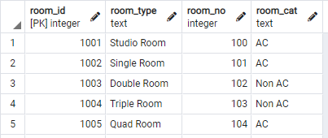

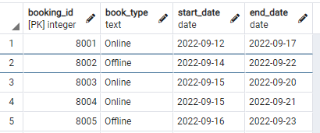

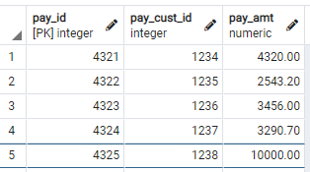

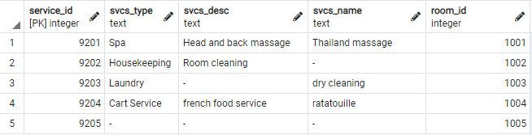

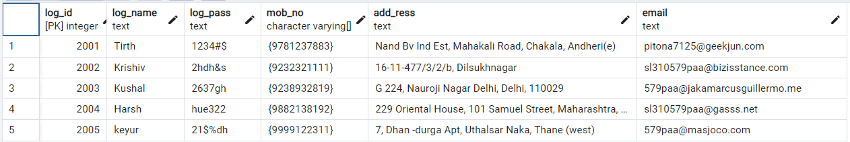

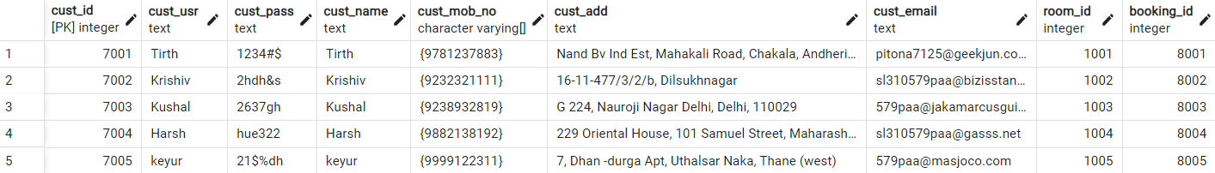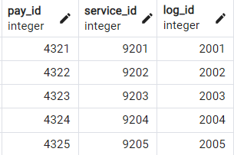

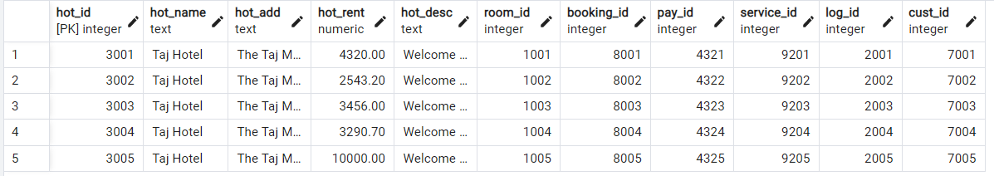

UPDATE and WHERE statement
UPDATE ROOMS SET Room_Type = 'Studio Room' , Room_no = '106' WHERE Room_ID = 1002;

Before

After Updating
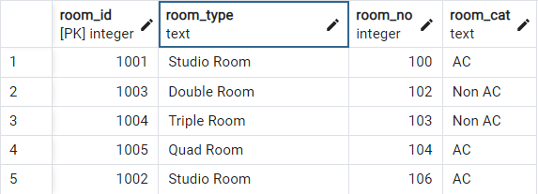

DELETE and FROM statement

DELETE FROM ROOMS WHERE Room_ID = 1004;

Before

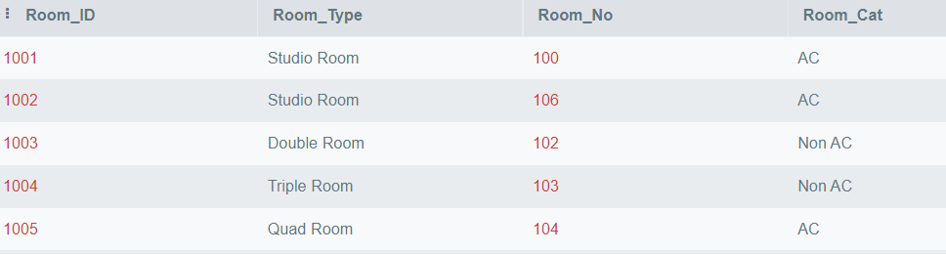

After Deleting

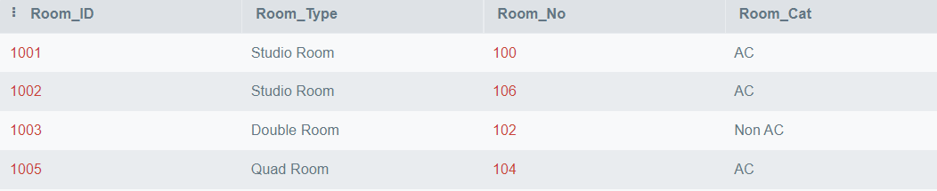________________________________________________________________________________
Questions:

Q1 Explain various data types used in SQL
String Data Types

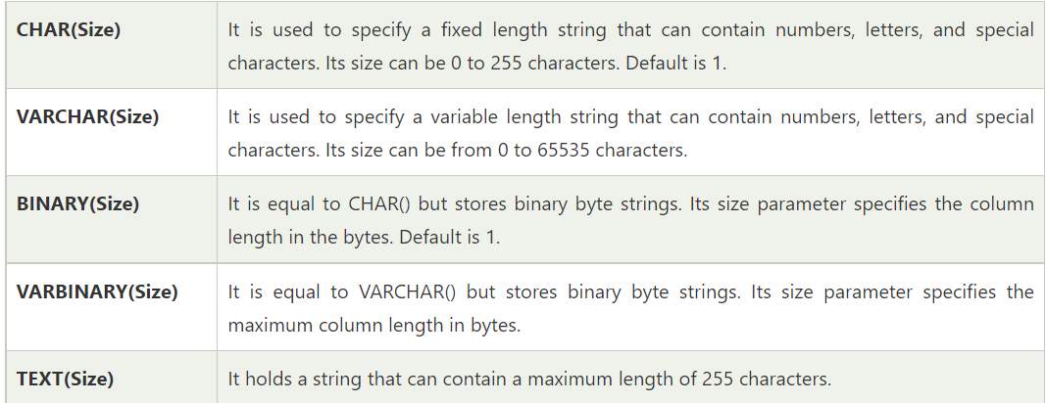
Numeric Data Types
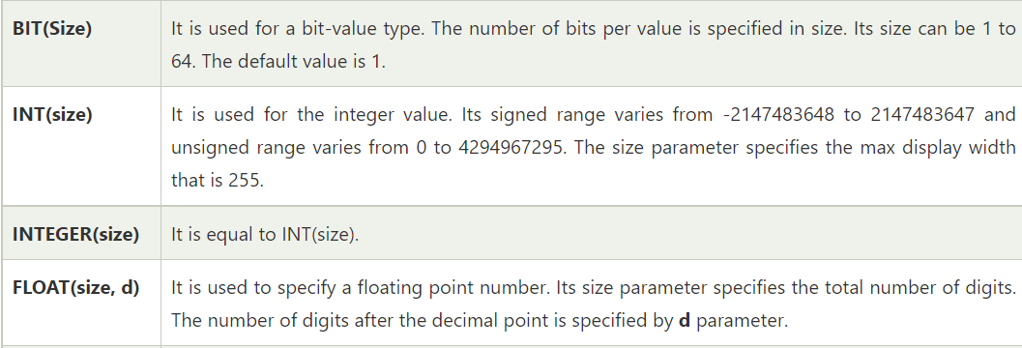
Date and Time Data Types
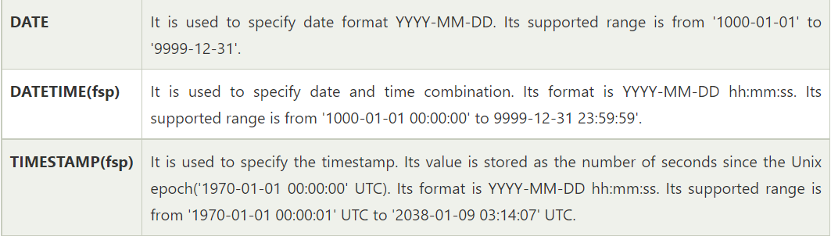

Q2 what is outer JOIN and why it is used? Explain its type with example

Outer joins are joins that return matched values and unmatched values from either or both tables.
The FULL OUTER JOIN (aka OUTER JOIN ) is used to return all of the records that have values in either the left or right table. For example, a full outer join of a table of customers and a table of orders might return all customers, including those without any orders, as well as all of the orders.
Outer join of two types:
1.Left outer join (also known as left join): this join returns all the rows from left table combine with the matching rows of the right table. If you get no matching in the right table it returns NULL values.
2.Right outer join (also known as right join): this join returns all the rows from right table are combined with the matching rows of left table .If you get no column matching in the left table .it returns null value.

__________________________________________________________________________________

Conclusion: (Conclusion to be based on the objectives and outcomes achieved)

In this experiment we learned about the use of DDL statement like SELECT , INSERT , DELETE, UPDATE , FROM and WHERE Statements.

Grade: AA / AB / BB / BC / CC / CD /DD

Signature of faculty in-charge with date

__________________________________________________________________________________

References:

Books:

- Elmasri and Navathe, “Fundamentals of Database Systems”, 6th Edition, Pearson Education
- Korth, Slberchatz,Sudarshan, :”Database System Concepts”, 6th Edition, McGraw –
Hill.

WebSite:
- http://www.tutorialspoint.com/postgresql/
- http://sage.virtual-labs.ac.in/home/pub/21/

