**LAB 3:**

3.1.a)

d) Higher values of N, which indicates taking average over large number of values give a smooth increasing curve, which will help to determine the behavior of graph. Therefore, high values of N are preferred, at N=50 we start getting nearly monotonically increasing graph.

Longer term moving average are also better because they have less effect of sudden changes.

3.1.1) Convolution is a better approach, because in accumulation we get floating point error, and as the number of samples on which we are avreging increase the error increases, but in convolution method we don’t get these types of error as it uses FFT to compute the average.

Convolution: We don’t get floating point errors, but is slow as it uses FFT to calculate the average.

Summation: Is fast but has floating point error.

3.2)

b) On passing these files through up sampler:

1. q2_1.mat -> The graph values first increase then decrease, then again increase and then again decrease. The moving average of this graph give us below pattern:

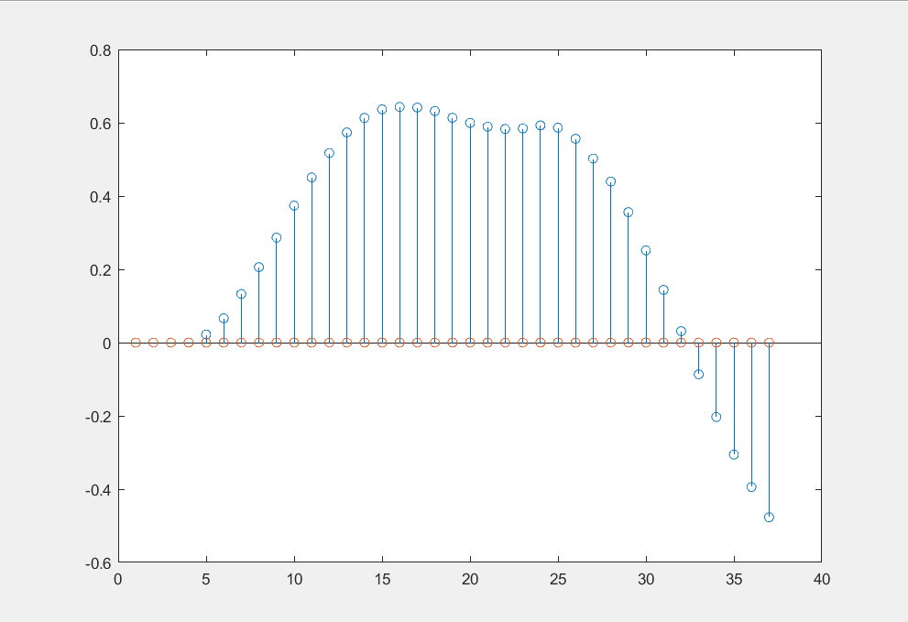

2. q2_2.mat -> We observe that the values have lot of noise, but overall the moving average increases,

Moving average graph for q2_2.m

