**REPORT: LAB 7**

**Q1.**

D) As we decrease B the error scale on x axis increases, i.e. You get higher value error.

Observation:

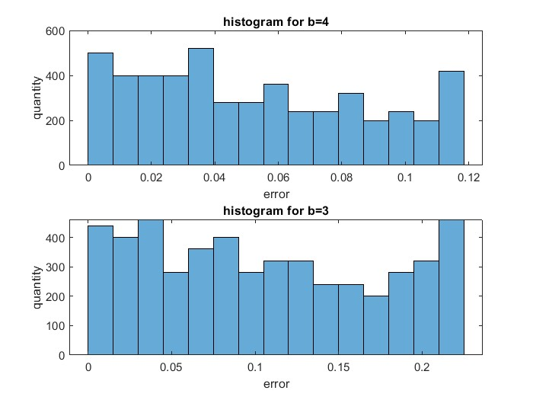

e) The maximum absolute error decreases as we increase B, we get closer to our original signal.

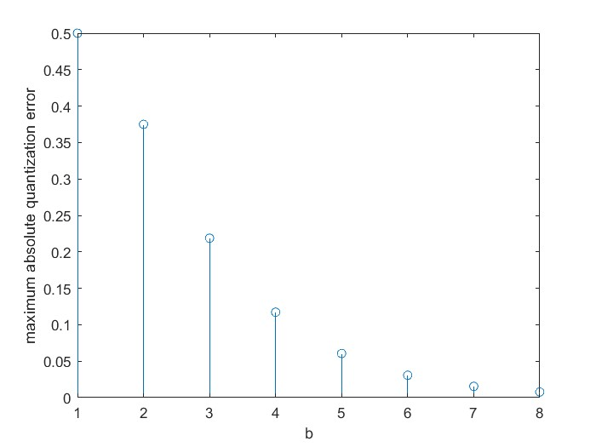­

f)

As we increase the B the SQNR index increases, this is because Σ|𝑒𝑞[𝑛]|2 value goes down.

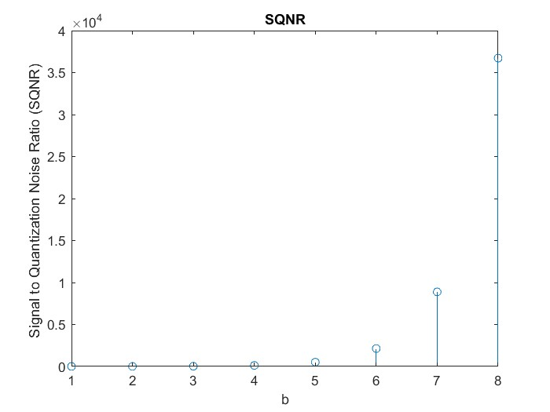

g) If it is uniform quantizer then the points near to origin will be less accurately marked to their true value compared to quadratic quantizer, here I am taking about values less than 1, but for higher value the mapping of linear quantizer will be more accurate compared to quadratic quantizer, because in quadratic quantizer the range of values to which it will quantize to is proportional to ri2 hence the interval range is increased, decreasing accuracy for value greater than 1.

**Q.2**

c) For a lower B division will be less compared to higher value of B, therefore the quantization will be more accurate for higher B. For lower B, the sound is highly distorted but the frequency remains the same.