1. **Write a Python program to create the multiplication table (from 1 to 10) of a number.**

**Code:**

**#Program to display multiplication table of a number from 1 to 10**

**n=int(input("Enter the number"))**

**for i in range(1,10):**

**print(n,"x",i,"=",n*i)**

**Output:**

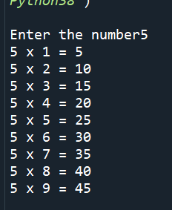

**2. Find the sum of series:**

**a) 1 + 1/2 + 1/3 + ….. + 1/N.**

**Code:**

**#Program to find sum of series 1 + 1/2 + 1/3 + ….. + 1/N**

**N=int(input("Enter last term of series"))**

**sum=0**

**for i in range(1,N+1):**

**sum=sum+1/i**

**print("Sum is",sum)**

**Output:**

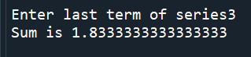

**b) 1 + 2/4 + 3/9 + ....+ N/(N*N)**

**Code:**

**#To find sum of series 1 + 2/4 + 3/9 + ....+ N/(N*N)**

**N=int(input("Enter the last term of the series"))**

**sum=0**

**for i in range(1,N+1):**

**sum=sum+i/(i*i)**

**print(sum)**

**Output:**

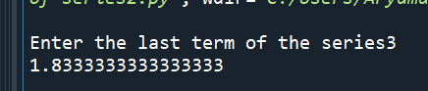

**c) 1 + sqrt(2) + sqrt(3) + sqrt(4) + sqrt(N)**

**Code:**

**#sum of 1+sqrt(2)+sqrt(3)...sqrt(n)**

**N=int(input("Enter last term of the series"))**

**sum=0**

**for i in range(1,N+1):**

**sum=sum+i**(0.5)**

**print("Sum",sum)**

**Output:**

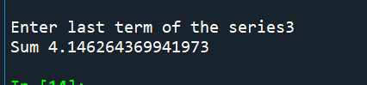

**3. Write a Python program which iterates the integers from 1 to 50. For multiples ofthree print "Fizz" instead of the number and for the multiples of five print "Buzz". For numberswhich are multiples of both three and five print "FizzBuzz".**

**Code:**

**for i in range (1,51):**

**if(i%3==0):**

**print("fizz")**

**if(i%5==0):**

**print("buzz")**

**if(i%3==0 and i%5==0):**

**print("fizzbuzz")**

**else:**

**continue**

**Output:**

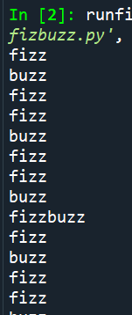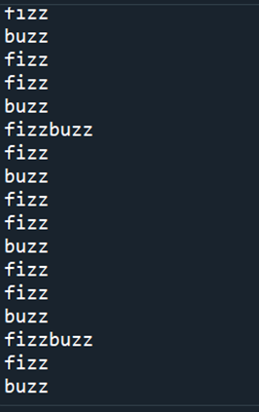

**4. Write a Python program to find numbers between 1 and 400 (both included) where each digit of a number is an even number. The numbers obtained should be stored in a list and displayed separated by commas.**

**Code:**

**#Program to display numbers with only even digits between 100 to 400**

**rem=0**

**sum=0**

**l=[]**

**q=''**

**for i in range(1,401):**

**n=i**

**while(n>0):#loop to check if digits are even**

**rem=n%10**

**if(rem%2!=0):#If digit is odd loop is broken**

**q=False**

**break**

**else:**

**q=True**

**n=n//10**

**if(q==True):**

**l.append(i)#number is stored in list**

**for i in range(0,len(l)):**

**print(l[i])**

**Output:**

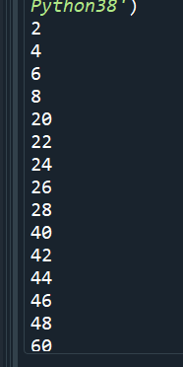 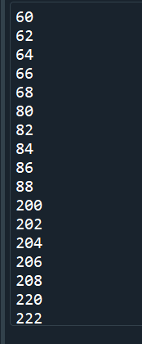 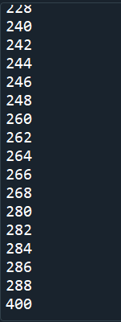

**5. Given a two Python list. Iterate both lists simultaneously such that list1**

**should display item in original order and list2 in reverse order**

**list1 = [10, 20, 30, 40]**

**list2 = [100, 200, 300, 400]**

**Expected output**

**10 400**

**20 300**

**30 200**

**40 100**

**Code:**

**#Program to iterate two list simulatneously**

**list1=[10,20,30,40]**

**list2=[100,200,300,400]**

**for i in range(0,4):**

**print(list1[i],list2[(i+1)*-1])**

**Output:**

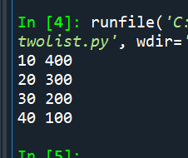

**6. Get first, second best scores from the list.**

**List may contain duplicates.**

**Ex: [86,86,85,85,85,83,23,45,84,1,2,0] => should get 86, 85**

**Code:**

**temp=0**

**s=[]**

**l=[86,86,85,85,83,23,45,84,1,2,0]**

**for i in range(0,len(l)-1):**

**for i in range(0,len(l)-1):#sorting list in ascending order**

**if(l[i]>=l[i+1]):**

**temp=l[i+1]**

**l[i+1]=l[i]**

**l[i]=temp**

**s.extend(l)**

**print("highest marks",s[len(s)-1])#last element of sorted list is highest marks**

**for i in range(0,len(s)):#ensuring duplicate element is not considered as second highest marks**

**if(s[-i]!=s[len(s)-1]):**

**print("second highest marks",s[-i])**

**break**

**Output:**

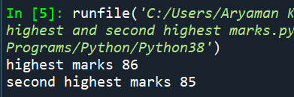

**7. Have a list of number of days in a month and another list of months. Traverse through both the lists appropriately.**

**Write program to display number of days in a month when the user enters the month.**

**L1=[Jan,Feb,March...]**

**L2=[31,28,31..]**

**Input: Dec**

**Output:31**

**Code:**

**#Program iterates two lists together**

**l1=['Jan','Feb','March','April','May','June','July','August','September','October ','November','December']**

**l2=[31,28,31,30,31,30,31,31,30,31,30,31]**

**month=input("Enter month")**

**for i in range(0,len(l1)):**

**if(month==l1[i]):**

**print(l2[i])**

**Output:**

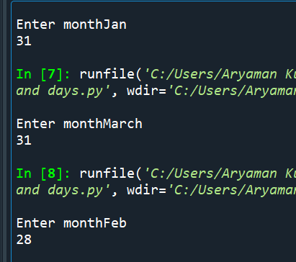

**8. Get a list of integers from the user.**

**Find the sum of all the elements in the even position of the list and store it in a variable called "EvenSum".**

**Find the average of all the elements in the odd position of the list and store it in another variable called "OddAverage"**

**Display both the values.**

**Code:**

**OddAverage=0**

**EvenSum=0**

**count=0**

**l=int(input("Enter the size of the list"))**

**list1=[]**

**for i in range(0,l):**

**n=int(input("Enter element"))**

**list1.append(n)**

**for i in range(0,l):**

**if(i%2==0):**

**OddAverage=OddAverage+list1[i]#Calculating average of odd numbers**

**count=count+1**

**else:**

**EvenSum=EvenSum+list1[i]#Calculating sum of even numbers**

**OddAverage=OddAverage/count**

**print("Average of odd numbers",OddAverage)**

**print("Sum of even numbers",EvenSum)**

**Output:**

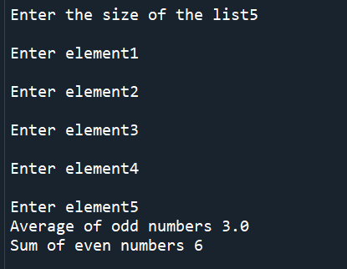

**9. Get a list of float values from the user and convert the elements to integer.**

**Remove the duplicate values in the resultant list as well.**

**Note: Do not use separate list.**

**Store the result in the same list.**

**Input: [2.3, 25.9, 456.01, 31.1, 25.8, 31.8]**

**Output: [2,26,456,31,32]**

**Code:**

**#Elements of list of float data type are converted to int data type and duplicates are removed**

**l=int(input("Enter the length of the list"))**

**l1=[]**

**for i in range(0,l):**

**n=float(input("enter element"))**

**l1.append(n)**

**for i in range(0,l):**

**l1[i]=int(round(l1[i]))#float values are converted to integer**

**for i in range(0,l):**

**for j in range(0,l):**

**if(l1[j]==l1[i] and j!=i):#Searching for duplicate list**

**l1.remove(l1[j])**

**l1.append(0)#adding extra element 0 to ensure list stays the same length so loop can run**

**continue**

**for i in range(0,l1.count(0)):**

**l1.remove(0)**

**print(l1)**

**Output:**

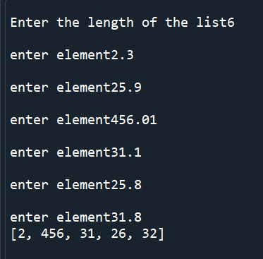

**10. Get a list of numbers from the user and sort the list in descending order of the last digit of each of the numbers in the list.**

**Do not use separate list. Do the sorting operation in the same list**

**Input: [19,21,38,47,39,56,12,54,75,93]**

**Output:[19,38,47,56,75,54,93,12,21]**

**Note: 39 is deleted as there is a number existing in the resultant list which**

**ends in the number 9.**

**Code:**

**#Program to accept a list as input from user and then arrange elements of the list in descending order of their last digit**

**l=int(input("Enter the length of the list"))**

**list1=[]**

**temp=0**

**for i in range(0,l):**

**n=int(input("Enter the element"))**

**list1.append(n)**

**print(list1)#Displaying original list**

**for i in range(0,l-1):**

**for j in range(0,l-1):**

**if(list1[j]%10<list1[j+1]%10):**

**temp=list1[j]**

**list1[j]=list1[j+1]**

**list1[j+1]=temp**

**for k in range(0,l-1):**

**if(list1[k]%10==list1[k+1]%10):**

**list1.remove(list1[k+1])**

**list1.append(0)#0 is added to ensure list remains the same length so that the loop can run**

**list1.remove(0)**

**print(list1)#Displaying reordered list**

**Output:**

