**A.Simple programs**

**1.Write a program in python to add two numbers and print the result.**

**Code:**

**#Program to find the sum of two numbers**

**a=int(input("Enter first number"))**

**b=int(input("Enter second number"))**

**sum=a+b**

**print("Sum of two numbers is",sum)**

**Output:**

**2. Write a program in python to find the area of a triangle.**

**import math.**

**Code:**

**#Program to find area of triangle using Herons formula**

**a=int(input("Enter first side"))**

**b=int(input("Enter second side"))**

**c=int(input("Enter third side"))**

**s=(a+b+c)/2**

**d=s*(s-a)*(s-b)*(s-c)**

**area=math.sqrt(d)**

**print(“Area of triangle is “,area)**

**print("Name-Aryaman Kumar,registration no-22BRS1184")**

**Output:**

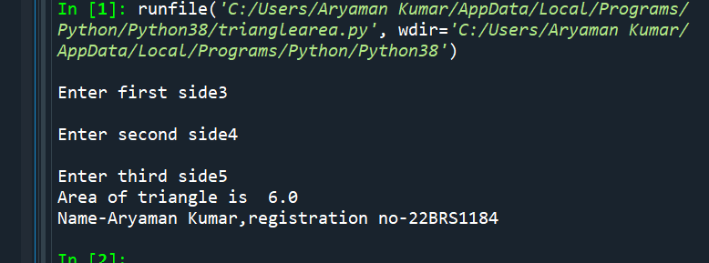

**3Write a program in python to find square root of a number.**

**Code:**

**#Program to find square root of a given number**

**N=int(input("Enter the number"))**

**sqrt=0**

**q=False**

**for i in range(0,N):**

**sqrt=i*i**

**if(sqrt==N):**

**q=True**

**break**

**if(q==True):**

**print("Square root of number is",i)**

**else:**

**print("Number does not have a integral square root")**

**Output:**

**4. Write a program in python to solve a quadratic equation.**

**#Program to find the roots of a quadratic equation**

**import math**

**a=int(input("Enter a value"))**

**b=int(input("Enter b value"))**

**c=int(input("Enter c value"))**

**D=b**2-4*a*c#Calculating discriminant**

**if(D<0):**

**print("Imaginary roots")**

**else:**

**x1=(-b+math.sqrt(D))/2*a#Calculating the two roots**

**x2=(-b-math.sqrt(D))/2*a**

**print("roots",x1,x2)**

**print("Name-Aryaman Kumar,registration no-22BRS1184")**

**Output:**

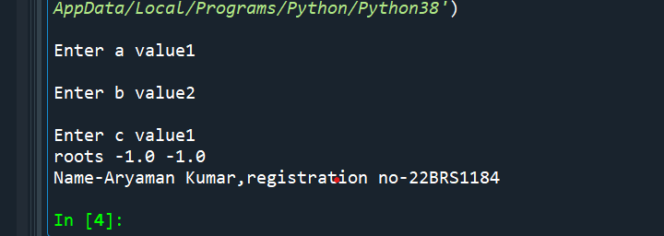

**5. Write a program in python to convert Fahrenheit to Celsius.**

**#Program to convert temperature given in Farenheit to Celsius**

**t=float(input("Enter temperature in farheneit"))**

**C=5/9*(t-32)**

**print("Temperature in Celsius is",C)**

**print("Name-Aryaman Kumar,registration no-22BRS1184")**

**Output:**

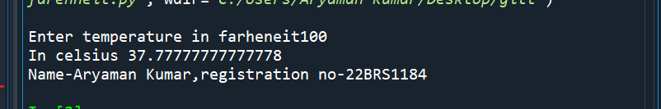

**6. Write a program in python to find quotient and reminder after division.**

**Code:**

**#Program to display quotient and remainder after division**

**a=int(input("Enter first number"))**

**b=int(input("Enter second number"))**

**q=a//b**

**r=a%b**

**print("Quotient",q)**

**print("Remainder",r)**

**Output:**

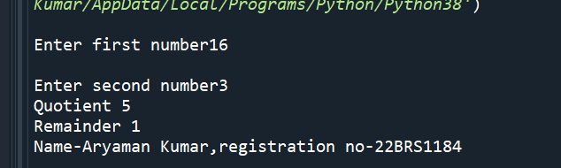

**7. Write a program in python to swap two numbers using tuple assignment.**

**#Program to swap the values of numbers using tuple assignement**

**a=int(input("Enter the first number"))**

**b=int(input("Enter the second number"))**

**print("Before swap",a,b)**

**t=a,b**

**b,a=t**

**print("After swap",a,b)**

**print("Name-Aryaman Kumar,registration no-22BRS1184")**

**Output:**

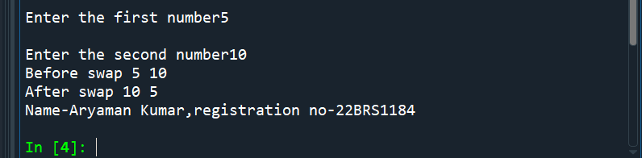

**8. Write a program in python to find the average of three marks.**

**#Program to calculate the average of the marks of a student in three subjects**

**a=int(input("Enter marks in first subject"))**

**b=int(input("Enter marks in second subject"))**

**c=int(input("Enter marks in third subject"))**

**avg=(a+b+c)/3**

**print("Average of three marks",int(avg))**

**Output:**

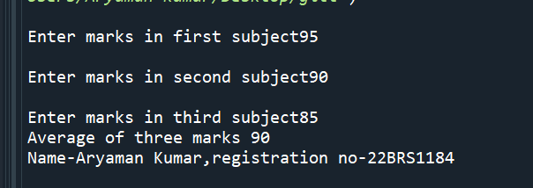

**9. Write a program in python to calculate simple interest.**

**#Program to calculate simple interest**

**P=int(input("enter the principal"))**

**r=int(input("enter the rate"))**

**t=int(input("enter time period"))**

**SI=P*r*t//100**

**print("Simple interest",SI)**

**print("Name-Aryaman Kumar,registration no-22BRS1184")**

**Output:**

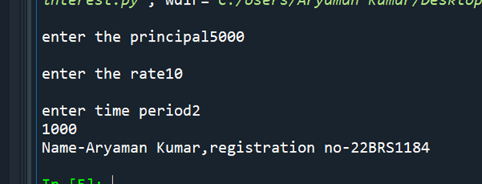

**10. Write a program in python to calculate the net pay given basic pay, hra, da and deductions.**

**#Program to calculate net pay**

**BP=int(input("Enter basic pay"))**

**DA=88/100*BP**

**HRA=8/100*BP**

**CCA=1000**

**insurance=2000**

**PF=PF=10/100*BP**

**Dd=insurance+PF**

**GP=BP+DA+HRA+CCA**

**Net=GP-Dd**

**print("Net pay",Net)**

**print("Name-Aryaman Kumar,registration no-22BRS1184")**

**Output:**

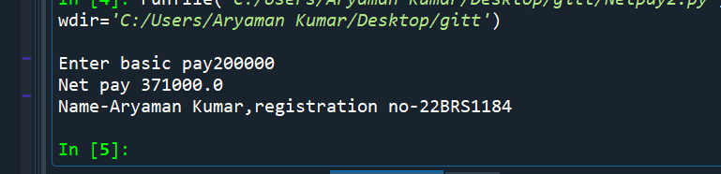

**B. Programs using Conditional Statements**

**1. Given age determine whether a person is eligible to vote or not. (if else)**

**#Program to check whether a person is eligible to vote or not**

**age=int(input("Enter voter age"))**

**if(age>=18):#person is eligible to vote if age is greater than 18**

**print("Eligible to vote")**

**else:**

**print("Uneligible to vote")**

**print("Name-Aryaman Kumar,registration no-22BRS1184")**

**Output:**

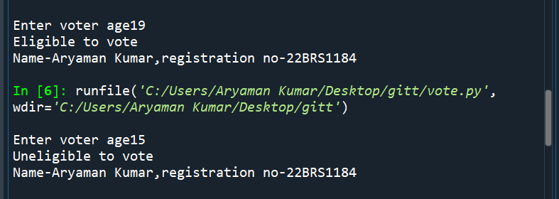

**2. Check whether a number is odd or even. (if else)**

**#Program to check if a given number is odd or even**

**a=int(input('Enter number'))**

**if(a%2==0):**

**print("even")**

**else:**

**print("odd")**

**print("Name-Aryaman Kumar,registration no-22BRS1184")**

**Output:**

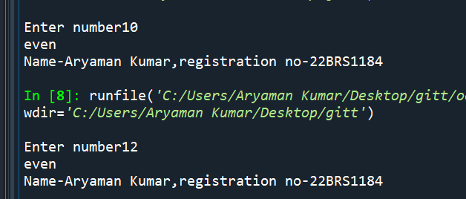

**3. Write a program to find largest of two numbers. (if else)**

**Code:**

**#Program to compare two numbers and tell which one is greatest**

**a=int(input("Enter the first number"))**

**b=int(input("Enter the second number"))**

**if(a>b):**

**print("First number is greatest")**

**else:**

**print("Second number is greatest")**

**print("Name-Aryaman Kumar,registration no-22BRS1184")**

**Output:**

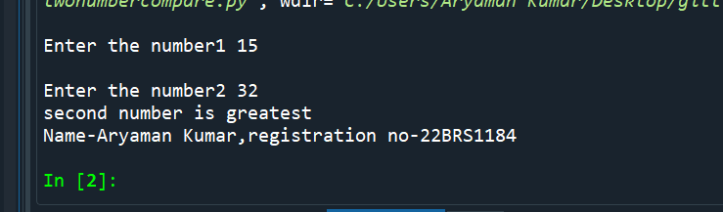

**4. Obtain a character convert lower case to uppercase and vice versa. (if else)**

**Code:**

**#Program to convert uppercase to lowercase and vice versa**

**a=input("Enter text")**

**if(a.islower()==True):**

**cc=a.upper()#Converting lowercase to uppercase**

**print(cc)**

**print("Converted to uppercase")**

**else:**

**cc=a.lower()#Converting uppercase to lowercase**

**print(cc)**

**print("Converted to lowercase")**

**print("Name-Aryaman Kumar,registration no-22BRS1184")**

**Output:**

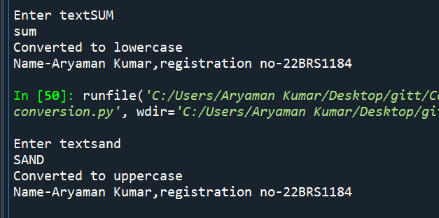

**5. Find the input year is leap year or not. (if else)**

**#Program to find out whether a given year is a leap year**

**Code:**

**n=int(input("Enter the year"))**

**if(n%100==0):**

**if(n%400==0):#If a leap year is also divisible by 100 then it has to**

**#be divisible by 400 to be a leap year**

**print("It is leap year")**

**else:**

**print("It is not a leap year")**

**elif(n%4==0):#If a year not divisible by 100 is divisible by 4 it is a**

**#leap year**

**print("It is leap year")**

**else:**

**print("It is not a leap year")**

**print("Name-Aryaman Kumar,registration no-22BRS1184")**

**Output:**

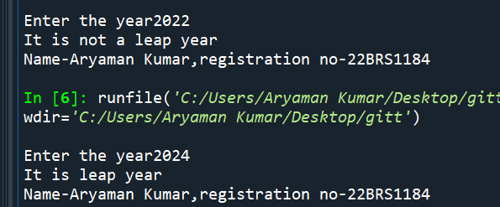

**6. Read a number, check if it is positive, negative or zero. Increment the number if it is positive, decrement if it is negative. (elif statement)**

**Code:**

**#Program checks whether a given number is positive,negative or zero and increments the number if it is positive and decrements it if negative.Number is unchanged if it is zero.**

**n=int(input("Enter the number"))**

**if(n>0):**

**n=n+1#If number is positive ,it is incremented**

**print(n)**

**elif(n<0):**

**n=n-1#If number is negative it is decremented**

**print(n)**

**else:**

**print(n)**

**print("Name-Aryaman Kumar,registration no-22BRS1184")**

**Output:**

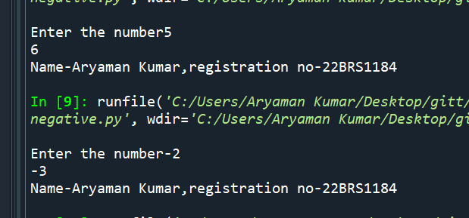

**7. Create a simple calculator. (elif statement)**

**#Program to make a simple calculator that can add,subtract,multiply and divide two numbers**

**a=int(input("Enter first number"))**

**b=int(input("Enter second number"))**

**ch=int(input("Enter your choice 1.Addition,2.Subtraction,3.Multiplication,4 division"))**

**if(ch==1):**

**c=a+b**

**print("Result",c)**

**if(ch==2):**

**c=a-b**

**print("Result",c)**

**if(ch==3):**

**c=a*b**

**print("Result",c)**

**if(ch==4):**

**c=a/b**

**print("Result",c)**

**print("Name-Aryaman Kumar,registration no-22BRS1184")**

**Output:**

**8. Estimate the Grade based on the marks obtained by a student. (elif statement)**

**#Program to calculate grade of student based on marks**

**marks=int(input("Enter the marks of the student"))**

**if(marks>=90):**

**print("A")**

**elif(marks>=70 and marks<90):**

**print("B")**

**elif(marks>=50 and marks<70):**

**print("C")**

**elif(marks>=35 and marks<50):**

**print("D")**

**else:**

**print("E")**

**print("Name-Aryaman Kumar,registration no-22BRS1184")**

**Output:**

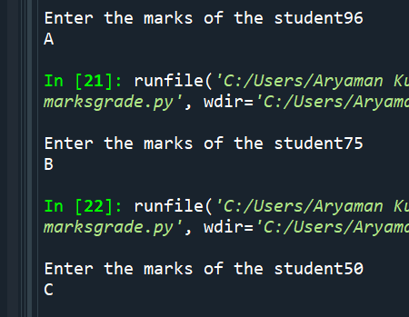

**9. Find the largest of 3 numbers. (elif statement)**

**#Program to find out the greatest number among three numbers**

**n1=int(input("Enter first number"))**

**n2=int(input("Enter second number"))**

**n3=int(input("Enter third number"))**

**if(n1>n2 and n1>n3):**

**print(n1,"n1 is greatest")**

**elif(n2>n1 and n2>n3):**

**print(n2,"n2 is greatest")**

**else:**

**print(n3,"n3 is greatest")**

**print("Name-Aryaman Kumar,registration no-22BRS1184")**

**Output:**

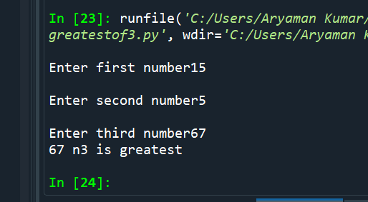

**10. Obtain a character, check if it is lower case, uppercase or digit. (elif statement)**

**#Program to find whether input character is uppercase,lowercase or digit**

**a=input("Enter character")**

**if(a.islower()==True):**

**print("Character is lowercase")**

**elif(a.isupper()==True):**

**print("Character is Uppercase")**

**elif(a.isdigit()==True):**

**print("Character is a digit")**

**print("Name-Aryaman Kumar,registration no-22BRS1184")**

**Output:**

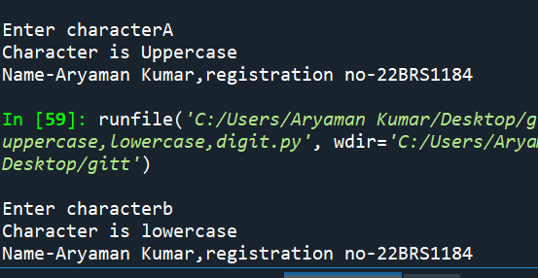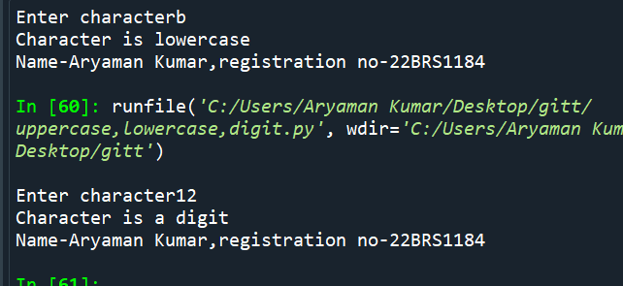

**Write the output that you obtain for the following Python questions.**

**1.Write a program to check whether a number is odd or even.**

**Code:**

**#Program to check if a given number is odd or even**

**a=int(input('Enter number'))**

**if(a%2==0):**

**print("even")**

**else:**

**print("odd")**

**print("Name-Aryaman Kumar,registration no-22BRS1184")**

**Output:**

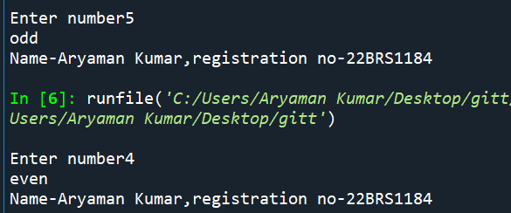

**2. Write a program in python to find the biggest of two numbers.**

**Code:**

**#Program to compare two numbers and tell which one is greatest**

**a=int(input("Enter the first number"))**

**b=int(input("Enter the second number"))**

**if(a>b):**

**print("First number",a,"is greatest")**

**else:**

**print("Second number",b,"is greatest")**

**print("Name-Aryaman Kumar,registration no-22BRS1184")**

**Output:**

**3. Write a program to convert a character from lower case to uppercase and vice versa.**

**Code:**

**#Program to convert uppercase to lowercase and vice versa**

**a=input("Enter text")**

**if(a.islower()==True):**

**cc=a.upper()#Converting lowercase to uppercase**

**print(cc)**

**print("Converted to uppercase")**

**else:**

**cc=a.lower()#Converting uppercase to lowercase**

**print(cc)**

**print("Converted to lowercase")**

**print("Name-Aryaman Kumar,registration no-22BRS1184")**

**Output:**

**4. Write a program in python to find whether a number is divisible by both 5 and 7 .**

**#Program to check whether a number is divisible by 5 and 7**

**n=int(input("Enter the number"))**

**if(n%5==0 and n%7==0):**

**print("Number is divisible by 5 and 7")**

**else:**

**print("Number is not divisible by both 5 and 7")**

**print("Name-Aryaman Kumar,registration no-22BRS1184")**

**Output:**

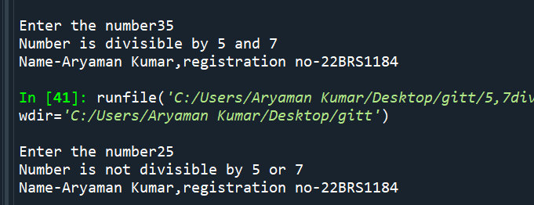

**5. Write a program to find the input year is leap year or not.**

**Code:**

**#Program to find out whether a given year is a leap year**

**Code:**

**n=int(input("Enter the year"))**

**if(n%100==0):**

**if(n%400==0):#If a leap year is also divisible by 100 then it has to**

**#be divisible by 400 to be a leap year**

**print("It is leap year")**

**else:**

**print("It is not a leap year")**

**elif(n%4==0):#If a year not divisible by 100 is divisible by 4 it is a**

**#leap year**

**print("It is leap year")**

**else:**

**print("It is not a leap year")**

**print("Name-Aryaman Kumar,registration no-22BRS1184")**

**Output:**

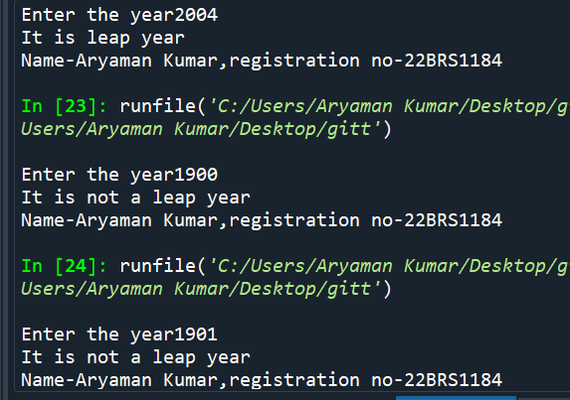

**6. Write a program in python to input three sides of a triangle and check whether the triangle is equilateral, isosceles or scalene .**

**#Program to determine the type of triangle from given three sides**

**a=int(input("Enter length of first side"))**

**b=int(input("Enter length of second side"))**

**c=int(input("Enter length of third side"))**

**if(a==b and b==c):**

**print("Equilateral triangle")**

**elif(a==b or b==c or c==a):**

**print("Isoceles triangle")**

**else:**

**print("Scalene triangle")**

**print("Name-Aryaman Kumar,registration no-22BRS1184")**

**Output:**

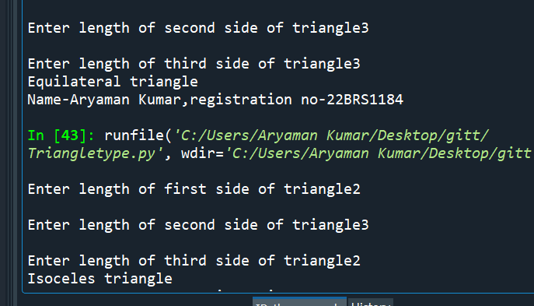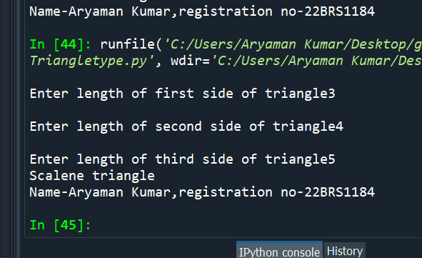

**7. Write a program in python to input three sides of a triangle and check whether it is right angled one.**

**Code:**

**import math**

**a=int(input("Enter length of first side"))**

**b=int(input("Enter length of second side"))**

**c=int(input("Enter length of third side"))**

**if(c>a and c>b):**

**if(c^2==a^2+b^2):#We apply pythagoras theorem to see if the square of the largest side**

**#is equal to the sum of squares of the other two sides**

**print("Right angle triangle")**

**else:**

**print("Not right angle triangle")**

**if(b>a and b>c):**

**if(b^2==a^2+c^2):**

**print("Right angle triangle")**

**else:**

**print("Not right angle triangle")**

**if(a>b and a>c):**

**if(a^2==b^2+c^2):**

**print("Right angle triangle")**

**else:**

**print("Not right angle triangle")**

**Output:**

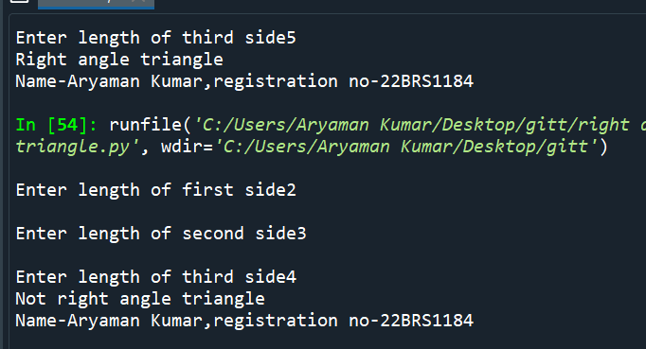

**8. Read a number, check if it is positive, negative or zero. Increment the number if it is positive, decrement if it is negative.**

**#Program checks whether a given number is positive,negative or zero and increments the number if it is positive and decrements it if negative.Number is unchanged if it is zero.**

**n=int(input("Enter the number"))**

**if(n>0):**

**n=n+1#If number is positive ,it is incremented**

**print(n)**

**elif(n<0):**

**n=n-1#If number is negative it is decremented**

**print(n)**

**else:**

**print(n)**

**print("Name-Aryaman Kumar,registration no-22BRS1184")**

**Output:**

**9. Create a simple calculator.**

**#Program to make a simple calculator that can add,subtract,multiply and divide two numbers**

**a=int(input("Enter first number"))**

**b=int(input("Enter second number"))**

**ch=int(input("Enter your choice 1.Addition,2.Subtraction,3.Multiplication,4 division"))**

**if(ch==1):**

**c=a+b**

**print("Result",c)**

**if(ch==2):**

**c=a-b**

**print("Result",c)**

**if(ch==3):**

**c=a*b**

**print("Result",c)**

**if(ch==4):**

**c=a/b**

**print("Result",c)**

**print("Name-Aryaman Kumar,registration no-22BRS1184")**

**Output:**

**10. Estimate the Grade based on the marks obtained by a student.**

**#Program to calculate grade of student based on marks**

**marks=int(input("Enter the marks of the student"))**

**if(marks>=90):**

**print("A")**

**elif(marks>=70 and marks<90):**

**print("B")**

**elif(marks>=50 and marks<70):**

**print("C")**

**elif(marks>=35 and marks<50):**

**print("D")**

**else:**

**print("E")**

**print("Name-Aryaman Kumar,registration no-22BRS1184")**

**Output:**

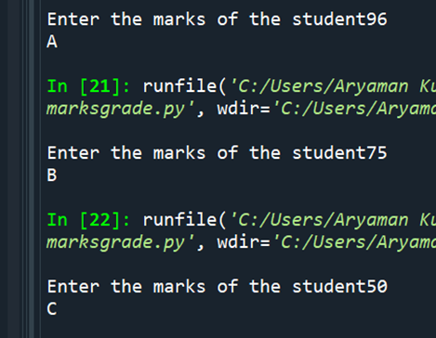

**11. Obtain a character, check if it is lower case, uppercase or digit.**

**#Program to find whether input character is uppercase,lowercase or digit**

**a=input("Enter character")**

**if(a.islower()==True):**

**print("Character is lowercase")**

**elif(a.isupper()==True):**

**print("Character is Uppercase")**

**elif(a.isdigit()==True):**

**print("Character is a digit")**

**print("Name-Aryaman Kumar,registration no-22BRS1184")**

**Output:**

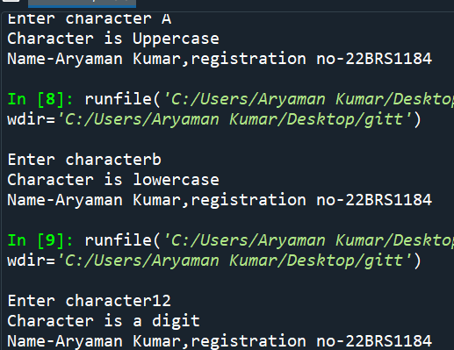

**12. Find the largest of 3 numbers.**

**#Program to find out the greatest number among three numbers**

**n1=int(input("Enter first number"))**

**n2=int(input("Enter second number"))**

**n3=int(input("Enter third number"))**

**if(n1>n2 and n1>n3):**

**print(n1,"n1 is greatest")**

**elif(n2>n1 and n2>n3):**

**print(n2,"n2 is greatest")**

**else:**

**print(n3,"n3 is greatest")**

**print("Name-Aryaman Kumar,registration no-22BRS1184")**

**Output:**

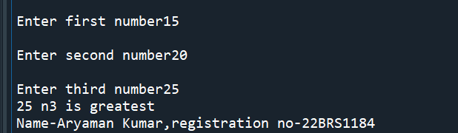

**13. Obtain a input from the user and display the corresponding data types (primitive and compound data type)**

**#Program to distinguish between primitive and compound data type**

**a=eval(input("Enter input"))**

**print(a)**

**print(type(a))**

**if(type(a) in [list,tuple,dict,set]):**

**print("Compound data type")**

**else:**

**print("Primitive data type")**

**print("Name-Aryaman Kumar,registration no-22BRS1184")**

**Output:**

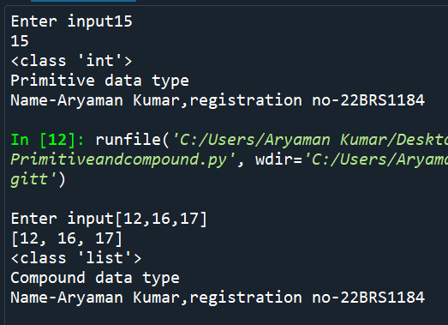

**While Loop**

**1. Compute Exponentiation (power of a number) without using ** operator.**

**Output:**

**#program to compute exponentiation without** operator**

**n=int(input("Enter the number"))**

**i=int(input("Enter power of number"))**

**count=0**

**expo=1**

**while(count<i):**

**#number is multiplied by itself for the number of times**

**expo =expo*n #specified by the user**

**count=count+1**

**print("ans",expo)**

**print("Name-Aryaman Kumar,registration no-22BRS1184")**

**Output:**

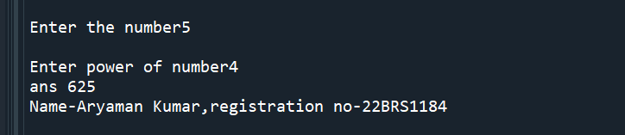

**2. Write a program in python to print all the two digit numbers which are either divisible by 3 or by 4.**

**#Program to c=print all two digit numbers divisible by 3 or 4**

**n=10**

**while(n<100):**

**if(n%3==0):#divisibility by 3 is checked first and then divisibility by 4**

**print(n)**

**elif(n%4==0):**

**print(n)**

**n=n+1**

**print("Name-Aryaman Kumar,registration no-22BRS1184")**

**Output:**

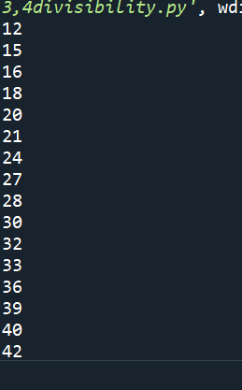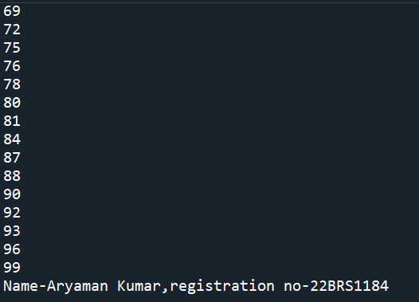

**3. Write a program in python to print the sum of all the digits of a number.**

**#Program to find the sum of digits**

**n=int(input("Enter the number")**

**rem=0**

**sum=0**

**while(n>0):**

**rem=n%10**

**sum=sum+rem**

**n=n//10**

**print("Sum of digits",sum)**

**print("Name-Aryaman Kumar,registration no-22BRS1184")**

**Output:**

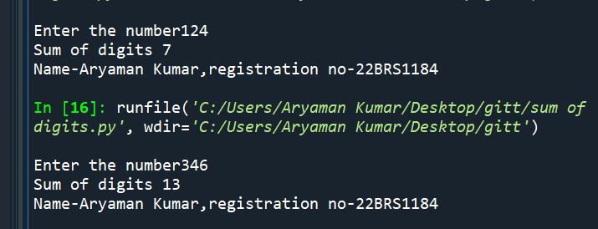

**4. Perform the division operation and find the quotient and remainder values. (without using /, // % operators) .**

**#Division without using /,// or %**

**a=int(input("Enter number"))**

**b=int(input("Enter divisor"))**

**q=0**

**sub=a**

**while(sub>0):**

**sub=sub-b**

**q=q+1#quotient is number of times the loop runs until divisor can no more be subtracted from original number**

**rem=a-b*(q)**

**if(rem<0):#To ensure remainder is not negative and product of quotient and divisor doesnt exceed number**

**rem=rem+b**

**q=q-1**

**print("Quotient",q)**

**print("Remainder",rem)**

**print("Name-Aryaman Kumar,registration no-22BRS1184")**

**Output:**

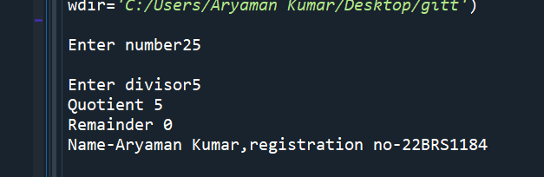

**5. Check whether the given number is palindrome or not .**

**Code:**

**#Program to check whether a given number is palindrome number**

**a=int(input("Enter the number"))**

**dig=0**

**sum=0**

**temp=a**

**while(a>0):**

**dig=a%10**

**a=a//10**

**sum=sum*10+dig**

**if (temp==sum):**

**print("Palindrome number")**

**else:**

**print("Not a palindrome number")**

**print("Name-Aryaman Kumar,registration no-22BRS1184")**

**Output:**

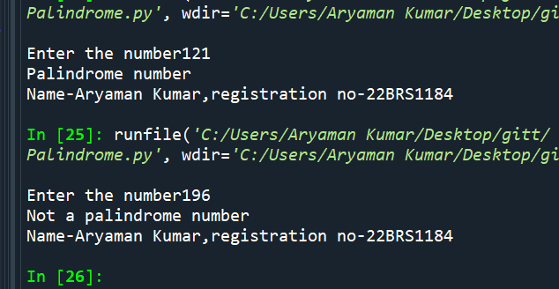

**6. Check whether the given number is Armstrong number or not.**

**Code:**

**#Program to find whether a given number is armstrong number or not**

**n=int(input("Enter the number"))**

**rem=0**

**sum=0**

**temp=n**

**while(n>0):**

**rem=n%10**

**sum=sum+rem**3#Calculating sum of cubes**

**n=n//10**

**if(sum==temp):#If original number equals sum of cubes of its digit it is armstrong number**

**print("It is a armstrong number")**

**else:**

**print("It is not armstrong number")**

**print("Name-Aryaman Kumar,registration no-22BRS1184")**

**Output:**

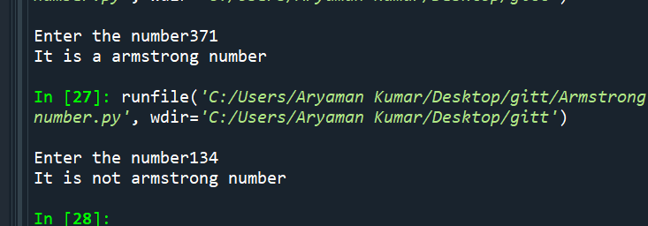

**7. Compute the GCD of two numbers.(Euclidean Method and using common factors)**

**Code:**

**#Program to find HCF of a number using euclidean algorithm and common factor method**

**a=int(input("Enter first number"))**

**b=int(input("Enter second number"))**

**x=a**

**y=b**

**c=1**

**i=1**

**fact=0**

**#using euclidean algorithm**

**while(b>0):**

**c=a%b**

**a=b**

**b=c**

**print(a,"is HCF by Euclidean method")**

**#Using common factor method**

**while((x//i)>0 and (y//i)>0):**

**if(x%i==0 and y%i==0):**

**fact=i**

**i=i+1**

**else:**

**i=i+1**

**print(fact,"is HCF by common factor method")**

**print("Name-Aryaman Kumar,registration no-22BRS1184")**

**Output:**

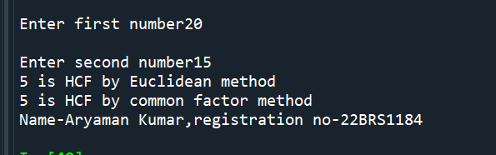

**8. Take integer inputs from user until he/she presses q (Ask to press q to quit after every integer input ). Print average and product of all numbers.**

**Code:**

**#Program to find the average and product of numbers entered by the user**

**inp='true'**

**avg=0**

**sum=0**

**prod=1**

**count=1**

**while(inp=='true'):**

**n=int(input("Enter number"))**

**sum=sum+n**

**avg=sum/count**

**prod=prod*n**

**count=count+1**

**e=input("If you wish to continue,press any key ,if you wish to exit press q")**

**if(e=='q'):**

**inp='false'**

**print("Average",avg)**

**print("Product",prod)**

**print("Name-Aryaman Kumar,registration no-22BRS1184")**

**Output:**

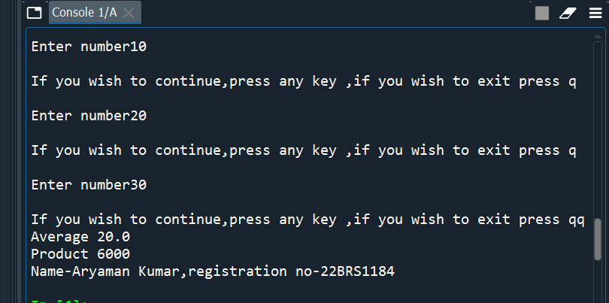

**9. Find the square root of a number. (Newton’s method**

**Code:**

**#Program to find root of a number using Newtons method**

**root=0**

**n=int(input("Enter the number"))**

**x=n**

**a=True**

**while(a==True):#root=x+n/x where x is the assumed value of the root and n is the number**

**root=0.5*(x+n/x)**

**if((root-x)<0):**

**root2=(root-x)*-1**

**if(root2<1):**

**a=False**

**x=root**

**print(int(root))**

**print("Name-Aryaman Kumar,registration no-22BRS1184")**

**Output:**

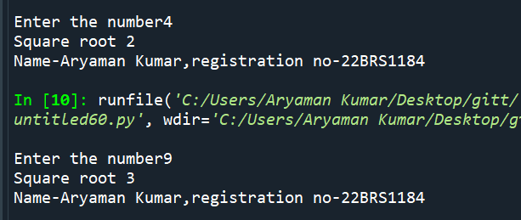

**For Loop**

**1. Write a Python program to construct the following pattern, using a nested for loop.**

**a)**

**\***

**\*\*\***

**\*\*\*\***

**\*\*\*\*\***

**\*\*\*\***

**\*\*\***

**\*\***

**\***

**Code:**

**for i in range(0,6):**

**for j in range(0,i):**

**print("*",end='')**

**print('')**

**for i in range(4,0,-1):**

**for j in range(i,0,-1):**

**print('*',end='')**

**print('')**

**print("Name-Aryaman Kumar,registration no-22BRS1184")**

**Output:**

**b)**

**1**

**21**

**321**

**4321**

**54321**

**Code:**

**for i in range(0,6):**

**for j in range(i,0,-1):**

**print(j,end='')**

**print('')**

**print("Name-Aryaman Kumar,registration no-22BRS1184")**

**Output:**

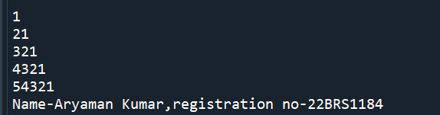

**c)**

**1**

**1 1**

**1 2 1**

**1 3 3 1**

**1 4 6 4 1**

**1 5 10 10 5 1**

**1 6 15 20 15 6 1**

**Code: """**

**#Program to display pascals triangle up till given row**

**from math import factorial**

**n=int(input("Enter the number of rows of Pascals triangle required"))**

**for i in range(n):**

**for j in range(1,n-i+1):**

**print(end=" ")**

**for j in range(0,i+1):**

**print(int(factorial(i)/(factorial(j)*factorial(i-j))),end=" ")**

**print("")**

**print("Name-Aryaman Kumar,registration no-22BRS1184")**

**Output:**

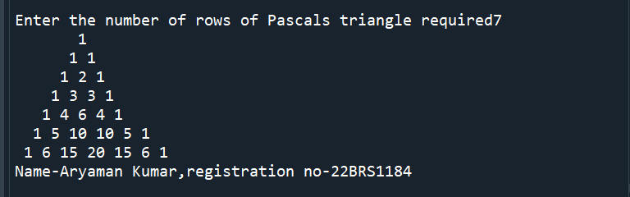

**2. Write a Python program that accepts a word from the user and reverse it.**

**Code:**

**#Program to reverse a string**

**newstring=input("Enter the string")**

**string2=newstring[::-1]**

**print(string2)**

**print("Name-Aryaman Kumar,registration no-22BRS1184")**

**Output:**

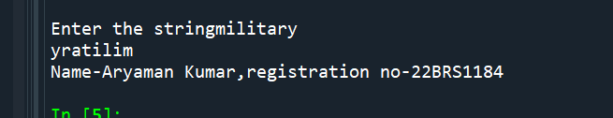

**3. Write a Python program to count the number of even and odd numbers from a series of numbers. Sample numbers : numbers = (1, 2, 3, 4, 5, 6, 7, 8, 9)**

**Code:**

**#Program to find odd and even numbers in given series of numbers**

**numbers = (1, 2, 3, 4, 5, 6, 7, 8, 9)**

**evencount=0**

**oddcount=0**

**for i in range(0,len(numbers)):**

**if(numbers[i]%2==0):**

**evencount=evencount+1**

**else:**

**oddcount=oddcount+1**

**print("Number of even numbers",evencount)**

**print("Number of odd numbers",oddcount)**

**print("Name-Aryaman Kumar,registration no-22BRS1184")**

**Output:**

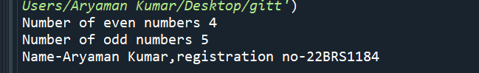

**4. Write a Python program that prints each item and its corresponding type from the following list.**

**Sample List : datalist = [1452, 11.23, 1+2j, True, 'w3resource', (0, -1), [5, 12],**

**{"class":'V', "section":'A'}]**

**Code:**

**#Program to display the datatype of all the elements of the given list**

**datalist = [1452, 11.23, 1+2j, True, 'w3resource', (0, -1), [5, 12], {"class":'V', "section":'A'}]**

**for i in range(0,len(datalist)):**

**print(type(datalist[i]))**

**print("Name-Aryaman Kumar,registration no-22BRS1184")**

**Output:**

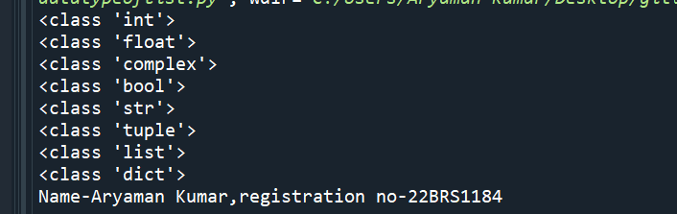

**5. Write a Python program that prints all the numbers from 0 to 6 except 3 and 6. Note : Use 'continue' statement.**

**Code: #Program to print every number in the given range except 3 and 6**

**for i in range(0,6):**

**if(i==3 or i==6):**

**continue**

**else:**

**print(i)**

**print("Name-Aryaman Kumar,registration no-22BRS1184")**

**Output:**

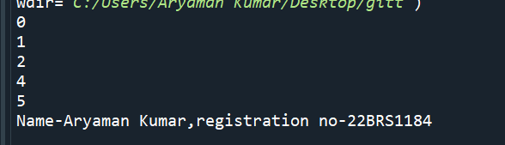

**6. Write a Python program which iterates the integers from 1 to 50. For multiples of three print "Fizz" instead of the number and for the multiples of**

**five print "Buzz". For numbers which are multiples of both three and five**

**print "FizzBuzz".**

**Code:**

**#Program iterates from 1 to 50 and displays fizz for multiples of 3 ,buzz for multiples of 5 and fizzbuzz for multiples of both.**

**#Print fizz for all multiples of 3 , buzz for all multiples of 5 and fizzbuzz for multiples of 3 and 5**

**for i in range(1,50):**

**if(i%3==0):**

**print("Fizz")**

**elif(i%5==0):**

**print("Buzz")**

**elif(i%3==0 and i%5==0):**

**print("FizzBuzz")**

**else:**

**print(i)**

**print("Name-Aryaman Kumar,registration no-22BRS1184")**

**Output:**

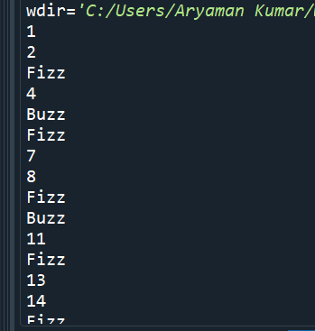 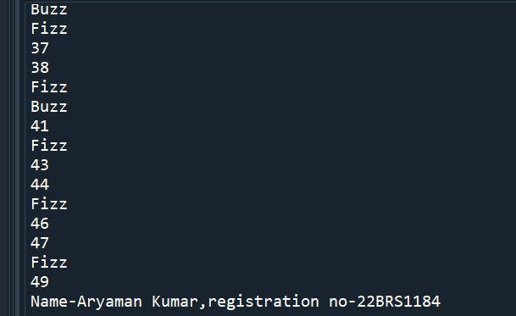

**7. Write a Python program to find numbers between 100 and 400 (both included) where each digit of a number is an even number. The numbers obtained should be printed in a comma-separated sequence.**

**Code:**

**#Program to display numbers with only even digits between 100 to 400**

**rem=0**

**sum=0**

**l=[ ]**

**q=''**

**for i in range(1,401):**

**n=i**

**while(n>0):#loop to check if digits are even**

**rem=n%10**

**if(rem%2!=0):#If digit is odd loop is broken**

**q=False**

**break**

**else:**

**q=True**

**n=n//10**

**if(q==True):**

**l.append(i)#number is stored in list**

**for i in range(0,len(l)):**

**print(l[i])**

**print("Name-Aryaman Kumar,registration no-22BRS1184")**

**Output:**

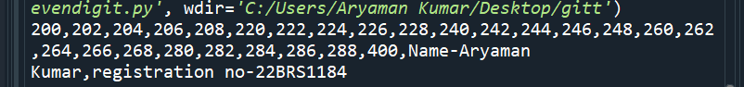

**8. Write a Python program to create the multiplication table (from 1 to 10) of**

**a number.**

**Code:**

**#Program to display multiplication table of a number from 1 to 10**

**n=int(input("Enter the number"))**

**for i in range(1,10):**

**print(n,"x",i,"=",n*i)**

**print("Name-Aryaman Kumar,registration no-22BRS1184")**

**Output:**

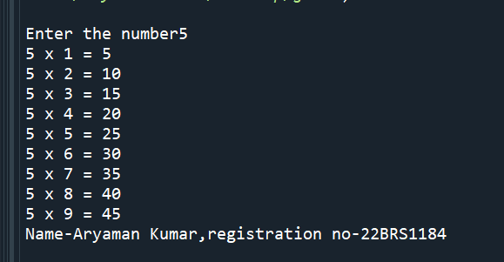

**9. Find the sum of series:**

**a. 1 + 1/2 + 1/3 + ….. + 1/N**

**#Program to find sum of series 1 + 1/2 + 1/3 + ….. + 1/N**

**N=int(input("Enter last term of series"))**

**sum=0**

**for i in range(1,N+1):**

**sum=sum+1/i**

**print("Sum is",sum)**

**print("Name-Aryaman Kumar,registration no-22BRS1184")**

**Output:**

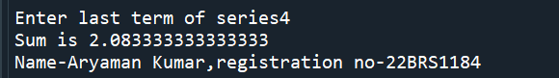

**b. 1 + x^2/2 + x^3/3 + … x^n/n**

**Code:**

**#To find sum of series 1 + 2/4 + 3/9 + ....+ N/(N*N)**

**N=int(input("Enter the last term of the series"))**

**sum=0**

**for i in range(1,N+1):**

**sum=sum+i/(i*i)**

**print("Sum",sum)**

**print("Name-Aryaman Kumar,registration no-22BRS1184")**

**Output:**

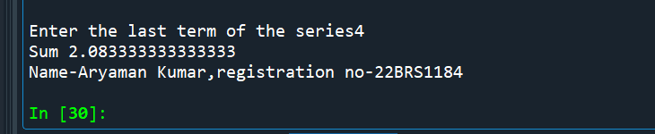

**10.Classify the given number is prime or composite number.**

**Code:**

**Program to find whether a number is prime number or composite number**

**q=False**

**n=int(input("Enter the number"))**

**if(n==1):**

**print("Number is a unique number")**

**for i in range(2,n):**

**if(n%i==0):**

**print("Number is a composite number")**

**break**

**else:**

**q=True**

**if(q==True):**

**print("Number is a prime number")**

**print("Name-Aryaman Kumar,registration no-22BRS1184")**

**Output:**

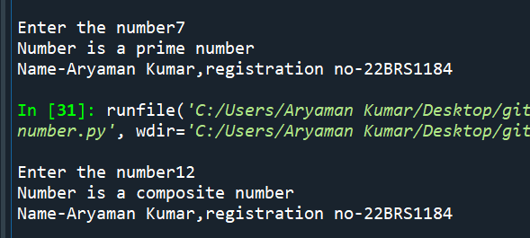

**G. Programming using Functions**

**1)** **Write a user-defined function to read the marks of 5 subjects, compute the total marks scored,**

**average, and grade of the student. The function should take the name and ID of the student as**

**arguments and print student name, ID, total, average, and grade. Write a Python program to print**

**the mark details for N students using the function.**

**Code:**

**#Program to calculate total marks,average ,grade and print name and ID of N students**

**sum1=0**

**def student(name,id1):**

**for i in range(5):**

**print("Enter marks of subject",+(i+1))**

**marks=int(input())**

**total(marks)**

**print("Name",name)**

**print("ID",id1)**

**print("total marks",sum1)**

**print("Average",avg(sum1))**

**grade(sum1)**

**def total(n1):**

**global sum1**

**sum1+=n1**

**print(sum1)**

**return sum1**

**def avg(sum2):**

**avg=sum2//5**

**return avg**

**def grade(n1):#Assuming 500 as total marks**

**if(sum1>=450):**

**print("A grade")**

**elif(sum1>=400):**

**print("Bgrade")**

**elif(sum1>=300):**

**print("C grade")**

**elif(sum1>=200):**

**print("D grade")**

**elif(sum1>=150):**

**print("Egrade")**

**else:**

**print("Fail")**

**N=int(input("Enter number of students"))**

**for i in range(N):**

**name=input("Enter name")**

**ID=input("Enter ID")**

**student(name,ID)**

**sum1=0**

**print("Name-Aryaman Kumar,registration no-22BRS1184")**

**Output:**

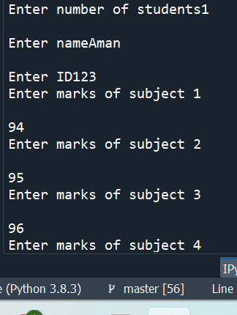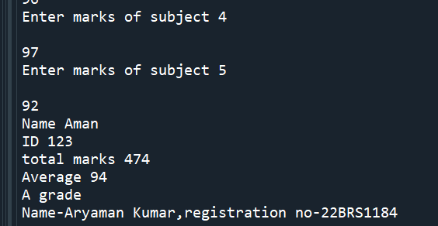

**2) Write a function power(X,N) that will allow a floating-point number to be raised to an integer**

**power and return the result. i.e. Y = X N . Write a Python program to invoke the function.**

**Code:**

**#Program to raise given number to given power**

**import math**

**def pow(X,N):**

**a=math.pow(X,N)**

**return a**

**X=int(input("Enter number"))**

**N=int(input("Enter power"))**

**print(pow(X,N))**

**print("Name-Aryaman Kumar,registration no-22BRS1184")**

**Output:**

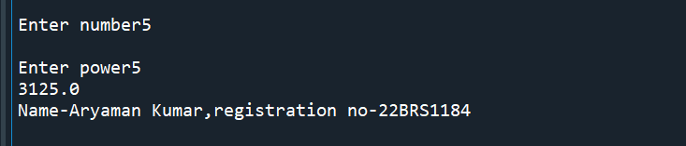

**3) Define a function CheckOddEven(num) that checks if the num is odd or even; the function sets**

**a flag accordingly and returns it. Use this function to find the sum of even and odd numbers**

**separately, from a given input of N numbers.**

**Code:**

**#Function to add odd and even numbers seperately in a given list of numbers**

**def CheckOddEven(n):**

**flag=0**

**if(n%2==0):**

**flag=1**

**return flag**

**else:**

**return flag**

**N=int(input("Enter number of numbers"))**

**sum1=0**

**sum2=0**

**list1=[]**

**for i in range(N):**

**num=int(input("Enter number"))**

**list1.append(num)**

**for i in range(len(list1)):**

**a=CheckOddEven(i)**

**if(a==1):**

**sum1+=list1[i]**

**else:**

**sum2+=list1[i]**

**print(“Even number sum”,sum1)**

**print(“Odd number sum”,sum2)**

**print("Name-Aryaman Kumar,registration no-22BRS1184")**

**Output:**

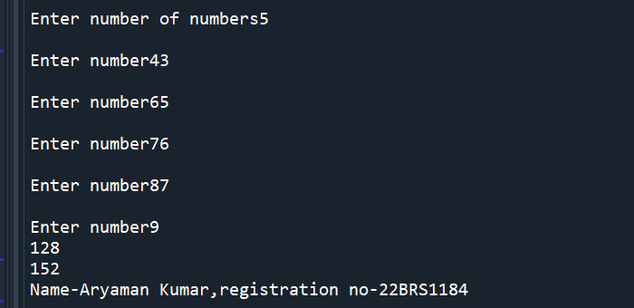

**4) Define a function to find the factors of the given number as an argument. If the number is not**

**given, then display the factors of the default argument.**

**Code:**

**Output:**

**5) Modify the function in Qn. (1) so that it returns total marks, average and grade of a student.**

**Code:**

**Output:**

**H. Programming using Recursive functions**

**1) Calculate factorial of a given number using recursive function. The base case should handle the**

**negative integers by printing an error message and returns none to indicate that something went wrong .**

**Code:**

**#Sum of digits of a number using recursion**

**def sod(n1):**

**if(n1<=0):**

**return 0**

**else:**

**return(n1%10+sod(n1//10))**

**num=int(input("Enter number"))**

**sum1=sod(num)**

**print("Sum",sum1)**

**print("Name-Aryaman Kumar,registration no-22BRS1184")**

**Output:**

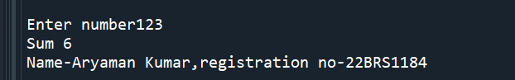

**3) Check whether a given number is prime or not using recursive function.**

**Code:**

**#Prime number using recursion**

**def prime(n,i):**

**if(n<=2): #1 and 2 are prime numbers**

**return True**

**if(n%i==0): #not a prime number**

**return False**

**if(i*i>n):#if this is true it means further values of i cannot divide this number,hence it is a prime number**

**return True#terminating condition**

**else:**

**return prime(n,i+1)**

**num=int(input("Enter number"))**

**if(prime(num,2)==True):**

**print("Prime number")**

**else:**

**print("Not a prime number")**

**print("Name-Aryaman Kumar,registration no-22BRS1184")**

**Output:**

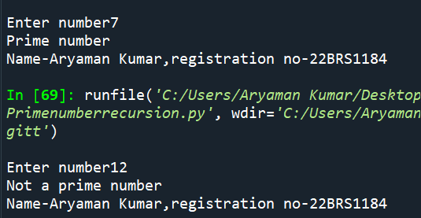

**4) The greatest common divisor (GCD) of a and b is the largest number that divides both of them**

**with no remainder. One way to find the GCD of two numbers is based on the observation that if r is**

**the remainder when a is divided by b, then gcd(a, b) = gcd(b, r). As a base case, we can use**

**gcd(a, 0) = a. Write a recursive function called gcd that takes parameters a and b and returns their**

**greatest common divisor.**

**Code:**

**#Finding gcd using recursion**

**def gcd(a,b):**

**if a==b:**

**return a**

**elif(a<b):**

**return gcd(b,a)**

**else:**

**return gcd(b,a-b)**

**a=int(input("Enter number"))**

**b=int(input("Enter number"))**

**print(gcd(a,b))**

**print("Name-Aryaman Kumar,registration no-22BRS1184")**

**Output:**

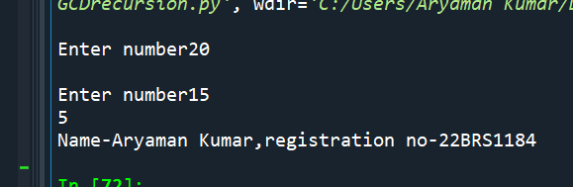

**5) The Ackermann function, A(m, n) is defined as follows:**



**Solve the above problem recursively for different values of m and n.**

**Code:**

**#Ackermann function**

**def A(m,n):**

**if(m==0):**

**return n+1**

**if (m>0 and n==0):**

**return A(m-1,1)**

**if(m>0 and n>0):**

**return A(m-1,A(m,n-1))**

**m=int(input(“Enter m value))**

**n=int(input(“Enter n value”))**

**c=A(m,n)**

**print(c)**

**print("Name-Aryaman Kumar,registration no-22BRS1184")**

**Output:**

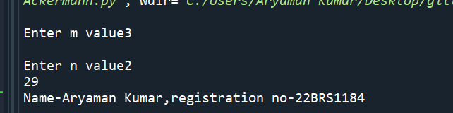

**I. Programming using Strings**

**1) Define a function to count the number of occurrences of a substring in a given string and print the starting index of the substring for each occurrence.**

**Code:**

**#Program to find number of times a substring appears in a string and first index of appearance of the string**

**str1=input("Enter string")**

**str2=input("Enter substring")**

**def check(s1,s2):**

**b=str1.count(str2,0,len(str1))**

**return b**

**def check2(s1,s2):**

**b=str1.find(str2)**

**return b**

**print(check(str1,str2))**

**print("First instance at index ",check2(str1,str2))**

**print("Name-Aryaman Kumar,registration no-22BRS1184")**

**Output:**

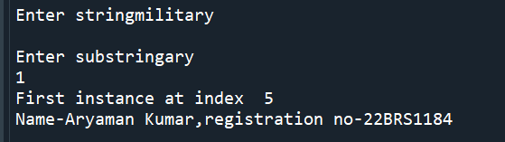

**2) Encrypt a given message by “rotating” each letter by a fixed number of places. To**

**rotate a letter means to shift it through the alphabet, wrapping around to the beginning if**

**necessary, so ‘A’ rotated by 3 is ‘D’ and ‘Z’ rotated by 1 is ‘A’. Write a function called**

**rotate_word that takes a string and an integer as parameters, and returns a new string that**

**contains the letters from the original string rotated by the given amount. E.g Given**

**String: HAL Encrypted String: JCN (Rotated by 2)**

**Code:**

**#Program to encrypt a string by adding specified number to ASCII value**

**def rotate_word(str1,n):**

**rt=""**

**b=0**

**for i in range(len(str1)):**

**b=ord(str1[i])+n**

**rt+=chr(b)**

**return rt**

**a=input()**

**n1=int(input())**

**c=rotate_word(a,n1)**

**print(c)**

**print("Name-Aryaman Kumar,registration no-22BRS1184")**

**Output:**

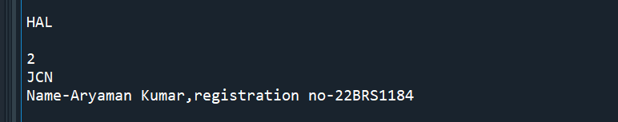

**3) Write a user-defined function to check whether a given text is palindrome or not using string slice method.**

**Code:**

**#Program to find if a word is palindrome or not**

**str1=input()**

**str2=str1[::-1]**

**if(str2==str1):**

**print("Palindrome")**

**else:**

**print("Not Palindrome")**

**print("Name-Aryaman Kumar,registration no-22BRS1184")**

**Output:**

