📘 COLLEGE ERP SYSTEM
📌 Placement & Alumni Modules Documentation
1️⃣ PLACEMENT MODULE
The Placement Module is designed to manage and streamline all placement-related activities within the college. It provides structured interaction between:
- Admin (TPO / Placement Officer)
- Students
- Companies
It ensures:
- Controlled drive creation
- Eligibility filtering
- Application tracking
- Round-wise status monitoring
- Offer management
- Report generation
🔹 1.2 Database Design Explanation
The placement module consists of the following core entities:
🧑‍💼 ADMIN : Stores placement administrators (TPO / Admin).
- Responsibilities:
- Create companies
- Create drives
- Define eligibility
- Update application status
- Generate reports
🎓 STUDENT: Stores student academic and login information.
Important Fields:
- university_roll_number (unique)
- branch
- cgpa
- batch
- is_alumni (for reference)
- password_hash (authentication)
Students can:
- View eligible drives
- Apply for drives
- Track application status
- View offers
🏢 COMPANY : Stores recruiter details.
Key Features:
- HR contact details
- Industry
- Website
- is_approved flag
Relationship:
- One Company → Many Drives
- One Company → Many Offers
- One Company → Many MOUs
📄 MOU : Stores agreements between college and company.
- Linked via company_id
- Stores file path of agreement
- Tracks signed date
🚀 PLACEMENT_DRIVE : Represents a hiring drive by a company.
Contains:
- Title
- Description
- Venue
- Drive date
- Registration open/close
- Publication status
Relationship:
- One Drive → One Eligibility Rule
- One Drive → Many Applications
- One Drive → Many Offers
- One Drive → Many Branch eligibility entries
📊 ELIGIBILITY_RULE : Defines eligibility criteria for the drive.
Includes:
- Minimum CGPA
- Maximum backlogs
- Gender restriction
- Batch limits
- Other criteria
This ensures automatic eligibility checking.
🏫 DRIVE_ELIGIBLE_BRANCH : Stores allowed branches separately.
📝 STUDENT_APPLICATION
Stores student applications for drives.
Tracks:
- student_id
- drive_id
- applied_at
- is_active
One Student → Many Applications
One Drive → Many Applications
🔁 APPLICATION_STATUS : Tracks round-wise progress.
Each application can have:
- Round 1 → Shortlisted
OPTIONAL
- Round 2 → Selected
- Round 3 → Final
💼 OFFER : Stores final offer details.
Contains:
- CTC
- Offer letter path
- Offer status
- Joined status
- Joining date
This separates: Selection ≠ Offer ≠ Joining
📑 REPORT : Stores generated placement reports.
Generated by Admin:
- Drive-wise report
NOT FIXED
- Company-wise report
- Batch-wise report
🔹 1.3 Placement Process Flow Explanation
Step 1 — Admin Activities
- Admin logs in.
- Creates/approves company.
- Creates placement drive.
- Defines eligibility.
- Adds eligible branches.
- Publishes drive.

Step 2 — Student Activities
- Student logs in.
- Views published drives.
- System checks eligibility.
- If eligible → student applies.
- Application stored in database.
Step 3 — Application Processing
- Admin reviews applications.
- Updates round status.
- Status stored in APPLICATION_STATUS.
Step 4 — Offer Management
- If selected → Offer record created.
- Student views offer.
- Student accepts/rejects.
- Joined status updated.
Step 5 - Report Generation:
- Admin generates report.
- Report stored in REPORT table.
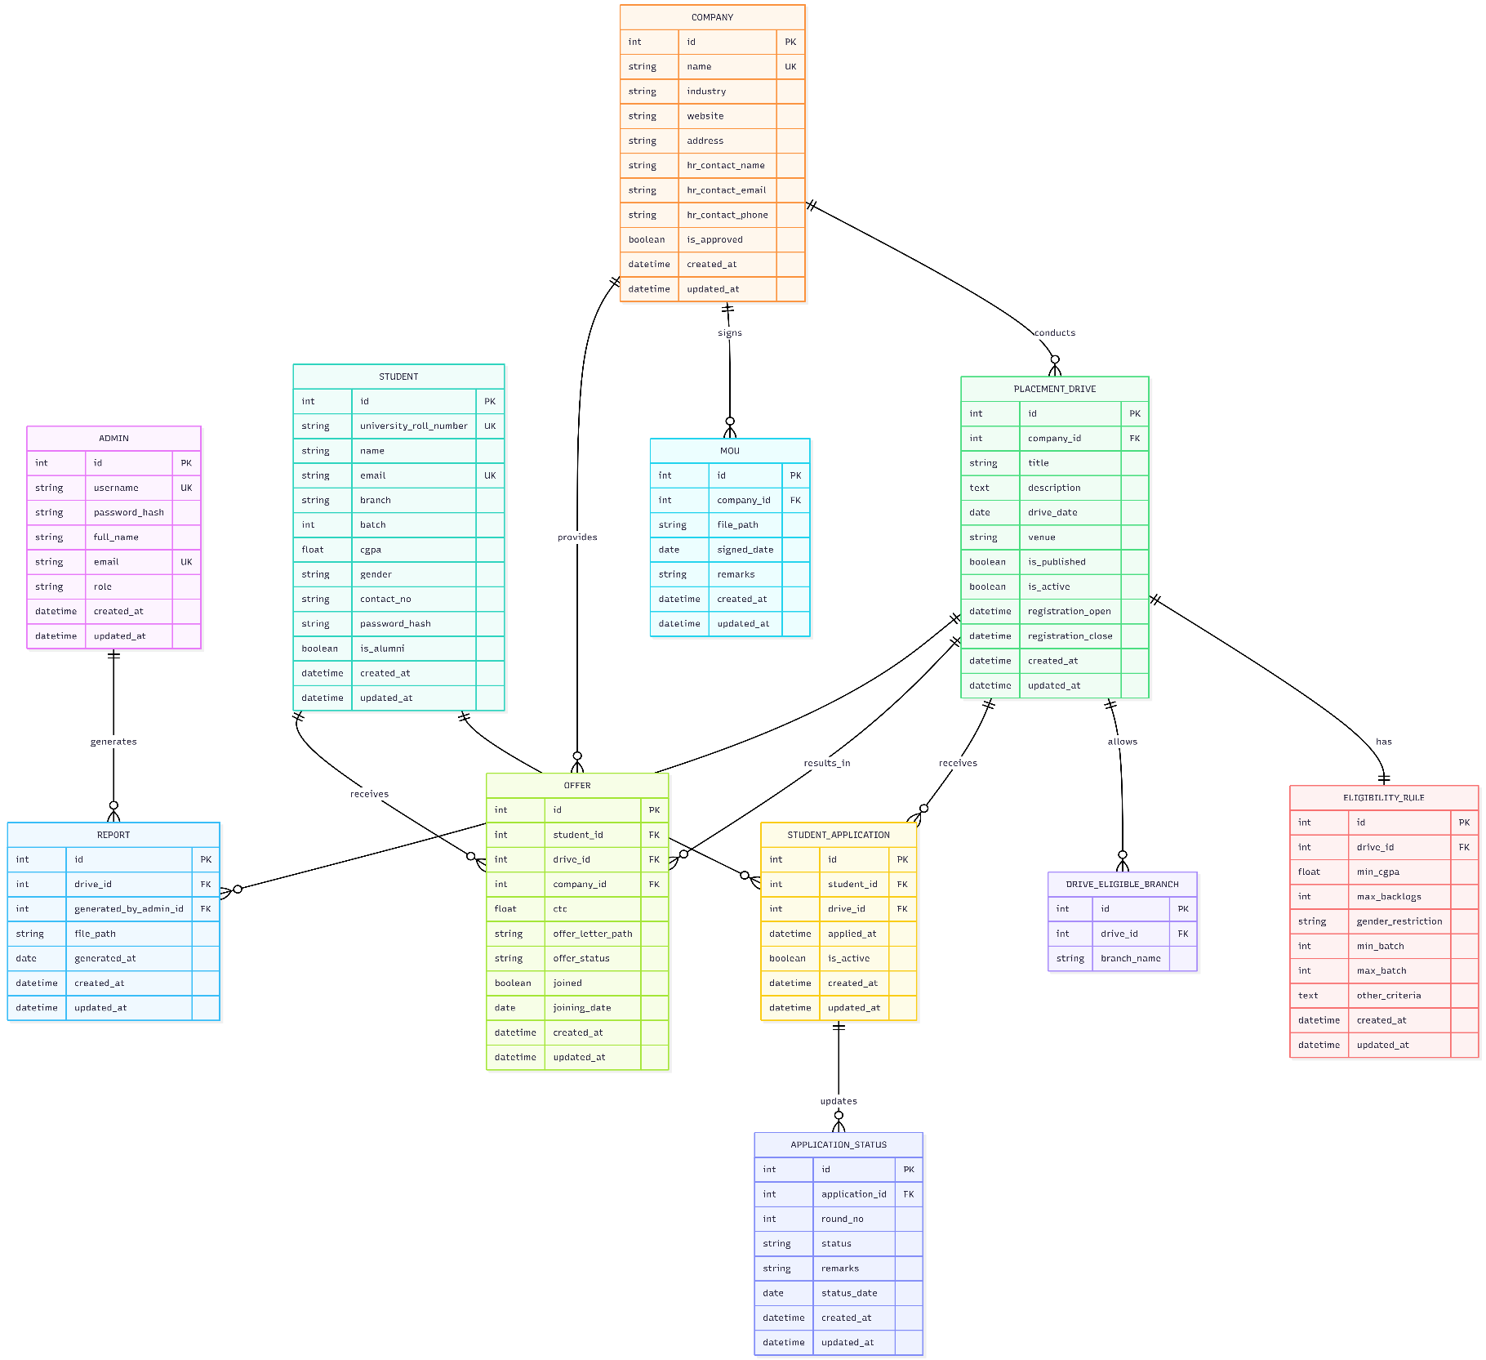
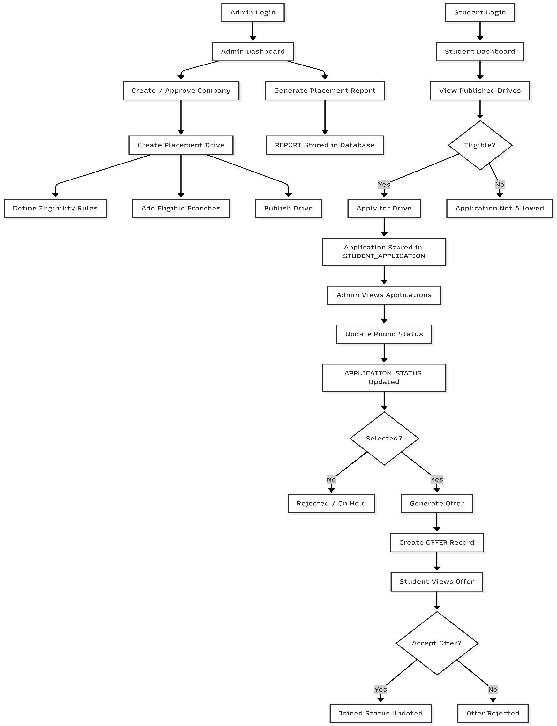
2️⃣ ALUMNI MODULE
This system follows a Selective Alumni Access Model.
Key design principle:
- Only selected alumni relevant to the college are invited and granted access.
- No automatic graduation conversion.
- No public registration.
🔹 2.2 Alumni Database Design
👨‍🎓 ALUMNI : Stores invited alumni records.
Important Fields:
- full_name
- email (unique login)
- company
- designation
- linkedin_url
- graduation_year
- invited_by_admin
- is_active
Relationship Design
- One Admin → Many Alumni
- One Alumni → Optional link to Student
student_id is optional:
- If alumni existed in system → link
- Else → manually created record
This makes system flexible.
🔹 2.3 Alumni Flow Explanation
Step 1 — Identification
- Admin identifies alumni via:
- LinkedIn
- College records
- References
Step 2 — Record Creation
- Admin creates alumni entry in database.

Step 3 — Credential Generation
- System generates:
  - Email
  - Password
- Admin shares credentials manually.
Step 4 — Login Process
Alumni logs in.
Step 5 — Alumni Features
Alumni can:
- Update profile
- Share company details
- Offer mentorship
- Participate in events
Alumni cannot:
- Access student applications
- Modify placement drives
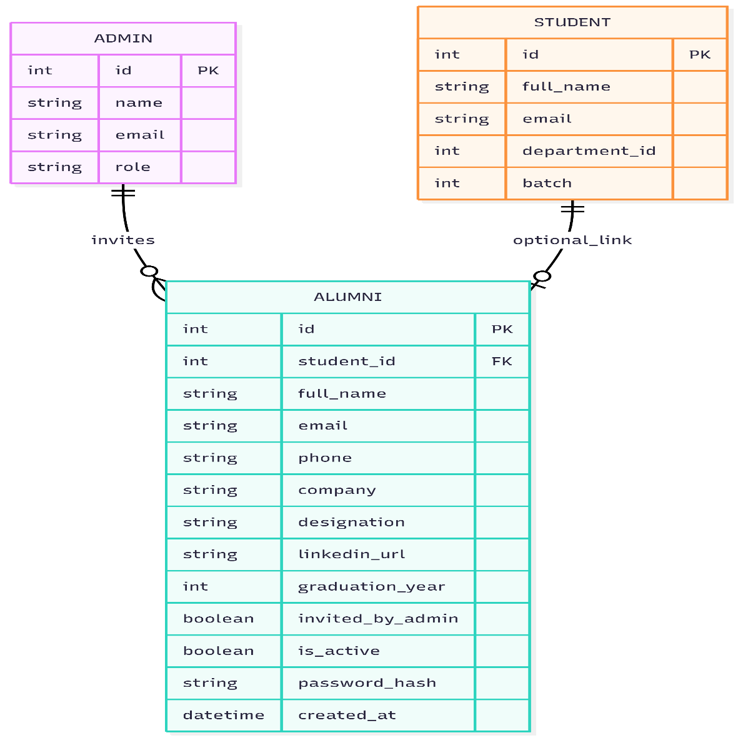
- Access admin reports
datetime Updated at
