ShareBoard(Real Time Chat Webapp)

Neel Modi  
*Department of Information Technology  
C S Patel Institute of Technology, CHARUSAT*Changa, India[20it071@charusat.edu.in](mailto:20it071@charusat.edu.in)

Aryakumar Patel   
*Department of Information Technology  
C S Patel Institute of Technology, CHARUSAT*Changa, India[20it082@charusat.edu.in](mailto:20it082@charusat.edu.in)

Abstract: Shareboard is an important tool for today’s generation as it help’s everypeople to talk from anywhere in the world and talk with them at real time without any issue and this webapp solve the issue of call every time for any query related anything about that work. Now with the help of Shareboard user can just send the message to the other user and resolve the issue or query without calling. The interesting part of the Shareboard is that all can send the similar message to lot of users at a same time without any inconvience as we can make a group of users or we can send the message to selected users to whom the sender wants to send the message.

# **Introduction (*Heading 1*)**

Shareboard uses web-based apps, which allow communication which is normally addressed directly but anonymously between users in a multi-user environment. Shareboard is virtually any online communication that provides real-time or live transmission of text messages from sender to recipient. Various software programs are available to enable real-time chat between individuals using Internet services.

Shareboard can be any direct text-based one-to-one chat or one-to-one group chat through tools like Instant Messenger (IMs), Talkers, Internet Relay Chat (IRC) and Multi-User Dungeon (MUDs).

ShareBoard having a additional functionality to create new room and join easily.

# **Obejtive**

The objective is to develop a real-time chat webapp which can be used by many people to share the information and communicate with each other easily and faster.

# **System Desing**

WebApp is two sided, one side is client and the other side is server. Client and Connector Connected Bilateral, when the client sends a message to the server and when the server receives the message, the server not able to print it, you can send it to the server or insert the file, but what we do Can do Want to do. Make sure the person with each person's chat home sends it and sees the message at the time.

We will add the other client and at this we will send the data from the server to the client. The server client no. 1 will send the message to no. 2 client that client no.1 has sent, the server will resend that message to the client and the client can load that message through the browser. When any client sends a message to the server and that server after receiving the message the server sends it to the other clients present in the created room at that time.

## Data Flow Diagram:

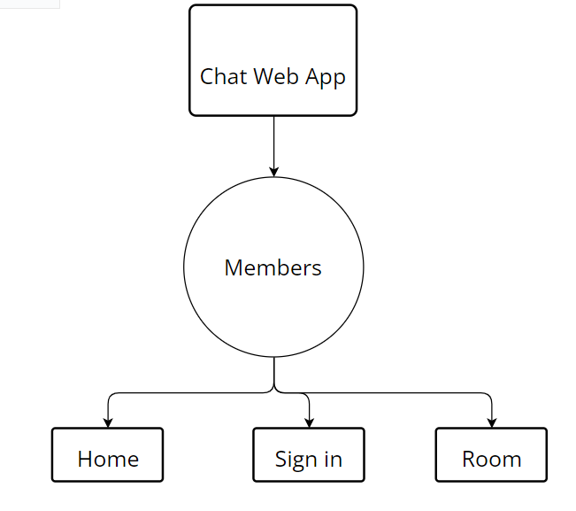

# **Implementation**

## Sign in page:

Users can create an account with their user credentials here. Another option is to register using a Google Account and when registering using any of these, select the account from which user wants to register for the chat app.

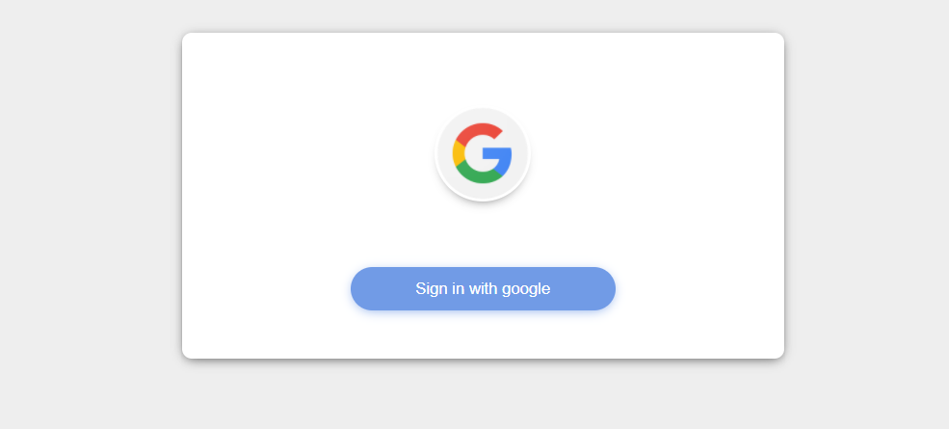

## Room Page:

In this a user can write a username and room name for making a room for transferring their message to the another user.

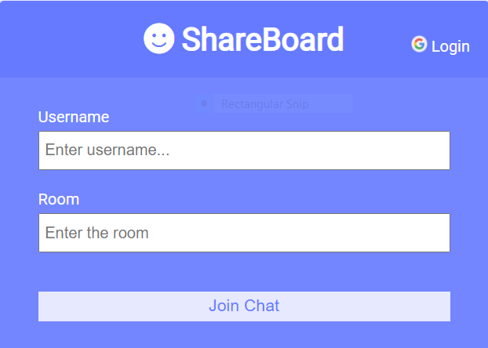

## Chat Page :

The user can only talk to 1 or more people by sending a single message. It will also show the time along with the message. It is possible to see at what time the message is sent and when it is received.

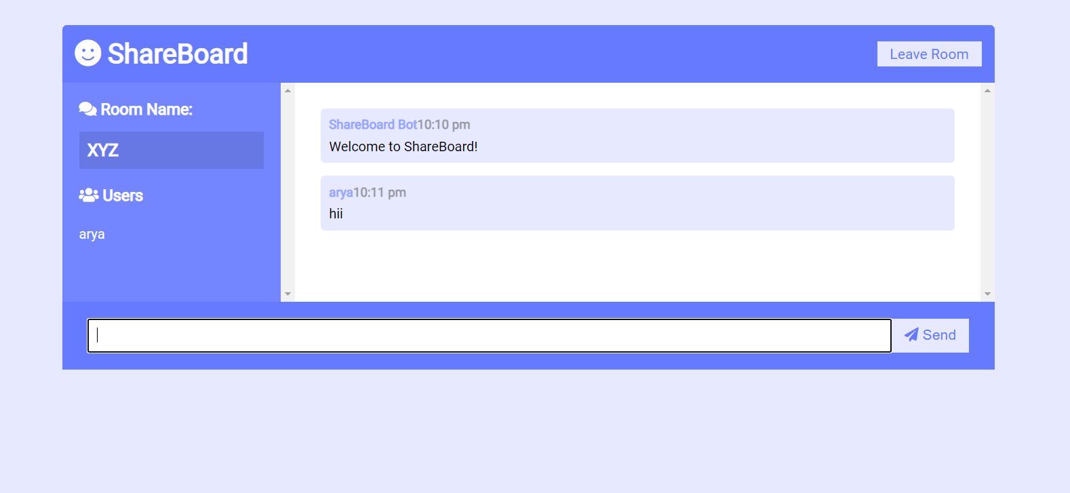

# **Advantages of ShareBoard:**

1. Faster support
2. Real time text preview
3. Clear Context
4. 24/7 hour support

# **Conclusion**

We found that creating a "real time chat webapp" is a very innovative and new thing. I can say that socket.io has make the chat webapp easy to create. I think that this project taught me a lot more than I expected.

# **References**

1. GeeksforGeeks:[GeeksforGeeks](http://www.geeksforgeeks.com)
2. Youtube:[youtube](http://www.youtube.com)
3. Google:[Google](http://www.google.com)