INTERNSHIP PROJECT REPORT

🤖 DecoBot
Rule-Based AI Chatbot

Project Title | DecoBot — Rule-Based AI Chatbot
Technology | Python 3.x
Type | Rule-Based Chatbot
Organization | Decodelabs Internship
Track | Standard / Career PRO
Status | ✅ Completed

1. Introduction
This report documents the development of DecoBot, a rule-based AI chatbot built using Python. The project was completed as part of the Decodelabs Internship Program. DecoBot is a terminal-based conversational agent that responds to user inputs based on predefined keyword-matching rules.

Chatbots represent one of the most widely used applications of Artificial Intelligence in modern computing. Rule-based chatbots, while simpler than modern Large Language Models, provide a solid foundation for understanding how machines can simulate conversation.

2. Project Objectives
- Build a functional chatbot using pure Python with no external libraries
- Implement keyword-matching logic for recognizing user intents
- Apply input sanitization to handle varied user input formats
- Design a graceful exit mechanism for the chatbot session
- Understand the fundamentals of rule-based Natural Language Processing

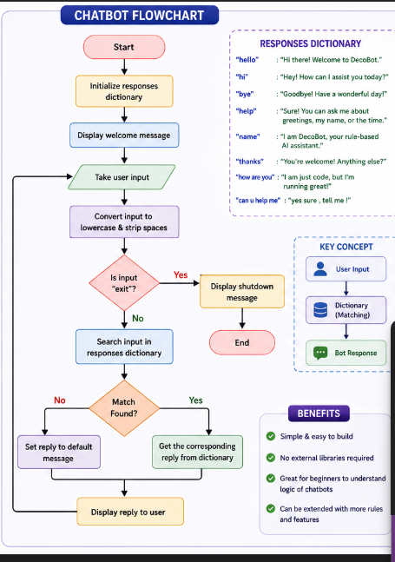

3. Technology Used
Technology / Tool | Purpose / Usage
Python 3.x | Core programming language for the entire project
Dictionary (dict) | Response mapping — acts as the rule engine
input() / print() | Terminal-based user input and output
str.lower() | Converts input to lowercase for matching
str.strip() | Removes leading/trailing whitespace from input
while loop | Keeps the chatbot running until user types 'exit'

4. How It Works
DecoBot follows a straightforward 3-step process for every message:

Step 1 — Take User Input
The chatbot reads the user's message from the terminal using Python's built-in input() function.

Step 2 — Sanitize & Match
The input is cleaned by converting it to lowercase and stripping extra spaces. It is then matched against a dictionary of predefined keywords.

Step 3 — Output Response
If a match is found, the corresponding response is printed. If not, a fallback message is displayed asking the user to rephrase.

5. Code Overview
Below is the complete source code of DecoBot:

def chatbot():
# Base responses dictionary (rule engine)
responses = {
"hello": "Hi there! Welcome to DecoBot.",
"hi": "Hey! How can I assist you today?",
"bye": "Goodbye! Have a wonderful day!",
"help": "Sure! Ask me about greetings or my name.",
"name": "I am DecoBot, your rule-based AI assistant.",
"thanks": "You're welcome! Anything else?",
"how are you": "I am just code, but I'm running great!",
"can u help me":"yes sure, tell me!"
}

print("DecoBot: Hello! I am DecoBot. Type 'exit' to quit.\n")

while True:
raw_input_text = input('you :')
clean_input = raw_input_text.lower(). strip() # sanitize

if clean_input == "exit":
print("DecoBot: Shutting down. Goodbye!")
break

# Match input to response, fallback if not found
reply = responses.get(clean_input, "I do not understand that. Can u rephrase?")
print(f"DecoBot: {reply}\n")

chatbot()

6. Sample Conversation Output
The following shows a typical conversation session with DecoBot:

DecoBot: Hello! I am DecoBot. Type 'exit' to quit.

you: hello
DecoBot: Hi there! Welcome to DecoBot.

you: what is your name
DecoBot: I am DecoBot, your rule-based AI assistant.

you: how are you
DecoBot: I am just code, but I'm running great!

you: can u help me
DecoBot: yes sure, tell me!

you: thanks
DecoBot: You're welcome! Anything else?

you: bye
DecoBot: Goodbye! Have a wonderful day!

you: exit
DecoBot: Shutting down. Goodbye!

7. Supported Commands
User Input | DecoBot Response
hello | Hi there! Welcome to DecoBot.
hi | Hey! How can I assist you today?
bye | Goodbye! Have a wonderful day!
help | Sure! You can ask me about greetings, my name, or the time.
name | I am DecoBot, your rule-based AI assistant.
thanks | You're welcome! Anything else?
how are you | I am just code, but I'm running great!
can u help me | yes sure, tell me!
exit | Shutting down. Goodbye!
(unknown input) | I do not understand that. Can u rephrase?

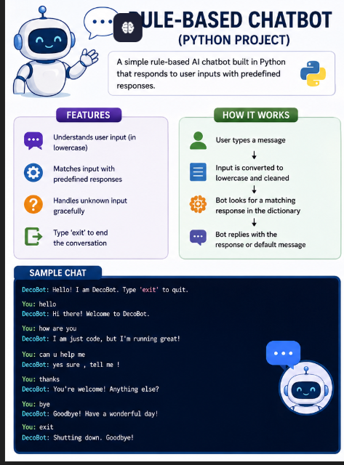
8. Challenges Faced
- Handling varied user inputs (uppercase, mixed case, extra spaces) — solved using .lower() and .strip()
- Designing a natural fallback response that doesn't confuse the user
- Keeping the rule engine scalable without using external libraries
- Ensuring the exit mechanism works reliably without crashing

9. Key Learnings
- How rule-based chatbots work using dictionary-based pattern matching
- The importance of input preprocessing in NLP applications
- Python control flow: while loops, break statements, conditional logic
- How to design user-friendly terminal interfaces
- Basics of chatbot architecture: input → process → output

10. Future Scope
- Add more intents and response variations for richer conversations
- Integrate NLP libraries like NLTK or spaCy for smarter intent detection
- Build a GUI using Tkinter or a web interface using Flask
- Add conversation memory to make responses context-aware
- Deploy as a web-based chatbot for wider accessibility

11. Conclusion
DecoBot successfully demonstrates the core concepts of a rule-based AI chatbot. Through this project, fundamental skills in Python programming, input handling, and conversational system design were developed. While the chatbot is simple in its current form, it provides a strong foundation for building more advanced AI-powered conversational agents in the future.

This project was developed with dedication and effort as part of the Decodelabs Internship Program, and represents a meaningful step in the journey of learning Artificial Intelligence and software development.

