INTERNSHIP PROJECT REPORT
Project Report: Image or Text
Recognition (Basic)

Project State: Completed AI Recognition System using OCR/Object Detection
Introduction
The Image and Text Recognition System is an Artificial Intelligence-based project developed using Python. The main objective of this project is to extract text information from images using Optical Character Recognition (OCR) technology. OCR enables computers to recognize printed or handwritten text from images and convert it into machine-readable text.
In this project, the user provides an image containing text as input. The system processes the image using OpenCV and extracts the text using the Tesseract OCR engine. The extracted text is then displayed to the user. This technology is widely used in document digitization, automated data entry, invoice processing, number plate recognition, and smart scanning applications.

Objectives
1. Read image input.
2. Apply image preprocessing.
3. Perform OCR or object detection.
4. Display recognized output.
5. Validate confidence and results.

Requirements
- Python 3.x
- OpenCV (cv2)
- Pytesseract
- NumPy
- VS Code
- Tesseract OCR Engine.

Algorithm
- Start
- Load Image
- Preprocessing
- OCR Detection
- Extract Text
- Display Output
- End

Project Workflow
- User uploads an image containing text.
- The image is loaded into the Python application.
- The image is converted into grayscale for better processing.
- Image preprocessing techniques are applied to improve text visibility.
- Tesseract OCR analyses the image and identifies characters.
- The recognized text is extracted.
- The extracted text is displayed on the screen.
- The process ends after successful text recognition.

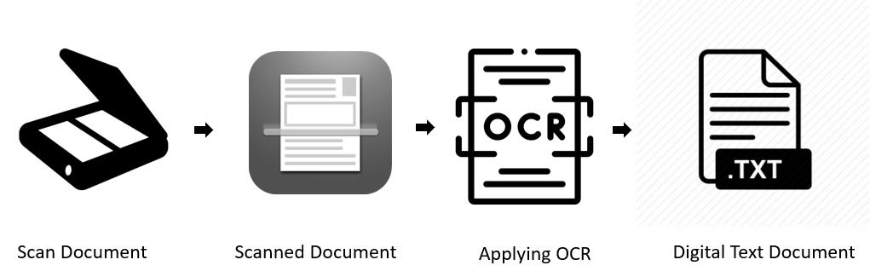
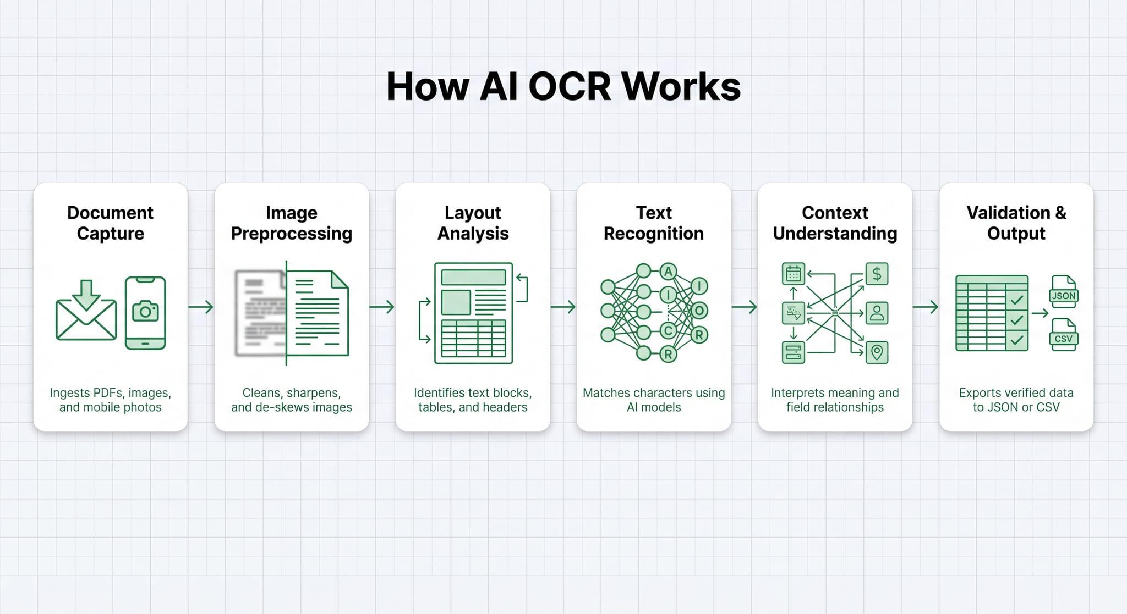

CODE OVERVIEW
The project is implemented using Python and consists of the following steps:
• Import required libraries such as OpenCV and pytesseract.
• Load the input image using OpenCV.
• Convert the image into grayscale format.
• Apply OCR using the Tesseract engine.
• Extract the recognized text.
• Display the extracted text to the user.
The code is simple, efficient, and suitable for beginners learning Artificial Intelligence and Computer Vision concepts.

Examples
Example 1: Student Details
Input Image:
Name: Aastha
Course: BCA
Roll No: 101
OCR Output:
Name: Aastha
Course: BCA
Roll No: 101
Example 2: Shop Bill
Input Image:
Milk 50
Bread 30
Butter 60
Total 140
OCR Output:
Milk 50
Bread 30
Butter 60
Total 140

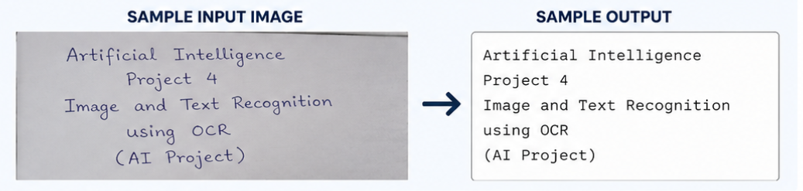

CHALLENGES FACED
- Installing and configuring the Tesseract OCR engine correctly.
- Handling low-quality and blurred images.
- Improving OCR accuracy for different font styles and sizes.
- Managing image preprocessing techniques for better recognition.
- Extracting text from images with complex backgrounds.
- Handling special symbols and handwritten text.
- Integrating OpenCV and Tesseract libraries within the Python environment.

FUTURE ENHANCEMENTS
- Add support for handwritten text recognition.
- Implement real-time OCR using webcam input.
- Support multiple languages for text extraction.
- Export extracted text to PDF and Word documents.
- Integrate cloud-based OCR services for higher accuracy.
- Develop a graphical user interface (GUI) for improved user interaction.
- Add automatic translation of extracted text into different languages.
- Improve recognition accuracy using deep learning models.

Applications
- Document digitization
- Number plate recognition
- Invoice processing
- Smart scanning
- Object recognition.

Conclusion
The Image and Text Recognition System successfully demonstrate the practical implementation of Artificial Intelligence and Optical Character Recognition technologies. The system efficiently extracts text from images and converts it into editable digital content. Through this project, valuable knowledge was gained in image processing, OCR technology,
and Python programming. The project serves as a foundation for developing advanced AI-powered document processing and recognition systems in the future

