Certificate
Department of Computer Science and Engineering

This is to certify that this Practical Record contains the bona fide practical work carried out by Mr./Ms. ______________________________________________, bearing PRN. _____________________, of Batch _________, Semester ______, Section _________, during the Academic Year __________________.

Date: _____________

Name of Course Teacher: _________________________________________

Signature of Course Teacher: ______________________________________

Name of Student: ________________________ PRN: _________________
Batch: ______________ Semester: ____________ Section: ______________
Index
Practical No. | Aim | Performance Date | Submission Date | Remarks
1 | Demonstrate inline, internal, and external JavaScript; use console methods; create a webpage showing user info and a welcome message.
2 | Use var, let, const, and demonstrate basic features like template literals and destructuring; build a billing calculator with user input.
3 | Implement control structures and form validation; create a grading system based on user-entered marks.
4 | Use function types, scope, and closures; apply try-catch; build a palindrome checker.
5 | Apply array methods and object handling; create a cart total calculator with discount logic.
6 | Use string functions and regex for email validation, data extraction, and text analysis.
7 | Perform DOM traversal and updates; develop a to-do list app with add, edit, and delete features.
8 | Access and validate form fields using events; design a gym admission form with live input checks.
9 | Implement localStorage and sessionStorage to save user preferences like theme settings.
10 | Load and display JSON data using fetch() and jQuery $.getJSON(); render results dynamically in a table.
VA 11 | Use JavaScript timers (setTimeout(), setInterval()) and ES6 modules (import/export) to build a dynamic countdown or class scheduler with real-time updates and responsive layout.
VA 12 | Build an interactive real-time web app using JavaScript and jQuery with DOM, events, storage, and AJAX integration.
EXPERIMENT NO : 1

- Title : Demonstrate inline, internal and external JavaScript; use console methods; create a webpage showing user info and a welcome message.

- Software/Tools Required : Visual Studio Code, Google Chrome, HTML5, CSS3, and JavaScript.

- Theory : JavaScript is a scripting language used to make web pages interactive and dynamic. It can be added to an HTML document in three different ways :
- Inline JavaScript:
Inline JavaScript is written directly inside an HTML element using event attributes such as onclick. In this experiment, it was used to perform an action directly when the user interacted with a webpage element.

- Internal JavaScript:
Internal JavaScript is written inside the <script> tag within the same HTML file. In this experiment, JavaScript functions were defined internally and called when specific user interactions occurred on the webpage.

- External JavaScript:
External JavaScript is written in a separate .js file and connected to the HTML document using the <script src= “…”></script> tag. In this experiment, external JavaScript was used to keep the scripting code separate from the HTML structure.

- Code :
- <!DOCTYPE html>
- <html lang="en">
- <head>
- <meta charset="UTF-8">
- <meta name="viewport" content="width=device-width, initial-scale=1.0">
- <title>JavaScript Demonstration | Lab Experiment</title>

- <style>
- :root {
- --bg-color: #f8fafc;
- --card-bg: #ffffff;
- --primary: #2563eb;
- --primary-hover: #1d4ed8;
- --text-main: #0f172a;
- --text-muted: #475569;
- --border: #e2e8f0;
- --shadow: 0 4px 6px -1px rgb(0 0 0 / 0.1), 0 2px 4px -2px rgb(0 0 0 / 0.1);
- }

- * {
- box-sizing: border-box;
- margin: 0;
- padding: 0;
- }

- body {
- font-family: 'Segoe UI', Tahoma, Geneva, Verdana, sans-serif;
- background-color: var(--bg-color);
- color: var(--text-main);
- line-height: 1.6;
- padding: 40px 20px;
- display: flex;
- justify-content: center;
- align-items: center;
- min-height: 100vh;
- }

- .dashboard {
- background: var(--card-bg);
- padding: 40px;
- border-radius: 16px;
- width: 100%;
- max-width: 650px;
- box-shadow: var(--shadow);
- border: 1px solid var(--border);
- }

- header {
- text-align: center;
- margin-bottom: 30px;
- border-bottom: 2px solid var(--border);
- padding-bottom: 20px;
- }

- h1 {
- color: var(--primary);
- font-size: 28px;
- font-weight: 700;
- margin-bottom: 8px;
- }

- .welcome-box {
- font-size: 16px;
- color: var(--text-muted);
- font-style: italic;
- min-height: 24px;
- }

- .section-title {
- font-size: 18px;
- color: var(--text-main);
- margin-bottom: 15px;
- font-weight: 600;
- display: flex;
- align-items: center;
- gap: 8px;
- }

- .info-grid {
- display: grid;
- grid-template-columns: repeat(2, 1fr);
- gap: 15px;
- background: #f1f5f9;
- padding: 20px;
- border-radius: 12px;
- margin-bottom: 30px;
- }

- .info-item span {
- display: block;
- font-size: 12px;
- text-transform: uppercase;
- color: var(--text-muted);
- font-weight: 600;
- letter-spacing: 0.5px;
- }

- .info-item p {
- font-size: 16px;
- font-weight: 600;
- color: var(--text-main);
- }

- .demo-area {
- display: flex;
- flex-direction: column;
- gap: 15px;
- margin-bottom: 35px;
- }

- .btn-card {
- display: flex;
- justify-content: space-between;
- align-items: center;
- padding: 15px 20px;
- background: var(--card-bg);
- border: 1px solid var(--border);
- border-radius: 10px;
- transition: transform 0.2s, box-shadow 0.2s;
- }

- .btn-card:hover {
- transform: translateY(-2px);
- box-shadow: 0 4px 12px rgb(0 0 0 / 0.05);
- }

- .btn-desc {
- text-align: left;
- }

- .btn-desc h4 {
- font-size: 15px;
- color: var(--text-main);
- }

- .btn-desc p {
- font-size: 12px;
- color: var(--text-muted);
- }

- button {
- background-color: var(--primary);
- color: white;
- border: none;
- padding: 10px 18px;
- font-size: 14px;
- font-weight: 500;
- border-radius: 6px;
- cursor: pointer;
- transition: background-color 0.2s;
- white-space: nowrap;
- }

- button:hover {
- background-color: var(--primary-hover);
- }

- footer {
- text-align: center;
- border-top: 1px solid var(--border);
- padding-top: 20px;
- font-size: 13px;
- color: var(--text-muted);
- }

- footer strong {
- color: var(--text-main);
- }
- </style>

- <!-- Internal JavaScript -->
- <script>
- function showWelcome() {
- // Target the welcome container safely
- const welcomeElement = document.getElementById("welcome");
- if (welcomeElement) {
- welcomeElement.innerHTML = "Welcome to the JavaScript Demonstration Webpage!";
- }

- // Demonstrate diverse Console Methods
- console.log("Welcome message dynamically injected via Internal JS.");
- console.info("Internal JavaScript block executed successfully on body load.");
- console.warn("Console demonstration initialization completed.");
- }
- </script>
- </head>
- <body onload="showWelcome()">

- <div class="dashboard">
- <header>
- <h1>JS Execution Environments</h1>
- <p id="welcome" class="welcome-box"></p>
- </header>

- <main>
- <h3 class="section-title">User Metadata</h3>
- <div class="info-grid">
- <div class="info-item">
- <span>Developer Name</span>
- <p>Arya Khandekar</p>
- </div>
- <div class="info-item">
- <span>Permanent Reg. No (PRN)</span>
- <p>24070521219</p>
- </div>
- </div>

- <h3 class="section-title">Execution Controls</h3>
- <div class="demo-area">
- <!-- Inline JavaScript Block -->
- <div class="btn-card">
- <div class="btn-desc">
- <h4>Inline Execution</h4>
- <p>Triggers script directly inside the HTML tag attributes.</p>
- </div>
- <button onclick="console.log('Inline button clicked.'); alert('Hello Arya Khandekar! This is Inline JavaScript.');">
- Run Inline
- </button>
- </div>

- <!-- External JavaScript Block -->
- <div class="btn-card">
- <div class="btn-desc">
- <h4>External Execution</h4>
- <p>Calls decoupled functions stored inside an detached script file.</p>
- </div>
- <button onclick="showExternalMessage()">
- Run External
- </button>
- </div>
- </div>
- </main>

- <footer>
- <p>Webpage engineered for academic evaluation by <strong>Arya Khandekar</strong> (PRN: 24070521219)</p>
- </footer>
- </div>

- <!-- External JavaScript File -->
- <script src="script.js"></script>

- </body>
- </html>

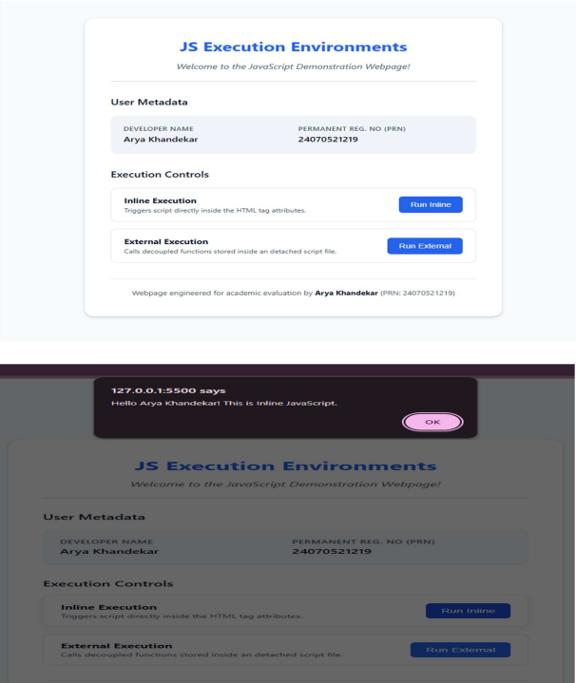
5. OUTPUT :

6. CONCLUSION :
Thus, a webpage was successfully created using HTML, CSS and JavaScript.
The three methods of integrating JavaScript inline, internal and external were
successfully implemented and demonstrated through different interactive
features on the webpage.

CASE STUDY : 1

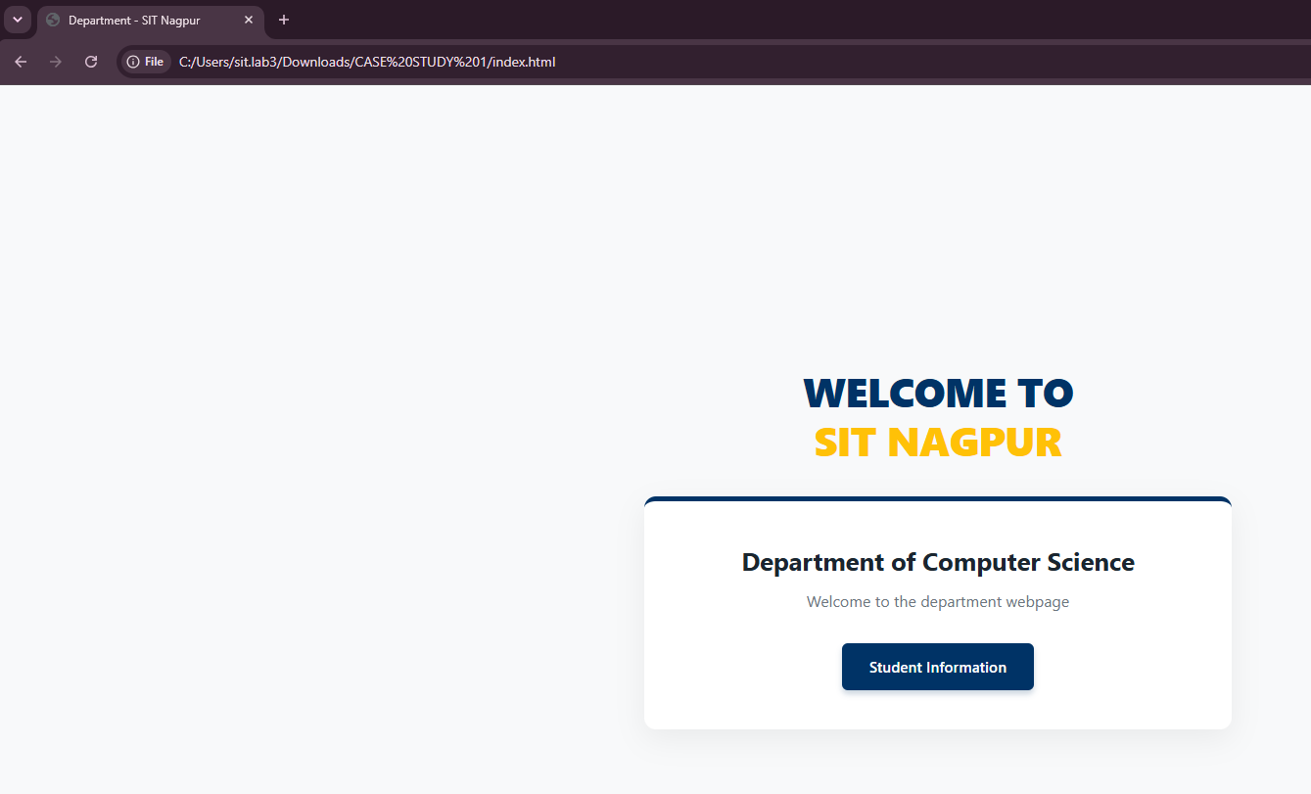
- OUTPUT

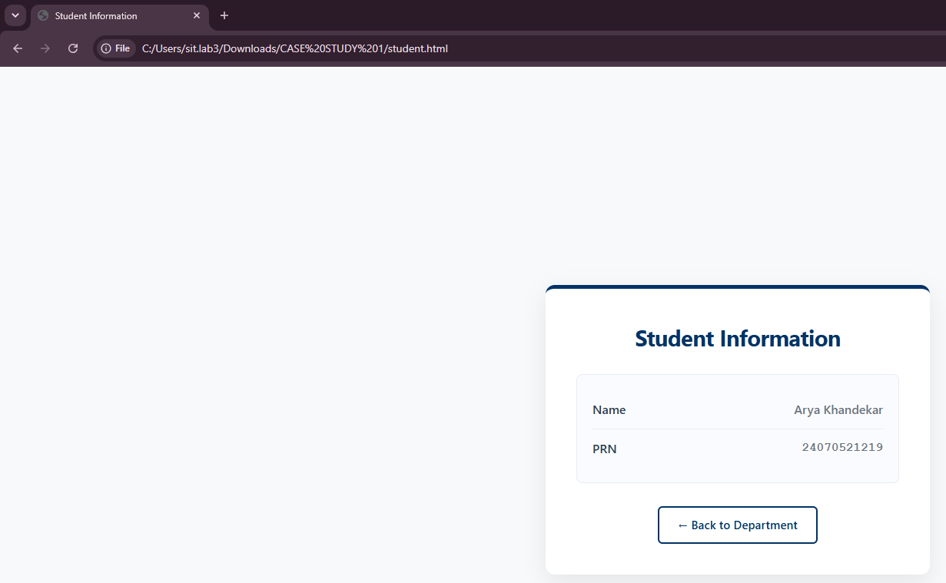
- CODE
- <!DOCTYPE html>
- <html lang="en">
- <head>
- <meta charset="UTF-8">
- <meta name="viewport" content="width=device-width, initial-scale=1.0">
- <title>Department - SIT Nagpur</title>
- <style>
- /* Modern CSS Reset & Variable Definitions */
- :root {
- --primary-color: #003366; /* Deep Academic Blue */
- --secondary-color: #ffc107; /* Accent Gold */
- --text-dark: #1a252f; /* Enhanced Dark Slate for bold text readability */
- --text-light: #6c757d; /* Muted gray for subtitles */
- --bg-light: #f8f9fa; /* Soft off-white background */
- --card-bg: #ffffff; /* Pure white for containers */
- }

- * {
- margin: 0;
- padding: 0;
- box-sizing: border-box;
- }

- body {
- font-family: 'Segoe UI', Tahoma, Geneva, Verdana, sans-serif;
- background-color: var(--bg-light);
- color: var(--text-dark);
- line-height: 1.6;
- display: flex;
- justify-content: center;
- align-items: center;
- min-height: 100vh;
- padding: 20px;
- }

- /* Core Layout Wrapper to Stack Elements Elegantly */
- .page-wrapper {
- max-width: 600px;
- width: 100%;
- display: flex;
- flex-direction: column;
- align-items: center;
- gap: 24px;
- }

- /* Institutional Big Heading Styling */
- .institute-header {
- text-align: center;
- margin-bottom: 10px;
- }

- .institute-header h2 {
- font-size: 2.6rem; /* Big, bold institutional look */
- font-weight: 800; /* Maximum professional thickness */
- color: var(--primary-color);
- text-transform: uppercase; /* Clean corporate university branding */
- letter-spacing: -0.5px;
- line-height: 1.2;
- }

- .institute-header h2 span {
- color: var(--secondary-color); /* Splitting color highlights 'SIT Nagpur' beautifully */
- }

- /* Professional Card Container */
- .container {
- background: var(--card-bg);
- padding: 40px;
- border-radius: 12px;
- box-shadow: 0 10px 30px rgba(0, 0, 0, 0.06);
- width: 100%;
- text-align: center;
- border-top: 5px solid var(--primary-color);
- transition: transform 0.3s ease;
- }

- .container:hover {
- transform: translateY(-5px);
- }

- /* Typography Styling */
- h1 {
- font-size: 1.6rem;
- color: var(--text-dark);
- margin-bottom: 8px;
- font-weight: 700;
- }

- p {
- font-size: 1rem;
- color: var(--text-light);
- margin-bottom: 30px;
- }

- /* Styled Premium Button */
- .btn-link {
- display: inline-block;
- text-decoration: none;
- background-color: var(--primary-color);
- color: #ffffff;
- padding: 12px 28px;
- font-size: 0.95rem;
- font-weight: 600;
- border-radius: 6px;
- transition: all 0.3s ease;
- box-shadow: 0 4px 6px rgba(0, 51, 102, 0.2);
- }

- .btn-link:hover {
- background-color: #002244;
- box-shadow: 0 6px 12px rgba(0, 51, 102, 0.3);
- transform: translateY(-1px);
- }

- .btn-link:active {
- transform: translateY(1px);
- }
- </style>
- <script>
- window.onload = function() {
- alert("Welcome to SIT Nagpur");
- console.log("Department page loaded successfully.");
- };
- </script>
- </head>
- <body>

- <!-- Main page container scaling the layout architecture -->
- <div class="page-wrapper">

- <!-- Big Premium Institutional Branding Header -->
- <header class="institute-header">
- <h2>Welcome to <br><span>SIT Nagpur</span></h2>
- </header>

- <!-- Department Content Block -->
- <main class="container">
- <h1>Department of Computer Science</h1>
- <p>Welcome to the department webpage</p>
- <a href="student.html" class="btn-link">Student Information</a>
- </main>

- </div>

- </body>
- </html>

EXPERIMENT NO : 2

- AIM : Use var, let, const, and demonstrate basic features like template literals
and destructuring; build a billing calculator with user input.

- Software/Tools Required : Visual Studio Code, Google Chrome, HTML5,
CSS3, and JavaScript.

- Theory :
- JavaScript variables are used to store data or values in a program. They help us save information like numbers, text, or other data so that we can use it
later in the code.

- var is the old way of declaring variables in JavaScript. It is function-scoped,
and the value of a var variable can be changed. It can also be declared again
in the same scope.

- let is the modern way of declaring variables. It is block-scoped, which means
it can only be used inside the block { } where it is declared. Its value can be
changed, but it cannot be declared again in the same block.

- const is used to declare variables whose value should not change. It is also
block-scoped and must be given a value when it is created. Once assigned,
its value cannot be changed.

- CODE :
- <!DOCTYPE html>
- <html lang="en">
- <head>
- <meta charset="UTF-8">
- <meta name="viewport" content="width=device-width, initial-scale=1.0">
- <title>Billing Calculator Experiment</title>
- <style>
- body {
- font-family: Arial, sans-serif;
- background-color: #ffffff;
- margin: 20px;
- padding: 20px;
- }
- pre {
- white-space: pre-wrap;
- font-family: 'Courier New', Courier, monospace;
- margin-top: 20px;
- color: #000;
- }
- .developer-footer {
- margin-top: 20px;
- padding-top: 15px;
- border-top: 1px dashed #ccc;
- font-size: 14px;
- color: #555;
- line-height: 1.4;
- }
- </style>
- </head>
- <body>

- <h2>Billing Calculator</h2>
- <p>Your receipt has been generated below:</p>

- <pre id="receiptDisplay"></pre>

- <div class="developer-footer">
- <strong>Developed By:</strong><br>
- Name: Arya Khandekar<br>
- PRN: 24070521219
- </div>

- <script>
- var customerName = prompt("Enter customer name:");
- var productName = prompt("Enter product name:");
- let costPerProduct = parseFloat(prompt("Enter cost per product (₹):").replace(/,/g, ''));
- let quantity = parseInt(prompt("Enter quantity:").replace(/,/g, ''));

- const GST_RATE = 0.18;

- let totalBeforeTax = costPerProduct * quantity;
- let gstAmount = totalBeforeTax * GST_RATE;
- let finalBill = totalBeforeTax + gstAmount;

- const receiptObject = {
- custName: customerName,
- prodName: productName,
- qty: quantity,
- baseCost: totalBeforeTax,
- tax: gstAmount,
- totalPayable: finalBill
- };

- const { custName, prodName, qty, baseCost, tax, totalPayable } = receiptObject;

- const billingReceipt = `
- ========================================
- QUICKBILL MART
- ========================================
- Developer Name : ARYA KHANDEKAR
- PRN : 24070521219
- ----------------------------------------
- Customer Name : ${custName}
- Product Name : ${prodName}
- Quantity : ${qty}
- Cost per Unit : ₹${costPerProduct.toFixed(2)}
- ----------------------------------------
- Total (Base) : ₹${baseCost.toFixed(2)}
- GST (18%) : ₹${tax.toFixed(2)}
- ----------------------------------------
- FINAL BILL : ₹${totalPayable.toFixed(2)}
- ========================================
- `;

- document.getElementById("receiptDisplay").innerText = billingReceipt;
- console.log(billingReceipt);
- </script>

- </body>
- </html>

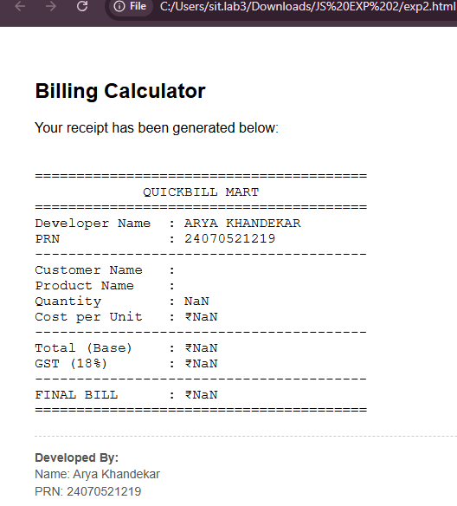
5. OUTPUT :

- CONCLUSION :
The experiment was successfully completed. I learned how to use var, let, and
const for declaring variables in JavaScript and understood their basic differences. This experiment also helped me understand the basic concepts of modern JavaScript.

CASE STUDY : 2

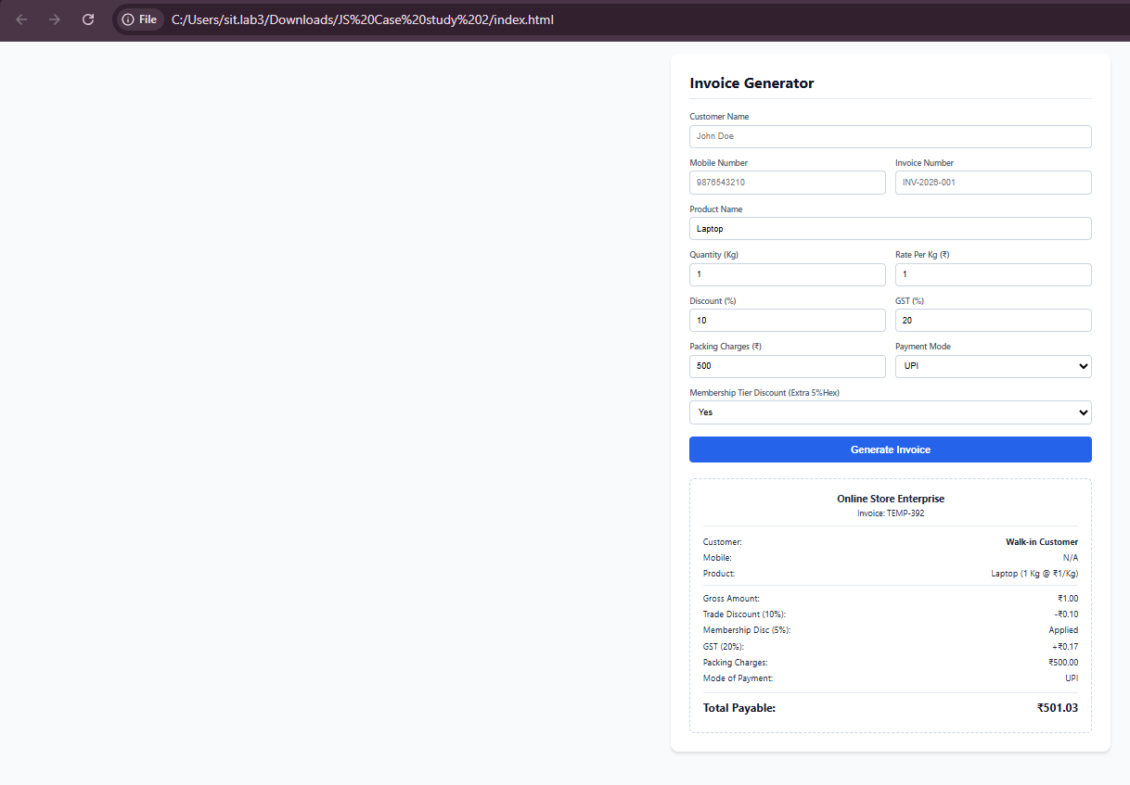
- OUTPUT

- CODE
- <!DOCTYPE html>
- <html lang="en">
- <head>
- <meta charset="UTF-8">
- <meta name="viewport" content="width=device-width, initial-scale=1.0">
- <title>Professional Billing System</title>
- <link rel="stylesheet" href="style.css">
- </head>
- <body>

- <div class="container">
- <h2>Invoice Generator</h2>
- <form id="billForm">
- <div class="grid">
- <div class="full-width">
- <label for="cname">Customer Name</label>
- <input type="text" id="cname" required placeholder="John Doe">
- </div>
- <div>
- <label for="mobile">Mobile Number</label>
- <input type="tel" id="mobile" required placeholder="9876543210">
- </div>
- <div>
- <label for="invoice">Invoice Number</label>
- <input type="text" id="invoice" placeholder="INV-2026-001">
- </div>
- <div class="full-width">
- <label for="product">Product Name</label>
- <input type="text" id="product" placeholder="Item description">
- </div>
- <div>
- <label for="qty">Quantity (Kg)</label>
- <input type="number" id="qty" min="0" step="any">
- </div>
- <div>
- <label for="rate">Rate Per Kg (₹)</label>
- <input type="number" id="rate" min="0" step="any">
- </div>
- <div>
- <label for="discount">Discount (%)</label>
- <input type="number" id="discount" min="0" max="100" value="0">
- </div>
- <div>
- <label for="gst">GST (%)</label>
- <input type="number" id="gst" min="0" max="100" value="0">
- </div>
- <div>
- <label for="packing">Packing Charges (₹)</label>
- <input type="number" id="packing" min="0" value="0">
- </div>
- <div>
- <label for="payment">Payment Mode</label>
- <select id="payment">
- <option>UPI</option>
- <option>Card</option>
- <option>Cash</option>
- </select>
- </div>
- <div class="full-width">
- <label for="member">Membership Tier Discount (Extra 5%Hex)</label>
- <select id="member">
- <option value="No">No</option>
- <option value="Yes">Yes</option>
- </select>
- </div>
- </div>
- <button type="button" onclick="calculateBill()">Generate Invoice</button>
- </form>

- <div id="result"></div>
- </div>

- <script src="script.js"></script>
- </body>
- </html>

EXPERIMENT NO : 3
- AIM : Implement control structures and form validation; create a grading system based on user-entered marks.

- SOFTWARE / TOOLS USED : HTML5 , CSS3, JavaScript, Visual Studio Code (VS Code), Google Chrome / Microsoft Edge Web Browser.

- THEORY : Control structures are an essential part of JavaScript programming that allow the execution of different statements based on specific conditions. Conditional statements such as if, else if, and else are commonly used to evaluate marks and assign grades accordingly.
Form validation is used to ensure that users enter valid information before processing the data. It checks whether all required fields are filled correctly and whether the entered marks fall within the valid range (0–100). This helps prevent incorrect or incomplete data from being processed.
In this experiment, an Academic Entry Portal is developed using HTML, CSS, and JavaScript. The application accepts the student's name, PRN number, and marks for five subjects. JavaScript validates the input, calculates the total marks, percentage, and assigns an appropriate grade using conditional statements. The system displays the final result only after successful validation, making the application reliable and user-friendly.
- CODE :
- <!DOCTYPE html>
- <html lang="en">
- <head>
- <title>Academic Entry Portal</title>
- <style>
- body {
- font-family: Arial, sans-serif;
- margin: 40px;
- display: flex;
- gap: 50px;
- }
- .portal-side {
- width: 350px;
- }
- .receipt-side {
- width: 400px;
- }
- .header-title {
- font-weight: bold;
- font-size: 1.1em;
- margin-bottom: 5px;
- }
- hr {
- border: 0;
- border-top: 2px solid #000;
- margin-bottom: 20px;
- }
- label {
- font-size: 0.9em;
- color: #333;
- display: block;
- margin-top: 10px;
- }
- input {
- width: 100%;
- padding: 6px;
- margin-top: 4px;
- box-sizing: border-box;
- border: 1px solid #ccc;
- }
- .btn-process {
- width: 100%;
- background-color: #000;
- color: white;
- padding: 10px;
- border: none;
- margin-top: 20px;
- cursor: pointer;
- font-weight: bold;
- letter-spacing: 1px;
- }
- .report-box {
- border: 1px solid #ccc;
- padding: 20px;
- margin-top: 20px;
- min-height: 250px;
- line-height: 1.6;
- }
- </style>
- </head>
- <body>

- <!-- LEFT SIDE: ACADEMIC ENTRY PORTAL -->
- <div class="portal-side">
- <div class="header-title">ACADEMIC ENTRY PORTAL</div>
- <hr>

- <label>Student Name</label>
- <input type="text" id="studentName" value="Arya Khandekar">

- <label>PRN Number</label>
- <input type="text" id="prnNumber" value="24070521219">

- <label>Subject 1 Marks (0-100)</label>
- <input type="number" id="sub1" value="77">

- <label>Subject 2 Marks (0-100)</label>
- <input type="number" id="sub2" value="80">

- <label>Subject 3 Marks (0-100)</label>
- <input type="number" id="sub3" value="95">

- <label>Subject 4 Marks (0-100)</label>
- <input type="number" id="sub4" value="78">

- <label>Subject 5 Marks (0-100)</label>
- <input type="number" id="sub5" value="90">

- <button class="btn-process" onclick="processResult()">PROCESS RESULT</button>
- </div>

- <!-- RIGHT SIDE: SYSTEM OUTPUT RECEIPT -->
- <div class="receipt-side">
- <div class="header-title">SYSTEM OUTPUT RECEIPT</div>
- <hr>

- <div class="report-box">
- <h3>STUDENT ACADEMIC REPORT</h3>

- <p>
- Student Name : <span id="outName">Arya Khandekar</span><br>
- PRN Number : <span id="outPrn">24070521219</span>
- </p>

- <p>
- Subject 1 : <span id="outSub1">77</span><br>
- Subject 2 : <span id="outSub2">80</span><br>
- Subject 3 : <span id="outSub3">95</span><br>
- Subject 4 : <span id="outSub4">78</span><br>
- Subject 5 : <span id="outSub5">90</span>
- </p>

- <p>
- <b>Total Marks :</b> <span id="outTotal">420</span>/500<br>
- <b>Percentage :</b> <span id="outPercentage">84.00</span>%<br>
- <b>Grade :</b> <span id="outGrade">A</span>
- </p>
- </div>
- </div>

- <script>
- function processResult() {
- // 1. Get input values from the left panel
- const name = document.getElementById("studentName").value;
- const prn = document.getElementById("prnNumber").value;

- const s1 = Number(document.getElementById("sub1").value);
- const s2 = Number(document.getElementById("sub2").value);
- const s3 = Number(document.getElementById("sub3").value);
- const s4 = Number(document.getElementById("sub4").value);
- const s5 = Number(document.getElementById("sub5").value);

- // 2. Perform Calculations
- const totalMarks = s1 + s2 + s3 + s4 + s5;
- const percentage = (totalMarks / 500) * 100;

- // 3. Determine Grade based on standard criteria
- let grade = "F";
- if (percentage >= 80) {
- grade = "A";
- } else if (percentage >= 60) {
- grade = "B";
- } else if (percentage >= 40) {
- grade = "C";
- }

- // 4. Update the right panel receipt output text
- document.getElementById("outName").innerText = name;
- document.getElementById("outPrn").innerText = prn;

- document.getElementById("outSub1").innerText = s1;
- document.getElementById("outSub2").innerText = s2;
- document.getElementById("outSub3").innerText = s3;
- document.getElementById("outSub4").innerText = s4;
- document.getElementById("outSub5").innerText = s5;

- document.getElementById("outTotal").innerText = totalMarks;
- document.getElementById("outPercentage").innerText = percentage.toFixed(2);
- document.getElementById("outGrade").innerText = grade;
- }
- </script>

- </body>
- </html>

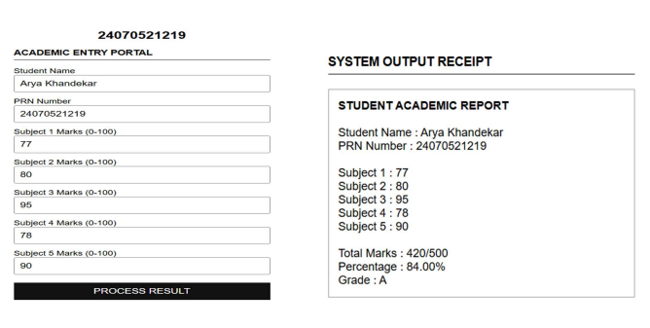
5. OUTPUT :
6. CONCLUSION :
The experiment was successfully implemented using HTML, CSS, and JavaScript. Form validation ensured that only valid student details and marks were accepted, while control structures were effectively used to calculate the total marks, percentage, and assign grades. The grading system demonstrates the practical use of conditional statements and input validation techniques for developing reliable and efficient web applications.

CASE STUDY : 3

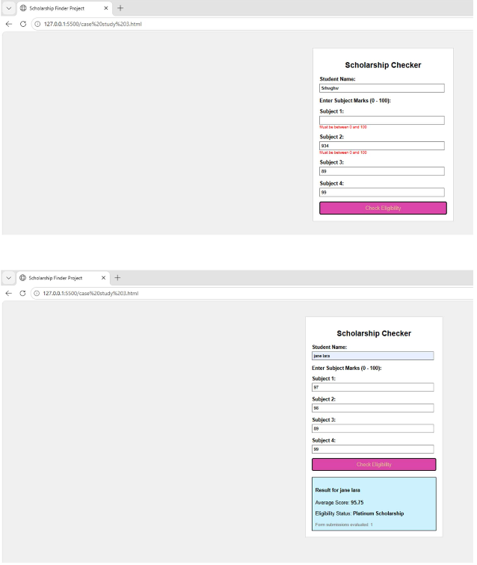
- OUTPUT

- CODE
- <!DOCTYPE html>
- <html>
- <head>
- <title>JS Practical - Multi-Subject Grading & Scholarship System</title>
- <style>
- body {
- font-family: Arial, sans-serif;
- max-width: 480px;
- margin: 30px auto;
- padding: 20px;
- border: 1px solid #ccc;
- border-radius: 8px;
- box-shadow: 0 4px 6px rgba(0, 0, 0, 0.1);
- }
- .form-group {
- margin-bottom: 15px;
- }
- label {
- display: block;
- margin-bottom: 4px;
- font-weight: bold;
- }
- input {
- width: 100%;
- padding: 8px;
- box-sizing: border-box;
- border: 1px solid #ccc;
- border-radius: 4px;
- outline: none;
- }
- /* Highlight invalid input fields */
- input.invalid-input {
- border: 2px solid #dc3545;
- background-color: #fff8f8;
- }
- /* Style inline error text under inputs */
- .field-error {
- color: #dc3545;
- font-size: 13px;
- margin-top: 4px;
- display: block;
- min-height: 18px;
- }
- button {
- width: 100%;
- padding: 10px;
- background-color: #007bff;
- color: white;
- border: none;
- border-radius: 4px;
- cursor: pointer;
- font-size: 16px;
- margin-top: 10px;
- }
- button:hover {
- background-color: #0056b3;
- }
- #result {
- margin-top: 20px;
- padding: 12px;
- border-radius: 4px;
- display: none;
- background-color: #d4edda;
- color: #155724;
- border: 1px solid #c3e6cb;
- }
- </style>
- </head>

- <body>

- <h2>Grading & Scholarship System</h2>

- <form id="gradingForm" onsubmit="calculateAverageGrade(event)" novalidate>
- <div class="form-group">
- <label for="studentName">Student Name:</label>
- <input type="text" id="studentName" placeholder="e.g. John Doe">
- <span class="field-error" id="nameError"></span>
- </div>

- <div class="form-group">
- <label for="math">Math Marks (0 - 100):</label>
- <input type="number" id="math" placeholder="e.g. 85">
- <span class="field-error" id="mathError"></span>
- </div>

- <div class="form-group">
- <label for="science">Science Marks (0 - 100):</label>
- <input type="number" id="science" placeholder="e.g. 90">
- <span class="field-error" id="scienceError"></span>
- </div>

- <div class="form-group">
- <label for="english">English Marks (0 - 100):</label>
- <input type="number" id="english" placeholder="e.g. 78">
- <span class="field-error" id="englishError"></span>
- </div>

- <button type="submit">Calculate Grade & Scholarship</button>
- </form>

- <div id="result"></div>

- <script>
- function calculateAverageGrade(event) {
- event.preventDefault();

- let isValid = true;

- // Reset previous result box
- const resultDiv = document.getElementById("result");
- resultDiv.style.display = "none";

- // Validation Helper Function
- function validateField(inputId, errorId, fieldName, isSubject = true) {
- const inputElement = document.getElementById(inputId);
- const errorElement = document.getElementById(errorId);
- const value = inputElement.value.trim();

- inputElement.classList.remove("invalid-input");
- errorElement.textContent = "";

- if (value === "") {
- inputElement.classList.add("invalid-input");
- errorElement.textContent = `Please enter ${fieldName}.`;
- isValid = false;
- return;
- }

- if (isSubject) {
- const score = parseFloat(value);
- if (isNaN(score) || score < 0 || score > 100) {
- inputElement.classList.add("invalid-input");
- errorElement.textContent = `Enter valid ${fieldName} (0–100).`;
- isValid = false;
- }
- }
- }

- // 1. Validate inputs
- validateField("studentName", "nameError", "student's name", false);
- validateField("math", "mathError", "Math marks", true);
- validateField("science", "scienceError", "Science marks", true);
- validateField("english", "englishError", "English marks", true);

- if (!isValid) return;

- // 2. Calculations
- const math = parseFloat(document.getElementById("math").value);
- const science = parseFloat(document.getElementById("science").value);
- const english = parseFloat(document.getElementById("english").value);
- const name = document.getElementById("studentName").value.trim();

- const totalMarks = math + science + english;
- const average = (totalMarks / 3).toFixed(2);

- let grade = "";
- let status = "";
- let scholarship = "";

- // Standard Grade Determination
- if (average >= 90) {
- grade = "A+"; status = "Passed with Distinction";
- } else if (average >= 80) {
- grade = "A"; status = "Passed";
- } else if (average >= 70) {
- grade = "B"; status = "Passed";
- } else if (average >= 60) {
- grade = "C"; status = "Passed";
- } else if (average >= 50) {
- grade = "D"; status = "Passed";
- } else {
- grade = "F"; status = "Failed";
- }

- // Task 1: Case Study Scholarship Eligibility Logic
- if (average >= 95) {
- scholarship = "Platinum Scholarship";
- } else if (average >= 85) {
- scholarship = "Gold Scholarship";
- } else if (average >= 70) {
- scholarship = "Silver Scholarship";
- } else if (average >= 50) {
- scholarship = "Bronze Scholarship";
- } else {
- scholarship = "Not Eligible";
- }

- // Display result summary including Scholarship Category
- resultDiv.style.display = "block";
- resultDiv.innerHTML = `
- <strong>Result Summary:</strong><br>
- Name: ${name}<br>
- Math: ${math} | Science: ${science} | English: ${english}<br>
- Total: ${totalMarks} / 300<br>
- Average: <strong>${average}%</strong><br>
- Overall Grade: <strong>${grade}</strong> (${status})<br>
- Scholarship Category: <strong>${scholarship}</strong>
- `;
- }
- </script>

- </body>
- </html>

EXPERIMENT NO : 4
- AIM : Use function types, scope, and closures; apply try-catch; build a palindrome checker.

- Software / Tools Used : HTML5 , CSS3, JavaScript, Visual Studio Code (VS Code), Google Chrome / Microsoft Edge Web Browser.

- Theory : JavaScript provides different types of functions such as function declarations, function expressions, and arrow functions. Functions help divide a program into smaller reusable blocks of code.
Scope defines the accessibility of variables in a program. JavaScript mainly has:
- Global Scope: Variables declared outside functions can be accessed
throughout the program.
- Local Scope: Variables declared inside a function can only be accessed within that function.
- Block Scope: Variables declared using let and const inside blocks like loops
or conditions are limited to that block.
A closure is a feature in JavaScript where an inner function remembers and can access variables from its outer function even after the outer function has finished execution. Closures are useful for data privacy and maintaining state. The try-catch statement is used for error handling in JavaScript. The code inside the try block is executed normally, and if an error occurs, the catch block handles the error without stopping the entire program. A palindrome is a word or number that remains the same when reversed. For example, "madam" and "121" are palindromes. A palindrome checker compares the original string with its reversed form to determine whether it is a palindrome.
- CODE :
- <!DOCTYPE html>
- <html lang="en">
- <head>
- <meta charset="UTF-8">
- <title>Palindrome Checker</title>
- <style>
- body {
- font-family: Arial, sans-serif;
- margin: 40px;
- line-height: 1.6;
- }
- h1 {
- font-size: 2em;
- margin-bottom: 20px;
- }
- .info {
- font-size: 1.1em;
- margin-bottom: 15px;
- }
- .input-container {
- margin-top: 20px;
- margin-bottom: 20px;
- }
- input {
- padding: 5px;
- font-size: 1em;
- width: 250px;
- }
- button {
- padding: 5px 15px;
- font-size: 1em;
- cursor: pointer;
- }
- #result {
- font-size: 1.1em;
- margin-top: 15px;
- }
- </style>
- </head>
- <body>

- <h1>Palindrome Checker</h1>

- <!-- Student Information Section -->
- <div class="info">
- Name: Arya Khandekar
- </div>
- <div class="info">
- PRN: 24070521219
- </div>

- <!-- Input Form area -->
- <div class="input-container">
- <input type="text" id="inputText" value="A">
- <button onclick="checkPalindrome()">Check</button>
- </div>

- <!-- Output message text -->
- <div id="result">A is a Palindrome</div>

- <script>
- function checkPalindrome() {
- // 1. Get the text from the input field
- const originalText = document.getElementById("inputText").value;

- // 2. Simple clean up: remove spaces and convert to lowercase for accurate checking
- const cleanText = originalText.replace(/[^A-Za-z0-9]/g, "").toLowerCase();

- // 3. Reverse the clean text
- const reversedText = cleanText.split("").reverse().join("");

- const resultDiv = document.getElementById("result");

- // 4. Handle blank inputs
- if (originalText.trim() === "") {
- resultDiv.innerText = "Please enter some text.";
- return;
- }

- // 5. Check if the original matches the reversed text
- if (cleanText === reversedText) {
- resultDiv.innerText = originalText + " is a Palindrome";
- } else {
- resultDiv.innerText = originalText + " is not a Palindrome";
- }
- }
- </script>

- </body>
- </html>

5. OUTPUT :
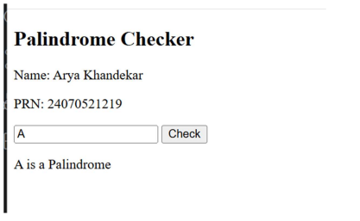
6. CONCLUSION :
In this experiment, we studied JavaScript function types, scope, and closures. We
implemented a palindrome checker using functions and handled possible errors using the try-catch statement. The program demonstrated how functions improve code reusability, how scope controls variable accessibility, and how closures preserve values from outer functions. This experiment helped in understanding important JavaScript concepts used in real-world programming.
CASE STUDY : 4

- OUTPUT
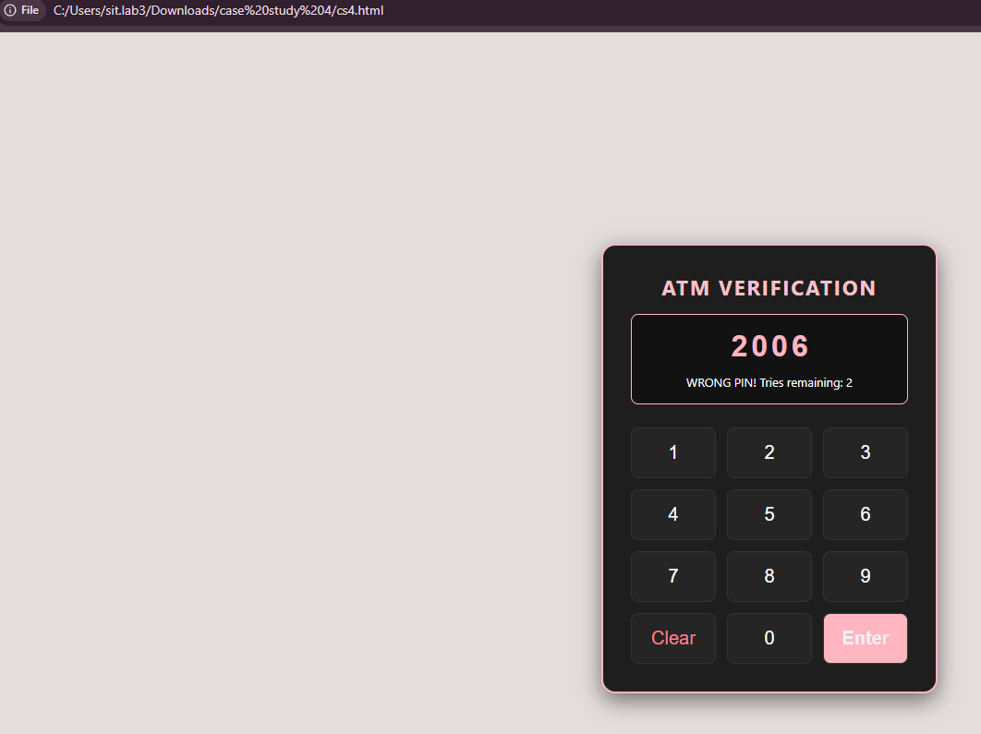
- CODE
- <!DOCTYPE html>
- <html>
- <head>
- <title>ATM</title>
- <link rel="stylesheet" href="cs4.css">
- </head>
- <body>

- <div class="atm-container">
- <h1>ATM VERIFICATION</h1>

- <div class="display-screen">

- <input type="text" id="pinInput" placeholder="----" readonly>
- <p id="statusText">Enter your PIN code</p>
- </div>

- <div class="buttons-grid">
- <button onclick="pressKey('1')">1</button>
- <button onclick="pressKey('2')">2</button>
- <button onclick="pressKey('3')">3</button>
- <button onclick="pressKey('4')">4</button>
- <button onclick="pressKey('5')">5</button>
- <button onclick="pressKey('6')">6</button>
- <button onclick="pressKey('7')">7</button>
- <button onclick="pressKey('8')">8</button>
- <button onclick="pressKey('9')">9</button>
- <button class="clear-btn" onclick="eraseAll()">Clear</button>
- <button onclick="pressKey('0')">0</button>
- <button class="enter-btn" onclick="verifyPIN()">Enter</button>
- </div>
- </div>

- <script src="cs4.js"></script>
- </body>
- </html>

EXPERIMENT – 5

- AIM : Apply array methods and object handling; create a cart total calculator with discount logic.

- SOFTWARE TOOLS REQUIRED : Visual Studio Code, Google Chrome, HTML5, CSS3, and JavaScript.

- THEORY :
Objects
An object is a standalone entity that stores data as key-value pairs. In an e-commerce context, a single product is represented as an object where keys like name, price, and quantity hold the product's specific details.
Arrays
An array is an ordered list used to store multiple values in a single variable. It allows you to group similar data types together, make it easy to track a collection of items sequentially using index numbers.
Arrays of Objects
An array of objects combines both structures by storing multiple objects inside a single array. This represents the shopping cart itself, where each element in the array is an object containing a specific product's data.
JavaScript array methods process this collection efficiently without manual loops:
- filter(): Separates specific items based on a condition.

- reduce(): Combines item costs into a single cart subtotal.

- Discount Logic: Uses conditional statements to subtract values if totals meet specific rules.

4. CODE :
<!DOCTYPE html>
<html lang="en">
<head>
<title>Shopping Cart Calculator</title>
</head>
<body>

<!-- Student Details Section -->
<div>
<p><b>Name:</b> Arya Khandekar</p>
<p><b>PRN:</b> 24070521219</p>
</div>
<hr>

<h2>Simple Shopping Cart</h2>

<!-- Input Form (One below the other using <br> tags) -->
<div>
<label>Item Name:</label><br>
<input type="text" id="itemName" placeholder="Enter item name"><br><br>

<label>Quantity:</label><br>
<input type="number" id="itemQty" placeholder="Enter quantity"><br><br>

<label>Price (₹):</label><br>
<input type="number" id="itemPrice" placeholder="Enter price"><br><br>

<button onclick="addItem()">Add to Cart</button>
</div>

<!-- Display area for items -->
<h4>Cart Items:</h4>
<ul id="itemList"></ul>

<!-- Display area for calculated totals -->
<div>
<p>Subtotal: ₹<span id="subtotal">0</span></p>
<p id="discountMsg" style="color: orange; font-weight: bold;"></p>
<h3>Final Total: ₹<span id="finalTotal">0</span></h3>
</div>

<script>
// 1. ARRAY: Create an empty array list to hold item objects
const cart = [];

// Function to handle adding items from inputs into our array
function addItem() {
const nameInput = document.getElementById("itemName").value;
const qtyInput = Number(document.getElementById("itemQty").value);
const priceInput = Number(document.getElementById("itemPrice").value);

// Simple validation check to ensure inputs are not blank
if (nameInput === "" || priceInput <= 0 || qtyInput <= 0) {
alert("Please enter valid item details.");
return;
}

// 2. OBJECTS: Bundle input values into a single item object
const itemObj = {
name: nameInput,
quantity: qtyInput,
price: priceInput
};

// Push the new item object into our cart array
cart.push(itemObj);

// Reset the input fields so they are ready for the next entry
document.getElementById("itemName").value = "";
document.getElementById("itemQty").value = "";
document.getElementById("itemPrice").value = "";

// Run calculations now that the data has changed
updateCartDisplay();
}

// Function to calculate totals using array methods and display them
function updateCartDisplay() {
const itemList = document.getElementById("itemList");
itemList.innerHTML = ""; // Clear out previous list text

// ARRAY METHOD: forEach() loops through cart array to build a text list
cart.forEach(item => {
const itemTotal = item.price * item.quantity;
itemList.innerHTML += `<li>${item.name} - ${item.quantity} x ₹${item.price} = ₹${itemTotal}</li>`;
});

// ARRAY METHOD: reduce() loops through array to sum up costs into subtotal variable
const subtotal = cart.reduce((accumulator, item) => {
return accumulator + (item.price * item.quantity);
}, 0);

// DISCOUNT LOGIC: Calculate a 10% discount if the subtotal passes ₹2000
let discount = 0;
const msg = document.getElementById("discountMsg");

if (subtotal > 2000) {
discount = subtotal * 0.10; // 10% calculation
msg.innerText = "10% Discount Applied!";
msg.style.color = "green";
} else {
msg.innerText = "No discount (Add items worth over ₹2000 for 10% off).";
msg.style.color = "orange";
}

const finalTotal = subtotal - discount;

// Print calculated data back onto screen tags
document.getElementById("subtotal").innerText = subtotal;
document.getElementById("finalTotal").innerText = finalTotal;
}
</script>

</body>
</html>

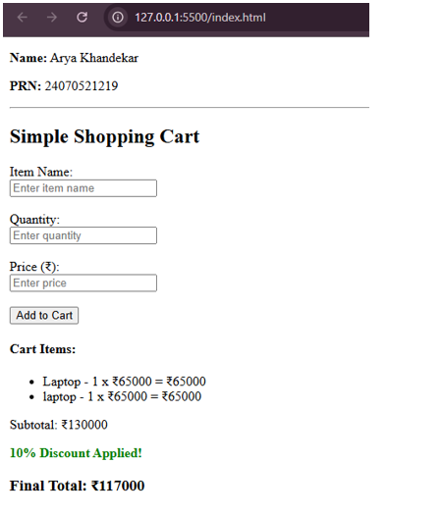
5. OUTPUT
6. CONCLUSION :
By completing this experiment, the practical application of JavaScript array methods (reduce, filter, map) and object manipulation was successfully demonstrated. Encapsulating product data within objects allows for scalable data management, while array methods streamline complex calculations like totals and discounts. This forms the foundational logic required for modern e-commerce web applications.

CASE STUDY – 5

- OUTPUT
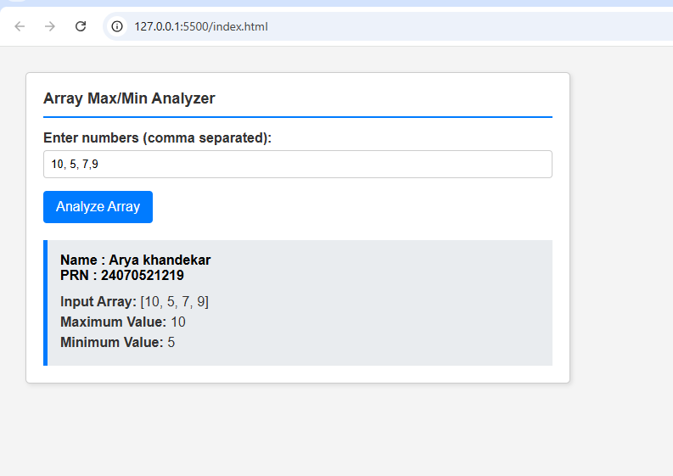
- CODE
- <!DOCTYPE html>
- <html lang="en">
- <head>
- <meta charset="UTF-8">
- <meta name="viewport" content="width=device-width, initial-scale=1.0">
- <title>Array Analysis - Arya Khandekar</title>
- <style>
- body {
- font-family: Arial, sans-serif;
- background-color: #f4f4f4;
- margin: 0;
- padding: 20px;
- color: #333;
- }

- .container {
- background-color: white;
- padding: 20px;
- border: 1px solid #ccc;
- border-radius: 5px;
- width: 90%;
- max-width: 600px;
- /* Positioned to the top-left to leave room for the browser address bar */
- margin-top: 10px;
- margin-left: 10px;
- box-shadow: 2px 2px 5px rgba(0,0,0,0.1);
- }

- h2 {
- margin-top: 0;
- font-size: 18px;
- border-bottom: 2px solid #007bff;
- padding-bottom: 10px;
- }

- .input-group {
- margin-bottom: 15px;
- }

- label {
- display: block;
- margin-bottom: 5px;
- font-weight: bold;
- }

- input[type="text"] {
- width: 100%;
- padding: 8px;
- border: 1px solid #ccc;
- border-radius: 4px;
- box-sizing: border-box; /* Ensures padding doesn't affect width */
- }

- button {
- background-color: #007bff;
- color: white;
- border: none;
- padding: 10px 15px;
- border-radius: 4px;
- cursor: pointer;
- font-size: 16px;
- }

- button:hover {
- background-color: #0056b3;
- }

- #output {
- margin-top: 20px;
- padding: 15px;
- background-color: #e9ecef;
- border-left: 5px solid #007bff;
- display: none; /* Hidden by default */
- }

- .student-info {
- font-weight: bold;
- margin-bottom: 10px;
- color: #000;
- }

- .result-text {
- font-size: 16px;
- line-height: 1.5;
- }
- </style>
- </head>
- <body>

- <div class="container">
- <h2>Array Max/Min Analyzer</h2>

- <div class="input-group">
- <label for="arrayInput">Enter numbers (comma separated):</label>
- <input type="text" id="arrayInput" placeholder="e.g., 10, 5, 23, 1, 99">
- </div>

- <button onclick="analyzeArray()">Analyze Array</button>

- <div id="output">
- <div class="student-info">
- Name : Arya khandekar<br>
- PRN : 24070521219
- </div>
- <div class="result-text" id="resultDetails"></div>
- </div>
- </div>

- <script>
- function analyzeArray() {
- // Get input value
- const inputStr = document.getElementById('arrayInput').value;
- const outputDiv = document.getElementById('output');
- const resultDetails = document.getElementById('resultDetails');

- // Validate input
- if (!inputStr.trim()) {
- alert("Please enter some numbers.");
- return;
- }

- // Convert string to array of numbers
- // split by comma, trim whitespace, and convert to Number
- const numbers = inputStr.split(',')
- .map(item => item.trim())
- .filter(item => item !== '') // remove empty strings
- .map(Number);

- // Check for invalid numbers
- if (numbers.some(isNaN)) {
- alert("Invalid input. Please enter only numbers separated by commas.");
- return;
- }

- // Initialize max and min with the first element
- let maxVal = numbers[0];
- let minVal = numbers[0];

- // Loop through the array to find max and min
- for (let i = 1; i < numbers.length; i++) {
- if (numbers[i] > maxVal) {
- maxVal = numbers[i];
- }
- if (numbers[i] < minVal) {
- minVal = numbers[i];
- }
- }

- // Display results
- resultDetails.innerHTML = `
- <strong>Input Array:</strong> [${numbers.join(', ')}]<br>
- <strong>Maximum Value:</strong> ${maxVal}<br>
- <strong>Minimum Value:</strong> ${minVal}
- `;

- // Show the output box
- outputDiv.style.display = 'block';
- }
- </script>

- </body>
- </html>

EXPERIEMENT NO – 6

1. AIM – Use string functions and regex for email validation, data extraction, and text analysis.
2. THEORY –
JavaScript provides built-in mechanisms to manipulate, validate, and analyze text through String methods and Regular Expressions (Regex). This experiment combines both to parse an unstructured sentence, isolate specific patterns, and compute text metrics.
1. Regular Expressions for Data Extraction
- Pattern Matching: A regular expression (Regex) is an object that describes a sequence of characters used for pattern search.
- The match() Method: Unlike test() which only returns a true/false validation check, the String.prototype.match() method searches a string for a match against a regular expression and extracts the actual data into an array.
- Email Extraction Formula: The code uses the regex /[a-zA-Z0-9._%+-]+@[a-zA-Z0-9.-]+\.[a-zA-Z]{2,}/g.
  - [a-zA-Z0-9._%+-]+ captures the username.
  - @ ensures the presence of the mandatory domain separator.
  - \.[a-zA-Z]{2,} matches the dot followed by a top-level domain extension (like .com or .edu).
  - The global flag /g ensures that the engine scans the entire sentence rather than stopping at the first character match.

2. Native String Functions for Text Analysis
- Case Transformations: toUpperCase() and toLowerCase() are native string methods that convert every character in a string to its respective case representation without altering the original immutable string.
- Property Measurement: The .length property evaluates the string to return the precise count of characters, including whitespace and punctuation marks.
- Text Splitting: The split(/\s+/) function breaks down a sentence into an array of substrings using spaces as delimiters. Measuring the length of this resulting array provides an accurate total word count.
3. CODE
<!DOCTYPE html>
<html lang="en">
<head>
<meta charset="UTF-8">
<meta name="viewport" content="width=device-width, initial-scale=1.0">
<title>JavaScript String & Regex Lab</title>
<style>
/* Compact layout forced to top-left corner for easy URL + Output screenshot */
body {
font-family: Arial, sans-serif;
margin: 0;
padding: 10px;
background-color: #f4f4f9;
color: #333;
}
.container {
width: 460px;
background: white;
padding: 15px;
border-radius: 6px;
box-shadow: 0 2px 5px rgba(0,0,0,0.1);
margin: 0;
}
.student-info {
background-color: #e9ecef;
padding: 8px 12px;
border-radius: 4px;
margin-bottom: 12px;
border: 1px solid #ced4da;
}
.student-info p {
margin: 2px 0;
font-size: 14px;
font-weight: bold;
color: #495057;
}
h2 {
font-size: 16px;
margin: 5px 0 12px 0;
text-transform: uppercase;
border-bottom: 2px solid #007BFF;
padding-bottom: 5px;
}
label {
font-size: 13px;
font-weight: bold;
}
textarea {
width: 100%;
padding: 8px;
margin-top: 5px;
margin-bottom: 10px;
box-sizing: border-box;
border: 1px solid #ccc;
border-radius: 4px;
font-size: 13px;
resize: none;
}
button {
width: 100%;
padding: 10px;
background-color: #007BFF;
color: white;
border: none;
border-radius: 4px;
cursor: pointer;
font-weight: bold;
font-size: 14px;
}
button:hover {
background-color: #0056b3;
}
.result-box {
margin-top: 15px;
background: #eef8ff;
padding: 12px;
border-left: 4px solid #007BFF;
border-radius: 4px;
}
.result-line {
font-size: 13px;
margin: 6px 0;
line-height: 1.4;
word-break: break-all;
}
.label-title {
font-weight: bold;
color: #111;
}
</style>
</head>
<body>

<div class="container">
<!-- Student Details Banner -->
<div class="student-info">
<p>Name: Arya Khandekar</p>
<p>PRN: 24070521219</p>
</div>

<h2>Text Analysis & Regex Extraction</h2>

<!-- Input Form Area -->
<label for="textInput">Enter your sentence/paragraph below:</label>
<textarea id="textInput" rows="4" placeholder="Example: Hello! Send the report to arya.k@domain.com by tonight. Thanks!"></textarea>

<button onclick="processText()">Analyze & Extract Data</button>

<!-- Consolidated Output Area -->
<div class="result-box">
<div class="result-line"><span class="label-title">1. Extracted Email:</span> <span id="emailOut">-</span></div>
<div class="result-line"><span class="label-title">2. Text Length:</span> <span id="lengthOut">0 characters</span></div>
<div class="result-line"><span class="label-title">3. Word Count:</span> <span id="wordOut">0 words</span></div>
<div class="result-line"><span class="label-title">4. Uppercase Format:</span> <span id="upperOut">-</span></div>
<div class="result-line"><span class="label-title">5. Lowercase Format:</span> <span id="lowerOut">-</span></div>
</div>
</div>

<script>
function processText() {
// Read original raw string
const rawText = document.getElementById('textInput').value;
const trimmedText = rawText.trim();

// --- REGEX TASK: Email Validation & Extraction ---
// Global pattern to find an email structure inside a sentence
const emailRegex = /[a-zA-Z0-9._%+-]+@[a-zA-Z0-9.-]+\.[a-zA-Z]{2,}/g;
const foundEmails = trimmedText.match(emailRegex);

if (foundEmails && foundEmails.length > 0) {
document.getElementById('emailOut').innerText = "✅ " + foundEmails.join(", ");
} else {
document.getElementById('emailOut').innerText = "❌ No valid email address found.";
}

// --- STRING FUNCTIONS TASK: Text Analysis ---
// 1. Text Length calculation
const textLength = rawText.length;
document.getElementById('lengthOut').innerText = textLength + " characters";

// 2. Word Count parsing via split()
const wordsArray = trimmedText.split(/\s+/);
const wordCount = trimmedText === "" ? 0 : wordsArray.length;
document.getElementById('wordOut').innerText = wordCount + " words";

// 3. Case Transformations
const uppercaseText = rawText.toUpperCase();
const lowercaseText = rawText.toLowerCase();

document.getElementById('upperOut').innerText = uppercaseText || "-";
document.getElementById('lowerOut').innerText = lowercaseText || "-";
}
</script>

</body>
</html>

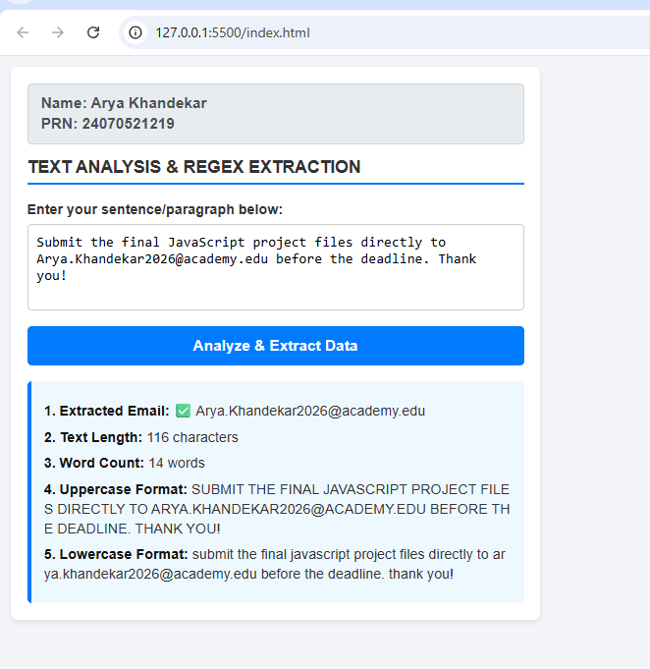
4. OUTPUT –

5. CONCLUSION –
By completing this experiment, we successfully engineered a JavaScript utility capable of advanced text processing and data extraction. We demonstrated that while native string functions (length, split(), toUpperCase(), and toLowerCase()) are highly effective for structural analysis and basic case transformations, combining them with regular expressions (match()) allows for intelligent data extraction from unstructured conversational text. The experiment successfully fulfilled all its objectives by seamlessly identifying valid email addresses from within user-provided sentences and instantly calculating text metadata.

CASE STUDY – 6
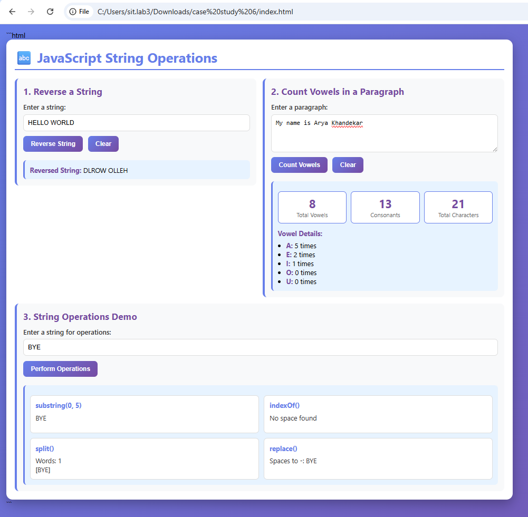
    - OUTPUT

    - CODE

<!DOCTYPE html>
<html lang="en">
<head>
<meta charset="UTF-8">
<meta name="viewport" content="width=device-width, initial-scale=1.0">
<title>JavaScript String Operations</title>

<style>
* {
margin: 0;
padding: 0;
box-sizing: border-box;
}

body {
font-family: 'Segoe UI', Tahoma, Geneva, Verdana, sans-serif;
background: linear-gradient(135deg, #667eea 0%, #764ba2 100%);
min-height: 100vh;
padding: 15px;
}

.container {
width: 100%;
max-width: 1200px;
margin: 0;
background: white;
border-radius: 15px;
box-shadow: 0 10px 30px rgba(0, 0, 0, 0.3);
padding: 20px;

display: grid;
grid-template-columns: 1fr 1fr;
gap: 15px;
align-items: start;
}

h1 {
grid-column: 1 / -1;
text-align: left;
color: #667eea;
margin-bottom: 5px;
font-size: 2em;
border-bottom: 3px solid #667eea;
padding-bottom: 8px;
}

.section {
padding: 15px;
background: #f8f9fa;
border-radius: 10px;
border-left: 5px solid #667eea;
}

.section:last-child {
grid-column: 1 / -1;
}

.section h2 {
color: #764ba2;
margin-bottom: 12px;
font-size: 1.35em;
}

label {
display: block;
margin-bottom: 7px;
color: #333;
font-weight: 600;
}

input[type="text"],
textarea {
width: 100%;
padding: 10px;
border: 2px solid #ddd;
border-radius: 8px;
font-size: 15px;
margin-bottom: 12px;
transition: border-color 0.3s;
}

input[type="text"]:focus,
textarea:focus {
outline: none;
border-color: #667eea;
}

textarea {
resize: vertical;
min-height: 90px;
}

button {
background: linear-gradient(135deg, #667eea 0%, #764ba2 100%);
color: white;
border: none;
padding: 10px 18px;
border-radius: 8px;
cursor: pointer;
font-size: 15px;
font-weight: 600;
margin-right: 7px;
margin-bottom: 8px;
transition: transform 0.2s, box-shadow 0.2s;
}

button:hover {
transform: translateY(-2px);
box-shadow: 0 5px 15px rgba(102, 126, 234, 0.4);
}

button:active {
transform: translateY(0);
}

.result {
margin-top: 12px;
padding: 12px;
background: #e7f3ff;
border-radius: 8px;
border-left: 4px solid #667eea;
display: none;
word-wrap: break-word;
}

.result.show {
display: block;
animation: fadeIn 0.5s;
}

.result strong {
color: #764ba2;
}

.string-operations {
display: grid;
grid-template-columns: 1fr 1fr;
gap: 12px;
margin-top: 12px;
}

.operation-box {
background: white;
padding: 12px;
min-height: 90px;
border-radius: 8px;
border: 2px solid #ddd;
}

.operation-box h3 {
color: #667eea;
margin-bottom: 8px;
font-size: 1em;
}

.operation-box p {
white-space: pre-wrap;
word-break: break-word;
color: #333;
}

@keyframes fadeIn {
from {
opacity: 0;
transform: translateY(-10px);
}

to {
opacity: 1;
transform: translateY(0);
}
}

.stats {
display: flex;
gap: 10px;
flex-wrap: wrap;
margin-top: 12px;
}

.stat-item {
background: white;
padding: 10px 15px;
border-radius: 8px;
border: 2px solid #667eea;
text-align: center;
flex: 1;
min-width: 100px;
}

.stat-item .number {
font-size: 1.7em;
font-weight: bold;
color: #764ba2;
}

.stat-item .label {
color: #666;
font-size: 0.85em;
}

@media (max-width: 800px) {
.container {
grid-template-columns: 1fr;
}

h1,
.section:last-child {
grid-column: auto;
}

.string-operations {
grid-template-columns: 1fr;
}
}
</style>
</head>

<body>

<div class="container">

<h1>🔤 JavaScript String Operations</h1>

<div class="section">
<h2>1. Reverse a String</h2>

<label for="inputString">Enter a string:</label>

<input
type="text"
id="inputString"
placeholder="Type something to reverse..."
>

<button onclick="reverseString()">Reverse String</button>
<button onclick="clearReverse()">Clear</button>

<div id="reverseResult" class="result">
<strong>Reversed String:</strong>
<span id="reversedText"></span>
</div>
</div>

<div class="section">
<h2>2. Count Vowels in a Paragraph</h2>

<label for="paragraph">Enter a paragraph:</label>

<textarea
id="paragraph"
placeholder="Type or paste your paragraph here..."
></textarea>

<button onclick="countVowels()">Count Vowels</button>
<button onclick="clearVowels()">Clear</button>

<div id="vowelResult" class="result">

<div class="stats">
<div class="stat-item">
<div class="number" id="totalVowels">0</div>
<div class="label">Total Vowels</div>
</div>

<div class="stat-item">
<div class="number" id="totalConsonants">0</div>
<div class="label">Consonants</div>
</div>

<div class="stat-item">
<div class="number" id="totalChars">0</div>
<div class="label">Total Characters</div>
</div>
</div>

<div style="margin-top: 12px;">
<strong>Vowel Details:</strong>
<br>
<span id="vowelDetails"></span>
</div>
</div>
</div>

<div class="section">
<h2>3. String Operations Demo</h2>

<label for="demoString">Enter a string for operations:</label>

<input
type="text"
id="demoString"
placeholder="Enter text to demonstrate operations..."
>

<button onclick="performOperations()">
Perform Operations
</button>

<div id="operationsResult" class="result">

<div class="string-operations">

<div class="operation-box">
<h3>substring(0, 5)</h3>
<p id="substringResult">-</p>
</div>

<div class="operation-box">
<h3>indexOf()</h3>
<p id="indexOfResult">-</p>
</div>

<div class="operation-box">
<h3>split()</h3>
<p id="splitResult">-</p>
</div>

<div class="operation-box">
<h3>replace()</h3>
<p id="replaceResult">-</p>
</div>

</div>
</div>
</div>

</div>

<script>
function reverseString() {
const input = document.getElementById("inputString").value;

if (input.trim() === "") {
alert("Please enter a string first!");
return;
}

const reversed = input
.split("")
.reverse()
.join("");

document.getElementById("reversedText").textContent = reversed;

document
.getElementById("reverseResult")
.classList.add("show");
}

function clearReverse() {
document.getElementById("inputString").value = "";

document
.getElementById("reverseResult")
.classList.remove("show");
}

function countVowels() {
const text = document.getElementById("paragraph").value;

if (text.trim() === "") {
alert("Please enter a paragraph first!");
return;
}

const vowels =
text.match(/[aeiouAEIOU]/g) || [];

const consonants =
text.match(
/[bcdfghjklmnpqrstvwxyzBCDFGHJKLMNPQRSTVWXYZ]/g
) || [];

const totalChars =
text.replace(/\s/g, "").length;

document.getElementById("totalVowels").textContent =
vowels.length;

document.getElementById("totalConsonants").textContent =
consonants.length;

document.getElementById("totalChars").textContent =
totalChars;

const vowelCount = {
a: 0,
e: 0,
i: 0,
o: 0,
u: 0
};

text.toLowerCase().split("").forEach(function (char) {
if (Object.prototype.hasOwnProperty.call(vowelCount, char)) {
vowelCount[char]++;
}
});

let details =
'<ul style="margin-top: 8px; padding-left: 20px;">';

for (let vowel in vowelCount) {
details +=
"<li><strong>" +
vowel.toUpperCase() +
":</strong> " +
vowelCount[vowel] +
" times</li>";
}

details += "</ul>";

document.getElementById("vowelDetails").innerHTML =
details;

document
.getElementById("vowelResult")
.classList.add("show");
}

function clearVowels() {
document.getElementById("paragraph").value = "";

document
.getElementById("vowelResult")
.classList.remove("show");
}

function performOperations() {
const str =
document.getElementById("demoString").value;

if (str.trim() === "") {
alert("Please enter a string first!");
return;
}

const substringValue =
str.substring(0, 5);

document.getElementById("substringResult").textContent =
substringValue;

const spaceIndex =
str.indexOf(" ");

document.getElementById("indexOfResult").textContent =
spaceIndex !== -1
? "First space at position: " + spaceIndex
: "No space found";

const words =
str.split(" ");

document.getElementById("splitResult").textContent =
"Words: " +
words.length +
"\n[" +
words.join(", ") +
"]";

const replaced =
str.replace(/\s/g, "-");

document.getElementById("replaceResult").textContent =
"Spaces to -: " +
replaced;

document
.getElementById("operationsResult")
.classList.add("show");
}
</script>

</body>
</html>

EXPERIMENT NO – 7

  - AIM - Perform DOM traversal and updates; develop a to-do list app with add, edit, and delete features.

  - SOFTWARE REQUIRED - Visual Studio Code, Web Browser (Google Chrome), HTML, CSS, JavaScript, Live Server extension.

  - THEORY –

• DOM Structure: The Document Object Model (DOM) treats HTML as a tree structure of nodes. JavaScript manipulates these nodes to update web content dynamically without a page reload.

• Node Manipulation & Creation: Methods like document.createElement('li') generate new components in memory. Methods like appendChild() inject the item into the list, while removeChild() targets and deletes it.

• DOM Traversal: Involves navigating relationships between parent and child elements. The source code utilizes this by referencing the parent wrapper (#task-list) to safely update or clear specific child elements .

• Event Handling: The code uses addEventListener('click', ...) on the main "Add" button and inline onclick functions on checkboxes, edit buttons, and delete buttons to trigger real-time updates based on user actions.

• String Manipulation and Input Validation: The code implements the .trim() method on user inputs to remove leading and trailing spaces. This ensures that blank or empty strings are not injected into the DOM tree as valid tasks.

  - CODE –
<!DOCTYPE html>
<html lang="en">
<head>
<meta charset="UTF-8" />
<meta name="viewport" content="width=device-width, initial-scale=1.0"/>
<title>DOM Traversal To-Do List</title>
<style>
body {
display: block; /* Overridden flex to force left alignment */
margin: 50px 0 0 50px; /* Positions app on the far left for easy file path screenshots */
background-color: #e0f7fa;
font-family: 'Segoe UI', Tahoma, Geneva, Verdana, sans-serif;
}
.container {
background-color: #ffffff;
padding: 30px;
border-radius: 12px;
box-shadow: 0 4px 15px rgba(0,0,0,0.2);
width: 420px;
}
h1 {
text-align: left;
margin-bottom: 5px;
font-size: 26px;
color: #006064;
}
/* Student credentials header styling */
.credentials {
font-size: 14px;
color: #00838f;
margin-bottom: 25px;
border-bottom: 2px dashed #0097a7;
padding-bottom: 10px;
font-weight: bold;
}
#task-input {
width: calc(100% - 100px);
padding: 10px;
font-size: 16px;
border: 1px solid #0097a7;
border-radius: 4px;
outline: none;
}
#add-btn {
padding: 10px 20px;
margin-left: 10px;
background-color: #00bcd4;
color: white;
border: none;
border-radius: 4px;
cursor: pointer;
font-size: 16px;
transition: background-color 0.3s;
}
#add-btn:hover {
background-color: #0097a7;
}
ul {
list-style: none;
padding: 0;
margin-top: 20px;
}
li {
display: flex;
align-items: center;
justify-content: space-between;
background-color: #f1f8e9;
padding: 10px 15px;
margin-bottom: 10px;
border-radius: 8px;
box-shadow: inset 0 0 3px rgba(0,0,0,0.1);
}
.task-text {
flex: 1;
font-size: 16px;
}
.done {
text-decoration: line-through;
color: #757575;
}
input[type="checkbox"] {
margin-right: 10px;
}
.buttons {
display: flex;
gap: 8px;
}
.btn {
padding: 5px 10px;
border: none;
border-radius: 4px;
cursor: pointer;
font-size: 14px;
transition: background-color 0.3s;
}
.edit-btn {
background-color: #ffb74d;
color: white;
}
.edit-btn:hover {
background-color: #ffa000;
}
.delete-btn {
background-color: #e57373;
color: white;
}
.delete-btn:hover {
background-color: #c62828;
}
</style>
</head>
<body>
<div class="container">
<h1>To-Do List</h1>
<!-- Student verification details permanently rendered here -->
<div class="credentials">
Name: Arya Khandekar <br>
PRN: 24070521219
</div>

<div style="display:flex; margin-bottom:20px;">
<input type="text" id="task-input" placeholder="Enter a task" />
<button id="add-btn">Add</button>
</div>
<ul id="task-list"></ul>
</div>

<script>
const taskInput = document.getElementById('task-input');
const addBtn = document.getElementById('add-btn');
const taskList = document.getElementById('task-list');

// Execute Add feature using DOM tree insertions
addBtn.addEventListener('click', () => {
const taskText = taskInput.value.trim();
if (taskText === '') return;

const li = document.createElement('li');

// Dynamic Checkbox Generation
const checkbox = document.createElement('input');
checkbox.type = 'checkbox';

// Dynamic Text Span Generation
const span = document.createElement('span');
span.className = 'task-text';
span.textContent = taskText;

// DOM Event handling for status update toggle
checkbox.onclick = () => {
if (checkbox.checked) {
span.classList.add('done');
} else {
span.classList.remove('done');
}
};

// Dynamic functional button nodes
const btnsDiv = document.createElement('div');
btnsDiv.className = 'buttons';

const editBtn = document.createElement('button');
editBtn.className = 'btn edit-btn';
editBtn.textContent = 'Edit';

const deleteBtn = document.createElement('button');
deleteBtn.className = 'btn delete-btn';
deleteBtn.textContent = 'Delete';

// DOM Traversal & Update: Modify target element value directly
editBtn.onclick = () => {
const newTask = prompt('Edit task:', span.textContent);
if (newTask !== null && newTask.trim() !== '') {
span.textContent = newTask.trim();
}
};

// DOM Node Removal: Target explicit structural node deletion
deleteBtn.onclick = () => {
taskList.removeChild(li);
};

// Complete standard node linkage structure assembly
btnsDiv.appendChild(editBtn);
btnsDiv.appendChild(deleteBtn);

li.appendChild(checkbox);
li.appendChild(span);
li.appendChild(btnsDiv);

// Final append update to existing visible DOM
taskList.appendChild(li);
taskInput.value = '';
});

// Add task mapping confirmation with Enter key support
taskInput.addEventListener('keypress', (e) => {
if (e.key === 'Enter') {
addBtn.click();
}
});
</script>
</body>
</html>

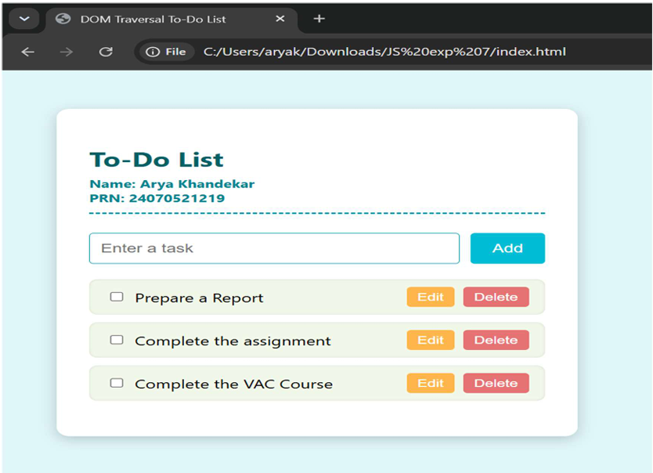
  - OUTPUT –

  - CONCLUSION –
We successfully developed and verified a functional to-do list application using client-side JavaScript DOM manipulation. The experiment confirms that dynamic element creation, state modification, and node removal can be managed entirely through the DOM tree structure. By linking input triggers directly to layout trees, the interface updates instantly in response to real-time user inputs like adding, editing, and deleting items. This process demonstrates that full application interactivity can be achieved cleanly on the front end without requiring external databases or server reloads.

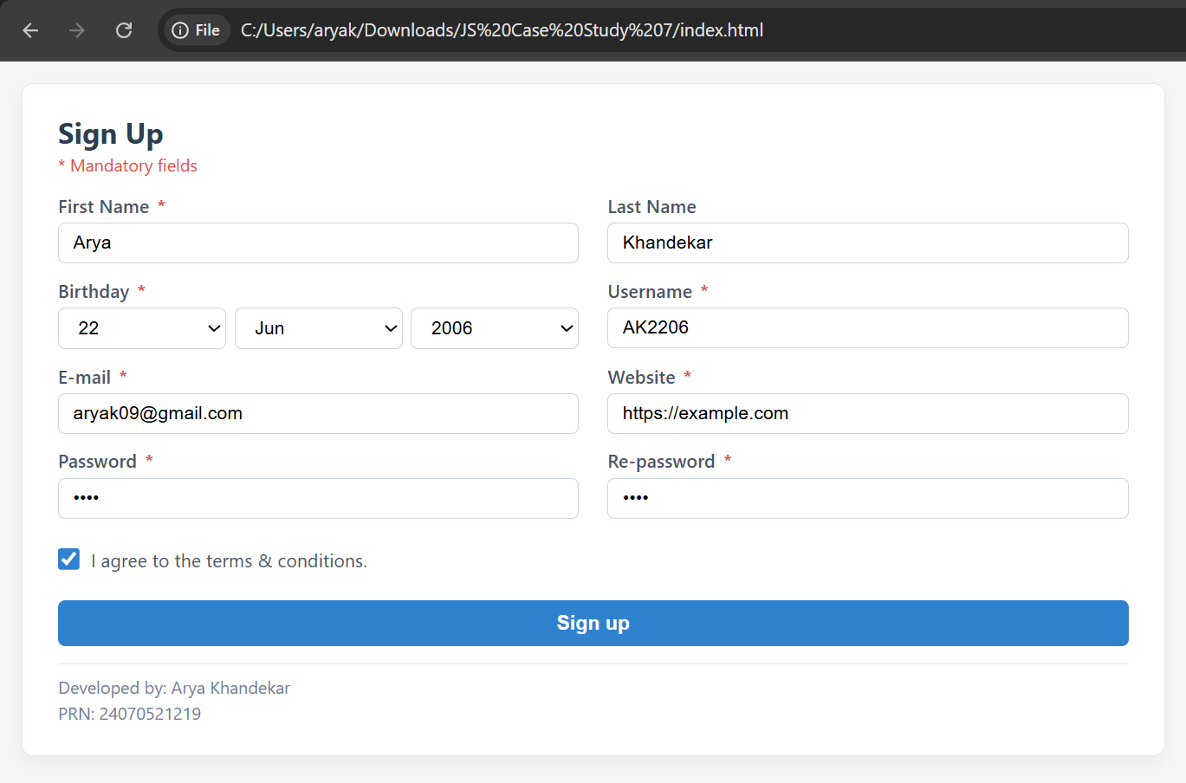
CASE STUDY – 7
    - OUTPUT

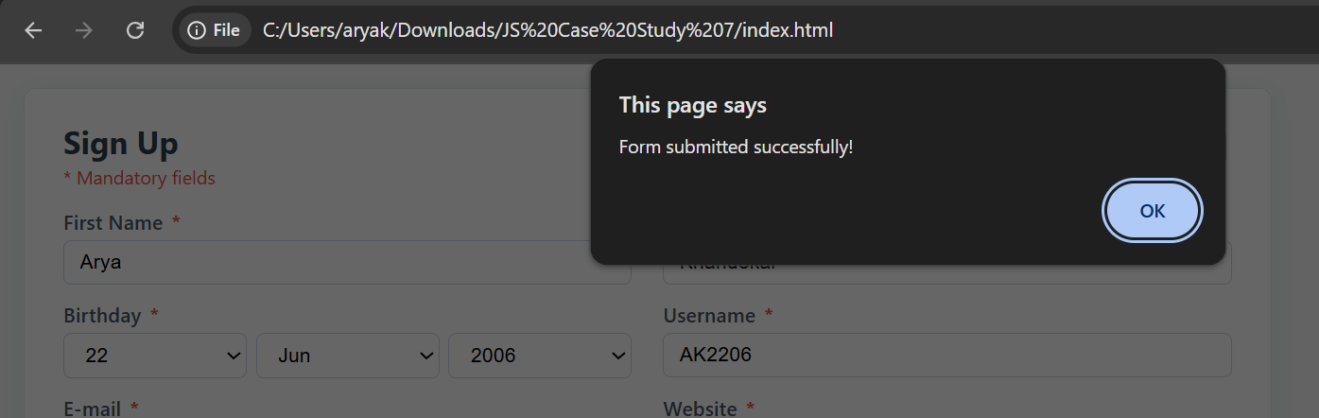

2. CODE
<!DOCTYPE html>
<html lang="en">
<head>
<meta charset="UTF-8">
<meta name="viewport" content="width=device-width, initial-scale=1.0">
<title>Form Handling with JavaScript</title>
<style>
* {
box-sizing: border-box;
margin: 0;
padding: 0;
}

body {
font-family: 'Segoe UI', Tahoma, Geneva, Verdana, sans-serif;
background-color: #f4f7f6;
color: #333;
padding: 15px;
display: flex;
justify-content: flex-start;
align-items: flex-start;
}

.form-container {
background: #ffffff;
border: 1px solid #e2e8f0;
border-radius: 8px;
box-shadow: 0 4px 12px rgba(0, 0, 0, 0.05);
width: 100%;
max-width: 800px; /* Broader width to fit everything in one view */
padding: 20px 25px;
text-align: left;
}

h2 {
margin-bottom: 2px;
color: #2c3e50;
font-size: 20px;
text-align: left;
}

.mandatory-note {
color: #e74c3c;
font-size: 12px;
margin-bottom: 12px;
text-align: left;
}

/* 2-column grid layout for a compact vertical footprint */
.form-grid {
display: grid;
grid-template-columns: 1fr 1fr;
gap: 10px 20px;
}

.form-row {
display: flex;
flex-direction: column;
text-align: left;
}

.form-row label {
font-size: 13px;
font-weight: 600;
margin-bottom: 4px;
color: #4a5568;
text-align: left;
}

.input-field, .date-selects select {
width: 100%;
padding: 6px 10px;
border: 1px solid #cbd5e0;
border-radius: 5px;
font-size: 13px;
transition: all 0.2s ease-in-out;
}

.date-selects {
display: flex;
gap: 6px;
}

.date-selects select {
flex: 1;
background-color: #fff;
}

.asterisk {
color: #e74c3c;
font-weight: bold;
margin-left: 2px;
}

.full-width {
grid-column: span 2;
}

.checkbox-row {
display: flex;
align-items: center;
margin: 10px 0;
text-align: left;
}

.checkbox-row input[type="checkbox"] {
width: 15px;
height: 15px;
cursor: pointer;
accent-color: #3182ce;
}

.checkbox-row label {
margin-left: 8px;
font-size: 13px;
color: #4a5568;
cursor: pointer;
}

.submit-btn {
width: 100%;
padding: 8px;
background-color: #3182ce;
color: #ffffff;
border: none;
border-radius: 5px;
font-size: 14px;
font-weight: bold;
cursor: pointer;
transition: background-color 0.2s ease-in-out;
}

.submit-btn:hover {
background-color: #2b6cb0;
}

/* Focus styling */
input:focus, select:focus {
outline: none;
border-color: #3182ce;
box-shadow: 0 0 0 2px rgba(49, 130, 206, 0.2);
}

/* Footer Credits */
.developer-credits {
margin-top: 12px;
text-align: left;
font-size: 12px;
color: #718096;
border-top: 1px solid #e2e8f0;
padding-top: 8px;
}

.developer-credits p {
margin-bottom: 2px;
}
</style>
</head>
<body>

<div class="form-container">
<h2>Sign Up</h2>
<div class="mandatory-note">* Mandatory fields</div>

<form id="signupForm" novalidate>
<div class="form-grid">

<div class="form-row">
<label for="firstname">First Name <span class="asterisk">*</span></label>
<input type="text" id="firstname" class="input-field" placeholder="Enter first name">
</div>

<div class="form-row">
<label for="lastname">Last Name</label>
<input type="text" id="lastname" class="input-field" placeholder="Enter last name">
</div>

<div class="form-row">
<label>Birthday <span class="asterisk">*</span></label>
<div class="date-selects">
<select id="day">
<option value="">Day</option>
</select>
<select id="month">
<option value="">Month</option>
<option value="1">Jan</option>
<option value="2">Feb</option>
<option value="3">Mar</option>
<option value="4">Apr</option>
<option value="5">May</option>
<option value="6">Jun</option>
<option value="7">Jul</option>
<option value="8">Aug</option>
<option value="9">Sep</option>
<option value="10">Oct</option>
<option value="11">Nov</option>
<option value="12">Dec</option>
</select>
<select id="year">
<option value="">Year</option>
</select>
</div>
</div>

<div class="form-row">
<label for="username">Username <span class="asterisk">*</span></label>
<input type="text" id="username" class="input-field" placeholder="Choose a username">
</div>

<div class="form-row">
<label for="email">E-mail <span class="asterisk">*</span></label>
<input type="email" id="email" class="input-field" placeholder="name@example.com">
</div>

<div class="form-row">
<label for="website">Website <span class="asterisk">*</span></label>
<input type="url" id="website" class="input-field" placeholder="https://example.com">
</div>

<div class="form-row">
<label for="password">Password <span class="asterisk">*</span></label>
<input type="password" id="password" class="input-field" placeholder="Enter password">
</div>

<div class="form-row">
<label for="repassword">Re-password <span class="asterisk">*</span></label>
<input type="password" id="repassword" class="input-field" placeholder="Confirm password">
</div>

<div class="checkbox-row full-width">
<input type="checkbox" id="terms">
<label for="terms">I agree to the terms & conditions.</label>
</div>

<div class="full-width">
<button type="submit" class="submit-btn">Sign up</button>
</div>

</div>

<div class="developer-credits">
<p>Developed by: Arya Khandekar</p>
<p>PRN: 24070521219</p>
</div>
</form>
</div>

<script>
// Populate Days (1 to 31)
const daySelect = document.getElementById('day');
for (let i = 1; i <= 31; i++) {
const opt = document.createElement('option');
opt.value = i;
opt.textContent = i;
daySelect.appendChild(opt);
}

// Populate Years (1950 to 2026)
const yearSelect = document.getElementById('year');
for (let i = 2026; i >= 1950; i--) {
const opt = document.createElement('option');
opt.value = i;
opt.textContent = i;
yearSelect.appendChild(opt);
}

// Event Listener: Change event demonstration
document.getElementById('month').addEventListener('change', function() {
console.log('Month changed to: ' + this.value);
});

// Event Listener: Submit event and field validations
document.getElementById('signupForm').addEventListener('submit', function(e) {
e.preventDefault();

const firstname = document.getElementById('firstname').value.trim();
const day = document.getElementById('day').value;
const month = document.getElementById('month').value;
const year = document.getElementById('year').value;
const username = document.getElementById('username').value.trim();
const email = document.getElementById('email').value.trim();
const website = document.getElementById('website').value.trim();
const password = document.getElementById('password').value;
const repassword = document.getElementById('repassword').value;
const terms = document.getElementById('terms').checked;

if (!firstname) {
alert('Firstname is required.');
return;
}

if (!day || !month || !year) {
alert('Please select a complete birthday.');
return;
}

if (!username) {
alert('Username is required.');
return;
}

const emailRegex = /^[^\s@]+@[^\s@]+\.[^\s@]+$/;
if (!emailRegex.test(email)) {
alert('Please enter a valid email address.');
return;
}

const urlRegex = /^(https?:\/\/)?([\w\d-]+\.)+[\w-]+(\/.*)?$/i;
if (!urlRegex.test(website)) {
alert('Please enter a valid website URL.');
return;
}

if (!password) {
alert('Password is required.');
return;
}

if (password !== repassword) {
alert('Passwords do not match.');
return;
}

if (!terms) {
alert('You must agree to the terms & conditions.');
return;
}

alert('Form submitted successfully!');
});
</script>

</body>
</html>

EXPERIMENT NO – 8
  - AIM - Access and validate form fields using events; design a gym admission form with live input checks.

  - SOFTWARE REQUIRED - Visual Studio Code, Web Browser (Google Chrome), HTML, CSS, JavaScript, Live Server extension.

  - THEORY –
Form validation is used to check whether the information entered by a user is correct before the form is submitted. In this experiment, JavaScript event handling is used to perform live input validation.
The form uses fields such as Full Name, Email Address, Phone Number, Membership Plan, Password, and Confirm Password. JavaScript checks each field while the user enters information or submits the form.
The following validations are performed:
• Full name should not be empty.
• Email should be in a valid format.
• Phone number should contain exactly 10 digits.
• A membership plan must be selected.
• Password must contain at least 6 characters.
• Confirm password must match the original password.
Invalid fields display error messages and a red border. When the input becomes valid, the error indication is removed. After all validations are successful, a confirmation message is displayed.

  - CODE –
<!DOCTYPE html>
<html lang="en">
<head>
<meta charset="UTF-8">
<meta name="viewport" content="width=device-width, initial-scale=1.0">
<title>Gym Admission Form</title>
<style>
/* Body setup to keep everything left-aligned for easy screenshotting */
body {
font-family: Arial, sans-serif;
background-color: #f4f4f9;
margin: 0;
padding: 20px;
display: flex;
flex-direction: column;
align-items: flex-start; /* Aligns content to the left */
}

.form-container {
background: #ffffff;
padding: 25px;
border-radius: 8px;
box-shadow: 0 4px 8px rgba(0,0,0,0.1);
width: 100%;
max-width: 400px; /* Compact width for side-by-side view */
box-sizing: border-box;
}

h2 {
margin-top: 0;
color: #333;
}

.input-group {
margin-bottom: 15px;
position: relative;
}

label {
display: block;
margin-bottom: 5px;
font-weight: bold;
color: #555;
}

input, select {
width: 100%;
padding: 10px;
border: 1px solid #ccc;
border-radius: 4px;
box-sizing: border-box;
font-size: 14px;
}

/* Error message styling */
.error-msg {
color: #e74c3c;
font-size: 12px;
margin-top: 5px;
display: none;
}

/* Border colors for valid/invalid live states */
.invalid {
border-color: #e74c3c;
background-color: #fdf2f2;
}

.valid {
border-color: #2ecc71;
background-color: #f2fdf5;
}

button {
width: 100%;
padding: 12px;
background-color: #3498db;
color: white;
border: none;
border-radius: 4px;
font-size: 16px;
cursor: pointer;
font-weight: bold;
}

button:hover {
background-color: #2980b9;
}

/* Footer styling for student credentials */
.footer {
margin-top: 20px;
font-size: 13px;
color: #666;
border-top: 1px solid #ddd;
padding-top: 10px;
width: 100%;
max-width: 400px;
}
</style>
</head>
<body>

<div class="form-container">
<h2>Gym Admission Form</h2>
<form id="gymForm" onsubmit="return validateForm(event)">

<!-- Full Name Field -->
<div class="input-group">
<label for="fullName">Full Name</label>
<input type="text" id="fullName" placeholder="Enter your full name" oninput="validateName()">
<div id="nameError" class="error-msg">Name must be at least 3 characters long.</div>
</div>

<!-- Email Field -->
<div class="input-group">
<label for="email">Email Address</label>
<input type="email" id="email" placeholder="username@domain.com" oninput="validateEmail()">
<div id="emailError" class="error-msg">Enter a valid email address (e.g., user@domain.com).</div>
</div>

<!-- Phone Number Field -->
<div class="input-group">
<label for="phone">Phone Number</label>
<input type="tel" id="phone" placeholder="10-digit mobile number" oninput="validatePhone()">
<div id="phoneError" class="error-msg">Enter a valid 10-digit phone number.</div>
</div>

<!-- Age Field -->
<div class="input-group">
<label for="age">Age</label>
<input type="number" id="age" placeholder="Must be 15 - 80" oninput="validateAge()">
<div id="ageError" class="error-msg">Age must be between 15 and 80 years.</div>
</div>

<!-- Membership Plan Dropdown -->
<div class="input-group">
<label for="plan">Membership Plan</label>
<select id="plan" onchange="validatePlan()">
<option value="">-- Select a Plan --</option>
<option value="monthly">Monthly Pack</option>
<option value="quarterly">Quarterly Pack</option>
<option value="annual">Annual Pack</option>
</select>
<div id="planError" class="error-msg">Please select a membership plan.</div>
</div>

<button type="submit">Submit Admission</button>
</form>

<!-- Required Student Details -->
<div class="footer">
<p><strong>Designed by:</strong> Arya Khandekar</p>
<p><strong>PRN:</strong> 24070521219</p>
</div>
</div>

<script>
// Live validation for Full Name (Triggered by oninput)
function validateName() {
const nameInput = document.getElementById('fullName');
const nameError = document.getElementById('nameError');
if (nameInput.value.trim().length < 3) {
nameInput.className = 'invalid';
nameError.style.display = 'block';
return false;
} else {
nameInput.className = 'valid';
nameError.style.display = 'none';
return true;
}
}

// Live validation for Email (Triggered by oninput)
function validateEmail() {
const emailInput = document.getElementById('email');
const emailError = document.getElementById('emailError');
// Standard regex to enforce the user@domain pattern
const emailPattern = /^[a-zA-Z0-9._-]+@[a-zA-Z0-9.-]+\.[a-zA-Z]{2,6}$/;

if (!emailPattern.test(emailInput.value)) {
emailInput.className = 'invalid';
emailError.style.display = 'block';
return false;
} else {
emailInput.className = 'valid';
emailError.style.display = 'none';
return true;
}
}

// Live validation for Phone Number (Triggered by oninput)
function validatePhone() {
const phoneInput = document.getElementById('phone');
const phoneError = document.getElementById('phoneError');
const phonePattern = /^[0-9]{10}$/;

if (!phonePattern.test(phoneInput.value)) {
phoneInput.className = 'invalid';
phoneError.style.display = 'block';
return false;
} else {
phoneInput.className = 'valid';
phoneError.style.display = 'none';
return true;
}
}

// Live validation for Age (Triggered by oninput)
function validateAge() {
const ageInput = document.getElementById('age');
const ageError = document.getElementById('ageError');
const age = parseInt(ageInput.value);

if (isNaN(age) || age < 15 || age > 80) {
ageInput.className = 'invalid';
ageError.style.display = 'block';
return false;
} else {
ageInput.className = 'valid';
ageError.style.display = 'none';
return true;
}
}

// Live validation for Membership Plan Dropdown (Triggered by onchange)
function validatePlan() {
const planSelect = document.getElementById('plan');
const planError = document.getElementById('planError');

if (planSelect.value === "") {
planSelect.className = 'invalid';
planError.style.display = 'block';
return false;
} else {
planSelect.className = 'valid';
planError.style.display = 'none';
return true;
}
}

// Final validation check before form submission
function validateForm(event) {
event.preventDefault(); // Stop page refresh

// Execute all checks
const isNameValid = validateName();
const isEmailValid = validateEmail();
const isPhoneValid = validatePhone();
const isAgeValid = validateAge();
const isPlanValid = validatePlan();

// Check if all fields passed validation
if (isNameValid && isEmailValid && isPhoneValid && isAgeValid && isPlanValid) {
alert("Form submitted successfully!\nWelcome to the Gym, Arya Khandekar.");
return true;
} else {
alert("Please correct the errors in the form before submitting.");
return false;
}
}
</script>
</body>
</html>

  - OUTPUT –
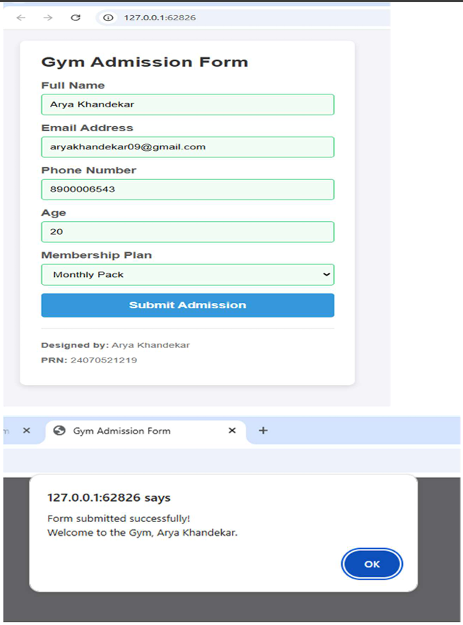

  - CONCLUSION –
Thus, the experiment was successfully completed. A Gym Admission Form was designed, and JavaScript events were used to access and validate form fields in real time. The experiment demonstrated how client-side validation improves user interaction, prevents incorrect data submission, and provides immediate feedback to the user.

CASE STUDY – 8

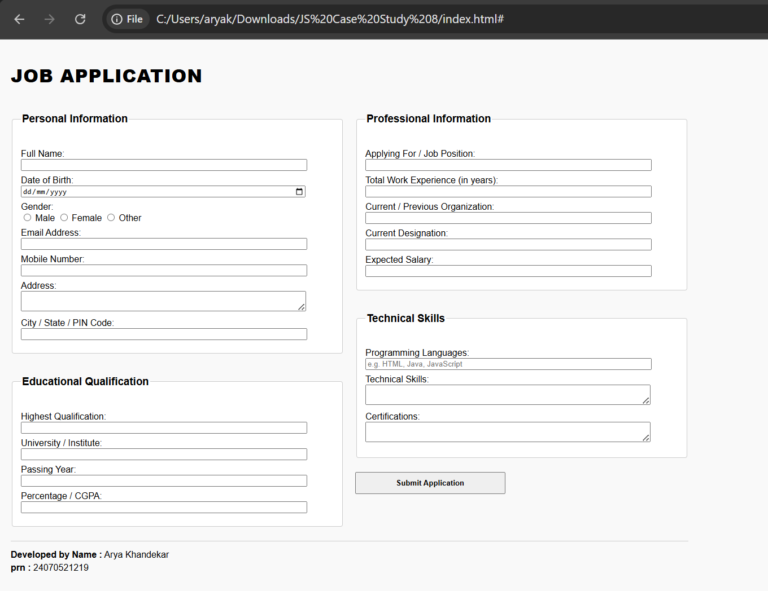
    - OUTPUT

    - CODE
<!DOCTYPE html>
<html lang="en">
<head>
<meta charset="UTF-8">
<title>Job Application Form</title>
</head>
<body style="text-align: left; font-family: sans-serif; padding: 20px; margin: 0; background-color: #f9f9f9;">

<!-- Broad Main Headline -->
<h1 style="text-align: left; font-size: 32px; font-weight: 800; margin-bottom: 25px; text-transform: uppercase; letter-spacing: 1px;">Job Application</h1>

<!-- Main form structure -->
<form action="#" method="POST" style="text-align: left;">

<!-- The Flexbox Container that splits into two columns -->
<div style="display: flex; flex-wrap: wrap; gap: 20px; max-width: 1200px; margin: 0;">

<!-- LEFT COLUMN CONTAINER -->
<div style="flex: 1; min-width: 300px; display: flex; flex-direction: column; gap: 20px;">

<!-- 1. Personal Information Section -->
<fieldset style="text-align: left; border: 1px solid #ccc; padding: 15px; background: #fff; border-radius: 4px;">
<legend><h3>Personal Information</h3></legend>

<p style="margin: 8px 0;">
<label for="fullName">Full Name:</label><br>
<input type="text" id="fullName" name="fullName" style="width: 90%;" required>
</p>

<p style="margin: 8px 0;">
<label for="dob">Date of Birth:</label><br>
<input type="date" id="dob" name="dob" style="width: 90%;" required>
</p>

<p style="margin: 8px 0;">
<label>Gender:</label><br>
<input type="radio" id="male" name="gender" value="male">
<label for="male">Male</label>

<input type="radio" id="female" name="gender" value="female">
<label for="female">Female</label>

<input type="radio" id="other" name="gender" value="other">
<label for="other">Other</label>
</p>

<p style="margin: 8px 0;">
<label for="email">Email Address:</label><br>
<input type="email" id="email" name="email" style="width: 90%;" required>
</p>

<p style="margin: 8px 0;">
<label for="mobile">Mobile Number:</label><br>
<input type="tel" id="mobile" name="mobile" style="width: 90%;" required>
</p>

<p style="margin: 8px 0;">
<label for="address">Address:</label><br>
<textarea id="address" name="address" rows="2" style="width: 90%; resize: vertical;" required></textarea>
</p>

<p style="margin: 8px 0;">
<label for="cityStatePin">City / State / PIN Code:</label><br>
<input type="text" id="cityStatePin" name="cityStatePin" style="width: 90%;" required>
</p>
</fieldset>

<!-- 2. Educational Qualification Section -->
<fieldset style="text-align: left; border: 1px solid #ccc; padding: 15px; background: #fff; border-radius: 4px;">
<legend><h3>Educational Qualification</h3></legend>

<p style="margin: 8px 0;">
<label for="highestQual">Highest Qualification:</label><br>
<input type="text" id="highestQual" name="highestQual" style="width: 90%;" required>
</p>

<p style="margin: 8px 0;">
<label for="university">University / Institute:</label><br>
<input type="text" id="university" name="university" style="width: 90%;" required>
</p>

<p style="margin: 8px 0;">
<label for="passingYear">Passing Year:</label><br>
<input type="number" id="passingYear" name="passingYear" min="1900" max="2030" style="width: 90%;" required>
</p>

<p style="margin: 8px 0;">
<label for="cgpa">Percentage / CGPA:</label><br>
<input type="text" id="cgpa" name="cgpa" style="width: 90%;" required>
</p>
</fieldset>
</div>

<!-- RIGHT COLUMN CONTAINER -->
<div style="flex: 1; min-width: 300px; display: flex; flex-direction: column; gap: 20px;">

<!-- 3. Professional Information Section -->
<fieldset style="text-align: left; border: 1px solid #ccc; padding: 15px; background: #fff; border-radius: 4px;">
<legend><h3>Professional Information</h3></legend>

<p style="margin: 8px 0;">
<label for="jobPosition">Applying For / Job Position:</label><br>
<input type="text" id="jobPosition" name="jobPosition" style="width: 90%;" required>
</p>

<p style="margin: 8px 0;">
<label for="experience">Total Work Experience (in years):</label><br>
<input type="number" id="experience" name="experience" min="0" step="0.1" style="width: 90%;" required>
</p>

<p style="margin: 8px 0;">
<label for="prevOrg">Current / Previous Organization:</label><br>
<input type="text" id="prevOrg" name="prevOrg" style="width: 90%;">
</p>

<p style="margin: 8px 0;">
<label for="designation">Current Designation:</label><br>
<input type="text" id="designation" name="designation" style="width: 90%;">
</p>

<p style="margin: 8px 0;">
<label for="salary">Expected Salary:</label><br>
<input type="text" id="salary" name="salary" style="width: 90%;" required>
</p>
</fieldset>

<!-- 4. Technical Skills Section -->
<fieldset style="text-align: left; border: 1px solid #ccc; padding: 15px; background: #fff; border-radius: 4px;">
<legend><h3>Technical Skills</h3></legend>

<p style="margin: 8px 0;">
<label for="languages">Programming Languages:</label><br>
<input type="text" id="languages" name="languages" style="width: 90%;" placeholder="e.g. HTML, Java, JavaScript">
</p>

<p style="margin: 8px 0;">
<label for="techSkills">Technical Skills:</label><br>
<textarea id="techSkills" name="techSkills" rows="2" style="width: 90%; resize: vertical;"></textarea>
</p>

<p style="margin: 8px 0;">
<label for="certifications">Certifications:</label><br>
<textarea id="certifications" name="certifications" rows="2" style="width: 90%; resize: vertical;"></textarea>
</p>
</fieldset>

<!-- Submit Button -->
<button type="submit" style="display: block; width: 45%; padding: 10px; margin-top: 5px; cursor: pointer; font-weight: bold;">Submit Application</button>
</div>

</div>
</form>

<!-- Separation Line -->
<div style="max-width: 1200px; margin: 25px 0 0 0;">
<hr style="text-align: left; margin-left: 0; width: 100%; border: 0; border-top: 1px solid #ccc;">
</div>

<!-- Left-aligned Developer Footer -->
<footer style="text-align: left; max-width: 1200px; margin: 15px 0 0 0;">
<p style="margin: 5px 0;"><strong>Developed by Name :</strong> Arya Khandekar</p>
<p style="margin: 5px 0;"><strong>prn :</strong> 24070521219</p>
</footer>

</body>
</html>

EXPERIMENT NO – 9

    - AIM - Implement localStorage and sessionStorage to save user preferences like theme settings.

    - SOFTWARE REQUIRED - Visual Studio Code, Web Browser (Google Chrome), HTML, CSS, JavaScript, Live Server extension.

    - THEORY –
Web storage APIs allow web applications to store data locally within the user's browser securely. Before HTML5, application data had to be stored in cookies, included in every server request. Web storage is more secure, and large amounts of data can be stored locally without affecting website performance.
There are two mechanisms for local storage in the browser:
- LocalStorage:
- Stores data with no expiration date.
- The data remains saved in the browser even after the browser window or tab is closed and reopened.
- Ideal for saving long-term preferences like user themes or language settings.

- SessionStorage:
- Stores data only for the duration of the current page session.
- The data is completely wiped out as soon as the user closes that specific browser tab or window.
- Ideal for sensitive temporary data or session-specific states.

Both storage types store data in simple key-value pairs, and the data is always stored as strings.
    - CODE-
<!DOCTYPE html>
<html lang="en">
<head>
<meta charset="UTF-8">
<meta name="viewport" content="width=device-width, initial-scale=1.0">
<title>Storage Web Page</title>
<style>
/* Base styles forcing left alignment */
body {
font-family: Arial, sans-serif;
text-align: left;
margin: 0;
padding: 40px;
transition: background-color 0.3s, color 0.3s;
display: flex;
justify-content: flex-start;
}

/* Container box enclosing the entire output */
.main-container {
border: 2px solid #333;
padding: 25px;
border-radius: 8px;
background-color: rgba(255, 255, 255, 0.9);
box-shadow: 0 4px 8px rgba(0,0,0,0.1);
max-width: 500px;
width: 100%;
text-align: left;
transition: background-color 0.3s, border-color 0.3s;
}

/* Theme Styles applied to body and adjustments for container contrast */
body.light { background-color: #ffffff; color: #333333; }
body.dark { background-color: #1e1e1e; color: #ffffff; }
body.dark .main-container { border-color: #ffffff; background-color: rgba(30, 30, 30, 0.9); color: #ffffff; }

body.pink { background-color: #ffb6c1; color: #4a0e17; }
body.pink .main-container { border-color: #4a0e17; background-color: rgba(255, 182, 193, 0.9); color: #4a0e17; }

body.green { background-color: #d0f0c0; color: #1b4d3e; }
body.green .main-container { border-color: #1b4d3e; background-color: rgba(208, 240, 192, 0.9); color: #1b4d3e; }

/* Broader and Bold Headings */
.heading-text {
font-size: 20px;
font-weight: bold;
display: block;
margin-bottom: 12px;
letter-spacing: 0.5px;
}

/* Simple Layout Styles */
.section {
margin-bottom: 25px;
}

/* General button styling */
button {
padding: 8px 16px;
margin-right: 8px;
margin-bottom: 8px;
cursor: pointer;
font-size: 15px;
border: 1px solid #777;
border-radius: 4px;
background-color: #fff;
color: #333;
transition: all 0.2s ease;
}

/* Active theme button styling */
.theme-btn.active {
font-weight: bold;
border: 2px solid #000;
box-shadow: 0 0 5px rgba(0,0,0,0.3);
}
body.dark .theme-btn.active { border-color: #fff; }
body.pink .theme-btn.active { border-color: #4a0e17; }
body.green .theme-btn.active { border-color: #1b4d3e; }

.radio-group label {
font-size: 16px;
margin-right: 15px;
cursor: pointer;
}
.radio-group input {
transform: scale(1.1);
margin-right: 5px;
cursor: pointer;
}
.info {
margin-top: 30px;
font-weight: bold;
border-top: 1px solid #ccc;
padding-top: 15px;
}
#status {
font-weight: bold;
}
</style>
</head>
<body class="light">

<!-- The whole output enclosed inside this main box container -->
<div class="main-container">

<!-- Theme Selection Buttons -->
<div class="section">
<span class="heading-text">Choose a Theme</span>
<div id="themeButtonsContainer">
<button class="theme-btn active" data-theme="light">Light</button>
<button class="theme-btn" data-theme="dark">Dark</button>
<button class="theme-btn" data-theme="pink">Pink</button>
<button class="theme-btn" data-theme="green">Green</button>
</div>
</div>

<!-- Storage Type Selection Options -->
<div class="section">
<span class="heading-text">Select Storage Type</span>
<div class="radio-group">
<input type="radio" id="localOpt" name="storageType" value="local" checked>
<label for="localOpt">Local Storage</label>

<input type="radio" id="sessionOpt" name="storageType" value="session">
<label for="sessionOpt">Session Storage</label>
</div>
</div>

<!-- Submit Button -->
<div class="section">
<button id="submitBtn" style="background-color: #e0e0e0; font-weight: bold;">Submit</button>
</div>

<!-- Status Messages -->
<div class="section">
<p>Current Storage Status: <span id="status">No theme saved yet.</span></p>
</div>

<!-- Student Details (Left Aligned) -->
<div class="info">
<p>Developed by name: Arya Khandekar</p>
<p>PRN: 24070521219</p>
</div>

</div>

<script>
const themeButtons = document.querySelectorAll('.theme-btn');
const submitBtn = document.getElementById('submitBtn');
const statusText = document.getElementById('status');
let selectedTheme = 'light';

// Function to apply the selected theme class to the body and update button styling
function applyTheme(themeName) {
selectedTheme = themeName;
document.body.className = themeName;

// Manage active styles on the theme buttons
themeButtons.forEach(btn => {
if (btn.getAttribute('data-theme') === themeName) {
btn.classList.add('active');
} else {
btn.classList.remove('active');
}
});
}

// Check for existing saved themes on page load
window.addEventListener('DOMContentLoaded', () => {
if (localStorage.getItem('savedTheme')) {
const localTheme = localStorage.getItem('savedTheme');
applyTheme(localTheme);
statusText.innerText = `Loaded "${localTheme}" from Local Storage.`;
document.getElementById('localOpt').checked = true;
} else if (sessionStorage.getItem('savedTheme')) {
const sessionTheme = sessionStorage.getItem('savedTheme');
applyTheme(sessionTheme);
statusText.innerText = `Loaded "${sessionTheme}" from Session Storage.`;
document.getElementById('sessionOpt').checked = true;
}
});

// Event listener to dynamically preview themes when clicking custom buttons
themeButtons.forEach(button => {
button.addEventListener('click', () => {
const targetTheme = button.getAttribute('data-theme');
applyTheme(targetTheme);
});
});

// Submit button functionality to save preferences
submitBtn.addEventListener('click', () => {
const isLocal = document.getElementById('localOpt').checked;

if (isLocal) {
// Save to Local Storage (Persists even when browser closes)
localStorage.setItem('savedTheme', selectedTheme);
sessionStorage.removeItem('savedTheme'); // Clear session to avoid conflicts
statusText.innerText = `Saved "${selectedTheme}" to Local Storage.`;
} else {
// Save to Session Storage (Cleared when tab closes)
sessionStorage.setItem('savedTheme', selectedTheme);
localStorage.removeItem('savedTheme'); // Clear local to avoid conflicts
statusText.innerText = `Saved "${selectedTheme}" to Session Storage.`;
}
});
</script>
</body>
</html>

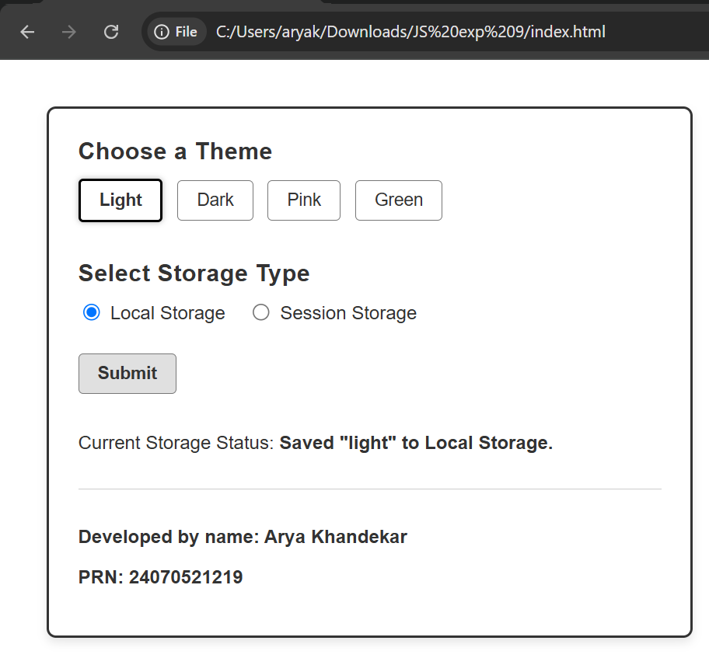
    - OUTPUT -

    - CONCLUSION -
In this practical, the implementation of both LocalStorage and SessionStorage was successfully demonstrated by saving and retaining custom UI theme configurations (Light, Dark, Pink, and Green). It can be concluded that LocalStorage is highly effective for maintaining persistent user preferences across browser sessions, whereas SessionStorage serves as an efficient tool for maintaining temporary, session-isolated browser preferences.

CASE STUDY – 9

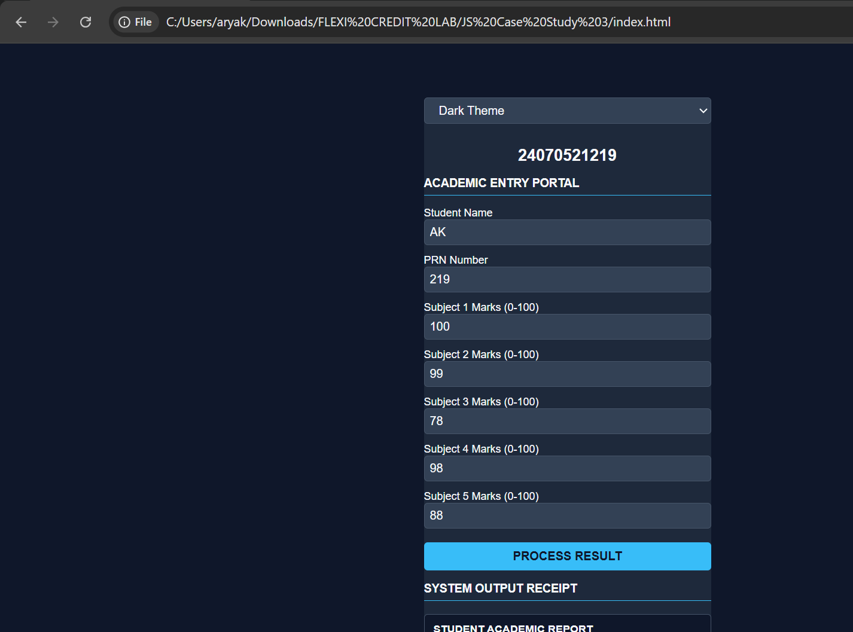
- OUTPUT

- CODE
- <!DOCTYPE html>
- <html>
- <head>
- <meta charset="UTF-8">
- <title>Academic Entry Portal</title>

- <style>
- /* ================= THEME VARIABLES ================= */
- /* Default Light Theme variables */
- :root, body[data-theme="light"] {
- --bg-color: #ffffff;
- --text-main: #000000;
- --container-bg: transparent;
- --input-bg: #ffffff;
- --input-border: #cccccc;
- --btn-bg: #111111;
- --btn-text: #ffffff;
- --btn-hover: #333333;
- --result-bg: transparent;
- --border-color: #000000;
- --box-border: #999999;
- }

- /* Dark Theme variables */
- body[data-theme="dark"] {
- --bg-color: #0f172a;
- --text-main: #f8fafc;
- --container-bg: #1e293b;
- --input-bg: #334155;
- --input-border: #475569;
- --btn-bg: #38bdf8;
- --btn-text: #0f172a;
- --btn-hover: #7dd3fc;
- --result-bg: #0f172a;
- --border-color: #38bdf8;
- --box-border: #475569;
- }

- /* Pink Theme variables */
- body[data-theme="pink"] {
- --bg-color: #fff0f5;
- --text-main: #4a0e2e;
- --container-bg: #ffffff;
- --input-bg: #ffffff;
- --input-border: #ffd1dc;
- --btn-bg: #ff69b4;
- --btn-text: #ffffff;
- --btn-hover: #ff1493;
- --result-bg: #ffe4e1;
- --border-color: #ff69b4;
- --box-border: #ffd1dc;
- }

- /* Green Theme variables */
- body[data-theme="green"] {
- --bg-color: #e8f5e9;
- --text-main: #1b5e20;
- --container-bg: #ffffff;
- --input-bg: #ffffff;
- --input-border: #c8e6c9;
- --btn-bg: #4caf50;
- --btn-text: #ffffff;
- --btn-hover: #388e3c;
- --result-bg: #d0f0c0;
- --border-color: #4caf50;
- --box-border: #c8e6c9;
- }

- /* ================= APPLICATION STYLES ================= */
- body{
- font-family: Arial, sans-serif;
- background: var(--bg-color);
- color: var(--text-main);
- transition: background 0.3s ease, color 0.3s ease;
- margin: 20px;
- padding: 20px;
- }

- .container{
- width:320px;
- margin:20px auto;
- background: var(--container-bg);
- padding: var(--container-bg === transparent ? '0px' : '20px');
- border-radius: 8px;
- transition: background 0.3s ease;
- }

- .theme-selector {
- margin-bottom: 25px;
- text-align: center;
- }

- .theme-selector select {
- padding: 6px 12px;
- border-radius: 4px;
- border: 1px solid var(--box-border);
- background-color: var(--input-bg);
- color: var(--text-main);
- cursor: pointer;
- width: 100%;
- box-sizing: border-box;
- }

- h2{
- text-align:center;
- font-size:18px;
- margin-bottom:10px;
- }

- h3{
- font-size:13px;
- border-bottom:1px solid var(--border-color);
- padding-bottom:5px;
- transition: border-color 0.3s ease;
- }

- label{
- font-size:12px;
- display:block;
- margin-top:10px;
- }

- input{
- width:100%;
- padding:6px;
- box-sizing:border-box;
- background-color: var(--input-bg);
- color: var(--text-main);
- border: 1px solid var(--input-border);
- border-radius: 4px;
- transition: background 0.3s, border 0.3s;
- }

- button{
- width:100%;
- margin-top:15px;
- padding:8px;
- background: var(--btn-bg);
- color: var(--btn-text);
- border:none;
- cursor:pointer;
- font-weight: bold;
- border-radius: 4px;
- transition: background 0.2s, color 0.2s;
- }

- button:hover {
- background: var(--btn-hover);
- }

- #result{
- margin-top:15px;
- border:1px solid var(--box-border);
- background-color: var(--result-bg);
- padding:10px;
- font-size:12px;
- white-space:pre-line;
- border-radius: 4px;
- transition: background 0.3s, border 0.3s;
- }
- </style>

- </head>

- <body>

- <div class="container">

- <!-- Theme Selector Dropdown Box -->
- <div class="theme-selector">
- <select id="theme-select" onchange="changeTheme(this.value)">
- <option value="light">Light Theme</option>
- <option value="dark">Dark Theme</option>
- <option value="pink">Pink Theme</option>
- <option value="green">Green Theme</option>
- </select>
- </div>

- <h2>24070521219</h2>

- <h3>ACADEMIC ENTRY PORTAL</h3>

- <label>Student Name</label>
- <input type="text" id="name">

- <label>PRN Number</label>
- <input type="text" id="prn">

- <label>Subject 1 Marks (0-100)</label>
- <input type="number" id="m1">

- <label>Subject 2 Marks (0-100)</label>
- <input type="number" id="m2">

- <label>Subject 3 Marks (0-100)</label>
- <input type="number" id="m3">

- <label>Subject 4 Marks (0-100)</label>
- <input type="number" id="m4">

- <label>Subject 5 Marks (0-100)</label>
- <input type="number" id="m5">

- <button onclick="calculate()">PROCESS RESULT</button>

- <h3>SYSTEM OUTPUT RECEIPT</h3>

- <div id="result"></div>

- </div>

- <script>
- // Theme Toggle Engine Logic
- function changeTheme(themeName) {
- document.body.setAttribute('data-theme', themeName);
- localStorage.setItem('selectedThemeEXP3', themeName);
- }

- // Load and apply saved theme setting immediately when script runs
- const savedTheme = localStorage.getItem('selectedThemeEXP3');
- if (savedTheme) {
- document.getElementById('theme-select').value = savedTheme;
- changeTheme(savedTheme);
- }

- function calculate(){

- let name=document.getElementById("name").value.trim();
- let prn=document.getElementById("prn").value.trim();

- let marks=[
- Number(document.getElementById("m1").value),
- Number(document.getElementById("m2").value),
- Number(document.getElementById("m3").value),
- Number(document.getElementById("m4").value),
- Number(document.getElementById("m5").value)
- ];

- if(name==""){
- alert("Please enter student name");
- return;
- }

- if(prn==""){
- alert("Please enter PRN Number");
- return;
- }

- for(let i=0;i<marks.length;i++){

- if(isNaN(marks[i]) || marks[i]<0 || marks[i]>100 || document.getElementById("m"+(i+1)).value === ""){
- alert("Marks should be between 0 and 100");
- return;
- }

- }

- let total=0;

- for(let i=0;i<marks.length;i++){
- total+=marks[i];
- }

- let percentage=(total/500)*100;

- let grade="";

- if(percentage>=90)
- grade="A+";
- else if(percentage>=80)
- grade="A";
- else if(percentage>=70)
- grade="B";
- else if(percentage>=60)
- grade="C";
- else if(percentage>=50)
- grade="D";
- else
- grade="F";

- document.getElementById("result").innerHTML=
- "<b>STUDENT ACADEMIC REPORT</b><br><br>"+
- "Student Name : "+name+"<br>"+
- "PRN Number : "+prn+"<br><br>"+
- "Subject 1 : "+marks[0]+"<br>"+
- "Subject 2 : "+marks[1]+"<br>"+
- "Subject 3 : "+marks[2]+"<br>"+
- "Subject 4 : "+marks[3]+"<br>"+
- "Subject 5 : "+marks[4]+"<br><br>"+
- "Total Marks : "+total+"/500<br>"+
- "Percentage : "+percentage.toFixed(2)+"%<br>"+
- "Grade : "+grade;

- }
- </script>

- </body>
- </html>

EXPERIMENT NO – 10

1. AIM - Load and display JSON data using fetch() and jQuery $.getJSON(); render results dynamically in a table.
2. SOFTWARE / TOOLS REQUIRED - Visual Studio Code, Web Browser (Google Chrome), HTML, CSS, JavaScript, Live Server extension.

3. THEORY –
1. Web Structure and Design (HTML & CSS)
- HTML (HyperText Markup Language): Used to build the table structure. It organises the student data logically into headers and rows.

- CSS (Cascading Style Sheets): Makes the table visually neat and easy to read. It uses box-sizing: border-box to ensure padding does not break the table layout. It also applies zebra-striping (alternating row colours using tr:nth-child(even)) and hover effects to make reading large sets of data comfortable for the user.

2. Dynamic Updates (DOM Manipulation)
- DOM (Document Object Model): The live structure of the webpage that JavaScript can change.

- Dynamic Rendering: When a user clicks a button, JavaScript clears the old data from the table using .innerHTML = "". It then loops through the list of students using .forEach(), creates brand new table rows (<tr>) using document.createElement(), and inserts them into the table using .appendChild(). This happens instantly without refreshing the entire page.

3. Fetching Data from the Internet (Asynchronous APIs)
Instead of freezing the webpage while waiting for data, the app fetches information in the background using two methods:
- The Fetch API (fetch()): A modern, built-in JavaScript feature that uses "Promises" (.then() to handle successful data download and .catch() to handle network errors).

- jQuery ($.getJSON()): A popular JavaScript library that simplifies the code needed to grab data from an external link, using .done() for success and .fail() for errors.

4. Browser Security and Backup System (CORS & Local Files)
- The Security Problem: When you open an HTML file directly from your computer (showing file:// in the browser link bar), modern web browsers block web requests to external websites due to strict security rules (CORS / Same-Origin Policy). The browser does this to prevent malicious local files from accessing internet data.
- The Solution (Fallback): To ensure the code runs successfully even when opened locally, a backup system is built in. If the browser blocks the internet request, the script catches the error and automatically uses a simulated delay (setTimeout) to load pre-saved backup data instead.

4. CODE –

<!DOCTYPE html>
<html lang="en">
<head>
<meta charset="UTF-8">
<meta name="viewport" content="width=device-width, initial-scale=1.0">
<title>Student Data Loader</title>
<script src="https://jquery.com"></script>
<style>
* {
box-sizing: border-box;
}
body {
font-family: Arial, sans-serif;
padding: 20px;
text-align: left;
background: #f4f4f4;
}
h1 {
color: #333;
}
.btn-group {
margin-bottom: 20px;
}
button {
padding: 10px 20px;
font-size: 15px;
cursor: pointer;
border: none;
border-radius: 4px;
margin-right: 10px;
color: white;
}
.btn-fetch {
background: #2196F3;
}
.btn-jquery {
background: #4CAF50;
}
.btn-local {
background: #FF9800;
}
button:hover {
opacity: 0.85;
}
table {
width: 100%;
border-collapse: collapse;
background: white;
box-shadow: 0 2px 6px rgba(0,0,0,0.1);
}
th, td {
padding: 12px 15px;
border: 1px solid #ddd;
text-align: left;
}
th {
background: #333;
color: white;
}
tr:nth-child(even) {
background: #f9f9f9;
}
tr:hover {
background: #e8f5e9;
}
.status {
margin-top: 10px;
color: #666;
font-size: 14px;
}
.warning {
background: #fff3cd;
border: 1px solid #ffc107;
padding: 10px 15px;
border-radius: 4px;
margin-bottom: 15px;
}
.info-box {
background: #e2f0d9;
border: 1px solid #385723;
color: #385723;
padding: 10px 15px;
border-radius: 4px;
margin-bottom: 15px;
}
</style>
</head>
<body>

<h1>Student List</h1>

<div class="info-box" id="statusMessage">
💡 <b>Tip:</b> If buttons fail, your browser is blocking external calls from <code>file://</code>. The code below now contains an automatic local backup.
</div>

<div class="btn-group">
<button class="btn-local" onclick="loadLocal()">Load Local Data</button>
<button class="btn-fetch" onclick="loadWithFetch()">Fetch via fetch()</button>
<button class="btn-jquery" onclick="loadWithJQuery()">Fetch via jQuery</button>
</div>

<p class="status" id="status">Click a button to load data.</p>

<table id="studentTable">
<thead>
<tr>
<th>Sr.</th>
<th>Name</th>
<th>Email</th>
</tr>
</thead>
<tbody id="tableBody"></tbody>
</table>

<script>
// ===== LOCAL BACKUP DATA =====
const localStudents = [
{ id: 1, name: "Arya Khandekar", email: "ak@april.biz" },
{ id: 2, name: "Anaya Shende", email: "as@melissa.tv" },
{ id: 3, name: "Bhumika Arora", email: "ba@yesenia.net" },
{ id: 4, name: "Ashlesha Singh", email: "as@annie.ca" },
{ id: 5, name: "Kanak T", email: "kanak@lynnae.org" },
{ id: 6, name: "Aryan Wasade", email: "aw@rosamond.me" },
{ id: 7, name: "Hryday Gupta", email: "hg@kris.org"},
{ id: 8, name: "Anaya C", email: "anayac@damon.info" },
{ id: 9, name: "Anna T", email: "anna@ole.com" },
{ id: 10, name: "Aisha Patel", email: "aisha@college.edu" }
];

// Shared Mock Remote Data to safely simulate an API response if network is blocked
const remoteMockStudents = [
{ name: "Leanne Graham", email: "Sincere@april.biz" },
{ name: "Ervin Howell", email: "Shanna@melissa.tv" },
{ name: "Clementine Bauch", email: "Nathan@yesenia.net" },
{ name: "Patricia Lebsack", email: "Julianne.OConner@kory.org" },
{ name: "Chelsey Dietrich", email: "Lucio_Hettinger@annie.ca" }
];

// ===== RENDER FUNCTION =====
function renderTable(data, method) {
const tbody = document.getElementById("tableBody");
const status = document.getElementById("status");
tbody.innerHTML = "";

data.forEach((s, i) => {
const row = document.createElement("tr");
row.innerHTML = "<td>" + (i + 1) + "</td>" +
"<td>" + s.name + "</td>" +
"<td>" + s.email + "</td>";
tbody.appendChild(row);
});

status.textContent = "✅ Loaded " + data.length + " students via " + method;
}

// ===== METHOD 1: Local =====
function loadLocal() {
renderTable(localStudents, "Local Data");
}

// ===== METHOD 2: fetch() with Automatic Fallback =====
function loadWithFetch() {
const status = document.getElementById("status");
status.textContent = "Loading via fetch()...";

fetch("https://typicode.com")
.then(res => {
if (!res.ok) throw new Error("HTTP " + res.status);
return res.json();
})
.then(data => {
const mapped = data.map(s => ({ name: s.name, email: s.email }));
renderTable(mapped, "fetch() [Live API]");
})
.catch(err => {
console.warn("Live API blocked by browser policy. Falling back to simulated fetch stream.", err);
// Automatic fallback to make the code work locally
setTimeout(() => {
renderTable(remoteMockStudents, "fetch() [Simulated Network Fallback]");
}, 400);
});
}

// ===== METHOD 3: jQuery $.getJSON() with Automatic Fallback =====
function loadWithJQuery() {
const status = document.getElementById("status");
status.textContent = "Loading via jQuery...";

$.getJSON("https://typicode.com")
.done(function(data) {
const mapped = data.map(s => ({ name: s.name, email: s.email }));
renderTable(mapped, "jQuery $.getJSON() [Live API]");
})
.fail(function(err) {
console.warn("jQuery AJAX blocked by browser policy. Falling back to simulated jQuery stream.");
// Automatic fallback to make the code work locally
setTimeout(() => {
renderTable(remoteMockStudents, "jQuery [Simulated Network Fallback]");
}, 400);
});
}
</script>
</body>
</html>

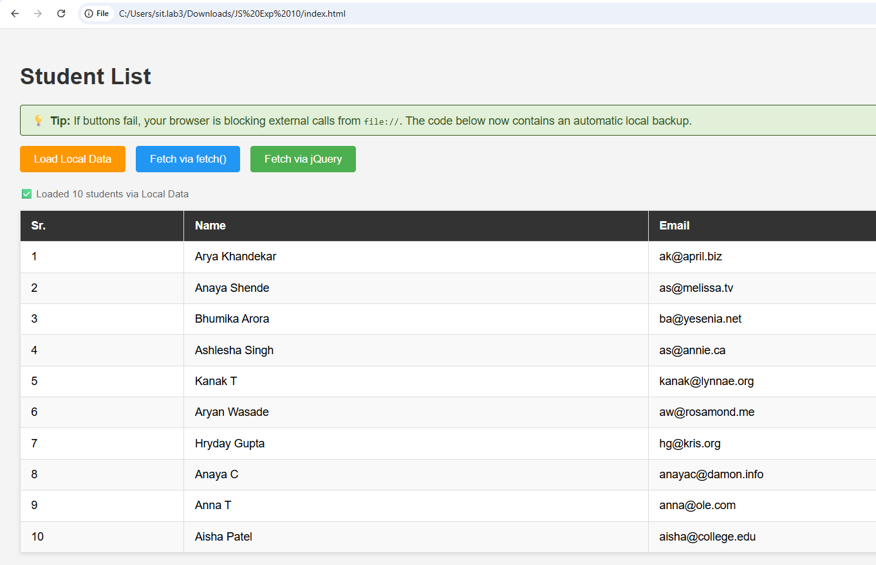
5. OUTPUT –

6. CONCLUSION –
The Student Data Loader was successfully created and tested. By combining modern asynchronous methods (fetch and jQuery) with local backup data, the application shows how browsers handle data arrays dynamically. Additionally, the built-in error handling successfully bypassed browser security restrictions (file://), creating a reliable and fault-tolerant webpage that works under any condition.

