Course: UI/UX Design Fundamentals

Instructor Name: Mrs. Nagaveena

Institution Name: Christ University

Date of Submission: 13/08/2025

1. **Metallica Band Page**

Submitted by:

1. Joshua Thomas - 246 - [Joshua.thomas@christuniversity.in](mailto:Joshua.thomas@christuniversity.in)
2. Alex Jilson - 2460321 -[alex.jilson@btech.christuniversity.in](mailto:alex.jilson@btech.christuniversity.in)
3. Arya Ramachandran - 2460338 -[arya.ramachandran@btech.christuniversity.in](mailto:arya.ramachandran@btech.christuniversity.in)
4. **Abstract**

This project is a fan-made Metallica band webpage designed to showcase the legendary heavy metal group through a clean, engaging, and responsive layout. The goal was to create a visually appealing platform that highlights key aspects of the band, including their history, members, featured songs in award winning movie, and contact information, while maintaining an intuitive user experience.

Core technologies used include

1. **HTML5** for the structure,
2. **CSS3** for styling and layout customization
3. **Google Fonts** for unique typography.

Images and a hero section were integrated to capture the band’s energy, while the design emphasizes clarity and accessibility across devices.

The final outcome is a modern, well-organized webpage that effectively presents Metallica’s identity and connects fans to relevant content. This webpage is useful as a music showcase, a template for fan sites, or a starting point for more interactive band portals, demonstrating practical web design and front-end development skills.

1. **Objectives**

While designing and developing this application, we put forth a set of objectives to follow and maintain throughout the project. They are:

* Design a **user-friendly UI** that is intuitive and visually appealing for fans.
* Create a **fully responsive layout** using HTML and CSS for optimal viewing on all devices.
* Implement **HTML5 semantic elements** to improve structure, SEO, and maintainability.
* Apply CSS for **branding consistency**, layout styling, and enhanced visual appeal.
* Ensure **accessibility** by following web standards, making the site usable for all audiences.
* Maintain **readability** with clear typography, contrast, and logical content flow.

1. **Scope of Project**

This project focuses solely on the **front-end design and development** of a Metallica band webpage.

It includes creating the complete HTML and CSS structure, integrating images, applying consistent branding, and ensuring a responsive layout for **desktop, tablet, and mobile** viewports.

The scope is limited to **static content**—there is no JavaScript functionality, server-side processing, or database integration. The design emphasizes **HTML5 semantic elements**, CSS-based styling, accessibility, and readability.

Only **open-source tools** and **pure hand-written code** were used, without reliance on external frameworks or libraries. This ensures that the codebase remains lightweight, maintainable, and fully customizable.

The project’s boundaries are clearly defined to focus on visual presentation, layout optimization, and responsive adaptation, serving as a showcase for clean, standards-compliant front-end development.

1. **Tools & Technologies Used**

|  |  |
| --- | --- |
| Tools/Technology | Purpose |
| HTML 5 | Markup and content structure |
| CSS 3 | Styling and layout management |
| VS Code | Code editor |
| Chrome DevTools | Testing and debugging |
| Google Fonts | Import and use various fonts |

1. **HTML Structure Overview**

The webpage is built using **HTML5 semantic tags** to create a well-organized and meaningful structure.

Content is divided into **reusable sections** for easy maintenance and clarity, including:

1. **About**
2. **Project**
3. **Contact Us**
4. **About Us**
5. **Gallery**
6. **Book Tickets**

A **navigation menu** is implemented using an unordered list (<ul>) with anchor links (<a>) that enable **smooth scrolling** to each section.

Semantic elements like <header>, <nav>, <section>, <article>, <footer> enhance accessibility and improve SEO. This structured approach ensures a logical content hierarchy, making the webpage both user-friendly and developer-friendly. The design prioritizes reusability, readability, and maintainability, providing a solid foundation for any future updates or expansions.

1. **CSS Styling Strategy**

The webpage uses an **external CSS file** (main.css) to maintain a clean separation between structure and styling.

The design strategy focuses on:

1. **Responsiveness**
2. **branding consistency**
3. **visual engagement**

Layout techniques include **Flexbox** for aligning navigation items and arranging content sections, as well as **CSS Grid** for organizing the gallery layout. A custom **colour theme** and **Google Fonts** are applied for branding and typography consistency.

Interactive elements used are:

1. buttons
2. navigation links
3. **hover effects**
4. **smooth transitions**

to enhance user experience. Margins, padding, and whitespace are carefully adjusted to maintain visual balance and readability across desktop, tablet, and mobile viewports. The CSS is written with reusability in mind, using class-based selectors and minimal redundancy, ensuring easy future maintenance and updates.

1. **Key Features**

|  |  |
| --- | --- |
| **Feature** | **Description** |
| Smooth Navigation | Fixed top nav with anchor links |
| Responsive Design | Adapt seamlessly to all screen sizes |
| Project Cards | Flex-based layout with hover effects |
| Contact Form | Placement layout for input and button |
| Accessible Fonts & Colours | High contrast and readable typography |

1. **Challenges Faced & Solutions**

|  |  |
| --- | --- |
| Challenges | Solution |
| Overlapping elements on small screens | Used media queries to stack elements |
| Difficulty aligning items using float | Shifted to flexbox and grid |
| Typography scaling issues | Used relative units instead of px |

**10.Final Outcomes**

The project successfully achieved a **clean, consistent, and visually engaging front-end layout** that reflects the energy and branding of the Metallica band.

All key components, including navigation, sections, gallery, and contact details, function exactly as intended using only **HTML and CSS**. The responsive design adapts seamlessly to desktop, tablet, and mobile viewports, ensuring a smooth user experience across devices.

Through this project, key skills were developed in **layout responsiveness**, **UI hierarchy**, semantic HTML structuring, and CSS-based design strategies. The outcome is a lightweight, standards-compliant webpage that demonstrates effective use of modern front-end techniques without relying on JavaScript or external libraries.

**11. Future Enhancements**

Several features can be added to expand the functionality and interactivity of the webpage:

* **JavaScript form handling** to validate user inputs before submission.
* **Dynamic content loading** to update sections without refreshing the page.
* **CSS/JavaScript-based animations** to enhance visual appeal and engagement.
* **Backend integration** for ticket booking, user accounts, or content management.
* **Theme toggler** to allow users to switch between light and dark modes.
* **Multimedia enhancements** such as embedded music players or video sections for richer user experiences.

These additions would transform the current static site into a more **interactive, feature-rich platform** while maintaining its responsive and user-friendly design.

**12. Sample Codes**

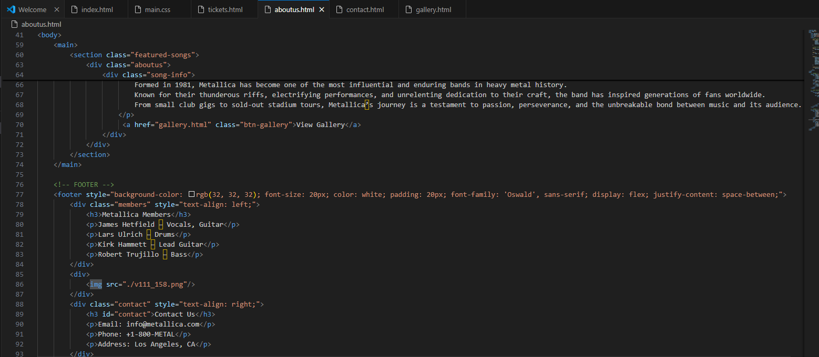

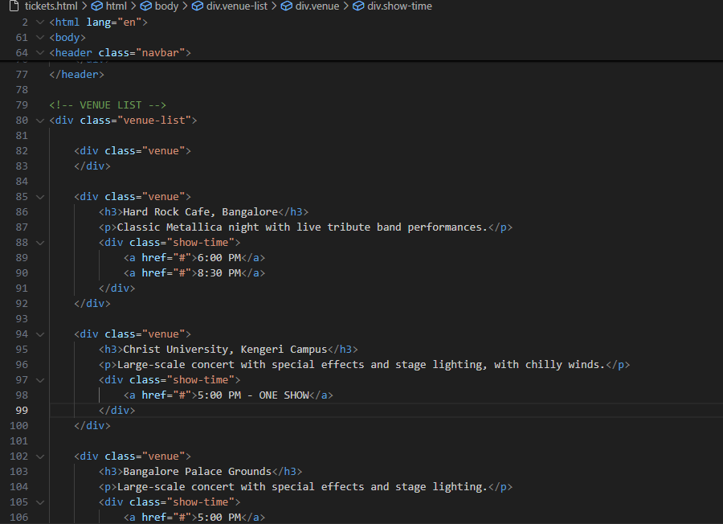

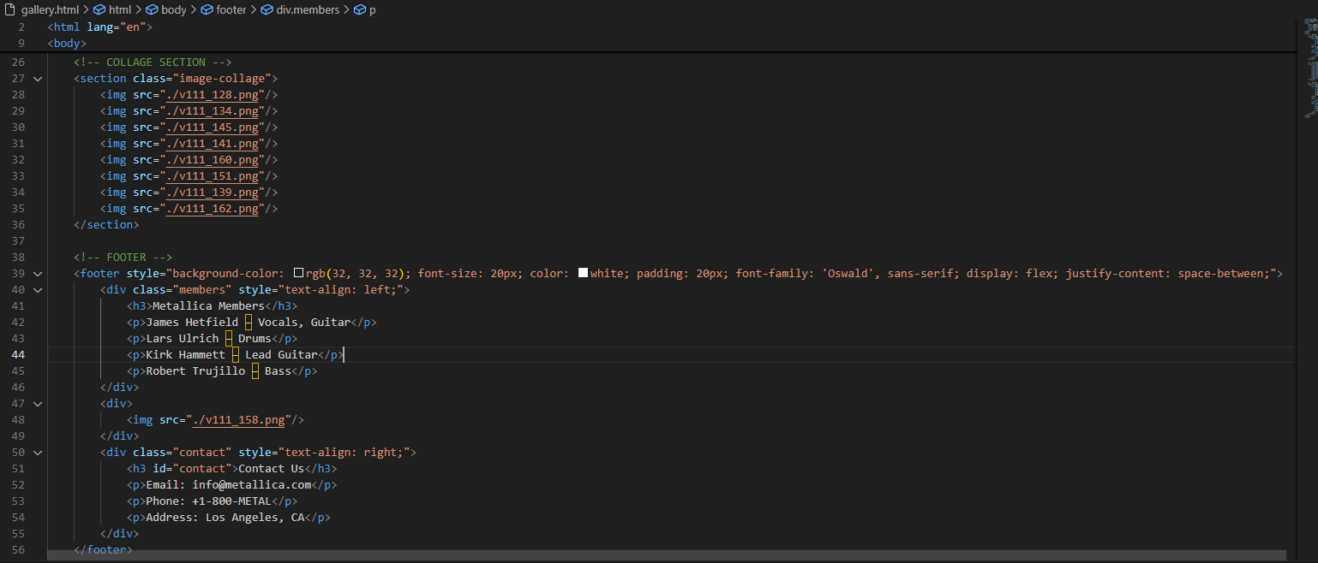

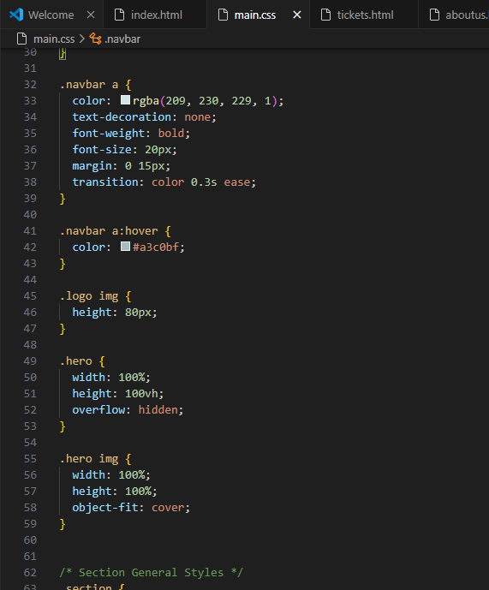

**13. Screenshots**

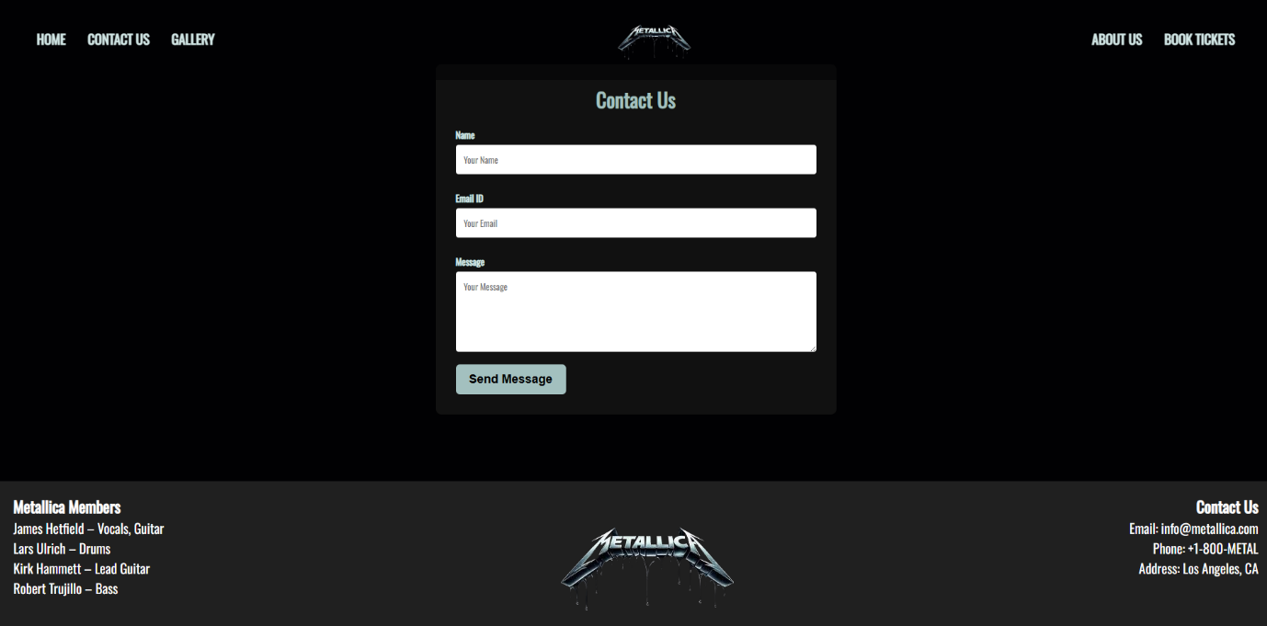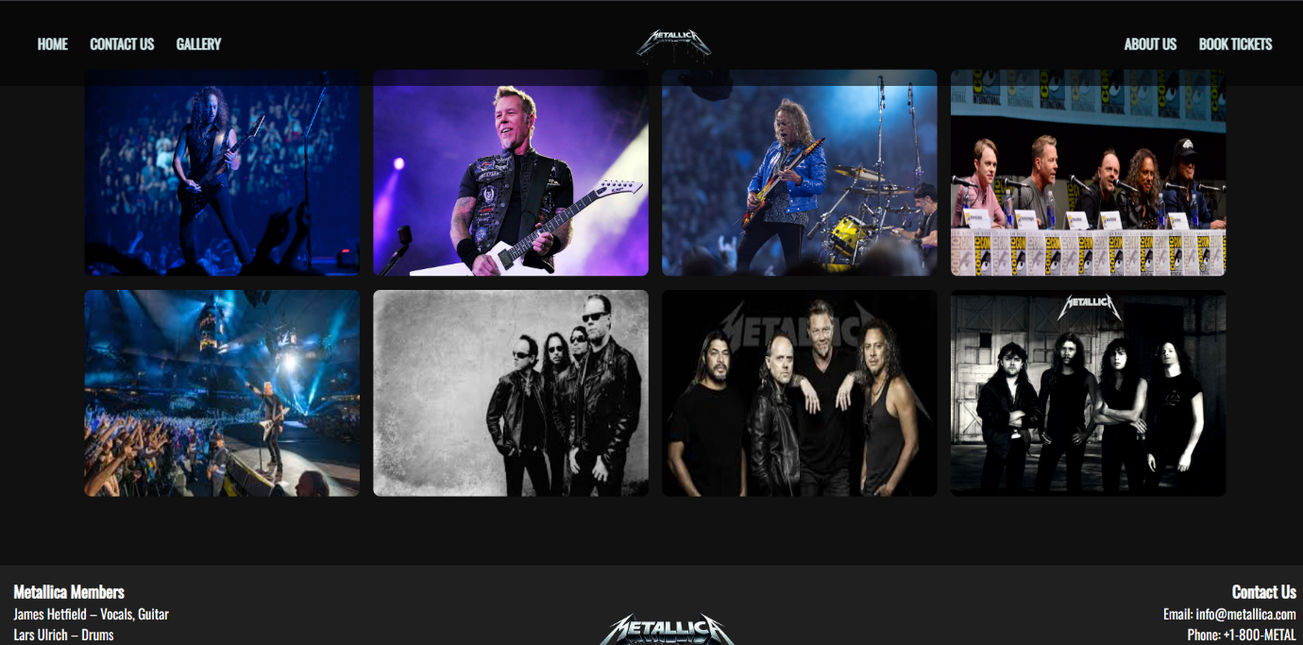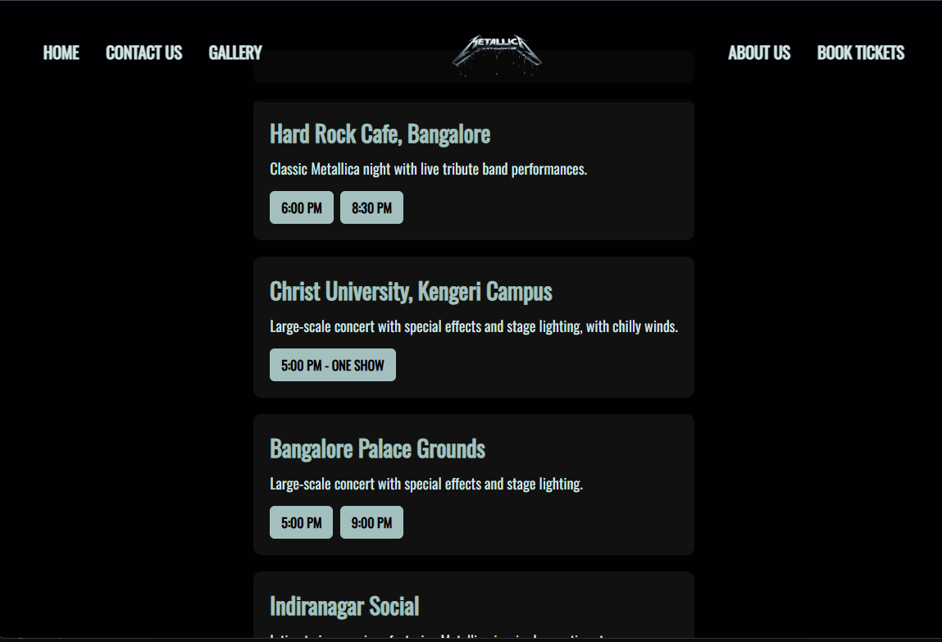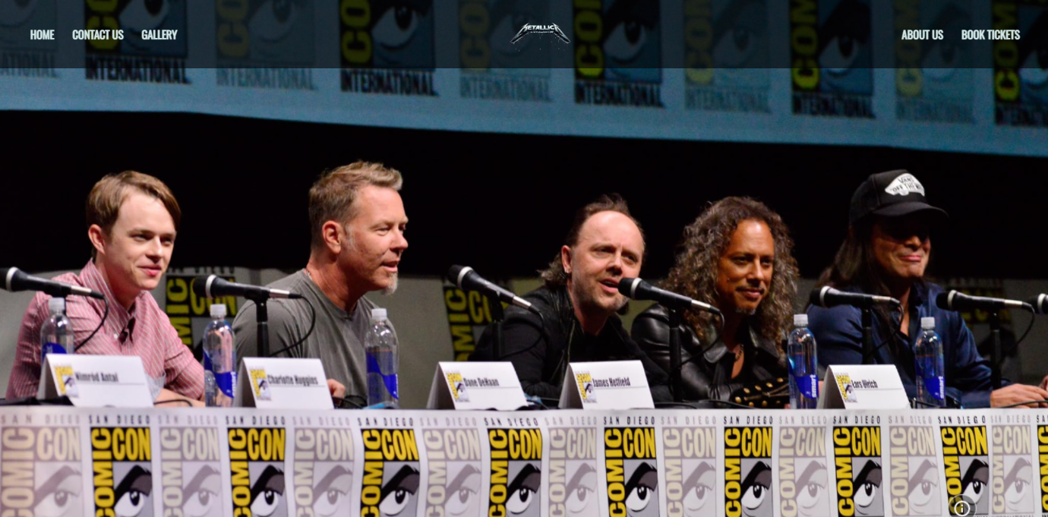

**References**

* **L&T LMS:**

https://learn.lntedutech.com/Landing/MyCourse