Design of PWM Generator in Verilog

Roll No | Name of the team Member | Sign
04 | Arya Mahesh Pal
Date of Submission: 5-04-2026
Abstract | The PWM (Pulse Width Modulation) Generator is designed using Verilog HDL. The design follows a behavioral modeling approach where a counter is compared with a duty cycle input to generate PWM output. Simulation is performed using Xilinx Vivado to verify correct operation for different duty cycles.
Introduction | Problem Statement :Design a PWM generator that produces a digital output signal with variable duty cycle.  System Specifications:  • 8-bit duty cycle input  • Output: PWM signal  • Clock driven system  • Duty cycle range: 0–100%  Tools Used: Xilinx Vivado
Design Methodology | Block Diagram:  +-------------+  Clk -- | |  | Counter |  | (8-bit) |  +-------------+  |  | counter value  v  +-----------------+  Duty | Comparator | ------> Pwm_out  (8-bit) | ( < check ) |  +-----------------+  Finite State Machine (FSM):  FSM is not used in this design as it is based on simple sequential logic and does not involve state transitions.  Module Hierarchy: The design consists of a single top-level module pwm_generator, which internally includes counter and comparator logic.
Verilog Implementation | Code:  module pwm_generator(  input clk,  input [7:0] duty,  output reg pwm_out  );  reg [7:0] counter = 0;  always @(posedge clk)  begin  counter <= counter + 1;  if(counter < duty)  pwm_out <= 1;  else  pwm_out <= 0;  end  endmodule  Design Style:  • Behavioral modeling used  • Simple comparator logic  • Efficient and synthesizable
Verification & Simulation  Waveform | Testbench:  module tb_pwm;  reg clk;  reg [7:0] duty;  wire pwm_out;  pwm_generator uut(.clk(clk),.duty(duty),.pwm_out(pwm_out));  always #5 clk=~clk;  initial begin  clk=0;  duty=64;  #100;  duty=128;  #100;  duty=192;  #100;  $stop;  end  endmodule  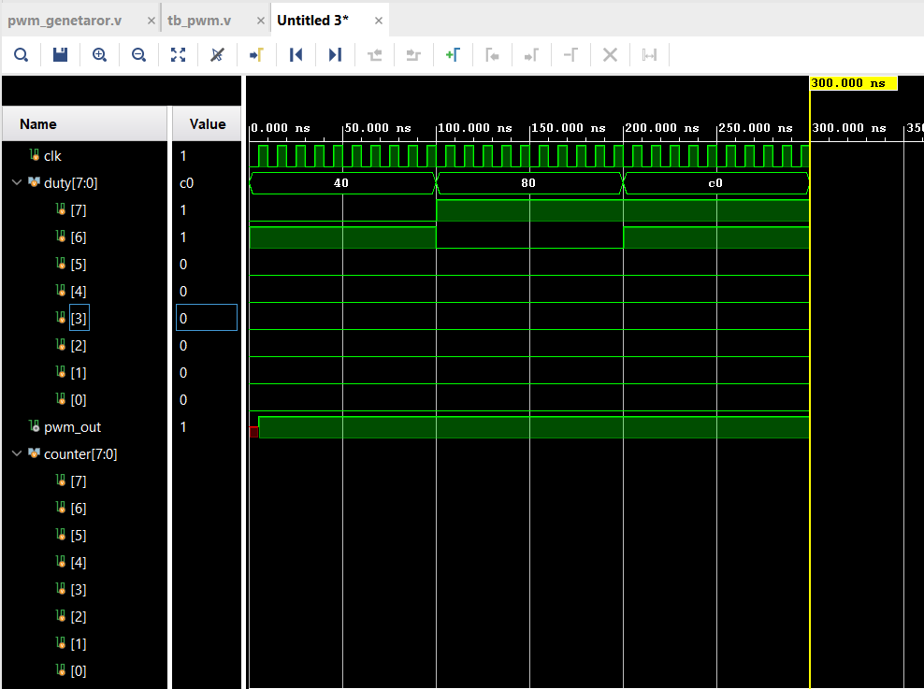
Synthesis Results  Resource Utilization  Power | RTL Schematic:  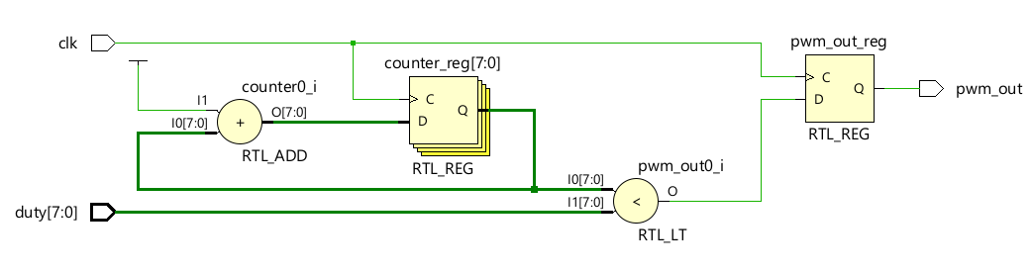  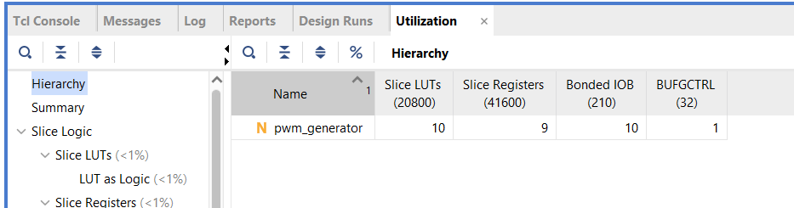  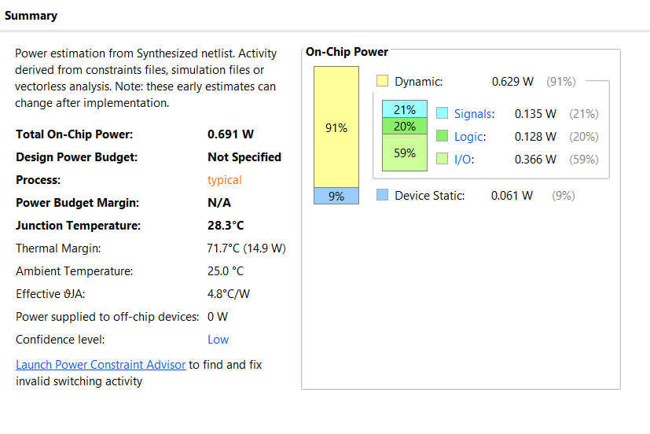
Conclusion  Future Scope | The PWM Generator was successfully designed and verified. The output waveform correctly changes with different duty cycle inputs.  • Increase resolution (more bits)  • Add variable frequency control  • Apply in motor control / LED dimming  • Optimize for low power

Name of Teacher | Mrs.M.N.Kalbande | Sign
Marks

