**CSC/ECE 573 Lab Instructions: Fall 2018**

**INSTRUCTIONS**

1. Access https://vcl.ncsu.edu to reserve a VCL Instance.
2. Login to your account to reserve a VM under Reservations Tab.
3. Click on New Reservation and select "Ubuntu 16.04 LTS Base" and Select duration in such a way that you have it reserved for long duration.
4. Copy CSC573LAB file to that VM and use “cd” to get into that folder.
5. Give permissions to docker-env.sh file in CSC573LAB folder by using the command:

“chmod u+x docker-env.sh”

1. In CSC573LAB folder, Run the below command to install setup, it will take few minutes:

“./docker-env.sh”

1. Once setup is installed, you could see it as below:

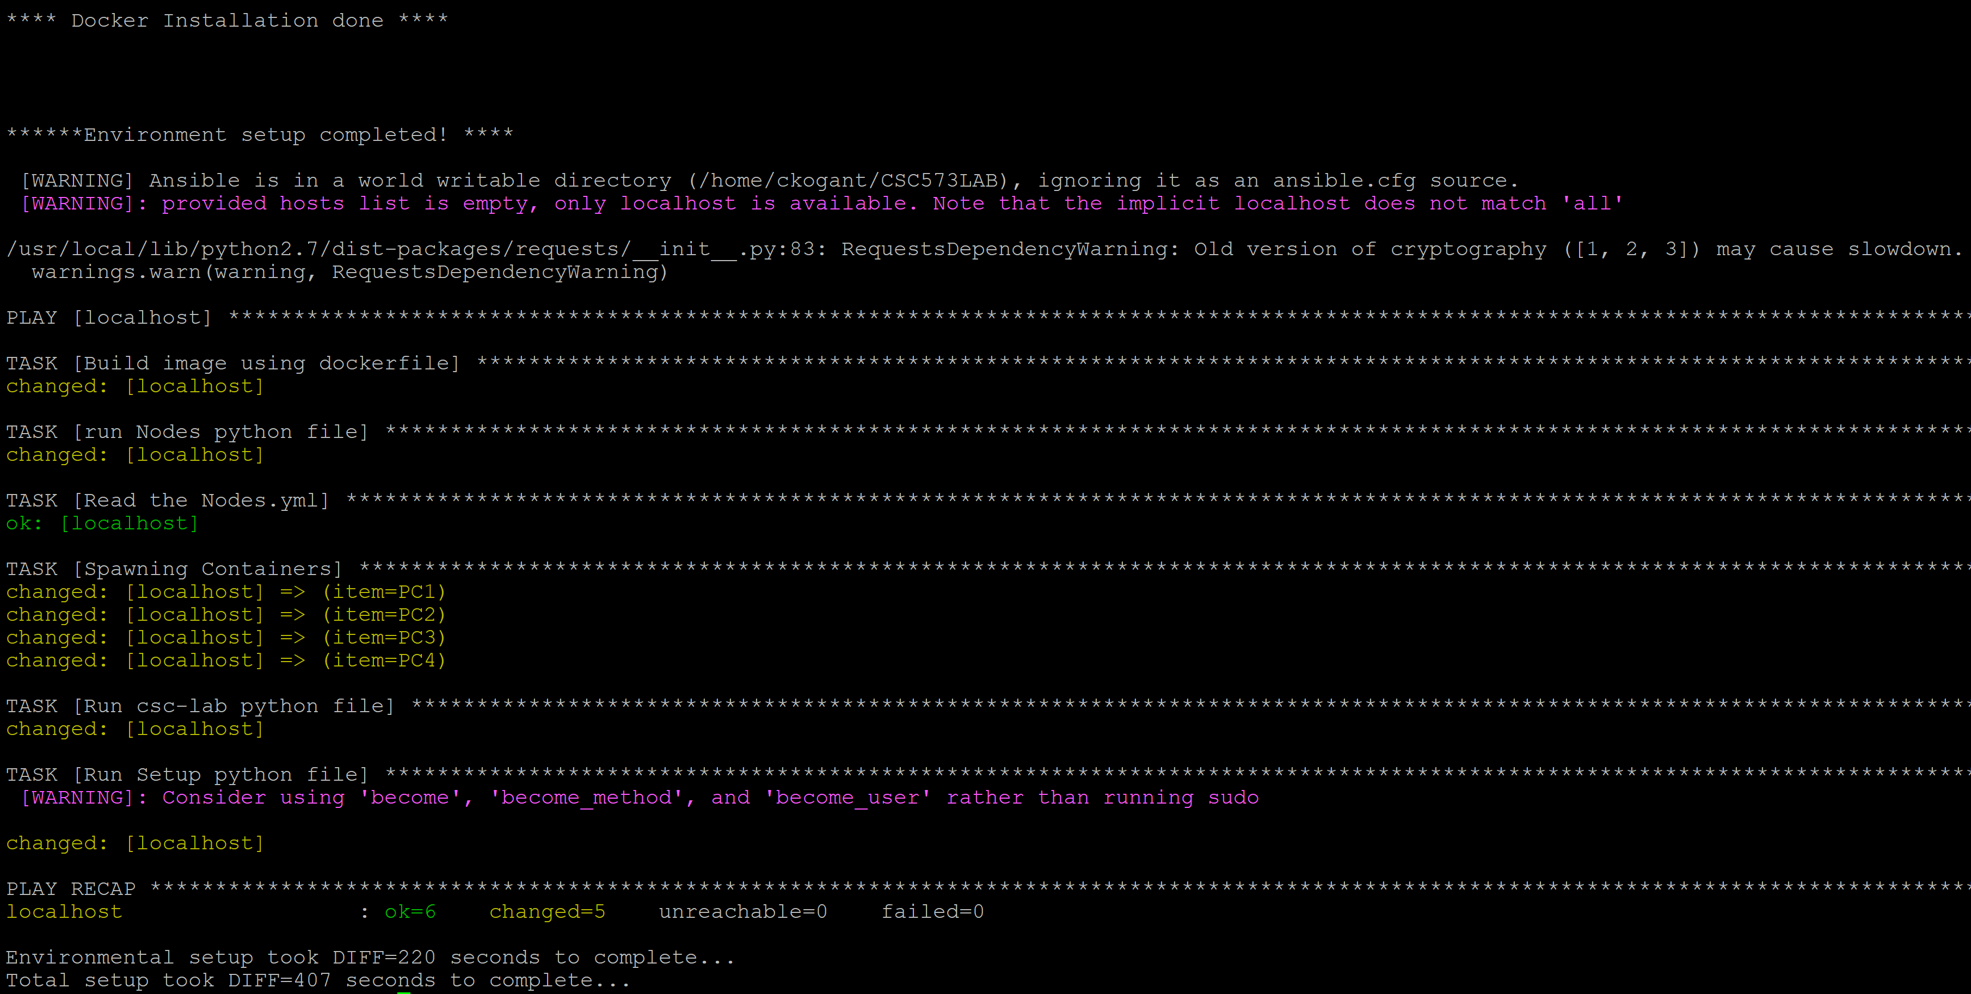

**LAB CONFIGURATION**

1. The machines PC1 – PC4 are connected as in the topology shown below.

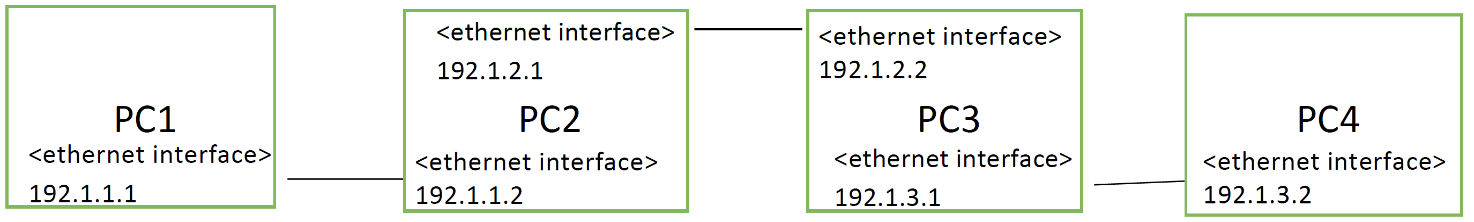

1. The IP address are to be assigned to the PC as per the exercise.
2. You can access the Management IP of the PC’s (PC1, PC2, PC3, PC4) in sequence of 172.17.0.2 ..... 172.17.0.254 respectively.
3. You can login into the PC(PC1), Similarly others with username: root, password: passwd as below:

“ssh root@PC1”

1. whenever done with a particular PC, you can logout by typing “exit” from that PC.

**INSTRUCTIONS TO CAPTURE WIRESHARK**

1. You can download wireshark at “https://www.wireshark.org/download.html” on to your

Laptop.

2. Find the path where wireshark is installed (For Windows it would be mostly "C:\Program

Files\Wireshark")

3. Open Command Prompt and enter below command:

“cd C:\Program Files\Wireshark”

4. In command prompt, To take wireshark capture at an interface(eth1) of a particular PC(PC1 - 172.17.0.2), the port number would be 1702(last four digits from its IP), similarly for PC2 with 172.17.0.3 it would be 1703.

#Importantly we should use IP of the reserved host from VCL which is 152.46.19.96(in my example). The only parameter that varies for different PC’s is the part after -p. Run this command in command prompt of your laptop.

“ssh -X root@152.46.19.96 -p 1702 tcpdump -U -s0 -n -w - -i eth1 | wireshark -k -i –“

5. After executing above command, you will notice wireshark application starting in your laptop, Go to command prompt and provide password as "passwd" in command prompt for wireshark to get access to the PC(PC1).