LORE Study Guide: Star Birth: From Cosmic Dust to Shining Suns
Generated by LORE — Live, Orchestrated, Reactive Encyclopaedia

Chapter 1: Cosmic Nurseries
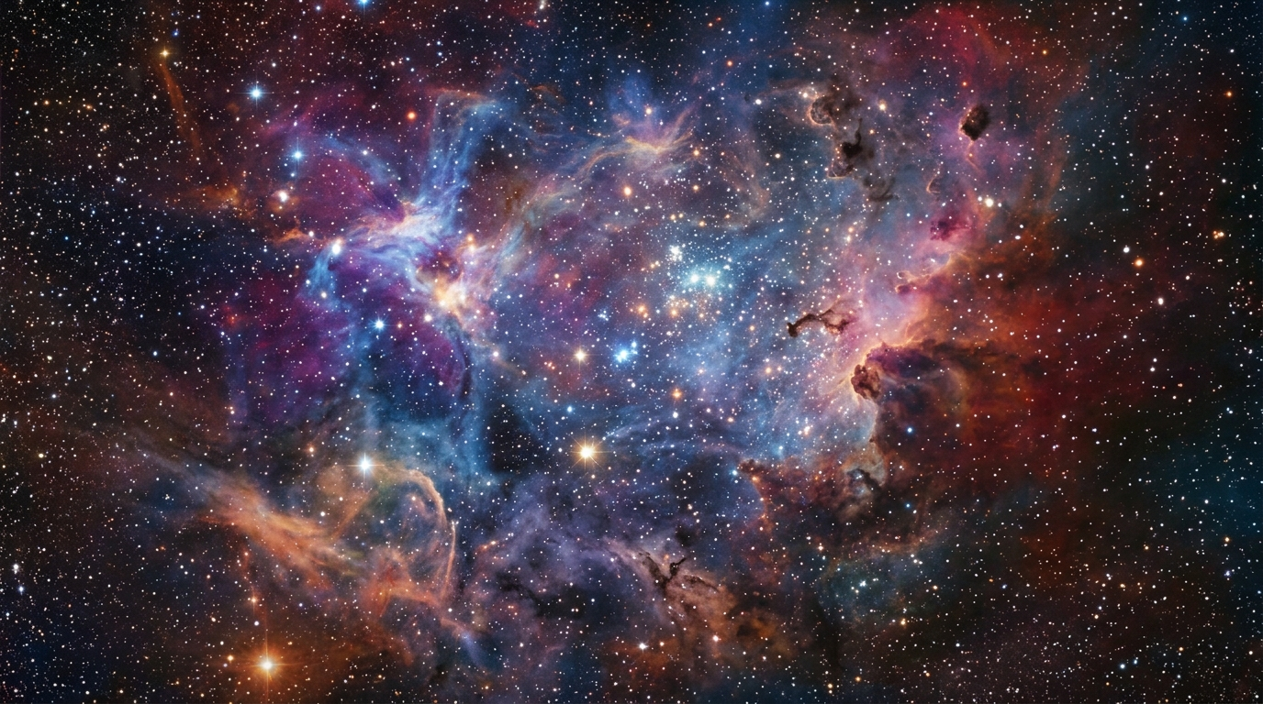
Deep within the cosmic abyss, stretching across distances so vast they defy imagination, lie the universe's most majestic nurseries: nebulae. These aren't merely ethereal clouds of gas and dust; they are the colossal wombs where stars are conceived. Primarily hydrogen and helium, laced with flecks of cosmic dust, these immense stellar cradles can span light-years, existing in a state of frigid stillness.
Yet, even in this profound quiet, an ancient force stirs. Gravity, the universe's patient sculptor, begins its work. Imperceptible differences in density—a slightly thicker clump of gas here, a denser pocket there—become tiny anchors. Slowly, over eons, these minute variations exert their gravitational pull, drawing in more material, setting the first, glacial wheels of star birth into motion.

Explore deeper:
- Nebula Colors: Discover how different elements within a nebula emit light at specific wavelengths, painting the cosmos with vibrant hues.
- Cosmic Dust Lanes: Uncover the role of these dark, obscuring lanes of interstellar dust and gas in shaping nebulae and fostering new stars.
- Stellar Nurseries: Learn how gravity slowly draws together pockets of denser material within nebulae, initiating the birth of new stars.

Chapter 2: The Protostar's Embrace
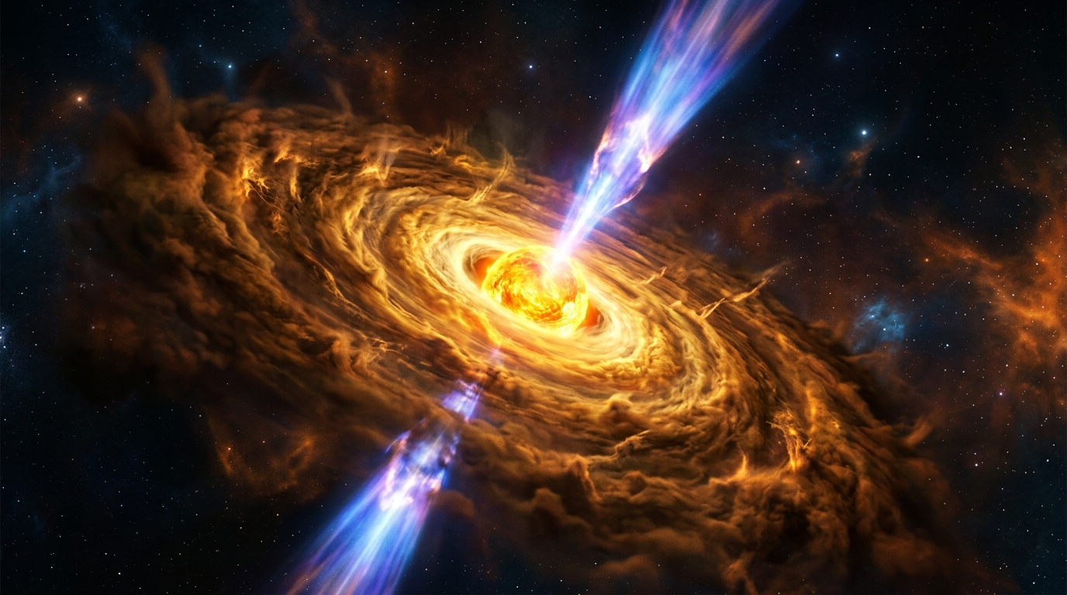
As the cosmic cloud contracts, gravity's grip tightens, pulling matter inward with ferocious speed. The once diffuse gas now races towards a growing heart, compressing, heating, and spinning ever faster – a dizzying ballet born of angular momentum conservation. At its core, a dense, fiery sphere ignites: the protostar.
Around this nascent sun, a vast, flat accretion disk takes shape, a swirling whirlpool of gas and dust spiraling relentlessly inward, feeding the hungry star. Yet, not all material succumbs. From the poles of this energetic infant, colossal jets of plasma erupt. Like cosmic geysers, these bipolar outflows, known as Herbig-Haro objects, blast away excess angular momentum, a violent but vital act that sculpts its future and clears a path for the star to truly shine.

Explore deeper:
- Nascent Protostar: Discover how gravity collapses vast clouds of gas and dust to ignite the birth of a new star.
- Protoplanetary Disk: Explore how this disk of cosmic material acts as a cosmic construction site for planets and other celestial bodies.
- Bipolar Plasma Jets: Uncover the mysterious forces that propel these powerful streams of matter thousands of light-years into space.

Chapter 3: Stellar Ignition
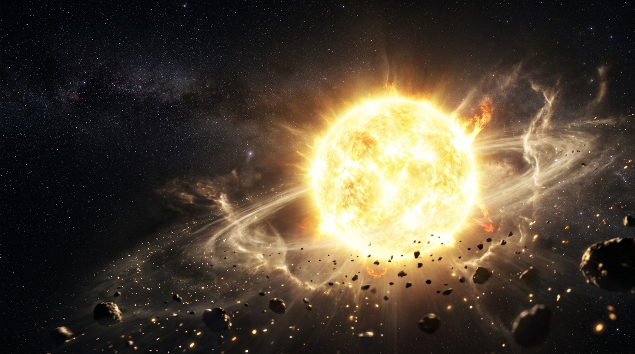
As gravity's crushing embrace tightened, the protostar's core became an inferno. Temperatures soared to millions of degrees Celsius, and pressure grew immense, a cosmic squeeze unlike anything imaginable. Then, deep within that superheated crucible, the universe's ultimate furnace roared to life. Hydrogen atoms, forged together with unimaginable force, finally fused into helium. This wasn't just a chemical reaction; it was nuclear alchemy, unleashing a torrent of pure energy. This outward rush of power met gravity's inward pull with an equal, outward roar. A perfect, fiery equilibrium was struck. A true star was born, blazing forth with steady brilliance, destined to illuminate the cosmos for billions of years.

Explore deeper:
- Young Star: Discover the dramatic birth and early life of a star, from collapsing gas cloud to luminous giant, and how it ignites its nuclear furnace.
- Accretion Disk: Uncover the swirling cosmic dance of gas and dust that feeds a newborn star and paves the way for planet formation.
- Starfield Background: Journey beyond the new star to explore the vast, dark tapestry of interstellar space, dotted with countless distant suns and cosmic wonders.

Key Concepts Summary
- Nebula Colors: Discover how different elements within a nebula emit light at specific wavelengths, painting the cosmos with vibrant hues.
- Cosmic Dust Lanes: Uncover the role of these dark, obscuring lanes of interstellar dust and gas in shaping nebulae and fostering new stars.
- Stellar Nurseries: Learn how gravity slowly draws together pockets of denser material within nebulae, initiating the birth of new stars.
- Nascent Protostar: Discover how gravity collapses vast clouds of gas and dust to ignite the birth of a new star.
- Protoplanetary Disk: Explore how this disk of cosmic material acts as a cosmic construction site for planets and other celestial bodies.
- Bipolar Plasma Jets: Uncover the mysterious forces that propel these powerful streams of matter thousands of light-years into space.
- Young Star: Discover the dramatic birth and early life of a star, from collapsing gas cloud to luminous giant, and how it ignites its nuclear furnace.
- Accretion Disk: Uncover the swirling cosmic dance of gas and dust that feeds a newborn star and paves the way for planet formation.
- Starfield Background: Journey beyond the new star to explore the vast, dark tapestry of interstellar space, dotted with countless distant suns and cosmic wonders.

