LORE Study Guide: The Epic Journey of Human Evolution
Generated by LORE — Live, Orchestrated, Reactive Encyclopaedia

Chapter 1: First Steps: The Dawn of Bipedalism
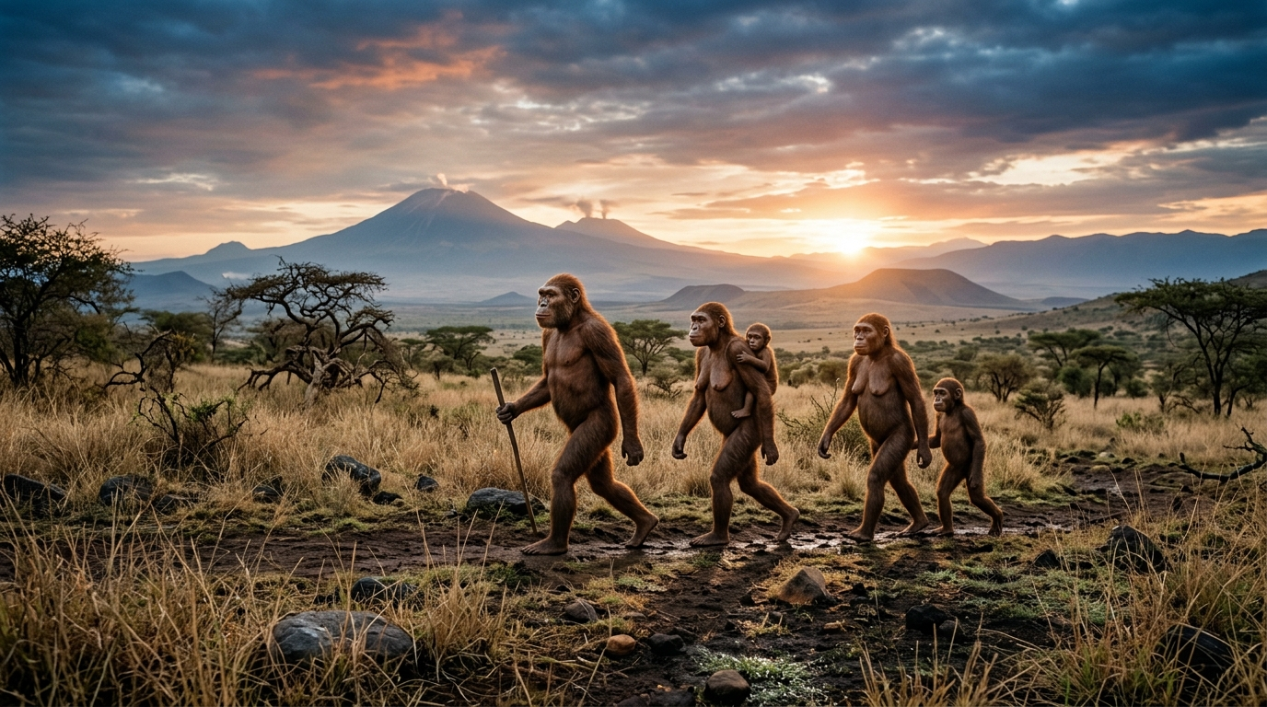
Millions of years ago, Africa's lush forests began to recede, giving way to vast, sun-drenched savannas. This shifting landscape presented a profound challenge, and an extraordinary opportunity. Among our ancient ancestors, like the nimble *Australopithecus*, a revolutionary gait began to emerge. Standing upright offered a panoramic view over tall grasses, crucial for spotting predators or distant food. It freed their hands to carry precious resources or even wield simple tools. Over countless generations, their bodies reshaped: the pelvis broadened, the spine curved into an S-shape, and feet evolved into stable platforms. Fossils like the iconic 'Lucy' reveal these pivotal adaptations, etched into bone. This audacious step, from knuckle-walking to upright stride, wasn't just a change in posture; it was the genesis of humanity.

Explore deeper:
- Australopithecus afarensis: Discover how these early hominids took humanity's first significant steps towards walking upright, fundamentally changing their future.
- Ancient Savanna: Explore how the changing landscape of the East African savanna spurred the evolution of bipedalism and shaped early hominid life.
- Distant Volcanoes: Uncover the dramatic geological forces of the East African Rift Valley that shaped the landscape where early human ancestors walked.

Chapter 2: Mastering the Environment: Tools, Fire, and Migration
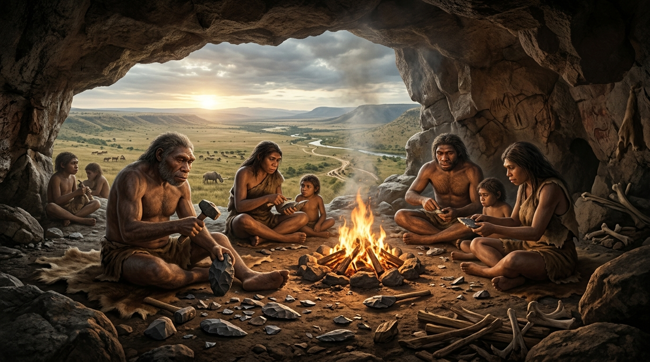
A new era dawned with *Homo erectus*, marked by an unprecedented surge in ingenuity. Their hands sculpted the Acheulean hand-axe – a true Stone Age multi-tool, a testament to a mind capable of foresight and refined design.
But their greatest triumph was the taming of fire. No longer just a terrifying force, the wild flame became a controlled ally: a warmth against the cold, a guardian in the dark, and a kitchen that unlocked vital nutrients from tougher foods. This richer diet fueled an expanding brain, a cognitive leap.
Empowered by sophisticated tools and the hearth's glow, *Homo erectus* shattered the boundaries of their African birthplace. They became the first hominids to embark on a global odyssey, their footprints tracing an epic path across continents, from the plains of Asia to the forests of Europe. A testament to unparalleled adaptability.

Explore deeper:
- Homo erectus Clan: Discover how Homo erectus, with their larger brains and upright stance, mastered their environment and became the first global travelers.
- Controlled Fire: Uncover the transformative impact of controlled fire, a pivotal invention that revolutionized cooking, protection, and social bonding for early humans.
- Acheulean Tools: Explore the ingenuity behind Acheulean handaxes, revealing how these versatile stone tools shaped Homo erectus's ability to hunt, butcher, and thrive.

Chapter 3: The Neanderthal World: Culture and Coexistence
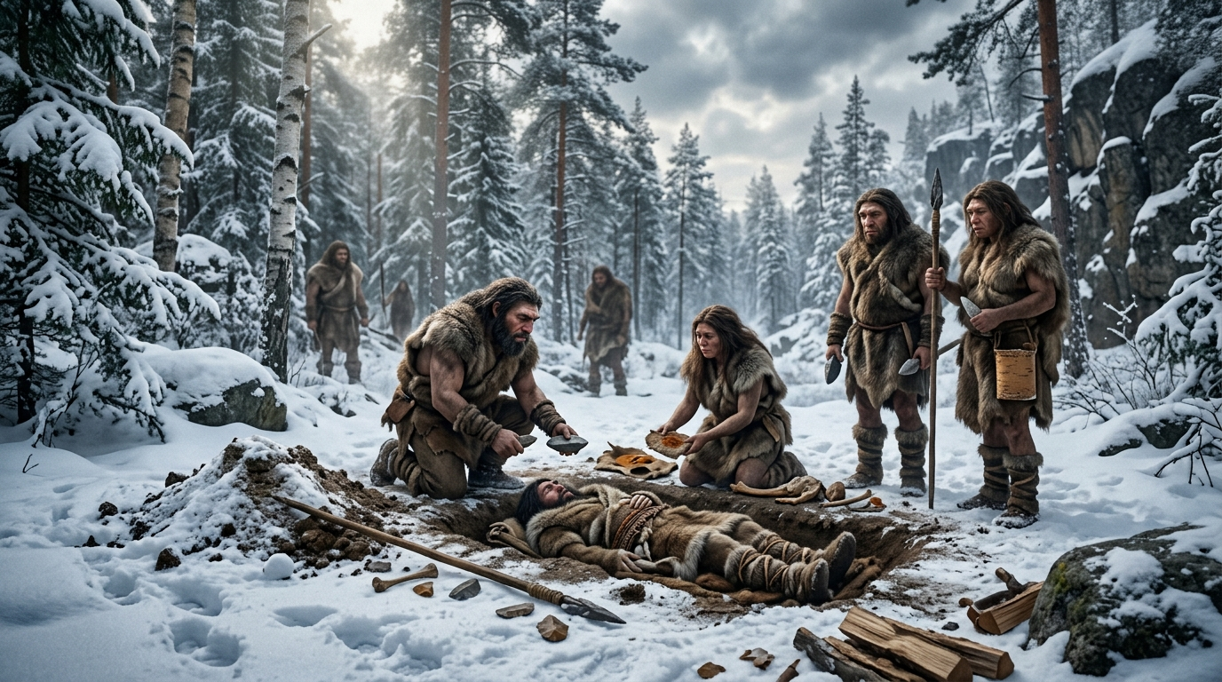
Imagine a world sculpted by ice, where towering glaciers carved landscapes and the air bit with a relentless chill. This was the stage for the Neanderthals. Stockier, more robust than us, their bodies were living fortresses against the cold, perfectly honed for survival in Ice Age Eurasia. But they were far more than just resilient survivors. Their hands crafted sophisticated tools, their minds devised intricate hunting strategies, and their communities cared for the sick and elderly. They buried their dead with purpose, adorned themselves with shells and pigments, and perhaps even left their mark on cave walls—whispers of a complex inner world. For millennia, they navigated this harsh world, sometimes even sharing the landscape with our own ancestors, Homo sapiens, before their eventual disappearance.

Explore deeper:
- Neanderthal Physique: Discover how their stocky build, strong bones, and distinctive facial features were perfect adaptations for surviving the Ice Age.
- Mousterian Stone Tools: Uncover the ingenuity behind the specialized stone tools crafted by Neanderthals, essential for hunting, butchering, and daily survival.
- Neanderthal Society: Explore the complex social structures, cooperative behaviors, and cultural practices that allowed Neanderthals to thrive in challenging environments.

Chapter 4: The Global Pioneers: Homo sapiens' Ascent
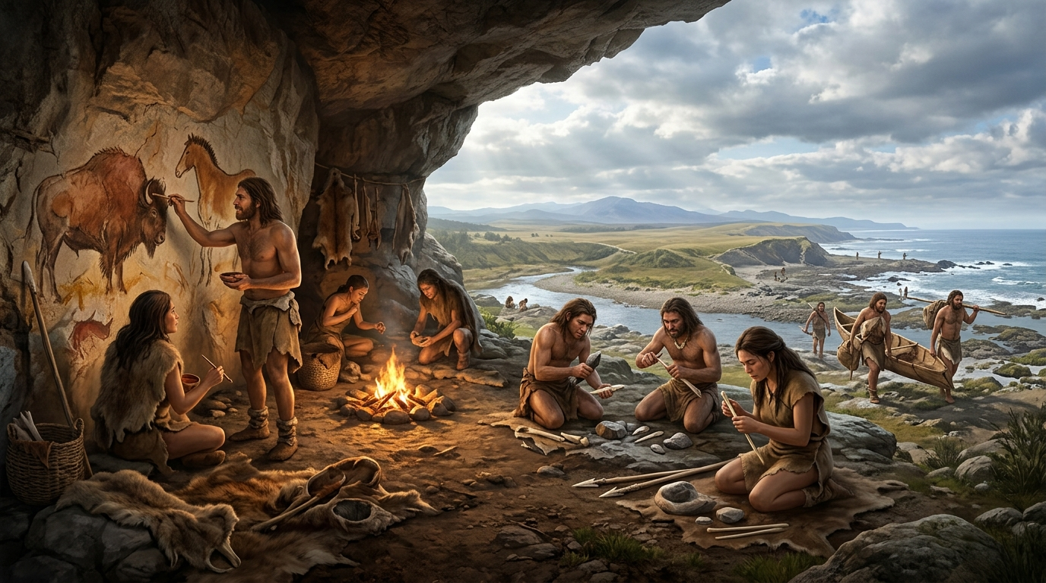
From the crucible of Africa, a new kind of hominid emerged: Homo sapiens. Unlike their predecessors, these pioneers possessed an extraordinary spark – a mind capable of abstract thought, complex language, and a boundless capacity for innovation. With each generation, their tools grew sharper, their hunting techniques more sophisticated, from finely crafted blade tools to the ingenious atlatl. This cognitive leap fueled an epic journey. They ventured 'Out of Africa', navigating deserts, frozen tundras, and vast oceans. Their adaptability was unmatched, allowing them to thrive in every corner of the planet, ultimately shaping every environment they touched and leaving other hominids in their wake.

Explore deeper:
- Cave Art: Discover how early humans used pigments and natural surfaces to create enduring masterpieces that tell stories of their world.
- Bone Tools: Uncover the ingenious methods early humans employed to transform animal bones into essential tools for survival, hunting, and daily life.
- Coastal Migration: Learn how early Homo sapiens used coastlines as pathways for expansion, adapting to new marine environments and exploring uncharted territories.

Key Concepts Summary
- Australopithecus afarensis: Discover how these early hominids took humanity's first significant steps towards walking upright, fundamentally changing their future.
- Ancient Savanna: Explore how the changing landscape of the East African savanna spurred the evolution of bipedalism and shaped early hominid life.
- Distant Volcanoes: Uncover the dramatic geological forces of the East African Rift Valley that shaped the landscape where early human ancestors walked.
- Homo erectus Clan: Discover how Homo erectus, with their larger brains and upright stance, mastered their environment and became the first global travelers.
- Controlled Fire: Uncover the transformative impact of controlled fire, a pivotal invention that revolutionized cooking, protection, and social bonding for early humans.
- Acheulean Tools: Explore the ingenuity behind Acheulean handaxes, revealing how these versatile stone tools shaped Homo erectus's ability to hunt, butcher, and thrive.
- Neanderthal Physique: Discover how their stocky build, strong bones, and distinctive facial features were perfect adaptations for surviving the Ice Age.
- Mousterian Stone Tools: Uncover the ingenuity behind the specialized stone tools crafted by Neanderthals, essential for hunting, butchering, and daily survival.
- Neanderthal Society: Explore the complex social structures, cooperative behaviors, and cultural practices that allowed Neanderthals to thrive in challenging environments.
- Cave Art: Discover how early humans used pigments and natural surfaces to create enduring masterpieces that tell stories of their world.
- Bone Tools: Uncover the ingenious methods early humans employed to transform animal bones into essential tools for survival, hunting, and daily life.
- Coastal Migration: Learn how early Homo sapiens used coastlines as pathways for expansion, adapting to new marine environments and exploring uncharted territories.

