LORE Study Guide: Stellar Demise: From Giants to Black Holes
Generated by LORE — Live, Orchestrated, Reactive Encyclopaedia

Chapter 1: The Gentle Demise: Red Giants and White Dwarfs
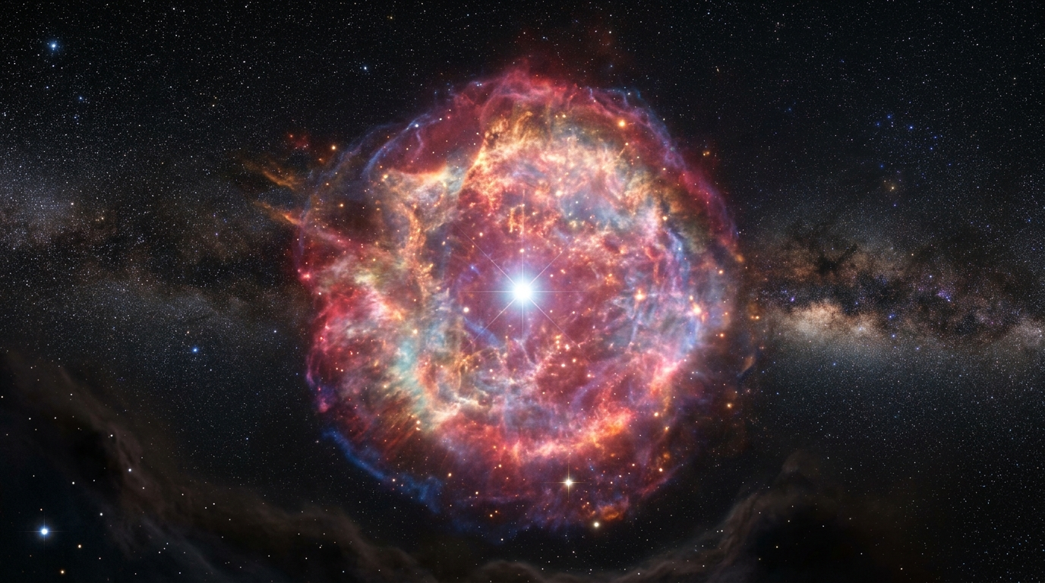
Our Sun, like countless stars across the cosmos, has a gentle, if dramatic, end awaiting it. For billions of years, it burns hydrogen in its core, a stable furnace. But eventually, that fuel runs low. The core contracts, heats up, and ignites a shell of hydrogen around it. This surge of energy forces the star's outer layers to balloon outwards, cooling as they expand into a luminous, sprawling red giant. Then, in a final act of stellar exhaling, these outer envelopes drift away into space, forming breathtaking, iridescent clouds known as planetary nebulae. What remains is a compact, incredibly dense ember – a white dwarf, a relic of a once-vibrant star, no longer fusing, but slowly cooling across the eons.

Explore deeper:
- Red Giant Star: Discover how stars like our Sun expand dramatically, shedding their outer layers to create cosmic wonders.
- Planetary Nebula: Uncover the beautiful, short-lived cosmic clouds formed from dying stars, revealing their intricate shapes and vibrant colors.
- White Dwarf Star: Explore the dense, hot remnants of stars like our Sun, shining brightly long after their nuclear fuel is exhausted.

Chapter 2: The Path to Cataclysm: Red Supergiants
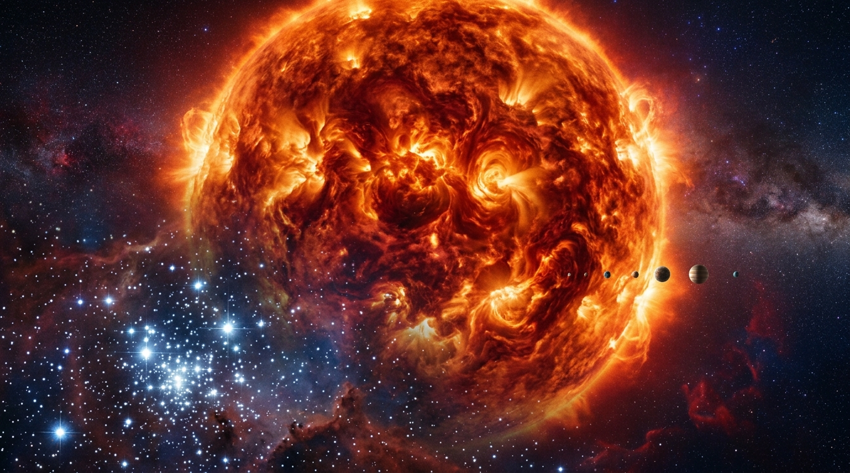
Imagine a star, once a brilliant blue beacon, now swollen to a titanic red giant, its outer layers billowing into the void. This colossal furnace, a red supergiant, lives fast and dies young. Within its heart, a furious alchemy unfolds in concentric shells. Hydrogen burns to helium, helium to carbon, then oxygen, neon, magnesium, and finally, silicon – each stage burning hotter, faster, and deeper. But this relentless cosmic forge has a limit. When silicon fuses, it creates iron. And iron is a cosmic dead end. It cannot fuse to release energy; instead, it *absorbs* it. With its internal furnace suddenly extinguished, the star's core loses its battle against the crushing grip of gravity. The stage is set for an unimaginable collapse.

Explore deeper:
- Red Supergiant Star: Discover why these colossal stars shine red and how they dwarf even our Sun in the cosmic scale.
- Turbulent Atmosphere: Explore the powerful forces that churn the glowing gases of a supergiant's outer layers, driving its visible instability.
- Stellar Core: Uncover the intense nuclear fusion processes deep within a supergiant that power its immense glow and lead to its dramatic end.

Chapter 3: The Cosmic Firework: Supernova!
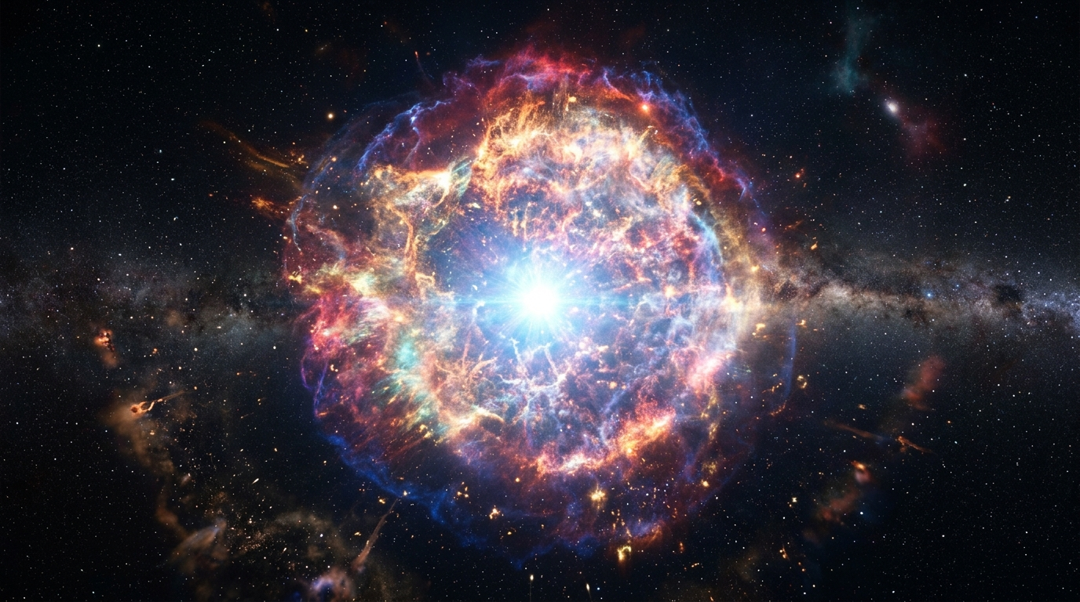
Imagine a star so vast, it’s a cosmic titan. But even giants face an end. When its core becomes pure iron, a sudden, catastrophic implosion begins. Gravity, unleashed, crushes the core inward at incredible speeds. But there's a limit. The core, now denser than an atomic nucleus, slams into itself, rebounding with unimaginable force. This is the cosmic bounce. A colossal shockwave rips through the star's outer layers, ejecting them into space in a spectacular, blinding explosion – a supernova. For a fleeting moment, it can outshine an entire galaxy. This cataclysmic event doesn't just destroy; it forges and scatters the universe's heavy elements, the very building blocks of new stars, planets, and even us.

Explore deeper:
- Supernova Remnant: Uncover the violent aftermath of a star's death, where its core collapses and its outer layers are violently flung into space.
- Expanding Shockwave: Witness the incredible speed and energy of the expanding wave of gas and dust pushing through the cosmos, carving out new structures.
- Interstellar Dust: Discover how the microscopic particles scattered between stars are illuminated and transformed by the supernova's powerful light and energy.

Chapter 4: The Extreme Remnants: Neutron Stars and Black Holes
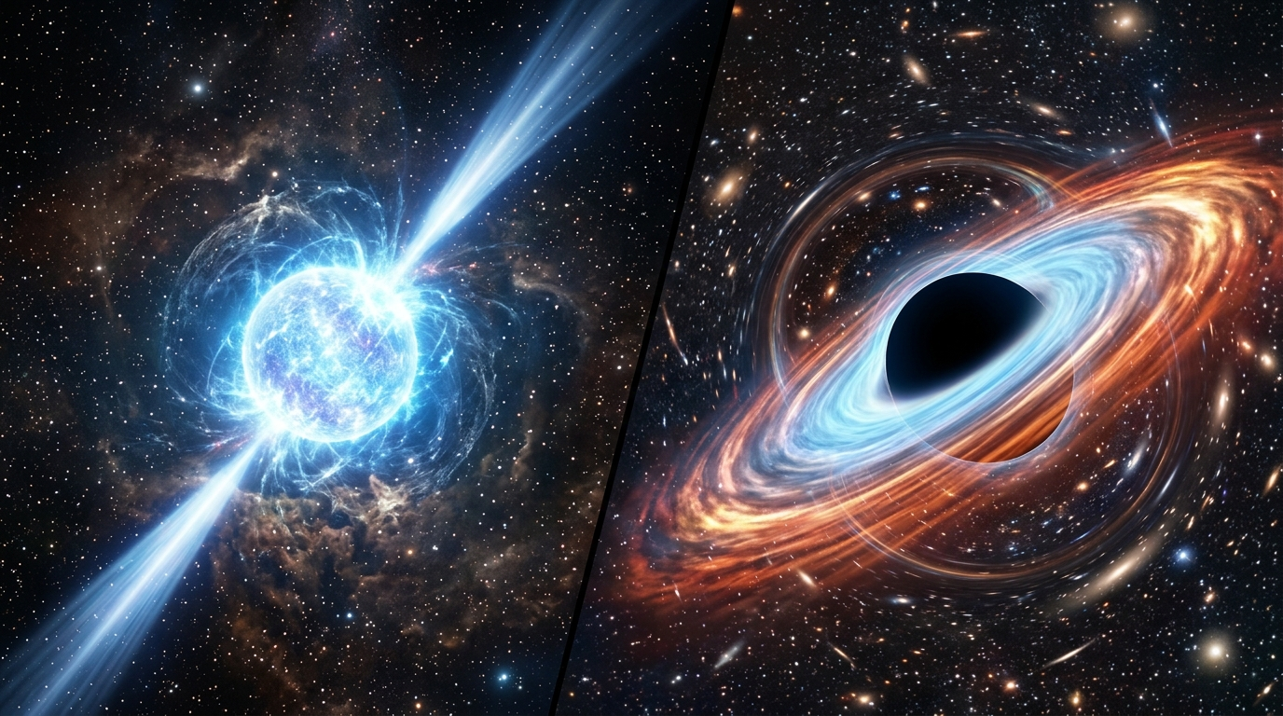
When a colossal star detonates in a supernova, its core faces a dramatic choice. If not too massive, the immense pressure crushes atoms, forcing protons and electrons to merge into an impossibly dense sphere of neutrons. This is a neutron star: a city-sized cosmic jewel weighing more than our sun, its degenerate matter resisting further collapse. Some spin furiously, beaming lighthouse-like pulses across the cosmos—pulsars.
But if the progenitor was truly gargantuan, gravity wins completely. The core collapses infinitely, tearing a hole in spacetime itself. This is a black hole, an inescapable abyss where a singularity waits, veiled by the event horizon—a cosmic boundary from which nothing, not even light, can ever return.

Explore deeper:
- Rotating Pulsar: Discover how these incredibly dense stellar corpses spin incredibly fast, emitting powerful beams of radiation detected as cosmic lighthouses.
- Accretion Disk: Explore the fiery dance of matter spiraling inward towards an invisible black hole, heating to extreme temperatures and emitting intense radiation.
- Gravitational Lensing: Uncover how the immense gravity of massive objects like black holes can bend and distort the path of light, warping our view of distant stars.

Key Concepts Summary
- Red Giant Star: Discover how stars like our Sun expand dramatically, shedding their outer layers to create cosmic wonders.
- Planetary Nebula: Uncover the beautiful, short-lived cosmic clouds formed from dying stars, revealing their intricate shapes and vibrant colors.
- White Dwarf Star: Explore the dense, hot remnants of stars like our Sun, shining brightly long after their nuclear fuel is exhausted.
- Red Supergiant Star: Discover why these colossal stars shine red and how they dwarf even our Sun in the cosmic scale.
- Turbulent Atmosphere: Explore the powerful forces that churn the glowing gases of a supergiant's outer layers, driving its visible instability.
- Stellar Core: Uncover the intense nuclear fusion processes deep within a supergiant that power its immense glow and lead to its dramatic end.
- Supernova Remnant: Uncover the violent aftermath of a star's death, where its core collapses and its outer layers are violently flung into space.
- Expanding Shockwave: Witness the incredible speed and energy of the expanding wave of gas and dust pushing through the cosmos, carving out new structures.
- Interstellar Dust: Discover how the microscopic particles scattered between stars are illuminated and transformed by the supernova's powerful light and energy.
- Rotating Pulsar: Discover how these incredibly dense stellar corpses spin incredibly fast, emitting powerful beams of radiation detected as cosmic lighthouses.
- Accretion Disk: Explore the fiery dance of matter spiraling inward towards an invisible black hole, heating to extreme temperatures and emitting intense radiation.
- Gravitational Lensing: Uncover how the immense gravity of massive objects like black holes can bend and distort the path of light, warping our view of distant stars.

