LORE Study Guide: The Epic Journey of Human Evolution
Generated by LORE — Live, Orchestrated, Reactive Encyclopaedia

Chapter 1: Stepping into the Savanna: The Dawn of Bipedalism

The Miocene epoch saw Africa’s dense forests begin to recede, replaced by vast, sun-drenched savannas. On this new, open stage, a revolutionary posture began to emerge: bipedalism. For early hominins like *Australopithecus*, famously embodied by "Lucy," standing upright was a monumental gamble. It demanded a complete re-engineering of the skeleton, from a bowl-shaped pelvis to angled femurs. Yet, the rewards were immense. A heightened vantage point allowed them to peer over tall grasses, spotting distant predators or food. Free hands could now carry precious resources or vulnerable offspring. And with less surface area exposed to the direct sun, they could stay cooler – a pivotal shift that charted an entirely new course for our lineage.

Explore deeper:
- Australopithecus afarensis: Discover how these ancient hominins, like the famous 'Lucy,' represent a pivotal stage in human evolution.
- Bipedal Walking: Unpack the revolutionary shift to walking on two legs and its profound impact on early human development.
- African Savanna Ecosystem: Journey into the ancient East African savanna, the cradle of humanity, and understand its vital role in shaping early hominin life.

Chapter 2: The Innovators: Tools, Fire, and First Migrations
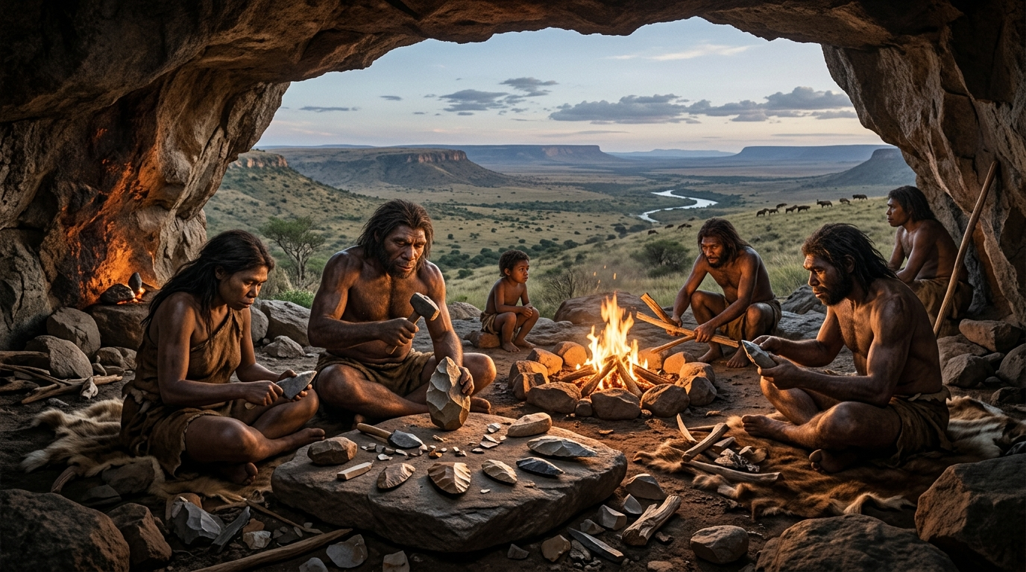
From humble beginnings, our ancestors began to sculpt their world. Early Homo habilis chipped crude Oldowan choppers – a first whisper of ingenuity. But with Homo erectus, a revolution dawned: the Acheulean handaxe. This teardrop masterpiece wasn't just a tool; it was a blueprint, demanding foresight and skill, hinting at minds growing sharper, diets richer.
Then came fire – a controlled blaze that transformed raw into cooked, darkness into safety, and scattered individuals into communal hearths. Armed with these innovations, Homo erectus embarked on an epic journey, the first great exodus out of Africa, a testament to their incredible adaptability, spreading humanity's footprint across continents.

Explore deeper:
- Acheulean Handaxes: Discover how these teardrop-shaped tools revolutionized early human survival, from hunting to butchering and woodworking.
- Controlled Campfire: Uncover the profound impact of mastering fire, transforming early human diet, social structures, and protection from predators.
- Homo erectus Group: Learn about the remarkable journey of Homo erectus, the first hominins to leave Africa and master complex tools and fire.

Chapter 3: The Thinkers: Brains, Culture, and Global Spread
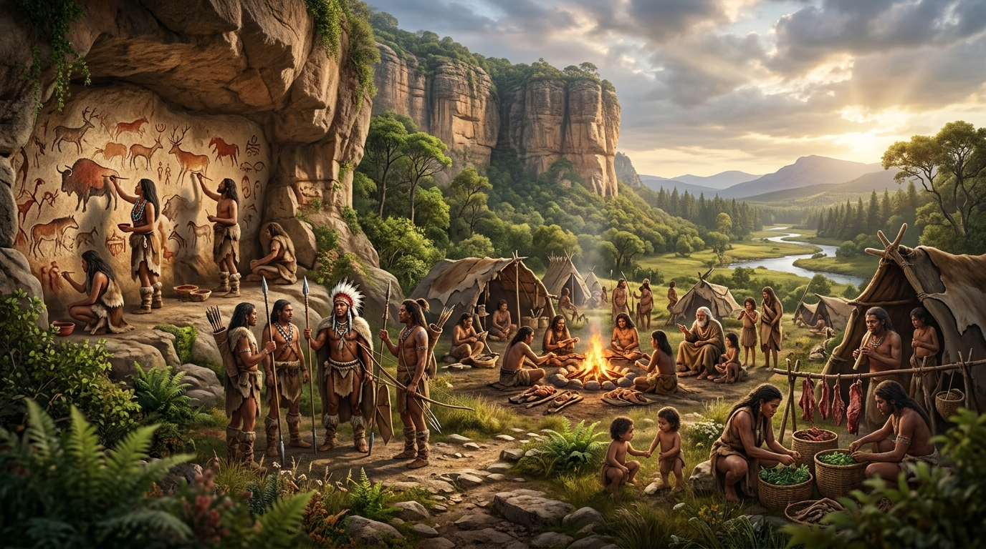
Then, the human story takes a profound turn: brains ignite. Both Neanderthals and early Homo sapiens experienced a cognitive explosion, unlocking complex behaviors, intricate language, and the first whispers of symbolic thought. Neanderthals, robust architects of the Ice Age, crafted tools and cared for their kin, thriving in harsh landscapes. But it was Homo sapiens, with their restless curiosity, who embarked on an unparalleled odyssey.
From an African cradle, they began their second great migration, a ripple across continents. Their journey was not solitary; ancient DNA reveals they met and mingled with other hominins, leaving a genetic mosaic that defines us today—a testament to a shared, complex past.

Explore deeper:
- Cave Art Creation: Discover how early humans transformed raw pigments and rock surfaces into enduring masterpieces, reflecting their worldview and spiritual beliefs.
- Prehistoric Hunting Tools: Explore the ingenuity behind early human hunting tools, from their design and crafting to their crucial role in survival and community development.
- Early Human Society: Uncover the intricate social structures and symbolic rituals that bound early human communities together, fostering cooperation and cultural identity.

Key Concepts Summary
- Australopithecus afarensis: Discover how these ancient hominins, like the famous 'Lucy,' represent a pivotal stage in human evolution.
- Bipedal Walking: Unpack the revolutionary shift to walking on two legs and its profound impact on early human development.
- African Savanna Ecosystem: Journey into the ancient East African savanna, the cradle of humanity, and understand its vital role in shaping early hominin life.
- Acheulean Handaxes: Discover how these teardrop-shaped tools revolutionized early human survival, from hunting to butchering and woodworking.
- Controlled Campfire: Uncover the profound impact of mastering fire, transforming early human diet, social structures, and protection from predators.
- Homo erectus Group: Learn about the remarkable journey of Homo erectus, the first hominins to leave Africa and master complex tools and fire.
- Cave Art Creation: Discover how early humans transformed raw pigments and rock surfaces into enduring masterpieces, reflecting their worldview and spiritual beliefs.
- Prehistoric Hunting Tools: Explore the ingenuity behind early human hunting tools, from their design and crafting to their crucial role in survival and community development.
- Early Human Society: Uncover the intricate social structures and symbolic rituals that bound early human communities together, fostering cooperation and cultural identity.

