LORE Study Guide: The Four Laws of Thermodynamics
Generated by LORE — Live, Orchestrated, Reactive Encyclopaedia

Chapter 1: The Zeroth Law: Defining Temperature

When a hot coffee cup meets a cool countertop, energy flows. But given enough time, they'd reach a point of perfect stasis, a shared thermal equilibrium where no more heat exchanges hands. This quiet truce reveals a fundamental truth: they now share the same temperature. The Zeroth Law of Thermodynamics codifies this insight. It says that if two separate objects are each in equilibrium with a third object—like a thermometer—then those first two objects must also be in equilibrium with each other. This seemingly simple axiom is the bedrock beneath all temperature measurement, allowing us to quantify hotness and coldness, and compare them across the universe, even though this foundational concept was only formally named long after the First and Second Laws.

Explore deeper:
- Digital Thermometer: Discover how thermometers work by reaching thermal equilibrium with their surroundings, a principle central to defining temperature.
- Beaker of Water: Explore the concept of thermal contact and how the Zeroth Law uses a reference object, like this water, to establish a consistent temperature scale.
- Metal Block: Understand how different materials like this metal block interact with heat, exploring concepts like thermal conductivity and insulation.

Chapter 2: The First Law: Energy Conservation
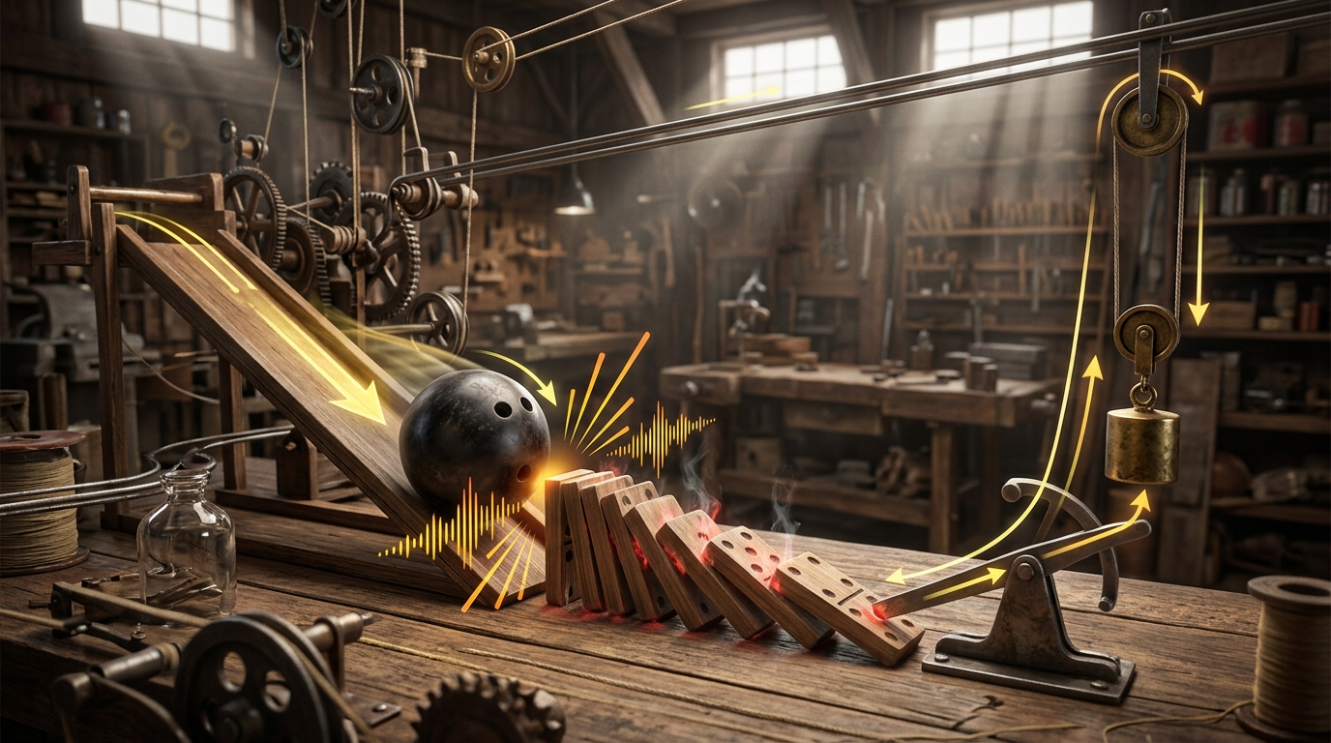
Imagine a grand cosmic accountant, meticulously tracking every single joule, every calorie. This is the universe's most fundamental rule: the First Law of Thermodynamics. It declares that energy is an eternal shape-shifter, never created from nothing, never vanishing into thin air. It simply changes costume – from the chemical potential in a fuel to the fiery heat of combustion, then perhaps to the kinetic thrust of an engine.
Within any isolated system, the total sum of this invisible currency – its internal energy – remains constant. Heat might flow in, work might be done, but the overall balance sheet never falters. Energy doesn't disappear; it merely finds a new expression.

Explore deeper:
- Rolling Bowling Ball: Discover how a heavy ball gains speed down a ramp, converting stored potential energy into motion while adhering to energy conservation.
- Falling Dominoes: Unpack the surprising science behind a chain of falling dominoes and how they efficiently transfer energy with each topple.
- Lifting Lever Mechanism: Explore the simple machine that can multiply force and how it demonstrates work and energy transfer to lift objects, conserving total energy.

Chapter 3: The Second Law: The Arrow of Time and Entropy

Every broken cup, every melting ice cube, every gas expanding to fill a room – these aren't just random events. They are whispers of a fundamental truth: the Second Law of Thermodynamics. This law introduces us to entropy, the universe's relentless drive towards disorder. Imagine a pristine sandcastle; time and tide inevitably reduce it to scattered grains. Systems, left to their own devices, always seek greater randomness. This isn't just a tendency; it's a cosmic imperative. It's why we remember yesterday but not tomorrow, why time flows ever forward. Entropy defines the universe's arrow, pointing towards an ultimate, inevitable state of uniform dispersal, and making perpetual motion an impossible dream.

Explore deeper:
- Eroding Sandcastle: This crumbling structure beautifully illustrates how nature's forces constantly work to increase disorder, a fundamental concept in thermodynamics.
- Pristine Sandcastle: Discover how the creation of this perfectly ordered structure temporarily defies the universe's natural tendency towards disorder, but only with an input of energy.
- Molecular Dispersion: Unpack the microscopic reality behind the Second Law, observing how individual particles naturally spread out to achieve maximum randomness.

Chapter 4: The Third Law: Approaching Absolute Zero
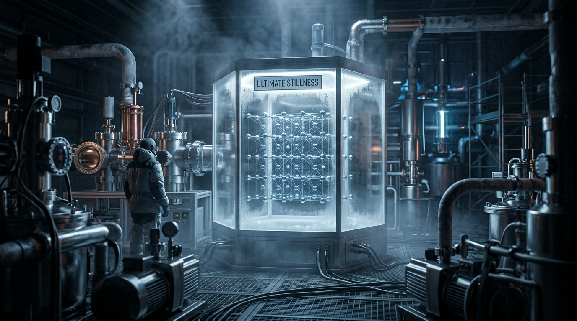
Imagine a temperature so cold, atoms themselves stop dancing. This is absolute zero, the ultimate quiet, where all motion theoretically ceases. The Third Law of Thermodynamics reveals that as we plunge towards this ultimate chill, a system's entropy – its measure of inherent disorder – doesn't just diminish; it approaches a state of perfect, crystalline order. Imagine a universe where every particle falls utterly silent, locked precisely into place. Yet, absolute zero remains an elusive mirage. We can get incredibly close, pushing temperatures to fractions of a Kelvin, but reaching it fully is like chasing a horizon: forever approachable, never attainable. This perpetual pursuit whispers of the quantum secrets hidden in the extreme cold.

Explore deeper:
- Cryogenic Laboratory: Discover the cutting-edge engineering and scientific challenges involved in creating environments just shy of absolute zero.
- Atomic Lattice: Explore how atoms behave in highly ordered, crystalline structures when their thermal energy is almost entirely removed.
- Absolute Zero: Uncover the theoretical limit of cold, its profound implications for matter, and why it can never be truly reached.

Key Concepts Summary
- Digital Thermometer: Discover how thermometers work by reaching thermal equilibrium with their surroundings, a principle central to defining temperature.
- Beaker of Water: Explore the concept of thermal contact and how the Zeroth Law uses a reference object, like this water, to establish a consistent temperature scale.
- Metal Block: Understand how different materials like this metal block interact with heat, exploring concepts like thermal conductivity and insulation.
- Rolling Bowling Ball: Discover how a heavy ball gains speed down a ramp, converting stored potential energy into motion while adhering to energy conservation.
- Falling Dominoes: Unpack the surprising science behind a chain of falling dominoes and how they efficiently transfer energy with each topple.
- Lifting Lever Mechanism: Explore the simple machine that can multiply force and how it demonstrates work and energy transfer to lift objects, conserving total energy.
- Eroding Sandcastle: This crumbling structure beautifully illustrates how nature's forces constantly work to increase disorder, a fundamental concept in thermodynamics.
- Pristine Sandcastle: Discover how the creation of this perfectly ordered structure temporarily defies the universe's natural tendency towards disorder, but only with an input of energy.
- Molecular Dispersion: Unpack the microscopic reality behind the Second Law, observing how individual particles naturally spread out to achieve maximum randomness.
- Cryogenic Laboratory: Discover the cutting-edge engineering and scientific challenges involved in creating environments just shy of absolute zero.
- Atomic Lattice: Explore how atoms behave in highly ordered, crystalline structures when their thermal energy is almost entirely removed.
- Absolute Zero: Uncover the theoretical limit of cold, its profound implications for matter, and why it can never be truly reached.

