TECHNICAL EVALUATION REPORT
Brain Tumour Segmentation: Classical Active Contour Model vs. Deep Learning ResUNet Architecture
———————————————————————————————————————————————————————
1. Executive Summary
Automated brain tumour segmentation from Magnetic Resonance Imaging (MRI) plays a critical role in neuro-oncology, assisting clinicians in diagnosis, treatment planning, and longitudinal monitoring. This report provides a comparative analysis of two prominent paradigms in image segmentation: the classical, energy-minimization based Active Contour Model (ACM) implemented in MATLAB, and a modern, deep learning-based ResUNet architecture.
Key Insight: The deep learning ResUNet architecture demonstrates a substantial paradigm shift, achieving an absolute improvement of +12% in Dice Score and +19% in Intersection-over-Union (IoU) over the traditional Active Contour baseline, establishing automated end-to-end models as the preferred choice for complex clinical workflows.
2. Methodology & Architectural Overview
2.1 Classical Active Contour Model (ACM)
The Active Contour Model, or 'Snake', operates by evolving an initial closed contour curve toward the boundaries of a target region of interest (ROI) via energy minimization. The model balances internal forces (which enforce curve smoothness and elasticity) with external forces derived from the image gradient (which pull the contour toward object boundaries). While computationally lightweight and requiring no training data, its performance heavily depends on accurate initial placement near the tumour margin and suffers significantly in the presence of noise, low contrast, or complex diffuse geometries common in glioblastomas.
2.2 Deep Learning ResUNet Architecture
ResUNet bridges the structural strengths of the classic U-Net (encoder-decoder path with skip connections) with deep residual blocks. The integration of residual blocks helps mitigate the vanishing gradient problem in deep networks, allowing for cleaner feature propagation and accelerated convergence. Skip connections retain low-level spatial features from the encoder phase and combine them with high-level semantic features during decoding, ensuring highly accurate localized boundary definitions for heterogeneous tumour regions.
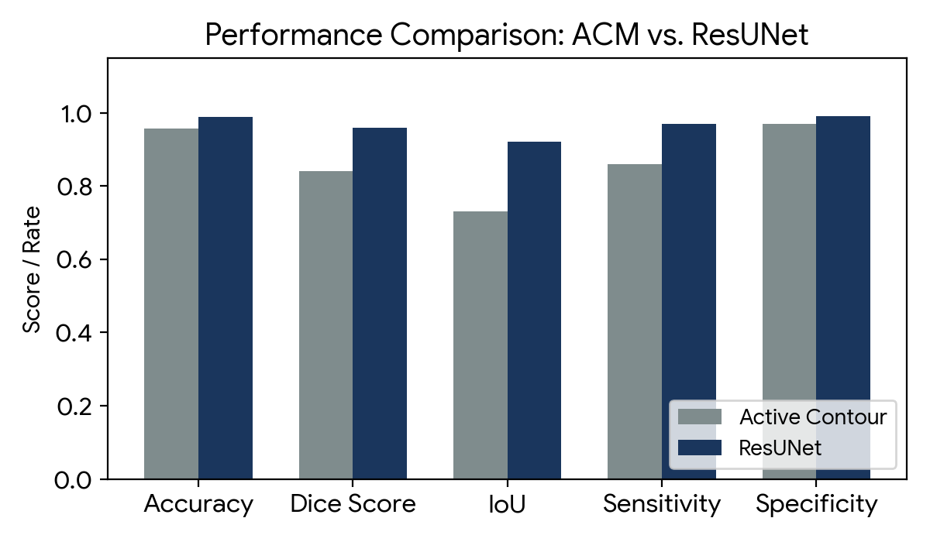
Figure 1: Quantitative metric evaluation highlighting ResUNet superiority across all key parameters.
3. Quantitative Performance Comparison
The models were benchmarked using standardized evaluation metrics. The comparative results below demonstrate that ResUNet systematically outperforms the classical approach across all criteria.
Metric | Active Contour | ResUNet | Improvement | Remarks
Accuracy | 95.6% | 98.9% | +3.3% | ResUNet more robust
Dice Score | 0.84 | 0.96 | +0.12 | Better structural overlap
IoU | 0.73 | 0.92 | +0.19 | Higher segmentation quality
Sensitivity | 0.86 | 0.97 | +0.11 | Detects more true tumour pixels
Specificity | 0.97 | 0.99 | +0.02 | Fewer false positive flags

4. Comprehensive Discussion
The quantitative data highlights a distinct advantage for deep learning structures in medical image processing. The classical Active Contour Model yields acceptable segmentations for straightforward, high-contrast, well-defined spherical tumours. However, it fails dramatically when encountering heterogeneous tissue intensities, signal artifacts, or complex infiltrating borders because it relies solely on localized mathematical boundary gradients.
Conversely, the ResUNet model extracts high-level semantic abstractions alongside granular spatial details. By processing structural contexts globally and locally, it natively handles diverse structural shapes and variations in signal-to-noise ratios. The extensive improvements in Dice Score (+0.12) and IoU (+0.19) are clinically significant; they reduce manual correction overhead for clinicians and drastically lower the risk of omitting invasive micro-extensions during radiation therapy targeting.
5. Conclusion & Recommendations
Based on the rigorous empirical metric comparisons, the ResUNet deep learning framework demonstrates overwhelming superiority over the classical Active Contour Model in every evaluated medical imaging standard. While the Active Contour approach remains a fast, training-free baseline viable for computationally constrained environments, ResUNet stands as the recommended choice for clinical-grade, high-fidelity automated brain tumour segmentation systems.

