

**Online Career Portal**

**Date Submitted:**

06/04/2022

**Submitted To:**

Praveen Nair

Program Director

|  |  |
| --- | --- |
| **Document Title** | Online Career Portal |
| **Issued By** | Ancia, Arya |
| **Issue Date** | 06/04/2022 |
| **Approved By** |  |

Document Revision History

|  |  |  |
| --- | --- | --- |
| Date | Update Description | Contact Name |
| 06/04/2022 | Initial Draft | Arya |
| 06/04/2022 | Initial Draft | Ancia |

**Contents**

1. Purpose
2. Project Overview
3. Business Scope
4. Use Case Diagrams
   1. Recruiter View
   2. Candidate View
   3. Admin View
5. Functional Requirement

5.1. Use Case FBR-001

5.2. Use Case FBR-002

5.3. Use Case FBR-003

1. Assumptions
2. **Purpose**

This need is to establish a career site where job searchers can locate work and recruiters can find the right person for the job.

1. **Project Overview**

This system is utilized as an online job gateway for job searchers. Recruiters will be able to discover the suitable employee with this solution. It keeps track of all the information including a user's registration, job search, application, and so on. Job seekers should be allowed to post their resumes and information. The admin/recruiters have access to application posted by job seekers.

1. **Business Scope**

This is for the purpose of developing an online career portal that would assist candidates in finding employment. In the existing system, candidate's resumes will not be prioritized . There is no way to upgrade a candidate's account to a premium account. Additionally, when a candidate's CV is shortlisted, he or she must wait for a mail. There is no way to check the application's status. By signing up for a membership package, individuals may make their résumé stand out to recruiters. This solution will allow you to tailor your job search using sophisticated search options. This website will include a summary report of all applications received, as well as information about the job's status. Recruiters may also use the site to advertise job openings and discover the ideal candidate for their firm.

1. **Use Case Diagrams** 
   1. **Candidate View**

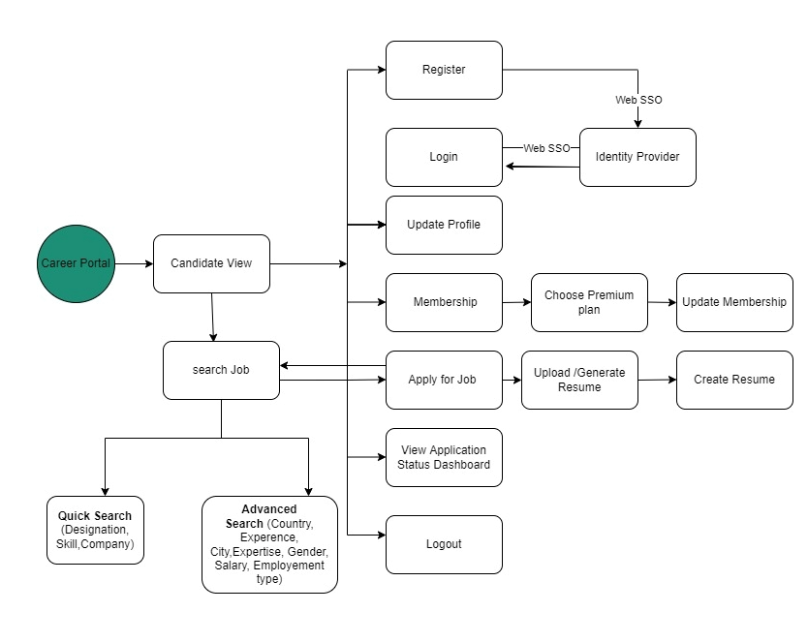

* 1. **Recruiter View**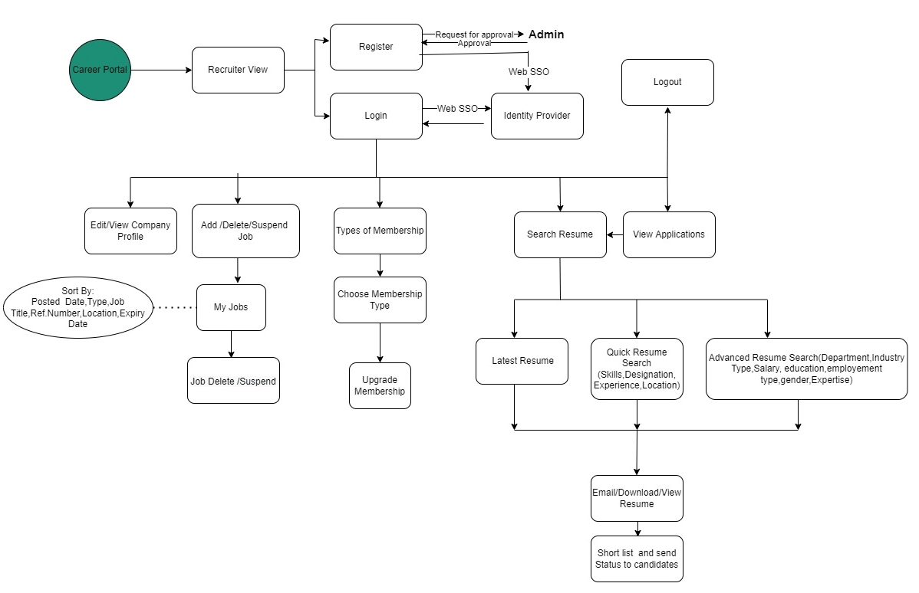
  2. **Admin View**

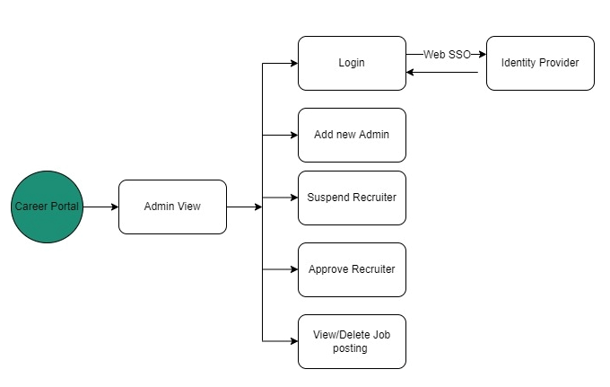

1. **Functional Requirement**

|  |  |
| --- | --- |
| **No** | **Use case** |
| FBR-001 | Candidate Search and Apply for a Job to different recruiter |
| FBR-002 | Recruiters post different job opening and shortlist the candidates. |
| FBR-003 | Admin manage all the functionalities of career portal |

* 1. Use case for Candidate view FBR-001

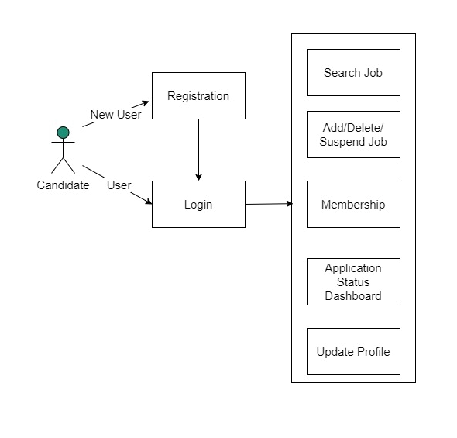

**Register**

Users browse into the website & visit the homepage of career portal

User click on signup to register into the portal

User fill username and password

User enter into login page

1. New users browse through the website and visit the homepage of career portal and they register their account to get benefited by this website. Users open the website and click on ‘Register’ and enter all the required information including Name, Email id and password and click ‘signup’ button. And their credentials were stored.

* Valid users will be directed to the ‘login’ page or else show error: -

1. Email does not match with Reg Exp, show error -please provide a valid email.
2. Password is less than 6 digits, -Password must include at least 6 digits time.
3. Any field left blank, -All the fields must be filled up.

**Login**

User login into their account using single sign on

User change the password if needed

User enter into homepage and choose change password option

User enter new and old passwords

User successfully created new password for their account

1. User login into their account using single time sign in. This formalizes the user access experience. If user wants to change the password and secure their account, user open the ‘profile’ tab and click on ‘My account’ option and click on ‘change password’ and enter the new password and old password and click ‘Done’.

* If the password matches the requirements a pop-up will show “password has been changed successfully”.

1. If the old password may not match with the given password [new], show error: - please provide your old password correctly.
2. New password is less than 6 digits, show error: - Password must include at least 6 digits time.
3. Any field left blank, show error: - All the fields must be filled up.

**Membership**

User login into their account

Select premium plan

make payments

1. Users select a premium membership and update their membership to highlight from other users and to easily get attention from recruiters. User open the homepage and click membership option and select premium plan. User directs to the payment page after selecting membership. Users will be able to select from a variety of payment options to make payment.
2. The User get notification when their membership expire or be renewed.

**Search Job**

Users login in to their account

make quick search and get jobs listing.

Select advanced search option for more refined results

1. User search for a job by quick search. Users open the home page and type designation or skill or company name in search bar and click ‘search’ button, User get a job listing based on the search.
2. User may opt advanced search option to search by location or experience or salary or employment type etc... With advanced filtering and user get more refined search result.

**Apply for Job**

User select particular jobs from the list

apply for job

Fill their details required for job application and submit

Logout

1. User select a particular job and click ‘apply’ button, if user qualify the requirements. User fill their details including Name, Email id, position applied for, skill set, years of experience and upload resume then click ‘submit’ button to send application.
2. When the application send successfully then a pop up will generate and user can view summary of application. Otherwise show errors as
   1. Email does not match with Reg Exp, show error -please provide a valid email.
   2. Any field left blank, -All the fields must be filled up.
3. User also get a mail notification from recruiter after submitting application.

**Application Status Dashboard**

1. User can view all the job who has applied already.
2. Five kinds of status are display in application dashboard.
   1. **Open:** if the recruiter active for calling application
   2. **Closed:** If therecruiter closed application
   3. **Suspend:** If the recruiter closed the application temporarily and may call in future
   4. **Accept:** If the recruiter accept the application
   5. **Reject:** If the recruiter reject the application

**Update Profile**

User login into their account

User enter into the homepage and click profile tab

User update their personal information and upload resume

1. Users edit their profile and keep them up to date to seek more attention from recruiters. Users open the homepage and click on ‘profile’ tab. User can then view the previously saved version of their profile. User can also update their personal information if needed. In the update profile page they can upload their Resume.
2. Users upload their resume to apply for jobs according to the specification. Users open the home page and click on ‘profile’ tab and click on ‘upload cv’ option and upload their resume. If the user does not have a resume, the system will create one for them by entering personal information such as address, education, work experience, area of interest, skill set, projects, and so on....
3. User logout from their account if everything done.
   1. **Use case for Recruiter view FBR-002**

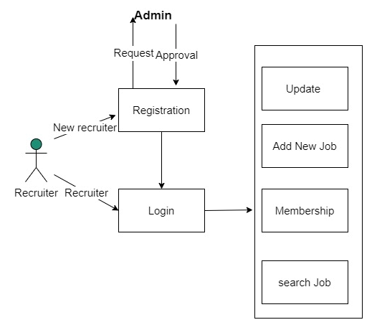

**Register**

Recruiter Sign Up to register into the system

Fill all information about the company

Recruiter fill all the informations

Enter into login page

1. Recruiter accesses the website and chooses the register option to become a member; they will be directed to the website's registration page. Recruiter completes all fields, including company name, technical expertise, number of employers, and location. Click the 'Sign Up' button after providing your email address and password.
2. If the result is successful, recruiter will send an approval request to admin to grant permission. Once admin approved the request then the recruiter will be sent to the login page; otherwise, certain problems may appear, such as
   * Email does not match with Reg Exp and show error as Please provide a valid email
   * Password is less than 6 digits, show error: Password must include at least 6 digits time.
   * Any field left blank, show error: All the fields must be filled up.

**Login**

Recruiter Log in to the System

Fill username and Password

Enter into the Home page of portal

Recruiter fill all the informations

1. Recruiter then goes to the Login page, fills his or her email address and password, and clicks the Login button. This will take you to the home page of the online career portal.
2. If the result is not Successful certain problems may appear such as,
   * Email does not match with Reg Exp and show error as Please provide a valid email
   * Password is less than 6 digits, show error: Password must include at least 6 digits time.
   * Any field left blank, show error: All the fields must be filled up.

**Update Profile**

1. Recruiter choose update profile from the home page and get into profile page. They can edit all the information including company name, technical expertise, number of employers, and location. A pop-up notification will appear after the profile has been changed.

**Add a New Job**

Recruiter Log into the System

Add a new job

Recruiter fill all the informations

Recruiter delete/suspend a job

Jobs are listed on the job board

Fill all the information about the job

1. They will be brought to the home page, where they may choose to add a new job, delete an existing job, or keep the job on hold until further notice.
2. If a recruiter creates a new job, a pop-up notice will appear when it is completed, and the job will be posted to the job board.
3. The recruiter can delete/suspend a job

**Membership**

Recruiter log in to the system

Choose membership tab

Select a membership type

Make Payment

1. A recruiter may go to the membership page by clicking on membership on the main page. Standard, Advanced, and Unlimited memberships are offered.
2. The Recruiter will be able to select from a variety of membership options, as well as upgrade from a current plan.
3. The recruiter get notification when their membership expire or be renewed.
4. The different membership plans and their features are shown in the given table

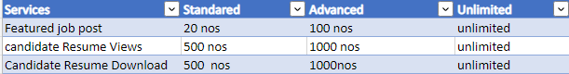

**Search Resumes**

Recruiter log in to the system

Search for a resume in quick search method and get a listing

Advance the search to get more refined results if necessary

Recruiter view the resume and download

1. When a recruiter visits the job portal's main page, they may utilize the search option to look for user resumes that are appropriate for their firm/ view all the applications that may receive for their job posting.
2. The recruiter does a speedy search to find resumes by defining skills, designation, experience, or location.
3. To acquire more focused results, the recruiter will refine the search by specifying Department, Industry Type, Salary, Education, Employment Type, Gender, and Expertise.
4. After receiving the narrowed searches, the recruiter will do the following steps.
   * Evaluate applicant resumes
   * If necessary, the selected resumes are sent to the HR email address.
   * By downloading the resume, the recruiter can store it to local storage.
5. Shortlisted candidates will be notified by the recruiter after the resumes have been evaluated. This status will be reflected on the user dashboard, and the relevant users will be notified through email.
   1. **Use case for Admin FBR-003**

Admin log into the system

Recruiter fill all the informations

Add a new admin

Recruiter fill all the informations

Fill the credential and assign to new admin

Recruiter fill all the informations

Notify the appropriate recruiter

Recruiter fill all the informations

Admin choose suspend recruiter

Recruiter fill all the informations

1. Admin log into the system using single sign on
2. Admins might choose to add a new admin to share the responsibilities.
3. Admin enter the user name and password and id and click on ‘Save’
4. Admins must now exchange their credentials with new admins in order for them to join the portal.
5. Admin is now taken to the main page, where he may select the Suspend option. If any malpractice or other issues are discovered, the admin can opt to suspend the recruiter on the appropriate page.
6. Admin will send a warning message to the appropriate Recruiter.

**Approve a Recruiter**

Admin log into the system

Recruiter fill all the informations

Check Approval request from recruiters

Recruiter fill all the informations

Admin grant the permission

Recruiter fill all the informations

1. The admin choose approve tab from home page
2. Admin is presently reviewing all of the recruiter permission requests and approving only legitimate recruiters.
3. Approval will be notify the recruiter so that they can get into the system and post their jobs and get access to all CV in the portal depending upon the membership plan

**Job Postings: View/Delete**

1. Admin selects the job posting tab from the home page and is redirected to the job posting page, where admin may review all newly submitted job and delete inappropriate jobs
2. **Assumptions**

* When a recruiter creates a new job, the recruiter awaits admin approval. It will be over head to admin due to the enormous amount of job postings.
* As a result, this function is excluded. To prevent illegal job postings, the administrator has the ability to inspect all positions and, if necessary, delete them.