**Comments**

* When writing code in Python, it’s important to make sure that your code can be easily understood by others, say by your friend who wants to see your code.
* Python ignores everything after the hash mark and up to the end of the line. You can insert them anywhere in your code!
* A shortcut for adding comments is by using CTRL + /

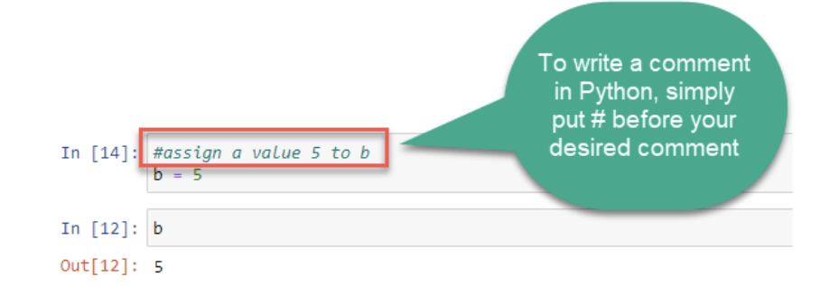

**Operators**

​

* Operators are used to perform simple operations such as additions, comparisons etc on variables and values.
* Python supports the following types of operators, we will be looking at some of the commonly used operators.

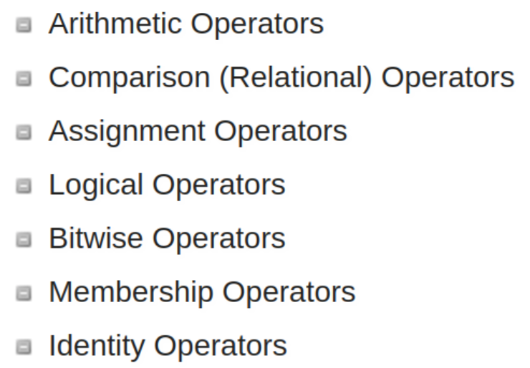

**Arithmetic Operator**

We can perform some basic arithmetic operations such as additions, subtraction, multiplication etc using python

Example: x = 2 y = 3 x + y # addition x * y # multiplication

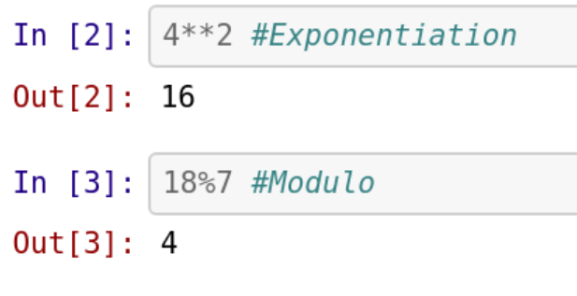

**Arithmetic Operators, Meanings & Examples**

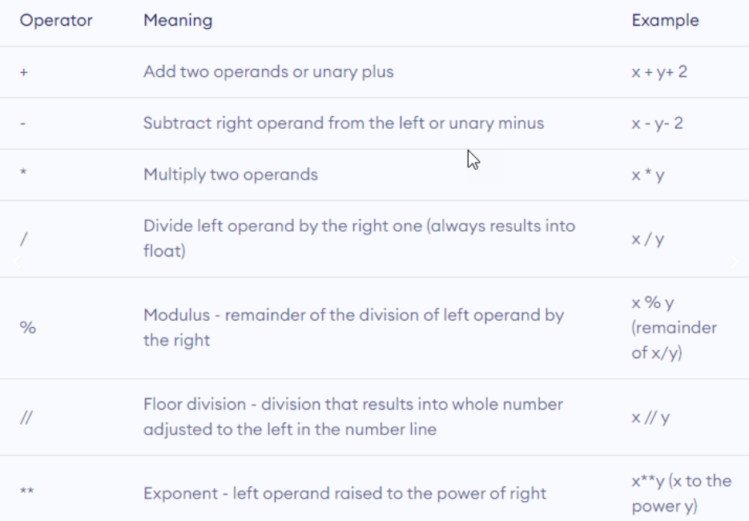

## Comparison Operator

* These are used to compare two values
* Gives a boolean result (True/False)

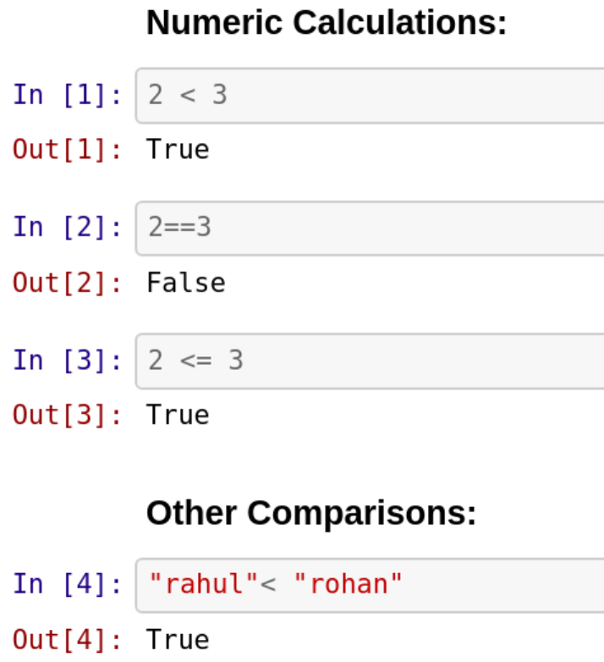

**Comparison Operators, Meanings & Examples**

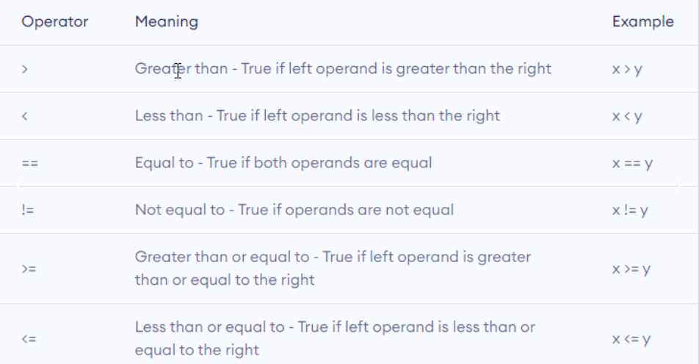

**Logical Operator**

* Logical operators are used to combine conditional statements
* Gives a boolean result (True/False)

