**Strings**

**Sequence Types**

* Sequences allow you to store multiple values in an **organized and efficient way**.
* There are seven sequence types: strings, Unicode strings, lists, tuples, bytearrays, buffers, and xrange objects.
* *Nothing to worry looking at this long list, you will get to know it gradually.*

**Python Strings**

* Strings are sequence of characters.
* Let us see some examples of String: My name is Rahul, Rahul, Go home. All these are examples of String.
* In Python, Strings are called str.
* There is a specific way of defining String in Python – it is defined within single quote (‘) or double quotes (“) or even triple quotes (“‘).

**Accessing String Elements**

* Square brackets can be used to access elements of the string.
* **Remember that the first character has index 0.**
* Index refers to position of a character in a string. In python index number starts from 0.
* Example: **a = "Hello, World!" print(a[1])**
* **Will give an output e. Can you understand why?**

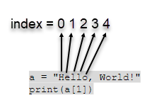

* Hope you got the answer to the previous question now!

**String Slicing**

* We can also call out a range of characters from the string using string slicing.
* Specify the start index and the end index, separated by a colon, to return a part of the string. Note that the character of the end index is not included.
* Suppose we want to print World from the string “Hello World”. We can do so as below:

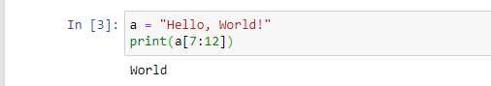

**Negative Indexing**

* If we have a long string and we want to pinpoint an item towards the end, we can also count backwards from the end of the string, starting at the index number -1
* Printing ‘r’ from the string : **a = "Hello, World!"**

**print(a[-4])**

* Get the characters from position -5 to position -1, starting the count from the end of the string: **print(a[-5:-2])**
* Will give an output :orl

**String Concatenation**

* String concatenation means adding strings together.
* Use the + character to add a variable to another variable:
* Example:

​

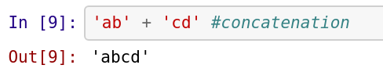

**​**

* Another example: **x = "Python is " y = "awesome" z = x + y print(z)**
* **Output: Python is awesome**

**String Concatenation: Add Space**

* We can also add spaces between two strings

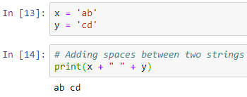

**String Length**

* To get the length of a string, use the len( ) function.
* Getting length of the string a :

**a = "Hello, World!"**

**print(len(a))**

* **Output: 13**

**String Methods**

* Python has a set of built-in methods that you can use on strings.
* Must learn: Learn about important string methods from the below cheatsheet: <https://www.codecademy.com/learn/learn-python-3/modules/learn-python3-strings/cheatsheet>
* Tip: If you are unable to follow, run the code and make out the difference.