**Variables**

​

* A variable can be considered as a storage container for data.
* Every variable will have a name.
* It is a good way to store information while making it easy to refer to that information in our code later.

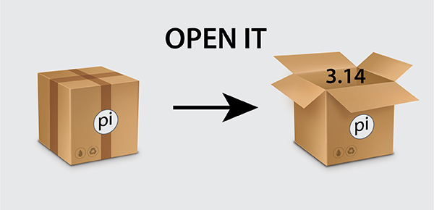

* For instance, instead of working with the number 3.14, we can assign it to a variable pi and use it as many times as we want in our code (wherever required).
* The equal sign (=) is used to assign values to variables.
* The syntax for assigning values to a variable is as follows: Variable name = value or information.
* Example:
  + x = 5
  + y = "John"