A Knowledge Graph for Pediatric Acute Lymphoblastic Leukemia
Arya Chilukuri · BIOT 6900 · Module 7 Assignment
I built a property graph for pediatric acute lymphoblastic leukemia (ALL), my Part I disease: 62 nodes and 74 directed edges, loaded into Neo4j AuraDB, queried with Cypher and analyzed in NetworkX. The question: which drugs reach the genes behind ALL, which drugs from a related disease could be repurposed, and which genes are most central?

1. Schema and evidence
Each type exists because a query needs it. Drug → gene → disease is the 2-hop drug query. The disease → phenotype ← disease bridge lets the 5-hop repurposing query reach a second disease. Pathways give genes a mechanism, so genes with shared biology cluster. Variants connect germline risk (GWAS) and pharmacogenomics (TPMT*3C from Module 5) to their genes. The graph is directed because the biology is: a variant sits in a gene and a drug acts on a target, never the reverse.
Node type | n | What it is and where it came from | Properties
Disease | 2 | Pediatric ALL; acute myeloid leukemia (AML) as the related disease | name
Gene | 26 | 15 from my Module 2 multi-omics ranking (Module 3 shortlist); 5 GWAS risk genes; 5 drug targets / pharmacogenes; FLT3 for AML | Ensembl ID (MyGene.info), gwas_p, rna_lfc, prot_lfc, druggability
Phenotype | 8 | HPO terms (anemia, thrombocytopenia, neutropenia, fever, bone pain, hepatosplenomegaly, lymphadenopathy, fatigue) | name
Pathway | 12 | Reactome pathways, one or more per gene | name
Drug | 7 | 5 targeted ALL drugs; midostaurin and gilteritinib (AML) | status
Variant | 7 | 5 B-ALL GWAS SNPs; TPMT rs1142345 and NUDT15 rs116855232 | rsID
Table 1. Node types. Edge types: ASSOCIATED_WITH (gene → disease, 26), PARTICIPATES_IN (gene → pathway, 22), HAS_PHENOTYPE (disease → phenotype, 12), TARGETS (drug → gene, 7), OCCURS_IN (variant → gene, 7).
Evidence on edges. Each gene–disease edge has a source tag. The five GWAS edges also hold the p-value from the GWAS Catalog (Vijayakrishnan et al. 2018, 2019): ARID5B 1e-106, IKZF1 6e-55, CDKN2A 7e-14, CEBPE 5e-14 and GATA3 4e-14. Evidence about a gene itself, not about one of its relationships, goes on the gene node: the RNA and protein fold changes from Module 2 and a druggability score, which is the higher of the Module 3 small-molecule and antibody probabilities. I checked all 22 gene–pathway memberships against the Reactome ContentService API, and all were confirmed. The phenotype and drug edges carry no numbers at all, which comes up again in Section 4.

2. Top targets
PageRank split the 26 genes into three tiers. CD19, ABL1 and FLT3 tie for first (0.0216); CD22, TPMT, NUDT15 and the five GWAS genes tie at 0.0148; all 15 multi-omics genes tie at the bottom (0.0080). The tiers come straight from edge direction. Edges point from drugs and variants into genes, and from genes out to the disease, so a gene gains rank only from what points at it: two drugs, one drug or variant, or nothing. Rank pools in the sinks, so the top nodes overall are the ALL node and the four cytopenias it shares with AML.
Does this match the biology? Partly, but for a circular reason. CD19, CD22 and ABL1 really are the established targets in ALL: blinatumomab and tisagenlecleucel for CD19, inotuzumab ozogamicin for CD22, and imatinib and dasatinib for Ph+ ALL. But they rank high only because I attached those drugs; the graph hands back what I put in. The GWAS genes are the best-supported germline risk loci, and IKZF1 and CDKN2A deletions are also somatic markers used in risk stratification. Even so, ARID5B (p = 1e-106) ties with CD22, which has no GWAS evidence at all. The table shows the evidence next to PageRank, but the score never uses it.
Non-obvious hits. First, FLT3 ties for the top spot even though it is the AML gene I added only to power the repurposing query, and nothing in my graph connects it to ALL. Its rank is an artifact of its two drugs, though it led to the hypothesis in Section 3. Second, and more interesting, is a gene that centrality buries: CD72. It is #8 on my Module 3 shortlist. It has the second-highest antibody druggability of the 15 (0.69) and is a B-cell surface co-receptor. CD72 has been proposed as a CAR-T target in KMT2A-rearranged B-ALL (Nix et al. 2021). PageRank puts it in the bottom tier because it has no drugs. I also gave it only one pathway (semaphorin interactions), even though CD72 is a negative regulator of B-cell receptor signaling, so it ended up alone in its own community instead of with CD19 and CD22.
How fragile is the ranking? When I re-ran PageRank undirected and then personalized to start from the ALL node, HLA-B and HLA-C moved to first (0.0206), CD19 and ABL1 dropped to second, and FLT3 fell out of the top eight. The HLA genes have three pathway edges each. So centrality here mostly measures how much annotation I happened to attach to a gene, not how important it is.
One community: thiopurine toxicity. Community 5 holds TPMT, NUDT15, their variants rs1142345 (TPMT3C) and rs116855232 (NUDT15 R139C), and the Reactome Azathioprine ADME pathway. It describes a type of patient*, not a leukemia subtype: carriers of loss-of-function alleles build up thioguanine nucleotides on standard mercaptopurine doses and become myelosuppressed, so CPIC recommends dose reduction (Relling et al. 2019). The graph keeps this module apart from the disease-biology modules (B-cell surface antigens, community 2; transcription and chromatin regulators, 4, 7 and 8), matching the clinical split between what drives the leukemia and what decides how a child tolerates treatment. The largest community (0), the disease plus its phenotypes and the pathway-less shortlist genes, is a bucket for genes I knew little about, not a biological signal.
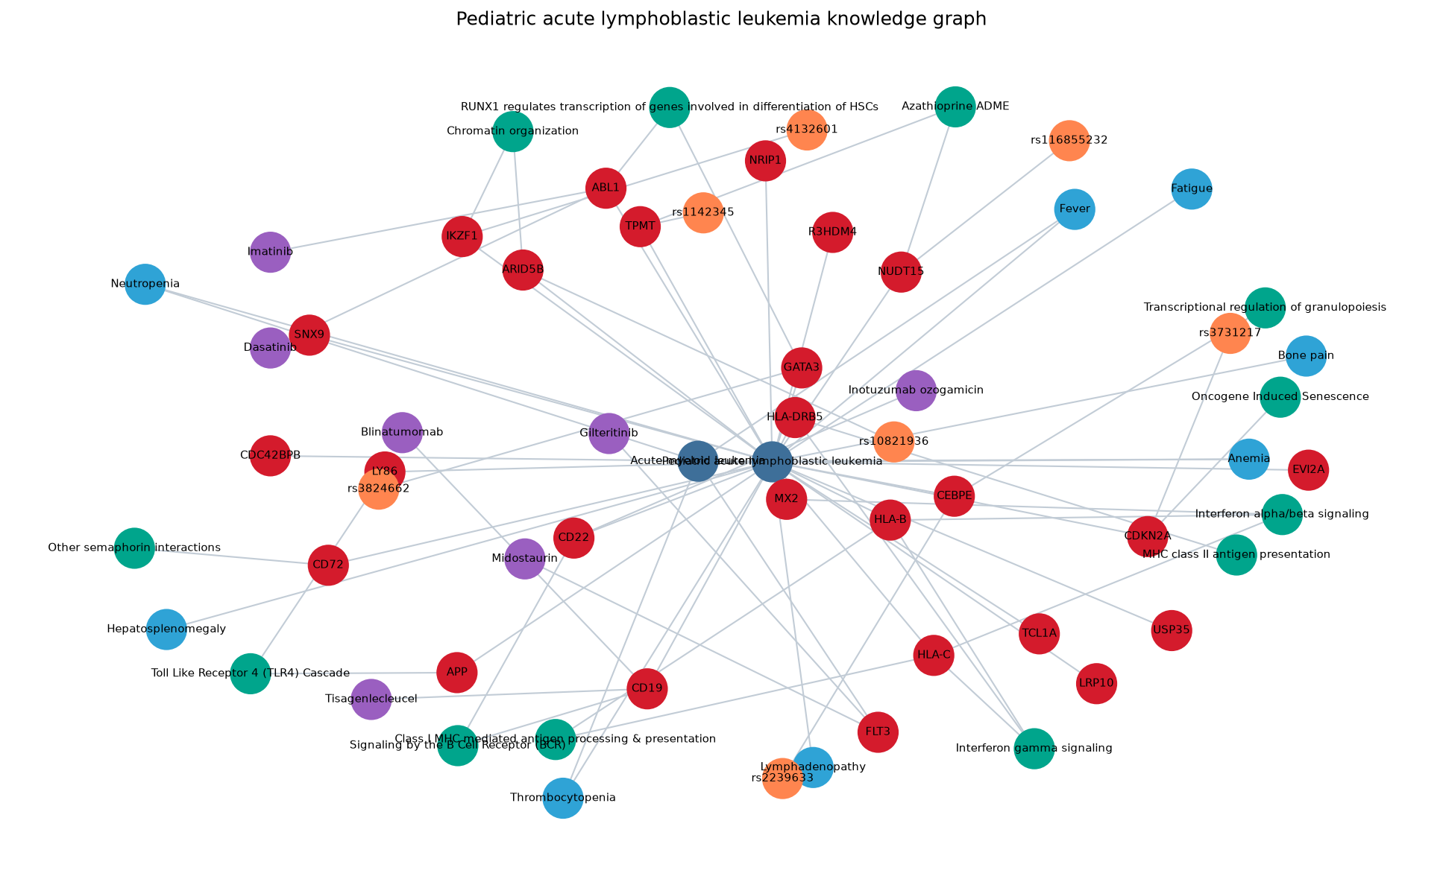
Figure 1. The ALL knowledge graph (my_knowledge_graph.png). Red: genes; dark blue: diseases; light blue: phenotypes; green: pathways; purple: drugs; orange: variants.

3. A hypothesis from a path
The 5-hop query returned exactly two candidates, both through the same path:
Gilteritinib (or midostaurin) → TARGETS → FLT3 → ASSOCIATED_WITH → AML → HAS_PHENOTYPE → anemia, thrombocytopenia, neutropenia, fever ← HAS_PHENOTYPE ← pediatric ALL
Taken literally, this path is weak: the shared phenotypes are signs of marrow failure that every acute leukemia causes, so they show the marrow is full of blasts, not a shared mechanism. As a pointer it is still useful, but the hypothesis has to be stated at the gene level: FLT3 inhibitors may benefit the subset of pediatric ALL with high FLT3 expression, mainly KMT2A-rearranged infant ALL and high-hyperdiploid ALL. There is precedent. Armstrong et al. (2003) found FLT3 highly expressed in MLL-rearranged ALL and showed that PKC412 (midostaurin) killed those cells. The COG trial AALL0631 then added lestaurtinib to chemotherapy for KMT2A-rearranged infant ALL and did not improve event-free survival overall, although patients with strong FLT3 inhibition in their plasma did better (Brown et al. 2021). That points to a more potent, selective inhibitor such as gilteritinib, given to selected patients.
How I would test it, cheapest step first:
- Check the data I already have. Compare FLT3 mRNA across subtypes in the cBioPortal pediatric ALL cohort from Module 2, and look up FLT3 dependency in DepMap ALL cell lines. If no subgroup shows high FLT3, I drop the hypothesis. If one does, I add a FLT3 → ALL edge with that expression evidence, so the path no longer has to go through symptoms.
- Cell lines. Run gilteritinib dose–response in FLT3-high KMT2A-rearranged B-ALL lines (SEM, RS4;11) against an FLT3-low B-ALL control. I would measure viability (IC50) and phospho-FLT3/STAT5 to show the drug is hitting its target. A selective effect in the FLT3-high lines supports the hypothesis. An equal effect in both, or no effect, argues against it.
- In vivo. If the cell-line results are positive, test gilteritinib plus standard induction in KMT2A-rearranged patient-derived xenografts.

4. Limitations
An edge is evidence, not truth. These are the weak points in my graph, roughly from weakest to strongest:
- The 15 multi-omics gene–disease edges. They carry no p-value, and they are tagged source = pharmacology, which is wrong. My loader gives that tag to any gene without a GWAS p-value, so these edges should really say multi-omics and carry the Module 2 score. The score itself is also weak. It combines pediatric genomic and transcriptomic data with proteomics from an adult AML study, and the fold changes are small. Several of these genes (APP, LRP10, USP35, R3HDM4) have no established role in ALL.
- The FLT3 → AML edge is tagged GWAS, but FLT3 is a somatic driver with no GWAS p-value. That tag is hard-coded for the related disease and should read somatic driver.
- Phenotype edges have no weights. HPO annotations come with frequencies, and generic cytopenias inflate disease similarity. Right now any disease with "fever" would match. With frequency weights, or by matching only on specific phenotypes (for example, mediastinal mass or CNS involvement), the repurposing query would return fewer and more meaningful hits.
- Drug coverage is thin. The graph has only the five targeted drugs. The chemotherapy backbone (mercaptopurine, methotrexate, vincristine, asparaginase, dexamethasone) is missing, so the TPMT/NUDT15 module has no drug to connect to. Adding mercaptopurine would complete the pharmacogenomic path (variant → TPMT → mercaptopurine).
- A database error I caught. My first 2-hop query returned Aducanumab and Lecanemab, which are Alzheimer's antibodies, as ALL drugs. The shared AuraDB instance still held the placeholder Alzheimer's graph. Because the load uses MERGE on name, my APP node merged with the old APP node and picked up its drug edges. After I wiped the database and reloaded, the query returned only the five ALL drugs. The fix is to key nodes on stable IDs (Ensembl, ChEMBL) and reset before each load. It also shows that a query cannot tell a wrong edge from a right one.
- Centrality ignores evidence. Unweighted, directed PageRank treats a 1e-106 GWAS edge the same as an unweighted shortlist edge. Weighting edges by −log10(p) or druggability, and personalizing the walk to the disease, would make the ranking reflect evidence instead of annotation density.
With better data, I would take gene–disease scores from Open Targets, drug–target mechanisms and trial phases from ChEMBL, phenotype frequencies from HPO, and protein data from a pediatric ALL cohort. I expect CD19, CD22 and the GWAS genes to stay near the top, because their evidence is strong. Most of the shortlist genes (USP35, R3HDM4, LRP10) would probably drop out. CD72 could rise once surface-protein and antibody evidence is included. FLT3 would gain a direct ALL edge, but only for the KMT2A-rearranged subgroup.
Use of AI. I used Claude (Anthropic) in VS Code to fix my Python environment (networkx was missing from my kernel) and to check the 22 gene–pathway memberships against the Reactome API. I also used it to diagnose the Neo4j contamination with read-only Cypher (node counts by label, all drug → target edges), to run the PageRank sensitivity check, and to help draft this report. I checked by re-running each step: the Reactome check confirmed every membership, I reproduced the centrality numbers from my exported nodes.csv and edges.csv, and I checked the literature claims against the original papers.

References
Armstrong SA et al. Inhibition of FLT3 in MLL: validation of a therapeutic target identified by gene expression based classification. Cancer Cell, 2003.
Brown PA et al. FLT3 inhibitor lestaurtinib plus chemotherapy for newly diagnosed KMT2A-rearranged infant ALL: Children's Oncology Group trial AALL0631. 2021.
Nix MA et al. Surface proteomics reveals CD72 as a target for in vitro–evolved nanobody-based CAR-T cells in KMT2A/MLL1-rearranged B-ALL. Cancer Discovery, 2021.
Relling MV et al. CPIC guideline for thiopurine dosing based on TPMT and NUDT15 genotypes: 2018 update. Clin Pharmacol Ther, 2019.
Vijayakrishnan J et al. B-ALL GWAS studies, Nature Communications 2018 and 2019 (via the NHGRI-EBI GWAS Catalog).
Data resources: Reactome, Human Phenotype Ontology, MyGene.info, cBioPortal, Neo4j AuraDB.

