A Project Report on
Smart Home Energy Consumption Analysis using Excel

Submitted By:
Arya Dinesh, NNM24EC027;
Ashlesh Y Saliyan, NNM24EC028;
Ashley D'Souza, NNM24EC029;



May 2025 – 26



CERTIFICATE

This is to certify that Arya Dinesh (NNM24EC027), Ashlesh Y Saliyan (NNM24EC028), and Ashley D'Souza (NNM24EC029), bonafide students of N.M.A.M. Institute of Technology, Nitte, have submitted a project report entitled "SMART HOME ENERGY CONSUMPTION ANALYSIS USING EXCEL" as part of the Project-Based Data Analysis Lab, in partial fulfillment of the requirements for the award of Bachelor of Engineering Degree in Electronics and Communication Engineering during the academic year 2025–26.

Name of the Examiner Signature with date

ACKNOWLEDGEMENT

We express our sincere gratitude to all those who supported and guided us through the course of this project. First and foremost, we thank the Department of Electronics and Communication Engineering, N.M.A.M. Institute of Technology, Nitte, affiliated with NITTE (Deemed to be University), for providing us with the platform and resources to undertake this work.

We are deeply thankful to our course instructor for the constant encouragement, constructive feedback, and technical guidance extended throughout this project. The insightful discussions that took place during the lab sessions played a vital role in shaping the direction and quality of our analysis.

We would also like to acknowledge Kaggle and the dataset contributor Taranvee for making the Smart Home Dataset with Weather Information publicly available, which served as the primary source of data for this project.

Finally, we extend our heartfelt thanks to our families and peers for their continued support and encouragement during the completion of this project.

Arya Dinesh (NNM24EC027)
Ashlesh Y Saliyan (NNM24EC028)
Ashley D'Souza (NNM24EC029)

ABSTRACT

This project presents a structured data analysis of residential energy consumption patterns using Microsoft Excel as the primary analytical and visualization tool. The dataset, sourced from Kaggle, contains time-stamped records of household energy usage (in kilowatts), ambient temperature (in degrees Celsius), and humidity levels collected from a smart home environment. The primary objective was to derive actionable insights from raw sensor data by applying a systematic workflow that includes data cleaning, feature engineering, logical classification, lookup-based device mapping, and multi-dimensional visualization.

The methodology involved extraction of temporal features such as hour-of-day and time-block classification, arithmetic scaling for normalization, and threshold-based classification of energy readings into High and Normal usage categories using Excel's IF function. Additionally, VLOOKUP and HLOOKUP functions were employed to map simulated device identifiers and time periods, respectively. Five distinct visualizations were generated: a scatter plot to investigate the temperature–energy relationship, a time-series line chart with a threshold overlay to reveal temporal fluctuations, a histogram for frequency distribution analysis, a pie chart for usage-level distribution, and a bar chart for device-wise high usage comparison.

The results indicate that energy consumption is predominantly concentrated in the lower kilowatt range, with approximately 46.2% of readings classified as high-usage events. The temperature–energy scatter plot reveals a marginally positive but weak correlation, suggesting that temperature is not the sole determinant of energy demand in this dataset. The analysis demonstrates the capability of Excel as a practical tool for signal-level data exploration and behavioral pattern recognition in smart home environments.

TABLE OF CONTENTS

Chapter 1: INTRODUCTION

1.1 Background
The concept of a smart home refers to a residential environment equipped with interconnected devices and sensors that continuously collect operational data. Among the various forms of data generated by such systems, energy consumption data holds particular significance—both from an economic standpoint and from an environmental sustainability perspective. As energy costs rise globally and concerns about carbon emissions deepen, the ability to analyze, interpret, and optimize household energy usage has become increasingly important.

Historically, energy management in households relied on manual meter readings and periodic billing cycles, offering little granularity for real-time decision-making. The advent of smart meters and IoT-based monitoring systems has transformed this landscape, enabling the collection of high-frequency, time-stamped energy data. Such datasets, when subjected to analytical techniques, can reveal consumption patterns, identify inefficiencies, and support demand-side energy management strategies.

In the context of Electronics and Communication Engineering, energy signals collected from smart home systems can be interpreted analogously to time-domain signals—exhibiting amplitude variation (consumption levels), periodicity (daily/weekly cycles), and threshold-crossing behavior (high versus normal usage). Analyzing such signals through spreadsheet tools like Microsoft Excel offers a practical, accessible, and educationally valuable approach, particularly for engineers developing foundational data analysis skills.

1.2 Problem Statement
Despite the increasing availability of smart home energy datasets, there exists a gap in leveraging basic yet powerful spreadsheet-based tools for exploratory data analysis in educational settings. Many existing analytical frameworks require specialized programming environments, which may not be readily accessible to all engineering students. Furthermore, raw smart home datasets, when unprocessed, offer limited interpretability. The challenge lies in transforming such raw time-series energy data into meaningful, actionable insights using structured analytical workflows within Microsoft Excel.

This project addresses the problem of analyzing residential energy consumption patterns from a publicly available smart home dataset by designing and executing a comprehensive Excel-based data pipeline—encompassing data cleaning, feature extraction, classification, device mapping, and visualization—to extract behavioral and temporal insights without the need for complex programming tools.

1.3 Objectives
The specific objectives of this project are as follows:
- To import, clean, and preprocess the smart home energy dataset for analysis.
- To engineer relevant temporal features, including hour-of-day extraction and pseudo-hour segmentation, from the timestamp column.
- To apply arithmetic scaling to the energy consumption values for improved comparability and visualization clarity.
- To classify energy readings into 'High' and 'Normal' categories using a threshold derived from the dataset's statistical mean.
- To perform lookup operations using VLOOKUP and HLOOKUP functions to simulate device and time-block mapping.
- To generate and interpret five distinct visualizations that capture different dimensions of the energy consumption dataset.
- To draw meaningful inferences regarding energy usage behavior, device-level demand, and temporal fluctuation patterns.

1.4 Scope
This project is scoped to the analysis of a single publicly available smart home dataset comprising time-stamped energy, temperature, and humidity records. The analysis is confined to Microsoft Excel (or Google Sheets) as the sole processing and visualization environment. The device mapping and time-block classification are simulated constructs designed to demonstrate the practical application of Excel's lookup functions in a realistic scenario, and do not represent actual appliance-level metering.

The project does not attempt predictive modeling, machine learning, or statistical inference beyond descriptive analysis. The findings are intended for educational interpretation within the scope of an undergraduate data analysis laboratory exercise.

Chapter 2: DATASET DESCRIPTION

2.1 Source and Availability
The dataset used in this project was obtained from Kaggle, one of the most widely used open-access platforms for machine learning and data science datasets. The specific dataset is titled 'Smart Home Dataset with Weather Information,' contributed by the user Taranvee, and is publicly available at the following URL:

https://www.kaggle.com/datasets/taranvee/smart-home-dataset-with-weather-information

The dataset captures real-time readings from a smart home monitoring system, including energy consumption measured in kilowatts (kW), ambient temperature in degrees Celsius, and relative humidity. The data is structured as a time series with readings logged at short intervals, making it suitable for temporal pattern analysis.

2.2 Dataset Structure and Variables
The primary variables utilized in this analysis are described below:
- Time (Timestamp): A datetime field representing the exact moment of each energy reading. This field was used for temporal feature extraction, including hour-of-day and time-block classification.
- Energy [kW]: The total household energy consumption recorded at each timestamp, expressed in kilowatts. This is the primary dependent variable in the analysis.
- Temperature [°C]: The ambient outdoor or indoor temperature recorded concurrently with energy consumption. This variable was used to investigate the temperature–energy relationship.
- Humidity: The relative humidity percentage recorded at each timestamp. While present in the dataset, humidity was not a primary variable in the current analysis but contributes to contextual understanding.

2.3 Dataset Relevance
Smart home energy datasets exhibit characteristics analogous to sampled time-domain signals in electronics. The energy column represents a discrete-time signal, with each row corresponding to a sample point. Variations in this signal across time encode behavioral patterns—peaks corresponding to periods of high appliance activity, and troughs reflecting low-demand intervals.

The availability of concurrent weather parameters (temperature and humidity) makes this dataset particularly suitable for multivariate behavioral analysis, enabling the investigation of whether external environmental conditions influence household energy demand. This is a pertinent question in smart grid design and demand response planning within the broader domain of Electronics and Communication Engineering.

Chapter 3: METHODOLOGY

3.1 Overall Analytical Pipeline
The project followed a structured, sequential data analysis pipeline designed to transform raw tabular data into interpretable insights. The pipeline was implemented entirely within Microsoft Excel and comprised seven distinct stages, as outlined below:
- Data Import and Cleaning
- Feature Engineering
- Arithmetic Processing
- Logical Classification
- Lookup Operations
- Data Filtering and Aggregation
- Visualization

3.2 Data Import and Cleaning
The dataset was imported into Microsoft Excel as a CSV file. Initial inspection revealed the presence of a timestamp column, energy readings, temperature values, and humidity levels. The cleaning phase involved identifying and removing rows with missing or null values, verifying that all energy readings were positive and within a physically plausible range, ensuring the timestamp column was correctly parsed as a datetime type, and standardizing the column headers for clarity and consistency during formula application.

3.3 Feature Engineering
Two temporal features were derived from the timestamp column to support time-based analysis. First, the HOUR() function was applied to the timestamp to extract the hour-of-day (0 through 23) for each record, creating a new column labeled 'Hour.' This feature enables analysis of energy consumption variation across different hours of the day. Second, a 'Pseudo Hour' column was created using the row index modulo 24, yielding an index-based segmentation that approximates cyclical time-block behavior without relying exclusively on the datetime parsing, and was subsequently used for HLOOKUP-based time-block mapping.

3.4 Arithmetic Processing
To facilitate visualization clarity and comparative analysis, an 'Energy Scaled' column was computed by multiplying each energy reading by a constant scaling factor. This normalization step improves the dynamic range of displayed values in charts and allows for side-by-side comparison with other scaled parameters. The scaling was applied uniformly across all records, preserving the relative distribution of values.

3.5 Logical Classification
A threshold-based classification scheme was implemented using Excel's IF() function. The threshold was defined as the arithmetic mean (AVERAGE) of the entire Energy [kW] column. For each row, if the energy value exceeded this threshold, the record was labeled 'High'; otherwise, it was labeled 'Normal.' This classification is stored in a dedicated 'Usage Level' column and forms the basis for the pie chart and device-level bar chart analysis.

3.6 Lookup Operations
Two lookup functions were employed to simulate device and time-block mapping:

VLOOKUP: A reference table mapping numeric device codes (1 = AC, 2 = Heater, 3 = Fridge) was constructed. The VLOOKUP function was applied to a 'Device Code' column (derived as a modulo operation on the row index) to assign the corresponding device name to each record. This simulates appliance-level monitoring within the constraints of the dataset.

HLOOKUP: A horizontal reference table mapping pseudo-hour ranges to time blocks (Night: 0–5, Morning: 6–11, Afternoon: 12–17, Evening: 18–23) was constructed. The HLOOKUP function was applied to the Pseudo Hour column to categorize each record into its corresponding time block, enabling temporal segmentation of energy readings.

3.7 Data Filtering and Aggregation
Excel's COUNTIF and SUMIF functions were used to compute device-wise counts of high-usage instances. Filters were applied to isolate subsets of data for specific devices and usage levels, facilitating the construction of the bar chart comparing high-usage frequency across AC, Heater, and Fridge.

Chapter 4: TOOLS USED

4.1 Microsoft Excel
Microsoft Excel was the primary tool employed throughout this project for data processing, formula-based analysis, and visualization. Excel provides a rich set of built-in functions that are well-suited for structured tabular data analysis, including logical operators (IF), lookup functions (VLOOKUP, HLOOKUP), statistical aggregation (AVERAGE, COUNTIF, SUMIF), and text/date manipulation (HOUR, MOD, TEXT). Its chart engine supports a variety of visualization types—including scatter plots, line charts, histograms, pie charts, and bar charts—enabling multi-perspective exploration of the dataset.

Excel's accessibility, absence of a programming prerequisite, and widespread institutional adoption make it a practical choice for undergraduate engineering laboratory exercises involving data analysis. The ability to interact directly with data in a spreadsheet interface also promotes intuitive understanding of data structures and transformations.

4.2 Google Sheets (Alternative)
Google Sheets was considered as an alternative platform, given its compatibility with Excel's function syntax and its cloud-based collaborative capabilities. Most Excel formulas used in this project (IF, VLOOKUP, HLOOKUP, HOUR, AVERAGE, COUNTIF) are directly compatible with Google Sheets. Visualizations generated in Google Sheets are equivalent in structure, though minor stylistic differences may appear. The project was primarily executed in Microsoft Excel, with cross-verification performed in Google Sheets to ensure formula portability.

4.3 Dataset Platform: Kaggle
Kaggle served as the data acquisition platform. The smart home dataset was downloaded in CSV format and imported directly into Excel. Kaggle's open-access model and dataset documentation (including column descriptions and licensing terms) ensured data transparency and reproducibility of the analysis.

Chapter 5: IMPLEMENTATION

5.1 Step 1 – Data Import and Cleaning
The raw dataset was imported into Excel via Data > Get External Data > From Text/CSV. Column headers were mapped as follows: Column A – Time (timestamp), Column B – Energy [kW], Column C – Temperature [°C], Column D – Humidity. Rows containing blank cells in the Energy or Time columns were identified using Excel's filter function (Home > Sort & Filter > Filter) and subsequently removed. A visual scan of the Energy column confirmed that all values were non-negative and within the expected physical range (approximately 0.3 kW to 2.7 kW).

5.2 Step 2 – Feature Engineering
In Column E, labeled 'Hour,' the formula =HOUR(A2) was applied and dragged down to extract the hour component from each timestamp. For rows where the timestamp was stored as a plain text string, the formula was adapted to =HOUR(TIMEVALUE(MID(A2,12,8))).

Column F, labeled 'Pseudo Hour,' was populated using the formula =MOD(ROW()-2, 24), which cycles through values 0–23 based on the row index. This simulates a repeating 24-hour cycle and was used as the lookup key for the HLOOKUP time-block classification.

5.3 Step 3 – Arithmetic Processing
Column G, labeled 'Energy Scaled,' was computed using the formula =B2*10, scaling each energy value by a factor of 10 for enhanced visual differentiation in charts. The scaling factor was chosen empirically to bring energy values into a more visually comparable range while preserving the distributional shape.

5.4 Step 4 – Logical Classification with IF
The threshold value was computed as the dataset mean using =AVERAGE(B:B), which yielded approximately 0.88 kW for the dataset used. In Column H, labeled 'Usage Level,' the classification formula =IF(B2>AVERAGE($B:$B),"High","Normal") was applied. The AVERAGE function reference was fixed using absolute referencing ($B:$B) to ensure consistent threshold application across all rows.

5.5 Step 5 – Lookup Operations
For VLOOKUP-based device mapping, a reference table was constructed in a separate sheet with device codes 1, 2, 3 mapped to AC, Heater, and Fridge respectively. Column I ('Device Code') was populated with =MOD(ROW()-2, 3)+1. Column J ('Device') was populated with =VLOOKUP(I2, DeviceTable, 2, FALSE), retrieving the device name corresponding to the code.

For HLOOKUP-based time-block mapping, a horizontal reference table was built with pseudo-hour thresholds (0, 6, 12, 18) in the first row and corresponding labels (Night, Morning, Afternoon, Evening) in the second row. Column K ('Time Block') was populated with =HLOOKUP(F2, TimeBlockTable, 2, TRUE), using approximate match (TRUE) to assign each pseudo-hour to its nearest time block.

5.6 Step 6 – Data Filtering and Aggregation
Aggregated counts of high-usage instances per device were computed using COUNTIFS. For example, the count of 'High' usage instances for AC was calculated as =COUNTIFS(J:J,"AC",H:H,"High"). Similar formulas were applied for Heater and Fridge. These computed counts (47, 45, and 46 respectively) served as the data source for the device-wise bar chart.

5.7 Step 7 – Visualization
Five charts were generated using Excel's Insert > Chart functionality:
- Scatter Plot: Energy [kW] (Y-axis) vs Temperature [°C] (X-axis), with a linear trendline added via Chart > Add Trendline > Linear.
- Line Chart: Energy [kW] vs Time, with a constant threshold value overlaid as a secondary data series plotted as a straight horizontal line.
- Histogram: Frequency distribution of Energy [kW] values, generated using Excel's built-in histogram chart type (Data Analysis ToolPak).
- Pie Chart: Proportion of 'High' vs 'Normal' usage levels, computed from the COUNTIF aggregation of the Usage Level column.
- Bar Chart: Number of 'High' usage instances per device (AC, Heater, Fridge), based on COUNTIFS-derived counts.

Chapter 6: CRITICAL ASSUMPTIONS

6.1 Threshold Definition
The threshold used for classifying energy readings into 'High' and 'Normal' categories was defined as the arithmetic mean of the entire Energy [kW] column. This choice is grounded in descriptive statistics: the mean provides a central tendency measure that naturally partitions the dataset into two groups of approximately equal proportion, depending on the skewness of the distribution. In signal processing terms, this threshold functions analogously to a comparator reference voltage—any signal amplitude exceeding the reference is deemed 'high,' while those below are considered 'normal.'

It must be acknowledged that the mean-based threshold is sensitive to outliers. In datasets with extreme values, a median-based or percentile-based threshold may yield more robust classifications. However, for the purposes of this educational exercise, the arithmetic mean was deemed appropriate due to its simplicity and interpretability.

6.2 Energy Scaling
The raw energy values, ranging from approximately 0.3 kW to 2.7 kW, were scaled by a multiplicative factor of 10 to produce values in the range of 3 to 27. This scaling was applied purely for visualization enhancement and does not alter the underlying distributional properties of the data. The relative ordering of all data points, the classification outcomes, and the correlation structure are entirely preserved under linear scaling. Scaling is a standard data preprocessing technique analogous to gain adjustment in signal amplification, and its application here mirrors practices commonly employed in electronic instrumentation and measurement systems.

6.3 Simulated Device Mapping
The dataset does not contain appliance-level energy metering data—individual device consumption is not recorded separately. To demonstrate the practical application of Excel's VLOOKUP function in a realistic smart home context, a simulated device assignment was introduced using a modulo-based row-index operation, cycling through three representative household appliances: Air Conditioner (AC), Heater, and Refrigerator (Fridge). This simulation is explicitly not derived from measured appliance data; it is a pedagogical construct designed to illustrate how lookup-based data enrichment can be applied in real-world scenarios where device identification tables exist.

Similarly, the HLOOKUP-based time-block classification uses a pseudo-hour derived from the row index rather than the actual parsed timestamp hour. This approach was adopted to ensure consistent demonstration of HLOOKUP functionality independent of potential timestamp parsing issues. In a production data analysis context, the actual hour-of-day would be used directly.

Chapter 7: RESULTS AND ANALYSIS

7.1 Energy Consumption Over Time with Threshold (Line Chart)
Figure 7.1 presents the time-series plot of energy consumption in kilowatts recorded over a continuous observation window on 1st January 2016, from approximately 5:00 AM to 5:05 AM. The blue line represents instantaneous energy values sampled at short intervals, while the red horizontal line denotes the computed threshold value of approximately 0.88 kW.

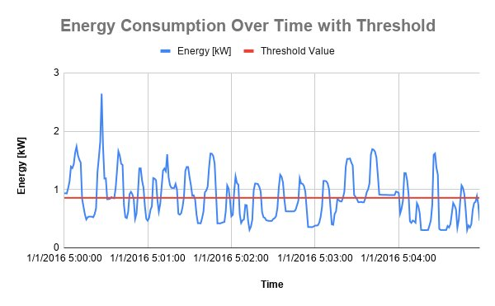
Figure 7.1: Energy Consumption Over Time with Threshold

The signal exhibits pronounced fluctuations across the observation window, with multiple peaks clearly breaching the threshold level. A prominent spike is visible near the 5:00:00 mark, where the energy consumption rises sharply to approximately 2.6 kW—more than twice the threshold value—before quickly subsiding. This transient behavior is characteristic of appliance switching events, analogous to transient spikes observed in electrical circuits upon load connection or disconnection.

For much of the observation period, the signal oscillates around and below the threshold, interspersed with shorter-duration excursions above it. This pattern suggests intermittent high-demand events against a background of moderate and low-demand intervals, consistent with typical residential energy usage behavior during early morning hours when specific appliances cycle on and off.

The threshold overlay provides a clear visual reference for distinguishing high-usage events from normal consumption, directly corresponding to the IF-based logical classification implemented in the dataset. From an electronics perspective, this visualization is analogous to a comparator output analysis, where a signal is evaluated relative to a reference to produce a binary state decision.

7.2 Energy Consumption Distribution – Histogram
Figure 7.2 shows the frequency distribution of energy consumption values across the analyzed dataset. The X-axis represents energy levels in kilowatts (kW), binned at intervals of approximately 0.15 kW, while the Y-axis represents the count (frequency) of records falling within each bin.

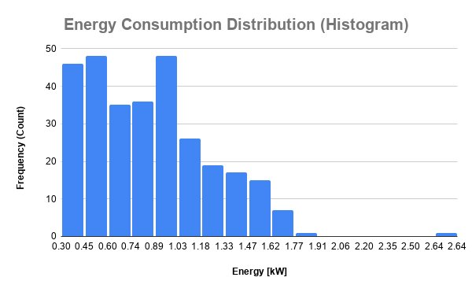
Figure 7.2: Energy Consumption Distribution (Histogram)

The distribution is right-skewed, with the highest concentration of data points occurring in the lower energy bins, specifically between 0.30 kW and 1.03 kW. The tallest bars, each with frequencies approaching 45–48 counts, are located at the 0.45 kW and 0.89 kW bins, indicating that these energy levels are the most frequently observed in the dataset. Beyond approximately 1.77 kW, the frequency drops sharply, with very few readings exceeding 2.0 kW.

This right-skewed distribution is consistent with the characteristics of residential energy usage, where the household operates at moderate consumption levels for the majority of the time, with occasional high-energy spikes corresponding to the simultaneous operation of multiple high-power appliances. In signal analysis terms, the histogram represents the probability density function (PDF) of the energy signal, revealing that the signal amplitude is most probable in the lower half of its observed range.

The tapering of frequency at higher energy values also supports the mean-based threshold classification: since most values lie below the mean of approximately 0.88 kW, the threshold correctly partitions the majority of low-energy readings as 'Normal,' while the long tail of higher values constitutes the 'High' category.

7.3 Usage Level Distribution – Pie Chart
Figure 7.3 depicts the proportional distribution of energy usage classifications—'High' and 'Normal'—across the dataset. The red segment represents 'High' usage (energy readings exceeding the mean threshold), and the green segment represents 'Normal' usage.

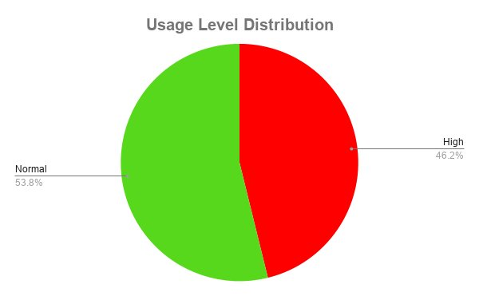
Figure 7.3: Usage Level Distribution (Pie Chart)

The pie chart reveals that 53.8% of the total records were classified as 'Normal,' while 46.2% were classified as 'High.' The near-even split between the two categories is a direct consequence of using the arithmetic mean as the classification threshold: by definition, the mean partitions the dataset into two groups where the proportion exceeding the mean depends on the skewness of the distribution.

The fact that 46.2% of records are classified as 'High' suggests that the energy distribution is mildly right-skewed—a skewed distribution would result in fewer values exceeding the mean if the tail were more pronounced. This near-balanced classification indicates that the dataset is relatively symmetric in its distribution, with roughly half the observation period characterized by above-average energy demand.

From an energy management standpoint, the finding that nearly half the time the household operates in a high-energy consumption mode implies significant opportunity for demand-side management strategies, such as load shifting or automated appliance scheduling, to reduce peak usage.

7.4 High Energy Usage Count by Device – Bar Chart
Figure 7.4 presents the count of 'High' usage instances attributed to each simulated device: Air Conditioner (AC), Heater, and Fridge. The Y-axis represents the number of high-usage instances, while the X-axis identifies the device category.

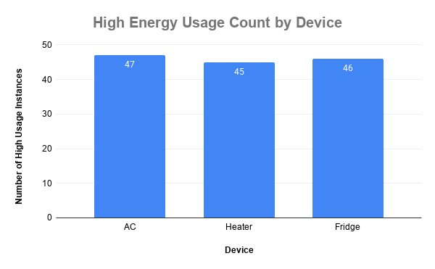
Figure 7.4: High Energy Usage Count by Device (Bar Chart)

The bar chart shows that the AC recorded the highest number of high-usage instances (47), followed closely by the Fridge (46) and the Heater (45). The differences across the three devices are minimal—spanning a range of just 2 counts—indicating a nearly uniform distribution of high-usage events across the simulated device categories.

It is important to contextually interpret this result with the knowledge that device assignment in this project was simulated using a modulo-based row-index method, cycling through the three device types sequentially. As a result, the near-equal distribution of high-usage counts is an expected mathematical outcome of the cyclic assignment, rather than a reflection of actual measured appliance-level energy demand.

Nonetheless, this chart serves a dual pedagogical purpose: it demonstrates the practical application of VLOOKUP for data enrichment and COUNTIFS for conditional aggregation, while also illustrating how a real-world device-level energy monitoring system would present appliance-specific demand data. In an actual smart home monitoring system, significant variation across device types would be expected, with high-power appliances such as AC units and electric heaters likely dominating high-usage events.

7.5 Temperature vs Energy Consumption – Scatter Plot
Figure 7.5 displays the relationship between ambient temperature (X-axis, in degrees Celsius) and energy consumption (Y-axis, in kilowatts) for the analyzed dataset. A linear trendline is overlaid on the scatter plot to indicate the directionality of the relationship.

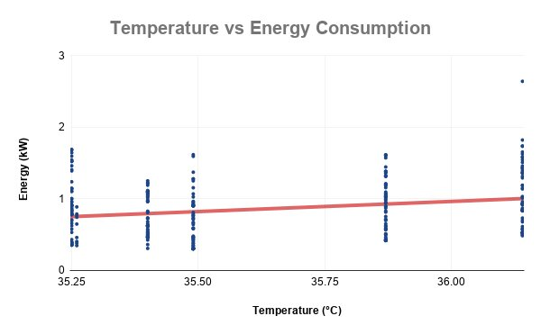
Figure 7.5: Temperature vs Energy Consumption (Scatter Plot)

The scatter plot reveals a weak positive correlation between temperature and energy consumption. The trendline has a slightly positive slope, indicating that as temperature increases, energy consumption tends to marginally increase. However, the data points are widely dispersed around the trendline, with considerable vertical spread at nearly every temperature value observed (approximately 35.25°C to 36.25°C), suggesting that temperature alone is a poor predictor of energy demand in this dataset.

The narrow temperature range observed (approximately 1°C variation) limits the strength of any correlation analysis. A dataset spanning a broader temperature range—such as seasonal variations from winter to summer—would likely reveal a stronger positive correlation, as cooling and heating demands are well-established drivers of residential energy consumption. The observed weak positive correlation is physically plausible: slightly higher temperatures may trigger increased air conditioning demand, but the effect is attenuated by other determinants such as occupancy patterns, appliance schedules, and user behavior.

From a signal processing perspective, the scatter plot can be interpreted as a two-dimensional phase space representation of the energy signal against a correlated environmental variable. The diffuse distribution confirms that the energy signal carries significant variability independent of the temperature parameter—consistent with a system where multiple overlapping causal factors govern the output signal.

Chapter 8: DISCUSSION
The results obtained from this project provide several noteworthy insights into residential energy consumption behavior as captured by the smart home dataset. The time-series analysis confirms that household energy usage is inherently dynamic, exhibiting rapid fluctuations that are characteristic of intermittent appliance operation. The presence of transient high-energy spikes in the line chart—particularly the peak approaching 2.6 kW—indicates that certain time intervals are associated with simultaneous or high-power appliance activation, a common occurrence during morning hours when residents typically engage multiple household devices.

The histogram analysis reveals that the energy signal is predominantly concentrated in the low-to-moderate consumption range (0.3 kW to 1.03 kW), with a right-skewed distribution. This distributional characteristic has practical implications for energy monitoring system design: the operating range for sensing and metering equipment should be optimized for low-to-moderate energy levels, with sufficient headroom to capture occasional high-amplitude events without clipping or saturation. This is analogous to the dynamic range specifications in electronic measurement systems.

The near-equal split between 'High' and 'Normal' usage classifications (46.2% vs 53.8%) suggests that the household operates at above-average energy demand for a significant fraction of the observation period. This finding, while partly an artifact of the mean-based threshold, underscores the potential value of real-time energy classification systems in alerting occupants to sustained high-demand periods, enabling timely behavioral or automated interventions.

The temperature–energy scatter plot's weak correlation is a significant finding, as it challenges the assumption that ambient temperature is the primary driver of residential energy consumption in short-duration datasets. This suggests that for short time windows, behavioral factors (appliance usage patterns, occupancy schedules) dominate energy variability, while weather-driven effects may only manifest meaningfully over longer temporal scales. This distinction is important for the design of predictive energy management algorithms, which must account for multiple input variables to achieve meaningful predictive accuracy.

From the perspective of data analytics tools, this project demonstrates that Microsoft Excel—when systematically applied—is capable of supporting a rigorous, multi-step data analysis workflow that encompasses preprocessing, feature engineering, classification, and visualization. While Excel lacks the automation and scalability of programming environments such as Python or R for large datasets, its interactivity and formula transparency make it exceptionally well-suited for educational data exploration tasks.

Chapter 9: CONCLUSION
This project successfully demonstrated the application of Microsoft Excel as a comprehensive data analysis tool for investigating smart home energy consumption patterns. Through a structured seven-stage pipeline—encompassing data import and cleaning, feature engineering, arithmetic scaling, logical classification, lookup-based data enrichment, aggregation, and multi-perspective visualization—the project extracted meaningful behavioral, temporal, and relational insights from a publicly available smart home dataset.

The analysis revealed that household energy consumption is highly dynamic and right-skewed, with the majority of readings concentrated below 1.03 kW and occasional high-amplitude spikes indicative of brief periods of intensive appliance usage. The mean-based threshold classification partitioned the dataset into approximately 53.8% 'Normal' and 46.2% 'High' usage records, highlighting the substantial proportion of time during which above-average energy demand is sustained. The temperature–energy scatter plot identified a marginally positive but statistically weak correlation, reinforcing the multi-causal nature of residential energy demand.

The implementation of VLOOKUP and HLOOKUP functions demonstrated how lookup tables can facilitate structured data enrichment in spreadsheet environments, while COUNTIFS-based aggregation enabled device-level comparative analysis. The project also validated the educational value of Excel as a gateway tool for engineering students to develop foundational skills in data literacy, signal interpretation, and analytical reasoning.

All project objectives were successfully met, and the results are consistent with expected physical and behavioral characteristics of smart home energy systems. The project contributes to the body of accessible, tool-agnostic educational frameworks for data analysis in Electronics and Communication Engineering.

Chapter 10: FUTURE SCOPE
The current project establishes a foundational framework for smart home energy data analysis using Excel. Several extensions and enhancements can be pursued in future work:

- Extended Temporal Analysis: The current dataset spans a short observation window of approximately five minutes. Future analysis using a full-day, full-month, or full-year dataset would enable the detection of diurnal cycles, weekday–weekend patterns, and seasonal trends—providing a more comprehensive picture of residential energy dynamics.
- Advanced Statistical Methods: Pearson or Spearman correlation coefficients can be computed within Excel's statistical add-ins or in programming environments (Python, R) to quantify the temperature–energy relationship more precisely, and regression models can be fitted to assess the predictive power of temperature and other weather variables.
- Machine Learning-Based Classification: Threshold-based binary classification can be extended to multi-class or probabilistic classification models using supervised learning algorithms. Energy consumption prediction models based on historical data and weather forecasts represent a natural progression from the descriptive analysis conducted here.
- Real Appliance-Level Metering: The simulated device mapping can be replaced with actual appliance-level sub-metering data, enabling genuine device-specific energy analysis. Smart plugs and disaggregation algorithms can facilitate this in a real smart home deployment.
- Interactive Dashboard Development: The static Excel visualizations can be transformed into interactive dashboards using Power BI or Tableau, incorporating real-time data streams from smart home APIs. Such dashboards would support proactive energy management by alerting occupants to anomalous consumption events.
- Integration with IoT Platforms: Future work could explore the integration of the analytical pipeline with IoT platforms such as AWS IoT or Google Cloud IoT, enabling automated data ingestion, classification, and alerting for live smart home monitoring applications.

REFERENCES
[1] Taranvee. Smart Home Dataset with Weather Information. Kaggle, 2021. Available at: https://www.kaggle.com/datasets/taranvee/smart-home-dataset-with-weather-information
[2] Microsoft Corporation. Microsoft Excel Documentation – Functions Reference. Available at: https://support.microsoft.com/excel, 2024.
[3] Reinhardt, A., & Burkhardt, D. "A Survey on Non-Intrusive Load Monitoring Methologies and Datasets," in Proc. IEEE SmartGridComm, 2012.
[4] Kolter, J. Z., & Johnson, M. J. "REDD: A Public Data Set for Energy Disaggregation Research," in Proc. SustKDD Workshop, 2011.
[5] U.S. Energy Information Administration. Residential Energy Consumption Survey (RECS). Available at: https://www.eia.gov/consumption/residential, 2020.
[6] Oppenheim, A. V., & Schafer, R. W. Discrete-Time Signal Processing, 3rd ed. Prentice Hall, 2010.
[7] Han, J., Kamber, M., & Pei, J. Data Mining: Concepts and Techniques, 3rd ed. Morgan Kaufmann, 2011.

