Modul4

Arya Gilang

2022-09-20

library(dslabs)  
data("murders")

sort(murders$population)

## [1] 563626 601723 625741 672591 710231 814180 897934 989415  
## [9] 1052567 1316470 1328361 1360301 1567582 1826341 1852994 2059179  
## [17] 2700551 2763885 2853118 2915918 2967297 3046355 3574097 3751351  
## [25] 3831074 4339367 4533372 4625364 4779736 5029196 5303925 5686986  
## [33] 5773552 5988927 6346105 6392017 6483802 6547629 6724540 8001024  
## [41] 8791894 9535483 9883640 9920000 11536504 12702379 12830632 19378102  
## [49] 19687653 25145561 37253956

pop <- murders$population  
index <- order(pop)

pop[index]

## [1] 563626 601723 625741 672591 710231 814180 897934 989415  
## [9] 1052567 1316470 1328361 1360301 1567582 1826341 1852994 2059179  
## [17] 2700551 2763885 2853118 2915918 2967297 3046355 3574097 3751351  
## [25] 3831074 4339367 4533372 4625364 4779736 5029196 5303925 5686986  
## [33] 5773552 5988927 6346105 6392017 6483802 6547629 6724540 8001024  
## [41] 8791894 9535483 9883640 9920000 11536504 12702379 12830632 19378102  
## [49] 19687653 25145561 37253956

order(index)

## [1] 29 5 36 20 51 30 23 7 2 49 44 12 13 47 37 22 19 26 27 11 33 38 43 31 21  
## [26] 34 8 14 17 10 41 16 48 42 4 45 24 25 46 9 28 6 35 50 18 3 40 39 15 32  
## [51] 1

min(murders$total)

## [1] 2

i_min <- which.min(murders$total)  
murders$state[i_min]

## [1] "Vermont"

i_min <- which.min(murders$population)  
murders$state[i_min]

## [1] "Wyoming"

temp <- c(35, 88, 42, 84, 81, 30)  
city <- c("Beijing","Lagos","Paris","Rio de Janeiro","San Juan","Toronto")  
city_temps <- data.frame(name = city, temperature = temp)  
city_temps

## name temperature  
## 1 Beijing 35  
## 2 Lagos 88  
## 3 Paris 42  
## 4 Rio de Janeiro 84  
## 5 San Juan 81  
## 6 Toronto 30

ranks <- c(city_temps)

ranks

## $name  
## [1] "Beijing" "Lagos" "Paris" "Rio de Janeiro"  
## [5] "San Juan" "Toronto"   
##   
## $temperature  
## [1] 35 88 42 84 81 30

negara <- c("USA","Germany", "Engleand", "Qatar", "France")  
populasi <- c(1,3,2,5,4)  
my_df <- data.frame(negara = negara,populasi_rendah = populasi )  
my_df

## negara populasi_rendah  
## 1 USA 1  
## 2 Germany 3  
## 3 Engleand 2  
## 4 Qatar 5  
## 5 France 4

ind <- order(my_df$populasi)  
my_df$populasi[ind]

## [1] 1 2 3 4 5

population_in_millions <- murders$population/log10(murders$population)  
total_gun_murders <- murders$total  
plot(population_in_millions, total_gun_murders)

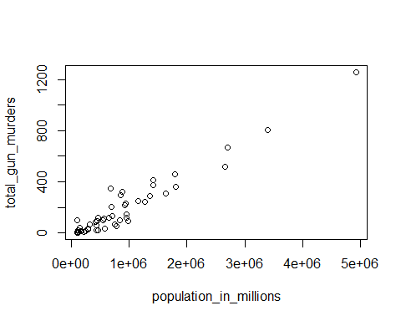

x <- with(murders, total_gun_murders / population_in_millions * murders$population)  
hist(x)

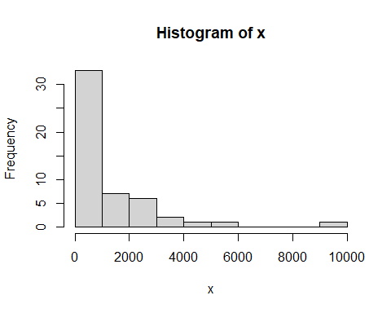

murders$rate <- with(murders, total_gun_murders / population_in_millions * murders$population)  
boxplot(rate~region, data = murders)

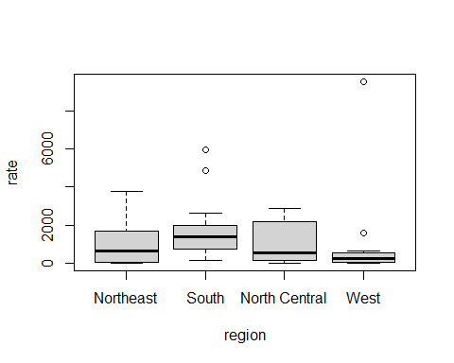

## R Markdown

This is an R Markdown document. Markdown is a simple formatting syntax for authoring HTML, PDF, and MS Word documents. For more details on using R Markdown see <http://rmarkdown.rstudio.com>.

When you click the **Knit** button a document will be generated that includes both content as well as the output of any embedded R code chunks within the document. You can embed an R code chunk like this:

summary(cars)

## speed dist   
## Min. : 4.0 Min. : 2.00   
## 1st Qu.:12.0 1st Qu.: 26.00   
## Median :15.0 Median : 36.00   
## Mean :15.4 Mean : 42.98   
## 3rd Qu.:19.0 3rd Qu.: 56.00   
## Max. :25.0 Max. :120.00

## Including Plots

You can also embed plots, for example:



Note that the echo = FALSE parameter was added to the code chunk to prevent printing of the R code that generated the plot.