Assessment-2

1. Write a program to iterate over a list using for loop.

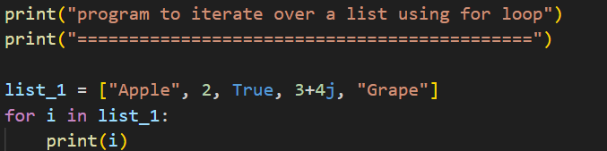

Output

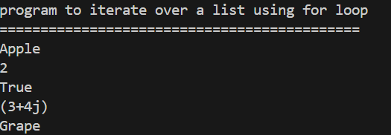

2. Create a tuple and find sum of the numbers in tuple using for loop.

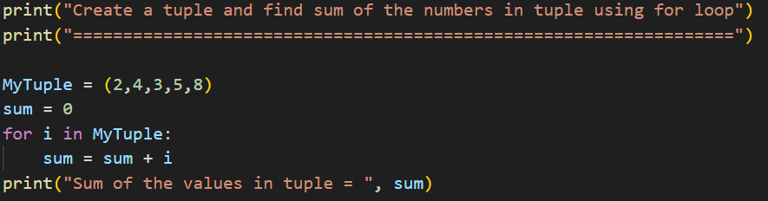

Output

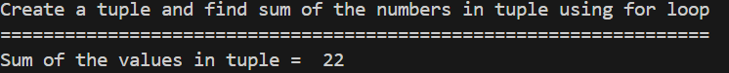

3. List = [“slbs”, “marklance”] Print each letter in separate lines using for loop.

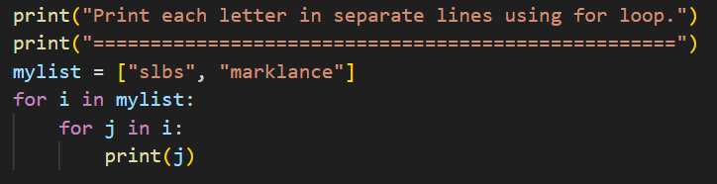

Output

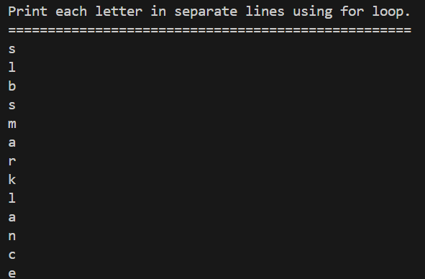

4. Write a program to print each letter in “marklance” without “k”.

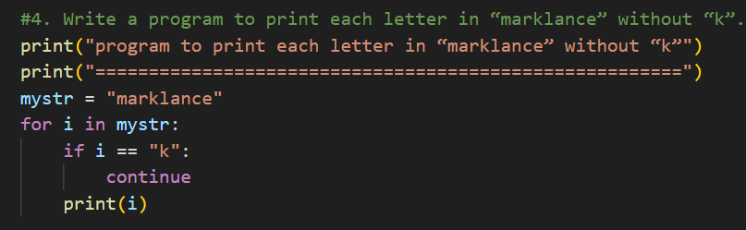

Output

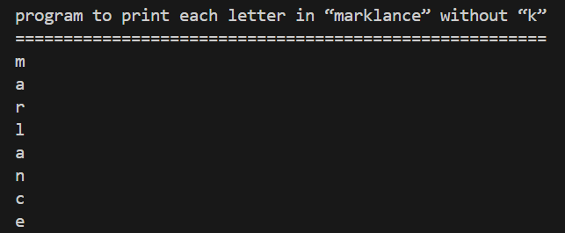

5. Write a program to add elements to an empty list using while loop.

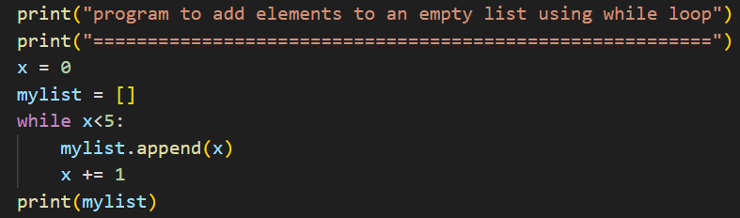

Output

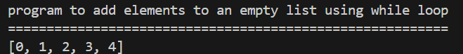

6. Write a program to find sum of numbers in a list.

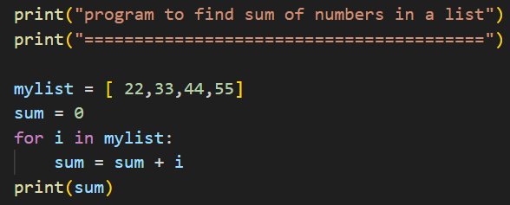

Output

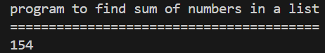

7. Find average of 3 numbers using while loop.

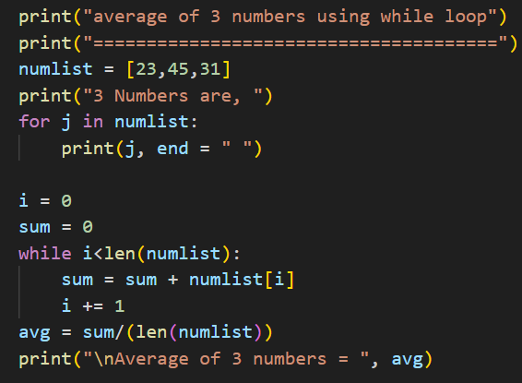

Output

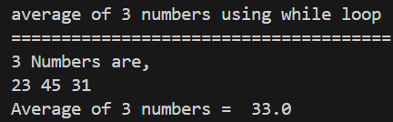

8. Write a program to print square of a number using while loop.

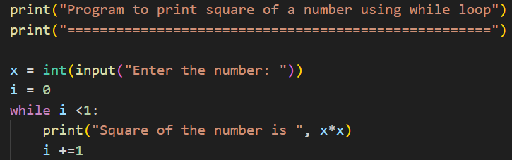

Output

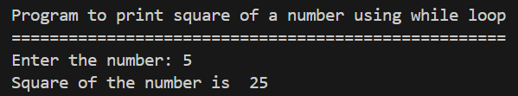

9. Program to find multiples of 5 (while loop)

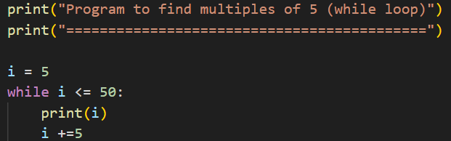

Output

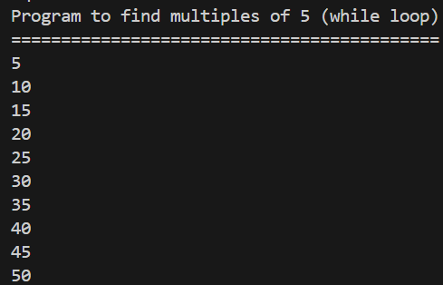

10. write a program to reverse a number.

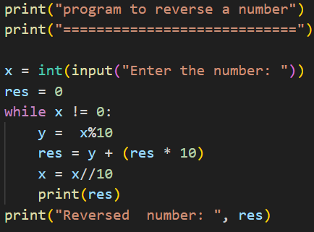

Output

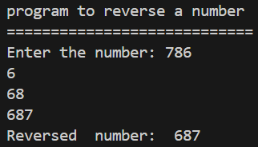

11. Python program to check whether a number is prime or not?

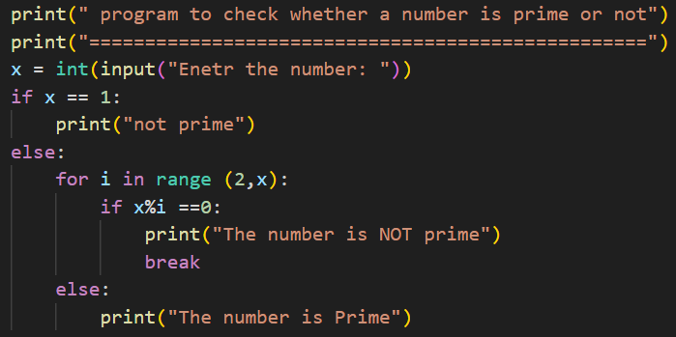

Output

