Application Flow Chart
This document outlines the architecture and data flow of the Remote MCP Control System.

Architecture Overview
The system consists of three main components orchestrated by the RemoteAgentApp:
1. TelegramBridge: Handles user interaction via Telegram.
2. OpenCodeAgent: Processes natural language requests using the opencode CLI.
3. MCPServer: specific tools and raw command execution.

Message Processing Flow
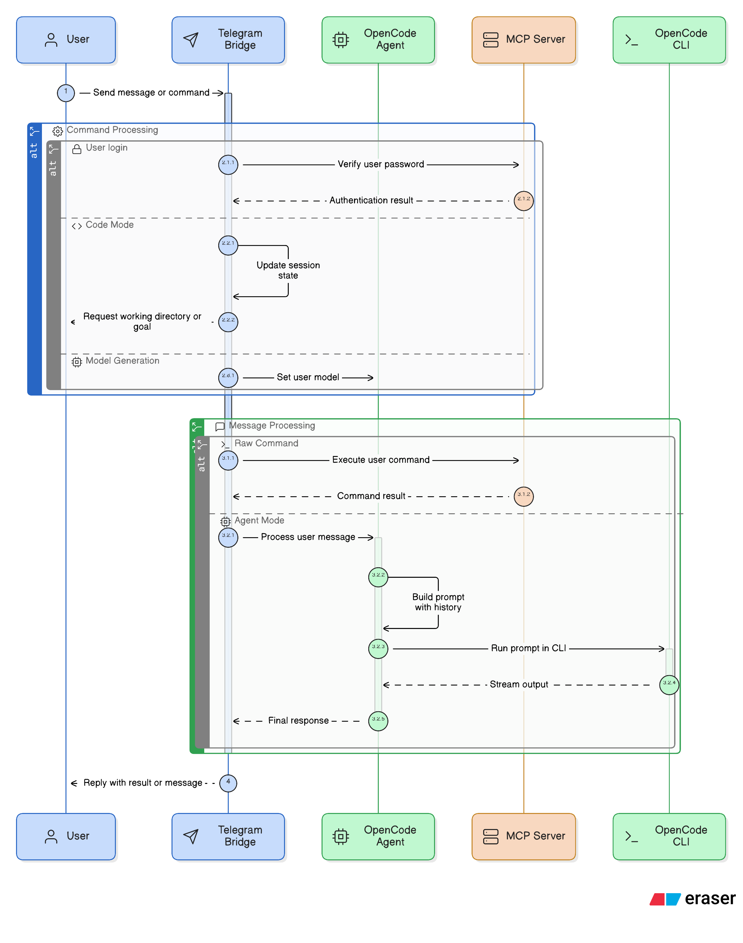

detailed Component Interaction

1. Initialization (src/main.py)
- RemoteAgentApp initializes MCPServer.
- RemoteAgentApp initializes OpenCodeAgent.
- RemoteAgentApp initializes TelegramBridge injecting mcp_server and opencode_agent.

2. Telegram Bridge (src/bridges/telegram_bridge.py)
- Acts as the entry point for all user interactions.
- Manages User Sessions:
  - Tracks authentication state.
  - specialized modes (e.g., CODING mode).
  - Session history and context.
- Routes messages:
  - Commands (/start, /login): Handled locally or via MCP Auth.
  - Raw Commands: Routed to MCPServer.
  - Natural Language: Routed to OpenCodeAgent.

3. OpenCode Agent (src/core/opencode_agent.py)
- Wraps the opencode CLI.
- Manages User Context (history of recent messages) to build context-aware prompts.
- Direct File Search: Optimized checking for file requests before calling the heavy agent.
- executes the request via opencode run and streams the output back.

4. MCP Server (src/core/mcp_server.py)
- Provides the core toolset (ShellTool, FilesTool, etc.).
- Used by TelegramBridge for raw command execution and authentication checks.
- Can be exposed as a standalone MCP server.

