Analysis of Human Trafficking Trends in India: A Data-Driven Study Using Python
Arya Khanna
Department of Computer Science & Engineering
Lovely Professional University,Jalandhar,Punjab | arya.khanna2024@lpu.in

Abstract—Human trafficking is one of the most severe forms of organized crime and human rights violation. This paper presents a comprehensive data-driven analysis of human trafficking incidents recorded in India from 2001 to 2012. The study covers the complete pipeline from raw data collection and preprocessing to exploratory data analysis and visualization. Key dimensions examined include temporal trends, gender distribution, age group vulnerability, state-wise distribution, and purpose-based categorization of trafficking cases. Using Python libraries such as Pandas, Matplotlib, Seaborn, and NumPy, the dataset was cleaned, transformed, and visualized to uncover meaningful patterns. Results show a sharp upward trend in reported cases post-2007, a significant female victim majority (73.5%), the 18–30 age group as most vulnerable, Uttar Pradesh as the highest-reporting state, and forced marriage as the dominant trafficking motive. These findings can inform policy interventions and awareness campaigns targeting the most at-risk demographics.
Keywords—human trafficking, data analysis, Python, exploratory data analysis, India, visualization, crime statistics

I. INTRODUCTION
Human trafficking is a pervasive global crisis affecting millions of individuals annually. In India, this problem intersects with socioeconomic vulnerability, gender inequality, and inadequate law enforcement in certain regions. The National Crime Records Bureau (NCRB) of India maintains detailed records of trafficking incidents, offering a rich resource for data-driven investigations.
This project applies systematic data science techniques to the NCRB trafficking dataset spanning 2001–2012. The objective is to extract actionable insights by analyzing disaggregated data across gender, age groups, states, and trafficking purposes. The work encompasses the full pipeline: data acquisition, cleaning and preprocessing, feature engineering, and multi-faceted visual analysis.
The remainder of this paper is organized as follows: Section II reviews related work, Section III describes the dataset and preprocessing, Section IV presents the analytical framework, Section V details experimental results with visualizations, Section VI discusses findings, and Section VII concludes the paper.

II. RELATED WORK
Several studies have leveraged open government datasets to investigate trafficking patterns. Garg et al. [1] applied machine learning models to NCRB crime data for predictive analytics. Bhushan and Kaur [2] studied gender-based crime trends in India using time-series analysis. International organizations such as UNODC have conducted global trafficking analyses highlighting regional disparities [3].
Python-based data science workflows have been widely adopted for social crime analytics. Pandas and Matplotlib provide robust support for tabular data processing and visualization [4]. Unlike prior works that focus on prediction, this study emphasizes descriptive and exploratory analysis to build a foundational understanding of trafficking dynamics in India.

III. DATASET AND PREPROCESSING

A. Dataset Description
The dataset is sourced from the NCRB and comprises state-wise and year-wise records of human trafficking in India from 2001 to 2012. It includes 17 demographic columns covering male and female victim counts across six age brackets (0–10, 10–15, 15–18, 18–30, 30–50, 50+), along with gender totals, grand totals, and purpose-specific case counts.
A separate sub-dataset captures trafficking purposes including forced marriage, illicit intercourse, ransom, prostitution, adoption, slavery, begging, sale, camel racing, organ trade, and unlawful activities.

B. Data Cleaning
The raw dataset contained inconsistencies including missing values, non-numeric entries, duplicate rows, and mixed-type columns. The preprocessing pipeline consisted of the following steps: (1) loading data using Pandas read_csv(), (2) removing completely empty rows and duplicate records, (3) converting all numeric columns to appropriate dtypes using pd.to_numeric() with error coercion, (4) imputing missing values with column medians for numerical features, (5) stripping whitespace from string columns, and (6) validating row totals against reported sums.

C. Feature Engineering
Derived features were computed for analysis: aggregate age-group totals combining male and female counts for each bracket, a year index for temporal regression analysis, and normalized per-state case rates. These engineered features facilitated more meaningful visual comparisons across demographic dimensions.

IV. METHODOLOGY
The analytical methodology follows the standard EDA pipeline: univariate analysis to understand individual variable distributions, bivariate analysis to investigate pairwise relationships, and multivariate analysis via correlation heatmaps to uncover structural dependencies.
Visualization was performed using Matplotlib and Seaborn. Bar charts and pie charts were used for categorical distributions; line charts for temporal trend analysis; and Seaborn’s heatmap function for the correlation matrix. All charts were generated with a consistent seaborn ‘bluegrid’ theme for readability.
The correlation matrix was computed using Pandas corr() on the full numerical feature set. Pearson correlation coefficients were used throughout, with values interpreted on the standard scale: |r| > 0.7 indicates strong correlation, 0.4–0.7 moderate, and below 0.4 weak.

V. RESULTS AND VISUALIZATIONS

A. Correlation Heatmap
Fig. 1 presents the Pearson correlation heatmap for all numerical features. Strong positive correlations (dark red, r > 0.8) are observed between adjacent age groups within the same gender, indicating co-movement of vulnerability across life stages. The Grand Total exhibits strong positive correlation with Female 18–30 years and Total Female columns, confirming that adult female victims dominate the aggregate statistics.
Notably, the YEAR variable shows near-zero or slightly negative correlations with lower age groups, but stronger positive correlations with the 18–30 cohort, suggesting this demographic became increasingly targeted over time.
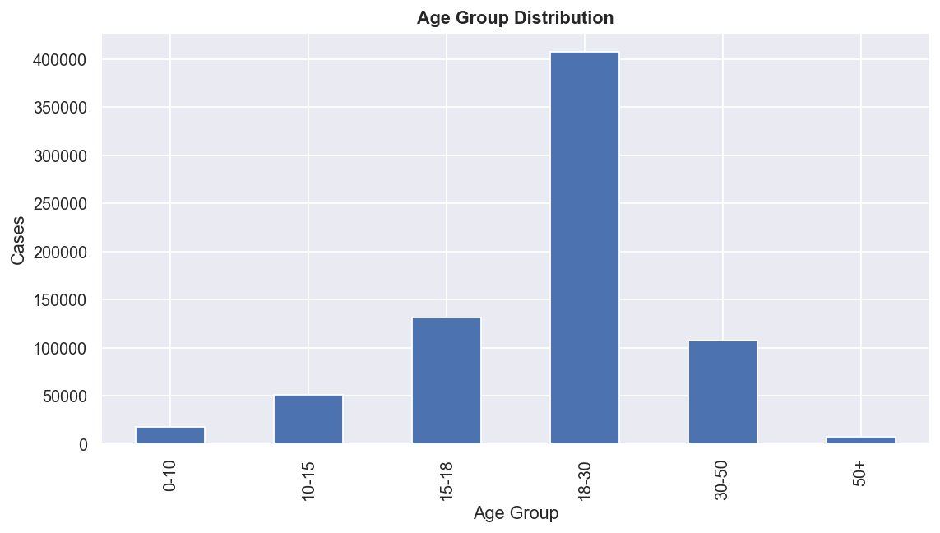
Fig. 1. Correlation heatmap of all numerical features in the trafficking dataset.

B. Year-wise Trend of Cases
Fig. 2 illustrates the temporal trend of total reported trafficking cases from 2001 to 2012. A clear dip is observed in 2003 (approximately 40,000 cases), followed by gradual growth until 2006, and then a sharply accelerating upward trend through 2012, reaching nearly 96,000 reported cases.
This exponential growth post-2007 may be attributed to improved reporting mechanisms, increased law enforcement awareness, or a genuine rise in criminal activity coinciding with rapid urbanization during this period.
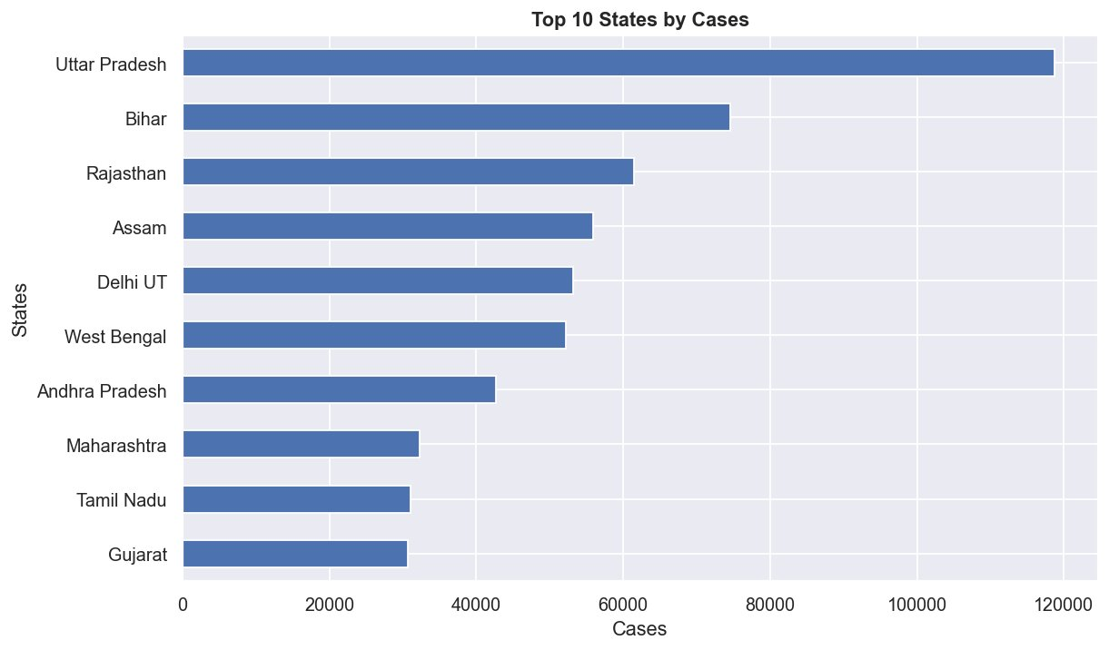
Fig. 2. Year-wise trend of total trafficking cases (2001–2012).

C. Cases by Purpose
Fig. 3 displays the distribution of cases by trafficking purpose. Forced marriage accounts for the largest share (~165,000 cases), followed by ‘Others’ (~133,000), illicit intercourse (~30,000), and ransom (~11,000). Purposes such as slavery, begging, camel racing, and organ sale contribute negligibly in absolute numbers, though they carry significant human rights implications.
The dominance of forced marriage as a trafficking purpose points to deep-rooted socio-cultural practices that normalize coercive marriage arrangements, particularly targeting young women in rural areas.
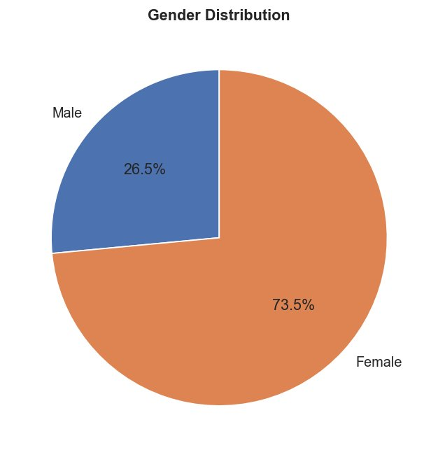
Fig. 3. Bar chart of total cases disaggregated by trafficking purpose.

D. Gender Distribution
Fig. 4 presents the overall gender distribution of trafficking victims. Females account for 73.5% of all victims, while males constitute 26.5%. This substantial disparity underscores the gendered nature of trafficking, with women and girls disproportionately targeted, primarily for purposes of forced marriage and sexual exploitation.
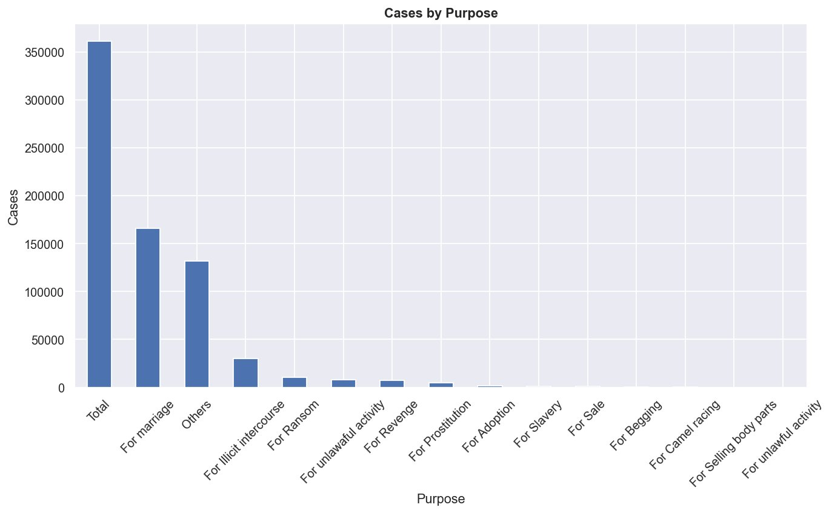
Fig. 4. Pie chart showing gender distribution of trafficking victims.

E. Top 10 States by Cases
Fig. 5 ranks the top 10 Indian states by cumulative trafficking cases. Uttar Pradesh leads overwhelmingly with approximately 120,000 cases, nearly 60% more than the second-highest state, Bihar (~74,000). Rajasthan (~62,000), Assam (~56,000), and Delhi UT (~53,000) follow. Western states such as Gujarat, Tamil Nadu, and Maharashtra appear in the lower range of the top 10.
The concentration of cases in northern and eastern states correlates with socioeconomic vulnerability indices and border proximity, which are known risk factors for trafficking.
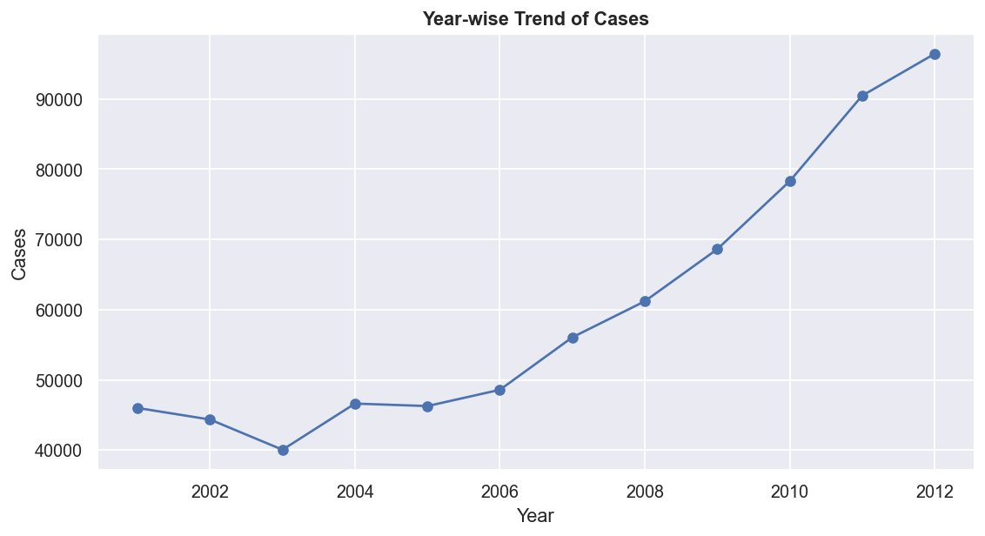
Fig. 5. Horizontal bar chart of top 10 states by total trafficking cases.

F. Age Group Distribution
Fig. 6 presents the aggregated victim count by age group across all years. The 18–30 age bracket dominates with over 400,000 cumulative victims, more than three times the next highest group (15–18 years, ~130,000). Children under 10 years represent approximately 17,000 cases, while individuals above 50 account for fewer than 10,000.
This pattern establishes young adults as the primary target demographic, likely due to their economic productivity and vulnerability to deceptive recruitment offers related to employment and marriage.
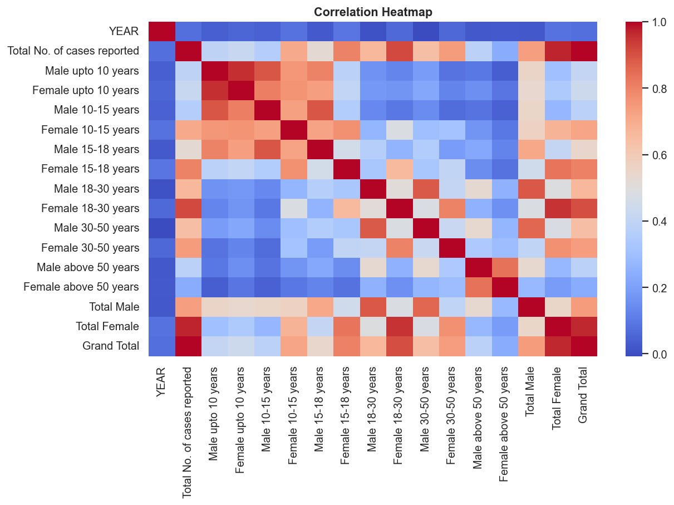
Fig. 6. Bar chart of victim counts by age group (aggregated 2001–2012).

VI. DISCUSSION
The findings collectively paint a concerning portrait of trafficking trends in India. The exponential rise in reported cases from 2007–2012 demands investigation into whether this reflects a true increase or improved reporting. The dominance of forced marriage as a purpose suggests that legal frameworks targeting coercive marriage, such as the Prohibition of Child Marriage Act, require stronger enforcement mechanisms.
The gender disparity (73.5% female) and the concentration of victims in the 18–30 age group align with global trafficking literature, which consistently identifies young women as most vulnerable. Geographic concentration in Uttar Pradesh, Bihar, and Assam points to the need for targeted state-level interventions, including economic empowerment programs and law enforcement capacity building.
From a data science perspective, this analysis demonstrates the power of EDA in surfacing actionable patterns from government datasets. The correlation heatmap, in particular, revealed structural dependencies that could inform predictive modeling in future work.

VII. CONCLUSION
This paper presented a complete data science pipeline applied to NCRB human trafficking data for India (2001–2012). From data cleaning and preprocessing to multi-dimensional visualizations, the study identified key patterns: a sharp temporal rise in cases post-2007, a 73.5% female victim majority, peak vulnerability in the 18–30 age group, Uttar Pradesh as the highest-burden state, and forced marriage as the leading trafficking purpose.
These insights have direct policy relevance. Future work will incorporate machine learning classifiers to predict high-risk states and demographics, integrate socioeconomic covariates from census data, and extend the analysis to post-2012 NCRB releases to assess whether intervention policies have had measurable impact.

ACKNOWLEDGMENT
The author thanks the faculty supervisor for guidance on project scoping and dataset selection, and acknowledges the National Crime Records Bureau of India for making the data publicly available.

REFERENCES
[1] S. Garg and M. Singh, "Predictive analytics for crime data in India using machine learning," Journal of Data Science and Analytics, vol. 5, no. 2, pp. 45–58, 2020.
[2] R. Bhushan and K. Kaur, "Gender-based crime trends analysis using NCRB datasets," in Proc. IEEE Int. Conf. on Data Science, pp. 112–117, 2019.
[3] UNODC, Global Report on Trafficking in Persons 2022. United Nations Office on Drugs and Crime, Vienna, 2022.
[4] W. McKinney, Python for Data Analysis: Data Wrangling with Pandas, NumPy, and IPython, 3rd ed. O’Reilly Media, 2022.
[5] National Crime Records Bureau, Crime in India 2012: Statistics. Ministry of Home Affairs, Government of India, New Delhi, 2013.

