10
Like Magna, Magneti Marelli is currently developing a subframe made of SMC compression moulding. The subframe assembly, shown in Figure 4, is currently being tested on four-door compact sedan vehicles [28].
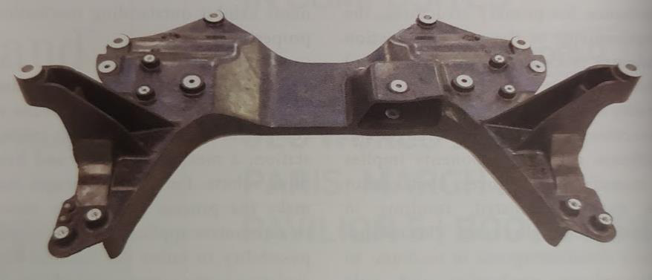
Figure 4 - SMC front subframe by Magneti Mirelli [29]
2.4Thermoset resins, the importance of mix homogeneity and
characterization methods
The most commonly used matrices for structural applications in the automotive industry are epoxies and vinyl esters for their higher mechanical resistance and thermal performance [30], [31]. Vinyl ester polymers have been widely used for their good mechanical properties, thickening and curing performance as a matrix for SMC [32].
Vinyl ester polymers are a hybrid between polyester and epoxy polymers that feature two catalytic reactions. They are produced by the esterification of epoxy with carboxylic acid, usually bisphenol A and methacrylic acid. The prepolymer is usually dissolved in styrene to decrease the viscosity and to allow the reaction with the methacrylate [33].
In SMC applications, the resin is mixed with a thickening agent to allow the sheets to be manipulated and put into a mould. Physical and chemical thickening methods can be employed. Physical thickening uses crystalline resins but their research difficulty and cost limit their use [32]. In contrast, chemical thickening can be accomplished with isocyanates to form covalent bonds between the hydroxyl and carboxyl groups of the resin, known as urethane linkage [34].
For SMC manufacturing, the resin is made of two major components, part A (vinyl ester monomer, catalyst, inhibitor) and part B (isocyanate). The first reaction is a typical polyurethane reaction which involves isocyanate (Part B) reacting with amines in the vinyl ester resin (Part A)

11
to thicken the resin. This reaction increases the size of the molecules, notable via the thickening of the resin. This allows rolls of prepreg material to be manufactured and manipulated. The secondary reaction involves vinyl ester crosslinking for part manufacturing and is activated through heat when the product is moulded to its final shape. The increase in thermal energy makes the catalyst sufficiently reactive to initiate the crosslinking reaction of the vinyl ester. This final reaction is what gives the product its properties.
It is important to note that part B, containing mostly a mix of various forms of isocyanate, is very sensitive to humidity [34]. Moisture in the air, a polar compound, reacts with the isocyanate functional group and releases carbon dioxide as a product. This product is undesirable for a resin system because it can create porosity and decrease its mechanical properties. Therefore, during all the manufacturing phase, great care must be given to ensure the resin is stored in an airtight container in a dry environment.
Vinyl ester’s mechanical properties and cost fall between polyesters and epoxies. Table 1 lists prices and tensile strength for polyester, vinyl ester and epoxy resin families.
Table 1 – Price and tensile strength comparison of polyester, vinyl ester and epoxy resins
Resin family | Average | Tensile Strength | Stiffness
 | price2 ($/lb) | (MPa) [35] | (GPa) [35]
Polyester | 2-3 | 6.4 | 2.8
Vinyl Ester | 3-8 | 7.6 | 3.0
Epoxy | 5-30 | 8.1 | 3.3
Mechanical properties of polyesters do not allow the resin to be used for structural applications. Even though epoxy resins have higher mechanical properties than vinyl ester resins, their higher cost may affect the business case viability in high production volumes. As seen above, BMW uses Huntsman’s Araldite LY 3585/Hardener XB 3458 epoxy system for its i3 passenger
2 Dubreuil, Personal discussion. 2018-10-04. Price listed are a rough estimate. Price will vary greatly depending on the desired properties and purchased volume. Price listed considers a high-volume purchase.

12
cell, but the car’s low production volume and high price, starting at 48,750 $ before taxes, makes it a niche model [36], [37]. In contrast, Magna uses vinyl ester resin for its prototype carbon fibre reinforced polymer front subframe in its development partnership with Ford [38]. The composite part, manufactured using SMC technology, is currently being tested on Ford Fusion models, a car that sold over 200,000 units in 2017 in the U.S. alone with a price starting at 22,838$, about half of BMW’s i3 [39], [40].
SMC part manufacturers add multiple additives and fillers to improve the resin properties and bring the cost down. Additives are used to improve performance and alter properties of the resin while fillers are mostly used to reduce cost. Figure 5breaks down typical SMC resin formulations additive and filler weight content.
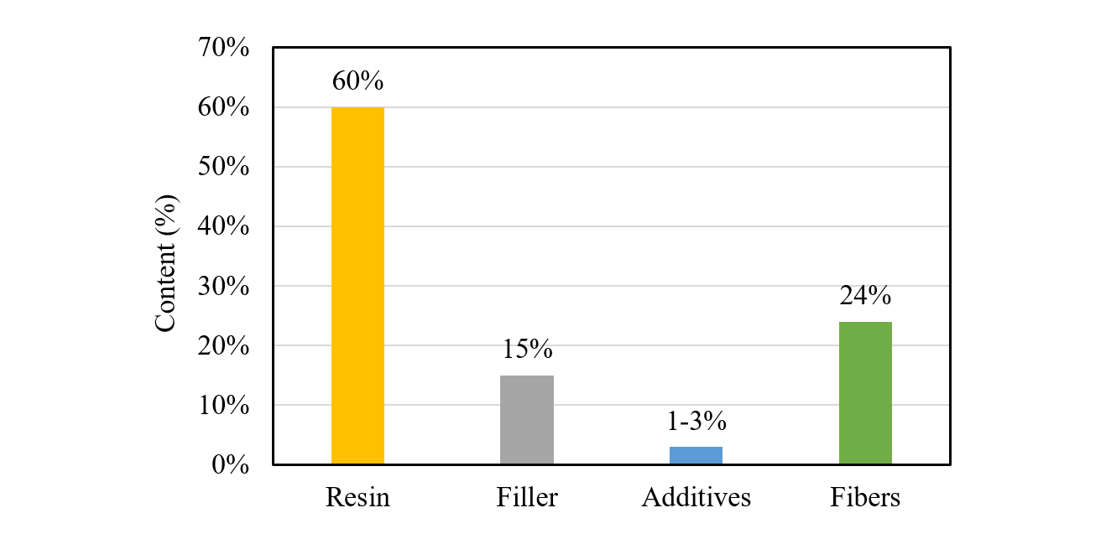
Figure 5 - Typical SMC resin formulations additive and filler content [17]
Filler content is much higher than additives, motivated by the economic advantage they offer. Table 2lists common additives and fillers with their effect on resin properties.

13
Table 2 – Common additives and fillers and their effect on resin properties
 |  | Effect on resin properties | Reference
Additive | Nanoclay | Improved toughness, flexural strength and | [41], [42]
modulus, tensile strength and modulus
 | Phosphorus | Flame retardancy | [43]
 | Carbon black | UV protection | [44]
Filler | Glass | Weight reduction and stiffness increase, | [45], [46]
 | microspheres | reduced shrinkage
 | Calcium | Increased crosslinking density and | [47]
 | carbonate | stiffness
 | Milled carbon or | Improved mechanical properties | [48]
glass fibers
Talc | Thermal stability and reduced shrinkage | [49]
2.4.1Mixing homogeneity
Two conditions are required for the polymer to reach the highest degree of polymerization; the components must be present in the right concentration and location [50], [51]. The first condition is dictated by the homogeneity of the mix while the second is a result of good dosage of the resin’s constituents. In process engineering, industrial mixing is the control of segregation and is used to obtain a homogeneous distribution of the components in the entire volume [52]. In the field of thermosetting polymers, because slight changes to the formulation can significantly affect the curing and properties of the resin, it is important to make sure that the homogeneity of the resin is sufficient and that the mixing process is well controlled [53].
Depending on the products to be mixed, a wide range of tests can be performed to evaluate homogeneity. Mix homogeneity is a statistical measure of the spatial dispersion of the components and is quantified using the coefficient of variation (CoV) of the products, also known as the intensity of segregation [54]. The CoV is the most commonly used metric to quantify the homogeneity of a mixture [55]. It is calculated by dividing the standard deviation 𝜎𝑐by the mean 𝜇 as,

14
𝐶𝑜𝑉% = (𝜎𝐶𝜇) ∗100 (1)
the standard deviation of the tested property is calculated by,
𝑁  𝜎𝑐= √1𝑁∑(𝐶𝑖−𝜇)2𝑖=1 | (2)
where 𝐶𝑖 represents the chosen numerical index, 𝜇 is the average of the index’s data set and 𝑁 is the sample size, by the mean. In other terms, the coefficient of variation is a measure of the dispersion of a data set to the mean, or in this case, how equal are the component concentrations in the polymer. The index used for CoV calculations should be associated with the mixture, characterize the final stage of the mixture, be independent of the mixing method and easily determined [56]. The technique used to obtain the index will depend on the materials to be mixed and their properties.
In most industrial processes, a product with a CoV of less than 5% (or. 0.05) is considered adequately mixed [57], [58]. In other terms, a CoV of 0.05 means that the product is 95% homogeneous. For example, a CoV limit of 0.05 is also required by the Canadian Food Inspection Agency for dilute drug mixing processes in the food industry for animals [59].
2.4.1.1Determination of the index used for CoV calculations
Infrared (IR) spectroscopy is by far one of the most versatile technique to characterize organic compounds. This technique exposes a sample of material to an infrared radiation. The energy absorption of the material with respect to the infrared wavelength is derived and can be related to the substance’s chemical functional groups. The machine expresses the results as absorbance or transmittance spectra, both of which are related using,
𝐴= −log (𝑇) (3)
where A and T are respectively the substance’s infrared absorbance and transmittance at a given wavenumber. More details on the working principle of FTIR can be found in reference [60]. This test method can be used for quantitative monitoring of chemical reactions as well as sample

15
homogeneity [61]–[64]. More specifically, Fourier Transform Mid-Infrared Spectroscopy (FTmIR), analyzing a sample at wavenumbers from 4000 to 1000 cm−1, is best suited for organic polymers like isocyanate thickened vinyl ester resins and allows the detection of important functional groups. Figure 6 presents the FTIR transmittance spectra of polyvinyl acetate and methyl isocyanate. Polyvinyl acetate has a chemical composition that is very similar to vinyl ester resin.
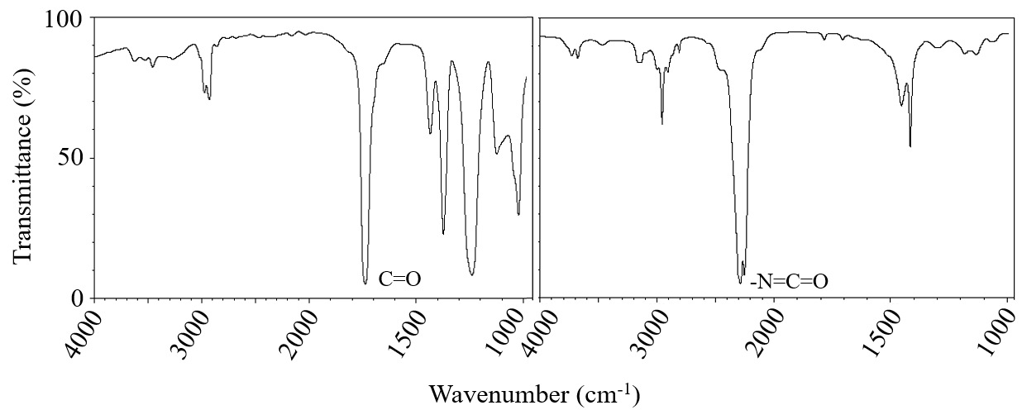
Figure 6 – FTIR transmittance spectra of polyvinyl acetate (left) and methyl isocyanate (right) [65]
Figure 6 shows the characteristic peak of the carbonyl group and isocyanate at 1738 cm-1 and 2810 cm-1 respectively. In the event of mixing both components together, as would be the case in SMC manufacturing, mostly the same absorbance peaks would be observed in the new spectrum unless rapid chemical reactions occur and modify the composition of the sample. Then, depending on the mixing ratio of both components, the spectrum of one of the components would dominate. In SMC, the chemical thickening agent is added in very low quantity to the resin [66]. This suggests the spectrum of the mixed sample will closely resemble the one for vinyl ester resin with the addition of the major absorbance peaks of the isocyanate infrared spectrum in diminished amplitude.
To use FTIR data to quantitatively evaluate the mixing homogeneity, the Beer-Lambert law is used. The law is expressed as,
𝐴= 𝜀𝑙𝑐(4)

16
where 𝐴is the absorbance, 𝜀 is the molar extinction coefficient, 𝑙 is the light path length and 𝑐 is the concentration, states that the FTIR absorbance of a functional group is proportional to its concentration in the sample [63].
This means the height of a characteristic peak on an FTIR absorbance spectrum graph can be measured and used for quantitative analysis to obtain the coefficient of variation between multiple samples. Figure 7 visually presents the Beer-Lambert law using the linearity of the correlation between FTIR absorbance and the concentration of aspirin dissolved in chloroform.
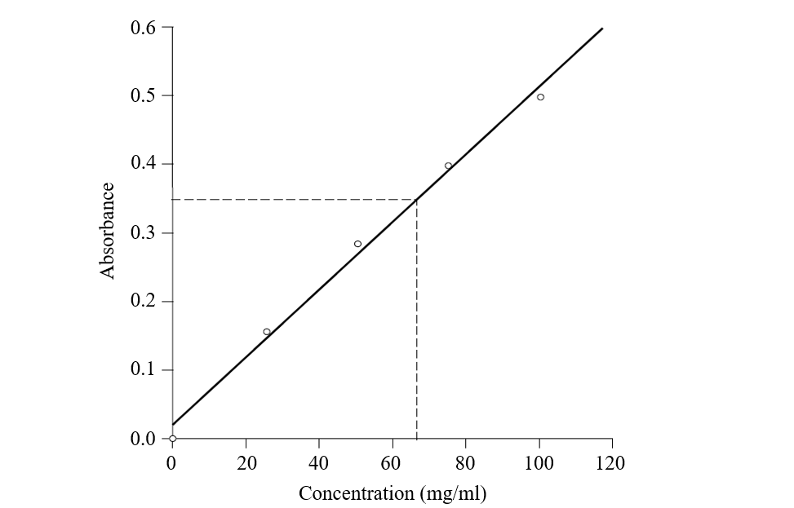
Figure 7 - FTIR calibration graph for aspirin dissolved in chloroform [63]
Applying this correlation to vinyl ester resin and isocyanate, the absorbance peak height of isocyanate at 2810 cm-1 can be measured and compared between multiple samples to determine the homogeneity of parts A and B of the resin. The result is expressed using the coefficient of variation (CoV).
Unfortunately, the Beer-Lambert law is only applicable under certain conditions. Non-linearities can be caused if the concentration is too high, if the sample contains solids that scatter the light or if the sample is fluorescent or phosphorescent. SMC vinyl-ester resin systems usually contain solid fillers and additives that could potentially make the Beer-Lambert law inapplicable.

17
Luckily, the resin does not contain conjugated double-bond systems which suggest it is not fluorescent.
Polymers mix homogeneity can also be evaluated by the mechanical property variations of the cured state. For thermoset polymers, mechanical properties can be directly correlated to the resin/hardener ratio [67]. Therefore, if the mixing is not homogeneous, specimens will show variance in their mechanical properties. On a microscopic scale, badly mixed samples will present areas with a higher or lower concentration of hardener, thus influencing the consistency of the results obtained from mechanical testing. Unfortunately, the test’s macroscopic scale does not inform about the intensity of segregation of the products.
A widely spread analytical technique for the characterization of thermosetting materials is differential scanning calorimetry (DSC). DSC essentially measures the energy required to change the temperature of the sample. Usually, this test allows the determination of glass transition and melting temperatures of a polymer compound. Studies have shown the dependence of the glass transition temperature on the composition of a sample [68]. Therefore, DSC analysis results can be compared to a reference sample to evaluate the variance in the mixing ratio. Unfortunately, DSC testing is a relatively slow and expensive test to perform and evaluating the homogeneity of a sample requires a modestly sized sample population to draw meaningful conclusions.
TGA measures the weight loss of a sample as a function of temperature. Applied to thermosetting polymers, this means that TGA testing records the change in mass due to the nature of the matter, monitoring the volatile and solid components. In a similar way to DSC, TGA test results can be used to evaluate the homogeneity of the sample as a different hardener to resin ratio will influence the cure reaction and consequently the weight loss behaviour of the sample. As with mechanical testing, TGA results do not explicitly allow quantifying the concentration of the products.
Other techniques using electrical property measurements can be used to evaluate the mix homogeneity of a two-component product. Unfortunately, it is hard to link the electrical properties of the polymer to its mixing ratio and draw meaningful conclusions because limited information is available on this characterization technique.
Finally, optical tests like spectrophotometry can be used when both components have different colours. For example, Figure 8 shows the homogeneity of two mixed fluids through a

18
static mixer. The colour difference between the two fluids allows for optical inspection to be used. Spectrophotometers can be used to obtain the red-green-blue (RGB) colour coordinates of a sample and compute the coefficient of variation [69].
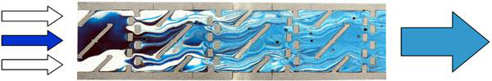
Figure 8 - Visual evaluation of the homogeneity of a two-component product mix through a static mixer [70]
Of all testing methods discussed, FTIR spectroscopy is the most suitable for the project because of its versatility and widespread use for chemical characterization of organic compounds.
Table 3 lists the advantages and disadvantages and of the reviewed characterization methods.

19
Table 3 - Advantages and disadvantages of mix homogeneity characterization methods
Characterization | Advantages | Disadvantages
method
FTIR Spectroscopy | •Versatile and widely used to | •Usually employed as a
 | characterize chemical compounds | qualitative characterization
 | •The data obtained can be linked to | method
the concentration of the samples
and homogeneity
Mechanical testing | •Equipment easily accessible | •It is hard to derive the
relations between the
mechanical properties of a
sample to the homogeneity
(intensity of segregation)
DSC | •Results are precise and can be | •Testing is relatively slow
 | linked to the resin to hardener ratio | and expensive to perform
TGA | •Results can be linked to the resin | •It is hard to derive the
 | to hardener ratio | relations between the TGA
results of a sample to the
homogeneity (intensity of
segregation)
Electrical testing | •N/A | •Cannot be applied to all
substances and results
cannot be explicitly linked
to the mixing ratio and
homogeneity of a sample
Spectrophotometry | •Results can directly be associated | •Only applies to samples that

with the homogeneity of a sample

show colour differences between the components

20
2.5Mixing technologies for in-line mixing systems
There are three broad categories for industrial in-line mixing devices: static, dynamic and impingement. Depending on the application and the products, different mixing technologies offer different advantages. The following literature review will focus on static mixers as they are used extensively in the polymer industry [71]. Dynamic and impingement mixing technologies will also be briefly reviewed.
2.5.1Static mixing
Static mixers are simple mixing devices and consist of blades positioned in-line within a tube where the fluids to be mixed are forced trough. There are no moving parts and the mixing process relies mainly on splitting the flow multiple times. Static mixers do not require an external energy source to operate in the sense that no electrical, hydraulic or pneumatic motor is attached to the mixer. Instead, the energy required to mix both components is drawn from the fluid itself, resulting in a pressure drop across the equipment. A wide variety of mixer geometries are developed for different applications but their working principle remains the same: splitting and/or twisting the flow to produce a multitude of layers [72]. Table 4 below lists the three (3) most used static mixers for industrial processes [73].

21 Table 4 – Popular types of static mixers
Type/Name | 3D model [73]

Kenics (twisted blades)
SMX (Static Mixer using
crossbars X)
LPD (Low Pressure Drop)

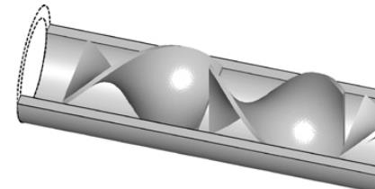
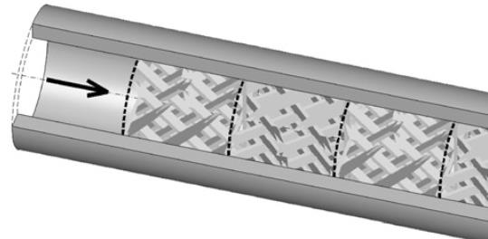
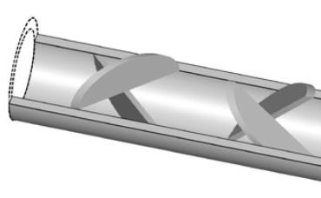

The Kenics mixer consists of a series of right and left-twisted plates, positioned so that each leading edge is at 90 degrees offset to the trailing edge of the previous element.
The SMX mixer is built of small stacked lamellae positioned in an X shaped formation. Each lamellae stage is rotated by 90 degrees compared to the previous stage. These mixers come in multiple lamella configurations denoted by n, NP, NX and θ which respectively represent the number of lamellae over the height of the channel, the number of parallel lamella along the length of one element, the number of lamella over the width of the channel, and the angle between the lamella. The standard SMX mixer is (2, 3, 8, 90°) as shown in Figure 9 [74].

22
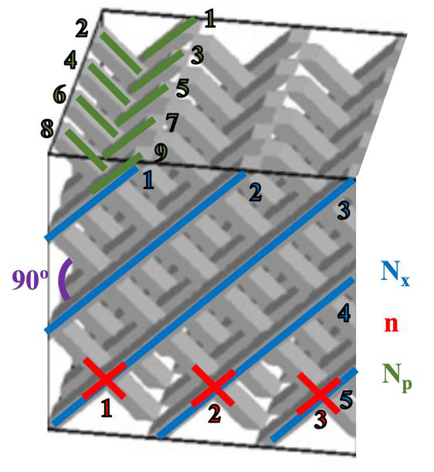
Figure 9 - SMX mixer geometrical configuration (n, NP, NX, θ) = (3, 5, 9, 90°)
The LPD mixer is made of a series of semi-elliptical plates positioned at a 90-degree plane to plane offset from one another. Each mixing stage is also rotated by 90 degrees along the pipe axis.
2.5.1.1Static mixer performance
Many research groups investigated the performance of static mixers using computational fluid dynamics. Among these groups, the most important contributions were performed by Rauline et al. and Meijer et al.
Rauline et al. made a quantitative analysis of the performance of six static mixer geometries including the Kenics, SMX (2, 3, 8, 90°), and LPD by computing the velocity field of the three-dimensional flow using POLY3DTM [54]. The analysis compared the mixers on many metrics that are considered to have an influence on mix homogeneity. The most significant analysis metrics are pressure drop, mean shear rate, interfacial stretching and intensity of segregation. The analysis was performed numerically. Results compared to the literature showed good agreement. A summary of the results obtained by Rauline et al. is presented in Table 5 for the Kenics, LPD and SMX mixers.

23
Table 5 - Mixing performance analysis of static mixers
Mean
 | ΔP | shear | Interfacial | Intensity of
 | (MPa) | rate (s-1) | stretching | segregation
Kenics | 0.71 | 10 | 0.57 | 0.57
LPD | 0.75 | 8.8 | 0.54 | 0.60
SMX | 1.8 | 21 | 4.2 | 0.13
The pressure drop is the differential pressure between the inlet and outlet of a three-element mixer. Higher pressure drop can be problematic for high flow and high viscosity applications. In addition, as the pressure drop is the static mixer’s energy source, it must be considered for efficiency analysis. The mean shear rate measures the mixers’ ability to shear or “work” the fluid. Higher shear indicates better performance. Interfacial stretching is the length stretch ratio of a fluid element over a time t. A higher interfacial stretching means a greater contact area between the liquids to be mixed [75]. Finally, the intensity of segregation is the spatial distribution of the phases in the sample. For a chemical mixing application in the polymer industry, this metric is significantly important as having an excellent spread of the chemical functional groups ensures the highest degree of the cure can be reached. Results show that the SMX mixer offers the best performance as it shows the lowest intensity of segregation with the higher shear rate and interfacial stretching. However, the ratio of shear rate to pressure drop, which can be used to quantify the efficiency of the mixer because the pressure drop is directly related to the shear rate since the power is lost to friction, shows the Kenics is more efficient.
Moreover, the team developed empirical relations for the pressure drop as a function of mixer length. This allowed them to conclude that the SMX mixer was the most efficient if space is limited to mix the products.
Meijer et al. made computational fluid dynamics flow simulations of the most popular static mixers as a function of the number of mixing elements [73]. Flow simulations of a two-component flow are shown in Figure 10. Each row represents a different mixer geometry while each column shows the cross section of the mixer after various numbers of mixing elements (Nelem). Column 1 is a cross-section of the mixer at the fluid entrance where both fluids are clearly visible in black and white with no mixing performed yet. The following columns are the cross sections after 1, 2, 3, 4 and 8 mixing elements.

24
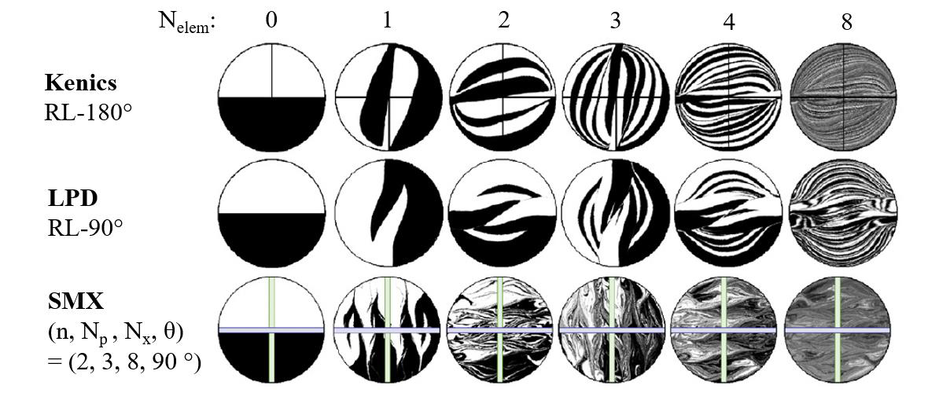
Figure 10 - Mixing profiles and layers as a function of the number of mixing elements [73]
Visually comparing the mixing profiles after eight (8) mixing elements, the SMX mixing profile is more chaotic compared to the Kenics and LPD. Small aggregation areas can be seen on the outer edge of the SMX mixing profile at this stage while the Kenics shows a more predictable and organized mixing pattern. These results correlate with the intensity of segregation presented in Table 5 by Rauline et al. Overall, Meijer et al. also conclude that higher mixing homogeneity can be achieved using the SMX static mixer.
Meijer et al. also qualitatively investigated the number of interfaces produced by the mixers. The higher the number of interfaces produced, the more effective the mixer is at ensuring maximum contact area between the constituents. Results are expressed using two schemes in Table 6. Scheme 1 is based on geometrical analysis while scheme 2 is based on actual interface stretching from their simulations and it refers to what is observed in Figure 10. The group found that the mixing profiles of most mixers do not behave as predicted. For instance, the (1, 1, 3) SMX mixer, with its two mirrored crossing blades, causes two counter-rotating vortices that split the fluid to create two interfaces each of length equal to the diameter D of the mixer. This observation depends on the mixer geometry. This alters the mathematical expression that described the number of interfaces produces by each mixing element. Table 6 also lists the dimensionless pressure drop per mixing element. It is defined as the pressure drop through the mixer divided by the pressure drop in an empty pipe of the same diameter as the mixing elements.

25
Table 6 – Pressure drop and interfacial stretch of different static mixers
Mixer type | ΔP/element | Interfaces produced
 |  | Scheme 1: expected |  | Scheme 2: actual
Kenics (RL-180°) | 5.5 | 2𝑁𝑒𝑙𝑒𝑚 |  | 4𝑁𝑒𝑙𝑒𝑚−1
LPD (RL-90°) | 8.5 | 3𝑁𝑒𝑙𝑒𝑚 |  | 2𝑁𝑒𝑙𝑒𝑚
SMX (2, 3, 8, 90°) | 38 | 8𝑁𝑒𝑙𝑒𝑚−1 | 5𝑁𝑒𝑙𝑒𝑚
Results show the SMX mixer’s higher efficiency at interfacial stretching, a result of the number of fluid interfaces produced. After 8 mixing elements, the number of interfaces produced would be 390,625 for the standard SMX (2, 3, 8, 90°) mixer against 65,535 for the Kenics (RL-180°). For visual interpretation, actual interfacial stretch (Scheme 2) is plotted as a function of the number of mixing elements in Figure 11.
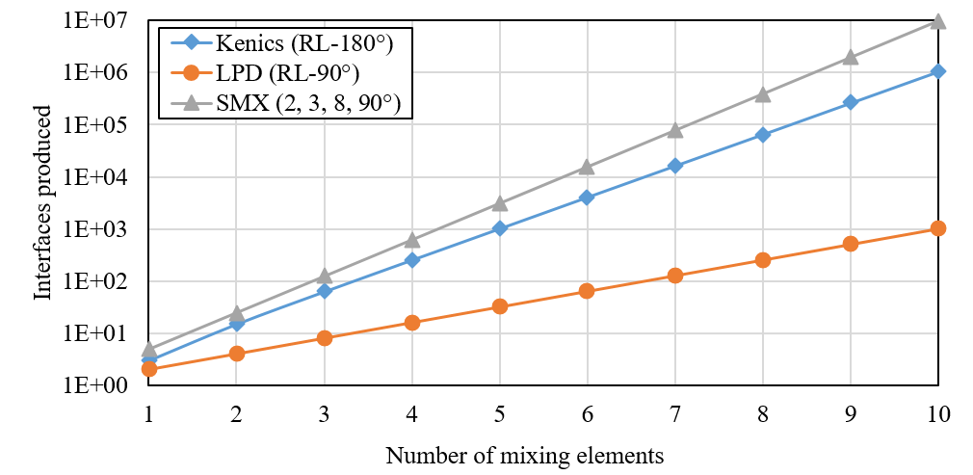
Figure 11 – Actual interfaces produced (Scheme 2) per mixing element
Overall, the literature shows that the SMX mixer is more efficient. However, this comes with the drawback of significantly higher pressure drop. Therefore, the SMX mixers should be used when space is limited and system pressure drop limitations are low. Nevertheless, it should

26
be kept in mind that high shear may be desirable for mixing but may be undesirable with shear sensitive fluids.
2.5.1.2Identification of ideal mixer geometry and sizing
Although a lot of research has been done to evaluate the performance of static mixers, mixing homogeneity results will vary depending on multiple factors, the most important being the volumetric and viscosity ratios of the components. High volumetric ratios, usually considered 100:1 or above, require more mixing elements to minimize the intensity of segregation [76]. Likewise, the higher the viscosity ratio, the higher the difference in interfacial stretch between the components, resulting in residual shear stress at the interface that prevents the fluids to mix [77]. Vinyl ester resins used with isocyanate thickening agents have a volumetric and viscosity ratio of approximately 10:1 [78], [79]. A high viscosity ratio is generally considered as anything above 100:1 [76]. This means that vinyl ester and isocyanate is not considered easy nor exceptionally hard to mix.
Ultimately, choosing the ideal mixer geometry and size is what will result in the best trade-off between a maximized mix homogeneity and a minimized pressure drop. It is possible to perform computational fluid dynamic (CFD) analysis using a mixer geometry to simulate the way both fluids will mix. However, this type of analysis is complex and hard to execute with accuracy [80]. Using the literature and empirical data from static mixer manufacturer, the right mixer can be identified, provided that the fluids’ properties and application conditions are known. From there, experimental testing and mixer size iterations can allow improving the mixer. However, in most cases, simply adding mixing elements suffices to meet the process criteria.
Static mixers are usually available in reusable and disposable versions [70]. The disposable versions are an interesting solution with polymers. At the end of a manufacturing cycle, the mixer can simply be replaced instead of cleaned, reducing maintenance time and costs.
2.5.2Dynamic mixing
Dynamic mixers consist of mixing elements that are mechanically agitated by an external power source. In its simplest form, a dynamic mixer can comprise of a shaft and blades submerged in a liquid. One common example is a regular household food processor or blender. In these instances, the mixer works in batches, meaning that one fixed and limited volume of fluid is mixed

27
at a time. This contrasts with the static mixer where the fluid is mixed continuously as it flows through. This can be a major drawback for an industrial process when large quantities of liquid must be mixed just-in-time for production. Also, this becomes especially critical with reacting polymers because the resin and hardener can react quickly, leaving little leftover time to manufacture the part.
Dynamic mixers are also offered in in-line versions, allowing continuous mixing. Figure 12 shows an in-line dynamic mixer with a two-component flow at the input (lower left) and the mixed output (top) [81]. The energy required for the mechanical agitation of the blades is provided by the electric motor (right). The added mechanical energy provided by the motor will result in less pressure drop when compared to static mixers.
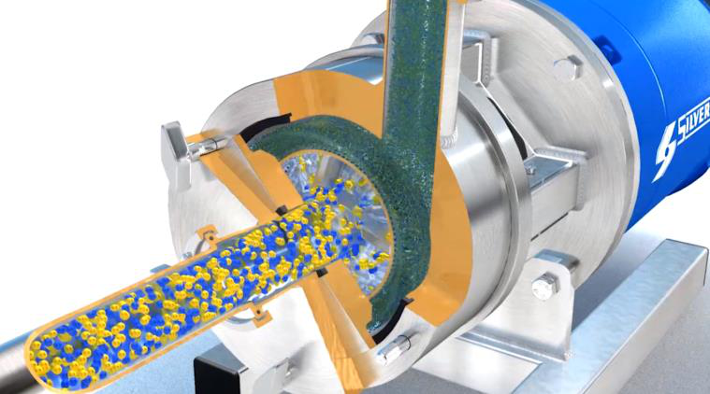
Figure 12 – In-line dynamic mixer by Silverson [81]
Hybrids between static and dynamic mixers are also available. Figure 13 presents two similar static-dynamic mixing heads. Both examples are handheld devices with a motor at the back and a disposable mixing chamber at the output. The term static-dynamic comes from the fact that the blades inside the static mixer are dynamically agitated by an external motor. These mixers are designed to take advantage of the simplicity and easy maintenance of in-line static mixers while adding the energy of the motor-driven mixing blades. In this design, the components to be mixed only meet in the disposable plastic mixer. This eases maintenance cost and complexity by requiring only a change of mixing chamber.

28

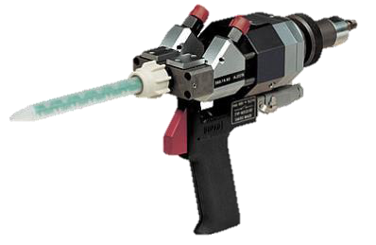

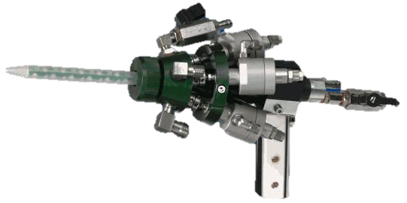

(a) (b)
Figure 13 – Static-Dynamic mixing heads: (a) Static-Dynamic by DOPAG [82] and (b) LC 5/3 by Tartler [83]
One significant drawback of dynamic mixers is the inherently more complex design of the assembly. The addition of moving parts, external motor and energy supply (air, electricity, hydraulics, etc.) and weight make these mixers sometimes a little too complex for certain applications. Even though the addition of a mechanical agitation generally helps to mix the products together, simpler static mixers have been shown to have the ability to adequately mix polymers. Choosing this technology results in higher purchasing and operating costs. Moreover, the moving parts usually make it less durable with abrasive fluids, a common reality with resins containing additives.
2.5.3Impingement mixing
The last commonly used mixing technology in the field of polymers is called impingement mixing. Figure 14 shows a schematic of a typical impingement mixing head along with a simulation of the mixing chamber. In this process, the two fluids collide at high pressure into a mixing chamber, typically around 80 to 200 bars [84]. This technology was developed for the polyurethanes industry, where conventional valves and actuators were too slow, too hard to clean and required regular maintenance. The sudden pressure drops exhibited by the fluids when entering the mixing chamber creates a lot of turbulence and mixes both products rapidly.

29

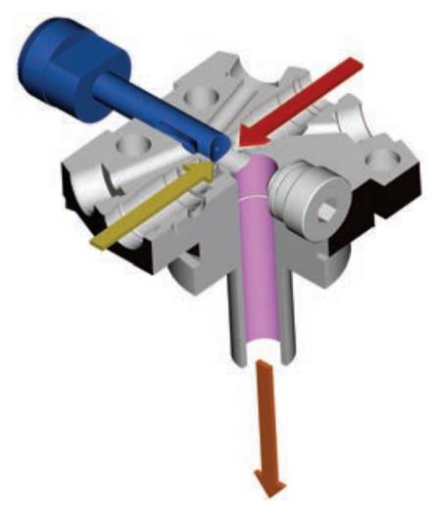

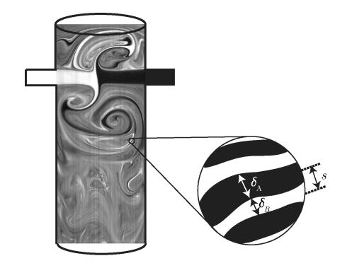

(a) (b)
Figure 14 –Impingement mixer: (a) Schematic of a typical impingement mixing head and (b) Simulation of impingement mixing for a two-component fluid [85]
Although high pressure mixing heads reliably create an even product distribution, they require more complex equipment to supply high-pressure flow. For a mixing chamber with directly opposed jets, the transition to turbulent mixing, a requirement for consistent mix quality, occurs at Reynolds number over 140 [86]. In the case of viscous polymers, achieving such flow requires significant amounts of energy and hydraulic units must be used, complexifying the resin dosing system.
An advantage of the impingement over the dynamic mixer is that cleaning is simplified because there are no rotating parts. Some models include a piston that can push the leftover polymer through at the end of a mixing phase while others have a dedicated solvent inlet for automated cleaning. Impingement mixers are ideal with high flow application, or processes requiring a high number of mixing shots per day, with some mixing units allowing flow rates of up to 8000 ml/sec [87].
Table 7 presents a summary and comparison of static, dynamic and impingement mixers based on their respective advantages and disadvantages.

30
Table 7 - Comparison of static, dynamic and impingement mixers
Mixing | Advantage | Disadvantage
technology
Static | •Simple design | •May create a significant pressure
 | •Inexpensive | drop
•Wide range of viscosities
•Does not require an external
energy source
Dynamic | •Reduced pressure drop | •Complex design
•High purchasing and maintenance
costs
Impingement | •High output flow rate and | •High purchasing costs
pressure capabilities
•Short fluid residence time for
rapid chemical reactions
Limited sources in the literature compare the various mixing technologies together [88]. The design criteria are more influencing the technology choice than the mix quality obtained with a specific technology. The literature shows that with all three technologies, very high homogeneity mixing can be achieved. Ultimately, cost, maintenance and applicability based on the fluids to be mixed will drive the technology choice.
2.6Pumping technologies for in-line mixing systems
Equally important equipment of an industrial-grade mixing and dosing system are the pumps. This equipment dictates the precision at which both fluids will be injected into the mixing unit. Pump requirements for dosing and mixing systems include high repeatability, pulse-free, low shear, high pressure and abrasive and corrosive fluids capability.
Out of the many pump types that are currently available, all can be categorized into one of the two following groups: centrifugal pumps and positive displacement pump. Centrifugal pumps

31
use impellers to convert velocity to flow and can pump up to very high flow rates. Unfortunately, these pumps’ output flow rate cannot be controlled or adjusted with high precision.
2.6.1Positive displacement pumps
Positive displacement (PD) pumps use rotating or reciprocating actions to directly push the fluid to the discharge side. The suction, on the other hand, is the wetted part located at the inlet of the pump. Through each cycle of the pump’s action, a specific volume of fluid passes from the suction to the discharge, making these pumps very precise and repeatable. The output of the pump can be controlled and adjusted automatically using a feedback loop when combined with a flowmeter. This guarantees a constant and precise flow rate in all conditions. Positive displacement pumps are separated into two categories: rotary pumps and reciprocating pumps.
2.6.1.1Rotary pumps
Rotary pumps use a rotating mechanical motion to pump the fluid. While the rotor spins, fluid is trapped in the spaces created by the moving parts. Contrastingly, centrifugal pumps use fluid velocity and the pressure differential between the suction and the discharge side to move the fluid. Rotary pumps have the advantages of creating a smooth flow as well as being compact. In addition, they are usually cheaper to acquire and maintain. Regrettably, rotary pumps tend to wear quickly when pumping abrasive fluids because of the tight tolerances between the moving parts. Several types of rotary pumps are available such as the gear, lobe, progressive cavity and peristaltic pumps. Figure 15 shows examples of these for types of rotary pumps.

32

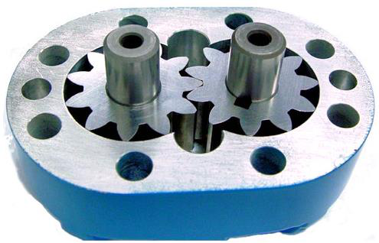

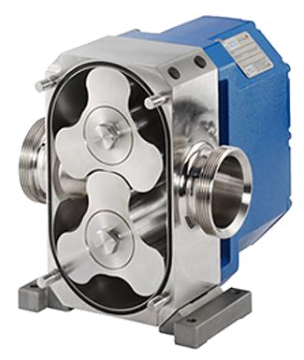

(a) (b)

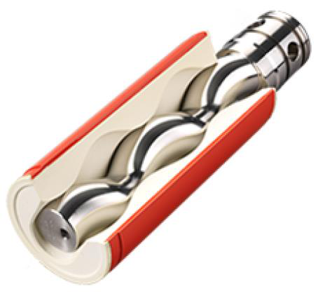

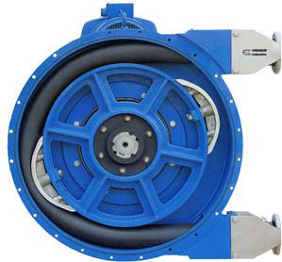

(c) (d)
Figure 15 – Rotary positive displacement pumps: (a) gear, (b) lobe, (c) progressive cavity and (d) peristaltic
•Gear pumps
Gear pumps are made of two wetted meshed gears that are mechanically driven. Each gear tooth brings a constant volume of fluid with it. The pumped flow rate is equal to the number of teeth per gear times the rotational speed of the pump. Ideal for high viscosity applications, gear pumps reduce the impact of pulsations in the flow because each gear has numerous teeth, thus creating many small pulsations that often go unnoticed. The major drawback of gear pumps is that they are not compatible with slurry fluid as they rely on the tight geometrical tolerance in the gear meshing to prevent backflow.

33
•Lobe pumps
Lobe pumps can be considered as a variation of gear pumps. Using the same working principle as gear pumps, they consist of two vanes that are meshed together to pump the fluid around the interior casing. However, unlike gear pumps, the lobes do not touch one another and this is prevented through an external gearbox that is not in contact with the fluid. As a result, lobe pumps are known for their ability to pump fluids with solid contents without being damaged. Figure 15 shows a lobe pump with the front cover taken off. It is possible to notice the small gap between the two lobes that allows this pump to work with abrasive fluids.
•Progressive cavity pumps
Also know as Moineau pumps, after the inventor, progressive cavity pumps operate using an ingenious combination of metallic or plastic worm screw rotor inside a rubber stator. The pump’s worm screw traps a certain volume of fluid and transports it to the discharge. The rotor and stator assembly are shown in Figure 15. Because the stator is made of soft rubber, these pumps can be used to pump abrasive fluids without damage. However, they cannot run dry for long periods and are very expensive.
•Peristaltic pumps
These pumps utilize a roller that compresses a flexible tube to move the liquid. The action is similar to the swallowing motion in the esophagus. The main advantage of this technology is that there is no contact of the fluid with the mechanical parts of the pump. This makes these pumps ideal for pumping harsh materials. When needed, the flexible tube can easily be replaced. In addition, they are self-priming, meaning that the suction end does not need positive pressure to operate, and they can run dry. One drawback is the pulsating flow that is produced at the discharged.

34
2.6.1.2Reciprocating pumps
Reciprocating pumps use linear motion on a piston or diaphragm to move the fluid. The reciprocation motion implies there are an upstroke and downstroke to every cycle, resulting in a pulsating flow. One-way check valves are added to the suction and discharge of the pumps to regulate the flow in and out of the system.

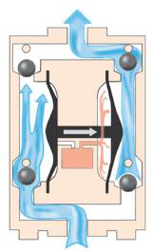

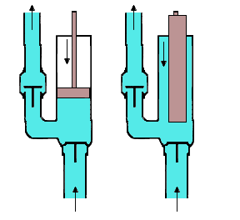

(a) (b)
Figure 16 – Reciprocating positive displacement pumps: (a) double diaphragm pump, (b) piston (left) and plunger (right) pump
•Diaphragm pumps
Diaphragm pumps are comprised of an elastomeric membrane that moves in a reciprocating motion to pull and push the fluid in and out the pump. Check valves are located at the suction and discharge of the pump to prevent backflow. In most cases, diaphragm pumps come in double configurations and use two distinct diaphragms that act opposite to one another. The internals of a double diaphragm pump are shown in Figure 16. Since each diaphragm has a charge and discharge phase, combining two diaphragms together allows getting rid of most of the pulsations. As one diaphragm pulls the fluid in, the other is discharging at the discharge and vice versa. Diaphragm pumps are relatively inexpensive and can either be pneumatically, hydraulically or electrically driven.

35
•Piston and plunger pumps
Piston and plunger pumps use almost identical technologies. In both cases, an arm moves linearly back and forth to move the fluid. These pumps excel in high viscosity and high-pressure applications. The working principle is shared with the diaphragm pump. Figure 16 shows a schematic of the minor difference between the plunger and piston pumps. Plunger pumps are better at working with abrasive fluids and can be used at higher pressures because the seal is stationary and tends to wear at a slower rate.
Like diaphragm pumps, piston and plunger pumps usually come in a duplex configuration to limit the pulsating effect. It is also possible, in some instances, to add more than two pistons to limit the pulsating effect and extend the life of the seals due to the slower stroke rate obtained with more pump heads.
Abrasive fluids compatibility depends on the pump technology. Choosing a pump with an intricate mechanism will obviously not work with fluids containing solids. Likewise, chemical compatibility will depend on the material of the wetted parts in the pump. This aspect must be considered both in normal operation and cleaning, where organic solvents are used.
2.6.2Importance of flow rate linearity
In-line mixing devices have low fluid residence time, meaning that the fluid does not stay long in the mixing chamber [89]. Static mixers are designed for radial mixing, and they are quite effective in removing radial variations in composition and temperature as seen in Figure 8. Radial mixing creates a net velocity profile in the axial direction that approximates piston flow even at low Reynolds numbers. However, the flat velocity profile is a disadvantage when the input composition or temperature varies with time. There is little damping of input disturbances since piston flow provides no axial mixing [90]. This translates to the importance of having a linear and precise flow from the dosing pumps. If the pumps generate a significant amount of pulsations, the composition of the fluid at the inlet of the mixer will vary. The mixer’s ability to attenuate this effect by providing axial mixing is limited and the mixed product will likely also present the same composition variations.
From their working principle, positive displacement pumps will almost always produce a certain level of flow rate variation. Luckily, for very sensible applications, there is the possibility

36
to add flexibility to the system by using pulsation dampeners. Pulsation dampeners are a bladder with an elastomeric membrane that absorbs the pressure surges from the pump’s output to level the system’s pressure. When chosen correctly, dampeners can remove up to 99% of pressure pulsations depending on the fluid conditions, pumping equipment, system setup and environment [91]. Figure 17 shows the original and dampened pressure as a function of time for a one-inch air-operated double-diaphragm pump. In addition to ensuring a steady flow for chemical metering applications, pulsation dampeners have the added benefit of protecting the instruments and equipment from pressure surges that could cause premature failure.
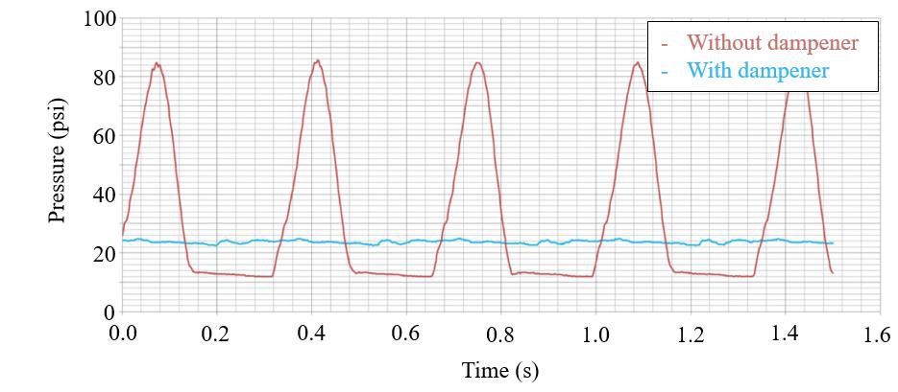
Figure 17 - Pulsation dampening on a 1" air operated double diaphragm positive displacement pump
2.7Resin metering and mixing systems
A wide variety of metering and mixing systems are available on the market. Because many different industries require them daily, these systems are now offered to cover a wide array of applications. Unfortunately, the applicability and performance of the available systems are limited in some industries. For instance, systems aiming at the food industry will possess high output capabilities and sturdy construction to satisfy very high output and long-term manufacturing forecasts. On the contrary, the pharmaceutical industry will mandate extremely high dosing precision and mixing homogeneity with lower production rates.

37
For polymer processing, dosing precision and mix homogeneity are very important from a chemical perspective. On top of that, systems must be powerful and reliable to handle products with high viscosities and abrasive characteristics. For composites applications using thermoset resins, a two-component metering and mixing system is usually used to mix the base resin with the hardener.
2.7.1Hazardous classified locations
Some polymer resin systems release flammable vapours. Under the right conditions, these vapours present risks of an explosion and make the environment surrounding the equipment hazardous. The National Fire Protection Agency (NFPA), an American standard for electrical safety in the workplace, issues standards and guidelines on the use of electrical equipment in a hazardous location in their NFPA 70E document. Canada adopted this standard through the Canadian Standards Association (CSA) in the CSA Z426 standard. Hazardous products can be classified as Class 1 (flammable gases and vapours), Class 2 (combustible dust) or Class 3 (easily ignitable fibres).
Class 1 classification is pertinent with organic compounds and solvent used in this project. Then, depending on the likelihood of the hazardous material being present in dangerous concentrations, Class 1 is subdivided into two Divisions and three Zones. Table 8 defines the two Divisions related to gas or vapours hazardous locations.

38
Table 8 - Project relevant flammable gas and vapour classification definitions in Canada
Division and Zones | Definition [92]
Classification
Division 1 | The explosive mixture of gas or vapour and air may exist under normal
operating conditions.
Division 2* The explosive mixture of gas or vapour and air may exist under abnormal conditions such as accidental rupture of a vessel or container or failure of a ventilating system.
* Normally, a Division 2 location is assumed to surround a Division 1 location unless the hazard is prevented from spreading beyond the Division 1 location by a solid, vapour proof (for gases and vapours) or dust-tight (for dust and fibres) partition wall without any openings (e.g. doors or windows).
As a result, classified locations standards impose electrical equipment to be certified for safe use within a certain volume around an open container as shown in Figure 18.
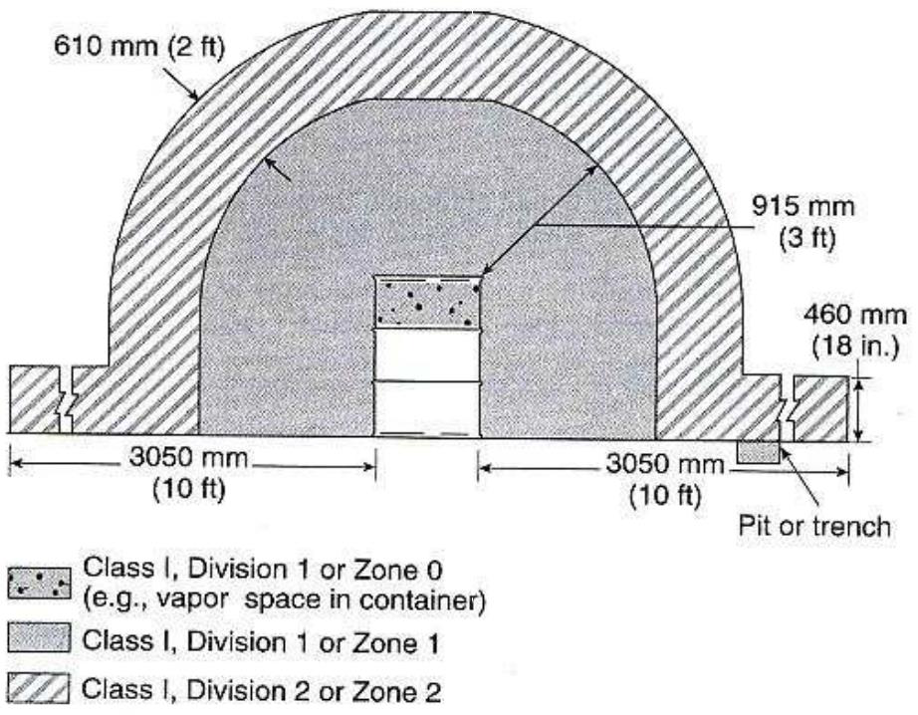
Figure 18 - Electrical area classification around an open container in a ventilated area

39
Electrical equipment located within three feet of the open container in any direction and down to the floor must be certified for use in Class 1 Division 1 locations. The same principle goes for Division 2 which is the volume surrounding Division 1 extending out another two feet in any direction and down to the floor with another five feet by 18 inches high on the ground.
2.7.2Resin abrasiveness
As reviewed in section 2.4, resins used for SMC manufacturing can contain around 15% fillers and 3% additives. These fillers and additives are generally non-reactive and non-soluble dry powders that can be very abrasive. Some of the most common SMC resin fillers and additives include hollow and solid glass microspheres, milled carbon and glass fibres and calcium carbonate, all abrasive materials with relatively high hardness.
Studies on the influence of fillers and additives particle size and content in resins on wear rate show the damage such fluids can cause on metal surfaces over time [48], [93]. More specifically, it has been confirmed that signs of wear caused by abrasion are most significant in areas of tight clearances within gear pumps for example [94]. Therefore, many pump technologies and equipment used in metering and mixing systems must be chosen to accept such abrasive fluids. A talking example is the use of gear pumps as their operation and precision rely on tight tolerances between the meshing gears and housing as shown in Figure 15. The same observation holds true for gear flowmeters as they are essentially passive gear pumps.
2.7.3Two-component metering and mixing systems
The following section presents the capabilities of five commercially available two-component in-line metering and mixing systems. The systems were selected because their technical specifications were closest to this project’s metering and mixing application. The systems are shown in Figure 19 and their technical data is listed in Table 9. Most of the performance data for the metering and mixing systems are available on the manufacturer’s website. However, in many cases, answers to more technical questions were obtained by directly contacting the companies’ representatives. The technical questions emphasized the system’s ability to process highly abrasive fluids and on certification to operate in classified hazardous locations, two common requirements with SMC vinyl ester resin systems.

40

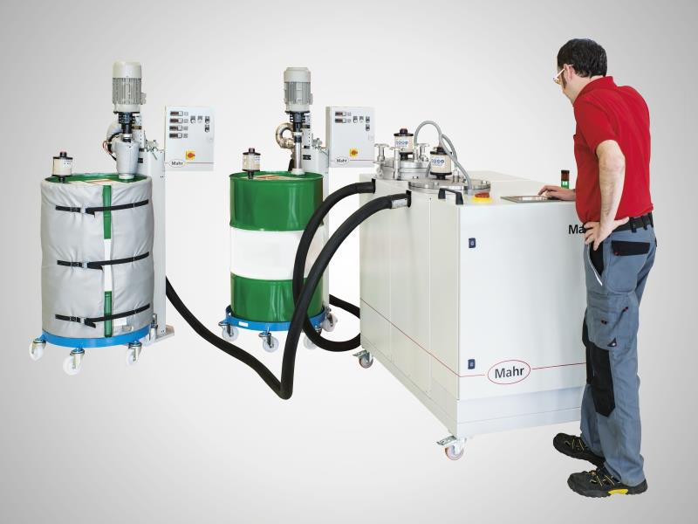

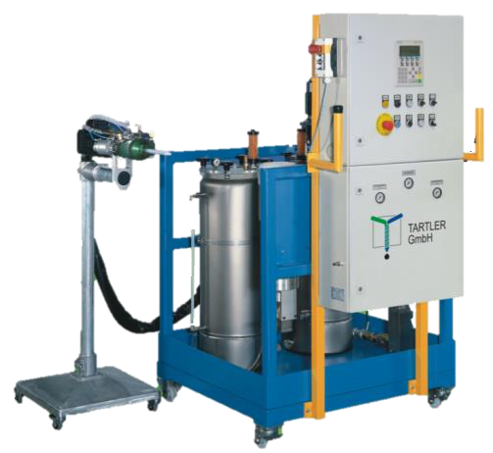

(a) | 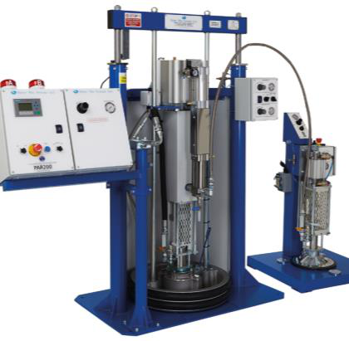 | (b)
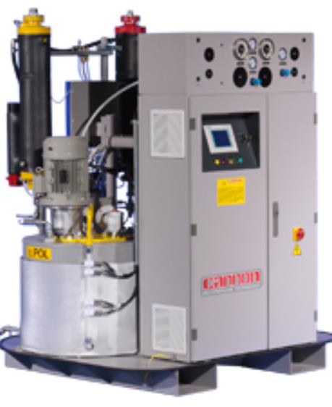 |  | 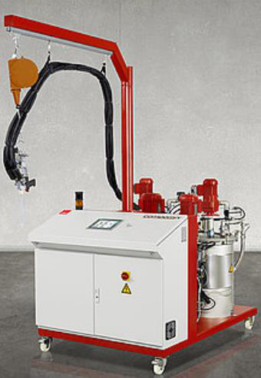
(c) | (d) | (e)
Figure 19 – Commercially available two-component metering and mixing system: (a) Mahr MarMax, (b) Tartler Nodopur, (c) Cannon B-System, (d) Meter Mix PAR200 and (e) DOPAG Compomix

41
Table 9 - Reviewed metering and mixing system technical data
 | Mahr | Tartler | Cannon | Meter Mix | DOPAG
 | MarMax | Nodopur | B-System | PAR 200 | compomix
Reference | 3 | 4 | [95] | 5 | 5
Viscosity (cP) | up to | Virtually no | 5,000 | Up to | 1 to 50,000*
 | 85,000* | limit* |  | 1,500,000*
Mixing ratio | 100:100 to | 100:10 to | 1:1 to | 1:1 to 20:1* | 100:5 to
 | 100:1* | 10:100* | 50:1* |  | 100:100
Flow rate | 50 to | 100 to | 1000 to | 161 to 2,910 | 2,000 to
(ml/min) | 4,000* | 13,000* | 400,000* |  | 20,000
Highly abrasive | No | No | No | Yes$ | No
fluids
capability
Mixing | Static or | Static- | Dynamic | Static or | Static or
 | Static-
technology |  | Dynamic |  | Dynamic$ | Dynamic$
 | Dynamic
Pump | Gear | Gear | Gear | Gear, Single | Gear
technology |  |  |  | acting piston$
Wetted parts | Stainless | Stainless | Carbon | Aluminum, | Aluminum,
 |  |  | steel, | Stainless | Stainless
material | Steel, PTFE | Steel, PTFE | Stainless | Steel$, Viton, | Steel$, Viton,
 |  |  | Steel$ | PTFE$ | PTFE$
Class 1 Div. 1
Hazardous | Yes$ | No | Yes$ | No | Yes$
locations
certified
*Depending on equipment selection at purchase
$ Optional
The first system is built by Mahr, a German company that specializes in metrology and
metering systems. The MarMax metering system features two high precision metering gear pumps
with gear flowmeters. Available options include day tanks with agitator and temperature control.
The mixing is performed by a static-dynamic mixing gun (not shown in the picture). The system is
versatile and allows wide flow rate and mixing ratio ranges. However, the system cannot handle
3 Flowers, Personal communication, November 14th, 2018
4 Fesel, Personal communication, October 19th, 2018
5 Ripberger, Personal communication, November 14th, 2018

42
fluids with abrasive fillers as it uses gear pumps to accurately dose the fluids. In addition, the base model is not certified to operate in Class 1 Division 1 hazardous locations. This feature is only available as an expensive option.
The Nodopur is made by Tartler, a German company, and is very similar to the MarMax system in terms of performance. The system features gear metering pumps and a static mixer. The flow rate and mixing ratio capabilities are similar to the MarMax system. The main drawbacks are that it is not designed to handle abrasive fillers and is not certified to operation in Class 1 Division 1 classified locations.
Next is the B-system by Cannon, an Italian company. This machine has limited viscosity capabilities and a lower mixing ratio range than the first two systems. It offers a higher flow rate range which might be a limitation for low-speed research and development SMC manufacturing lines. Moreover, it cannot handle abrasive fluids but can be certified to operate in Class 1 Division 1 classified locations as an option.
Meter Mix, a German company, makes the PAR 200 and offers a lower and narrower flow rate range capability than the previous systems. However, it is the only system that can be modified to process abrasive fluids. This can be achieved by replacing the base gear pumps with single acting piston pumps. Unfortunately, the single action of the piston means that the system cannot continuously dispense mixed resin to the production line. The system offers some of the highest viscosity capacity of any system but cannot operate in Class 1 Division 1 hazardous locations.
The last system, the Compomix, is made by DOPAG, another German company. Like most systems, it uses gear metering pumps and therefore cannot process abrasive fluids. It is available with Class 1 Division 1 classified location certification as an option. Otherwise, it offers a static or dynamic mixing unit and like Cannon’s B-system, its flow rate capacity is higher and might limit small production speed applications.
Overall all systems have stainless steel and PTFE wetted parts stock or available as an option. These materials have excellent chemical compatibility with a wide range of chemicals and organic solvents. In the case of a typical SMC vinyl ester resin, chemicals like styrene, isocyanate and acetone are most concerning. Nonetheless, stainless steel and PTFE offer outstanding chemical

43
resistance to these products. Moreover, stainless steel has a hardness of 70 on the Rockwell B scale, the highest of most metals available for processing equipment like. This normally means that it will have the added advantage of showing increased wear resistance, but it is highly dependent on the surface treatment applied [96].
2.7.4Summary of current systems limitations
It is important to note that the technical data shown in Table 9 cannot be achieved with any given configuration of the system. The design of the metering and mixing system must be adjusted and tailored to the specific fluids through equipment selection and sizing when purchasing the system. In addition, some performance data are not compatible with one another. For example, to be able to accurately meter and mix high viscosity fluids, the flow rate capabilities must be limited to avoid increased pressure drops in the piping.
There is no reviewed system that can handle abrasive fluids while being certified to operate in Class 1 Division 1 classified locations. This proves to be an important limitation for vinyl ester SMC resin formulations as they contain styrene and a high content of abrasive filler and additives.
Another important aspect to consider is that although all systems used positive displacement pumps, which are very precise, not all systems use flowmeters to control the pumps output using a feedback loop. Moreover, all systems use independent pumps to meter each component. This means that a slight lag in the feedback loop or even a slight motor speed variation will immediately affect the mixing ratio.
Finally, Table 9 shows there is a great innovation opportunity to develop a new in-line metering and mixing system that overcomes currently available system limitations.
2.8Summary and knowledge gaps
The literature review first covered the application and manufacturing processes of composites in the automotive industry before summarizing the available methods for resin mix homogeneity evaluation. Then, the different mixing and pumping technologies were studied along with an overview of the commercially available metering and mixing systems.

44
The automotive industry has been using composites material for more than 50 years. However, only now do we see OEM starting to invest in developing solutions for the use of composite materials for structural parts of high-volume production vehicles. For structural parts, carbon fibre reinforced epoxy or vinyl ester resins seems to provide adequate mechanical properties for these applications. Two major manufacturing processes stand out; resin transfer moulding and hot compression moulding.
Static mixers seem to offer adequate mixing while having a simple design, low cost and easy maintenance. However, the literature review does not allow to predict with accuracy the mix homogeneity obtained using a specific mixer and only compares most static mixer technologies together to facilitate geometry choice for a given application.
Currently, available in-line metering and mixing systems do not meet the requirements for the continuous mixing abrasive resins in Class 1 Division 1 hazardous location. Moreover, currently available systems use independent motors for each of the pumps. This does not guarantee that the mixing ratio will be maintained following a rapid increase or decrease in output flow rate as one motor could potentially change its rotational speed faster.
2.9Project objectives
The first objective of the project is to demonstrate that adequate mix homogeneity can be obtained using a commercially available static mixer with the partners vinyl ester resin formulation.
The second objective of the research project is to develop a new metering and mixing system that meets all the partner’s requirements. Deliverables of this objective include a complete 3D model along with the complete part list and costs. Then, the system must be assembled.
As a third and final objective, the newly developed system will be tested and validated. Resin samples will be mixed using the system and homogeneity will be evaluated using the same methods used in the first objective.

45
CHAPTER 3 DEMONSTRATION OF THE PERFORMANCE OF A
STATIC MIXER TO OBTAIN AN HOMOGENEOUS RESIN SAMPLE
The objective of this chapter is to demonstrate that adequate mix homogeneity, measured through the CoV, can be achieved with a static mixer. In order to meet the objective, three items are verified in this chapter. First, verification is done to determine if FTIR spectroscopy can be used to evaluate the homogeneity of a resin sample (item one). Then, the performance of a static mixer to obtain a homogeneous resin sample is evaluated (item two). Finally, the impact of mixing ratio variation on mix homogeneity is qualitatively evaluated to assess the axial mixing capabilities of a static mixer (item three).
Item three assesses the static mixer’s ability to attenuate flow rate variations that may be caused by the pumps. As seen in the literature review, a lot of research has been made on velocity profiles in static mixers. All have concluded that static mixers are ideal for radial mixing and only provide a limited amount of axial mixing. More specifically, the aim is to qualitatively evaluate the static mixer’s axial mixing capabilities, or the mixer’s ability to mix the fluid lengthwise in the direction of the flow. This aspect is important regarding the pump technology choice for the new system to know whether or not flow rate pulsations will significantly affect the product’s mix homogeneity.
The chapter first describes the materials and equipment used. Then, the procedure associated with each of the three items needed to achieve the chapter’s objective is detailed. These items are the recommended procedure for FTIR analysis, the validation of the performance of the static mixer to obtain a homogenous resin sample and the qualitative evaluation of the axial mixing provided by the static mixer, notable via the influence of mixing ratio variations on mix homogeneity. Finally, a conclusion summarizes the results for the three items.
3.1Materials
The resin used was provided by the industrial partner. It is a two-component vinyl ester resin (part A) with an isocyanate thickening agent (part B) used for SMC manufacturing. Part A is a typical unsaturated bisphenol-A epoxy vinyl ester resin in styrene while part B is a combination

