**Industrial Internship Report on**

**”Bank Management System”**

**Prepared by**

**Arya Patel**

|  |
| --- |
| *Executive Summary* |
| This report provides details of the Industrial Internship provided by upskill Campus and The IoT Academy in collaboration with Industrial Partner UniConverge Technologies Pvt Ltd (UCT).  This internship was focused on a project/problem statement provided by UCT. We had to finish the project including the report in 6 weeks’ time.  The Bank Management System project involves creating a software application to streamline and automate various banking operations.  This internship gave me a very good opportunity to get exposure to Industrial problems and design/implement solution for that. It was an overall great experience to have this internship. |

**TABLE OF CONTENTS**

1 Preface 3

2 Introduction 4

2.1 About UniConverge Technologies Pvt Ltd 4

2.2 About upskill Campus 8

2.3 Objective 9

2.4 Reference 9

2.5 Glossary 10

3 Problem Statement 11

4 Existing and Proposed solution 12

5 Proposed Design/ Model 13

5.1 High Level Diagram (if applicable) 13

5.2 Low Level Diagram (if applicable) 13

5.3 Interfaces (if applicable) 13

6 Performance Test 14

6.1 Test Plan/ Test Cases 14

6.2 Test Procedure 14

6.3 Performance Outcome 14

7 My learnings 15

8 Future work scope 16

# Preface

Summary of the whole 6 weeks’ work.

About need of relevant Internship in career development.

Brief about Your project/problem statement.

Opportunity given by USC/UCT.

How Program was planned

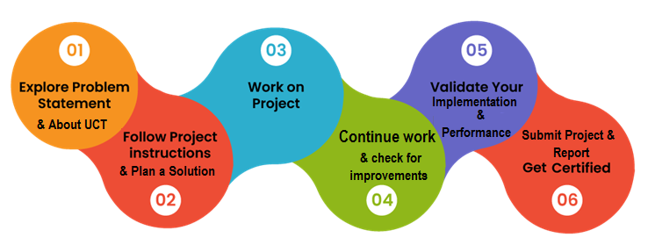

Your Learnings and overall experience.

Thank to all (with names), who have helped you directly or indirectly.

Your message to your juniors and peers.

# Introduction

## About UniConverge Technologies Pvt Ltd

A company established in 2013 and working in Digital Transformation domain and providing Industrial solutions with prime focus on sustainability and RoI.

For developing its products and solutions it is leveraging various**Cutting Edge Technologies e.g. Internet of Things (IoT), Cyber Security, Cloud computing (AWS, Azure), Machine Learning, Communication Technologies (4G/5G/LoRaWAN), Java Full Stack, Python, Front end**etc.

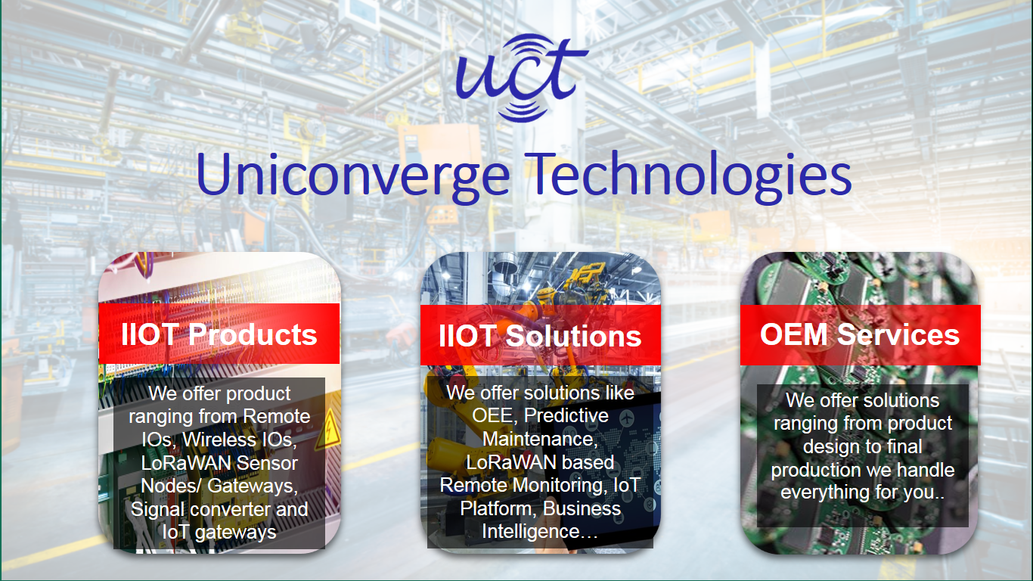

1. UCT IoT Platform **(****)**

**UCT Insight** is an IOT platform designed for quick deployment of IOT applications on the same time providing valuable “insight” for your process/business. It has been built in Java for backend and ReactJS for Front end. It has support for MySQL and various NoSql Databases.

* It enables device connectivity via industry standard IoT protocols - MQTT, CoAP, HTTP, Modbus TCP, OPC UA
* It supports both cloud and on-premises deployments.

It has features to  
• Build Your own dashboard  
• Analytics and Reporting  
• Alert and Notification  
• Integration with third party application(Power BI, SAP, ERP)  
• Rule Engine

 

1. **Smart Factory Platform (****)**

Factory watch is a platform for smart factory needs.

It provides Users/ Factory

* with a scalable solution for their Production and asset monitoring
* OEE and predictive maintenance solution scaling up to digital twin for your assets.
* to unleased the true potential of the data that their machines are generating and helps to identify the KPIs and also improve them.
* A modular architecture that allows users to choose the service that they what to start and then can scale to more complex solutions as per their demands.

Its unique SaaS model helps users to save time, cost and money.

 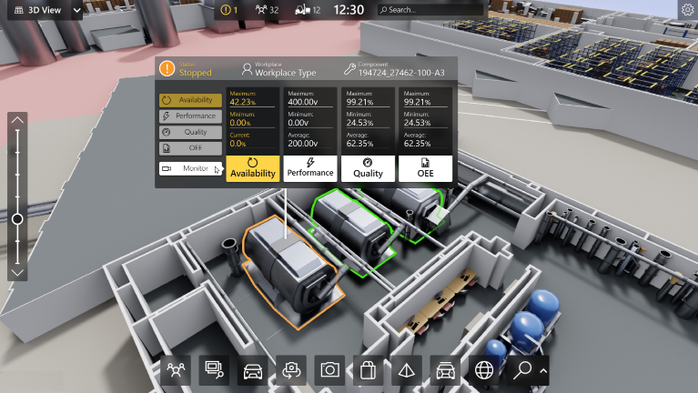

1. 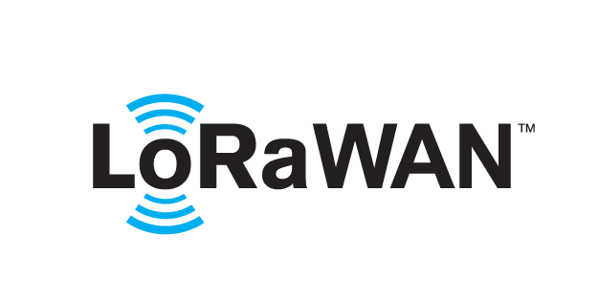 based Solution

UCT is one of the early adopters of LoRAWAN teschnology and providing solution in Agritech, Smart cities, Industrial Monitoring, Smart Street Light, Smart Water/ Gas/ Electricity metering solutions etc.

1. Predictive Maintenance

UCT is providing Industrial Machine health monitoring and Predictive maintenance solution leveraging Embedded system, Industrial IoT and Machine Learning Technologies by finding Remaining useful life time of various Machines used in production process.



## About upskill Campus (USC)

upskill Campus along with The IoT Academy and in association with Uniconverge technologies has facilitated the smooth execution of the complete internship process.

USC is a career development platform that delivers **personalized executive coaching** in a more affordable, scalable and measurable way.



Seeing need of upskilling in self paced manner along-with additional support services e.g. Internship, projects, interaction with Industry experts, Career growth Services

<https://www.upskillcampus.com/>

upSkill Campus aiming to upskill 1 million learners in next 5 year

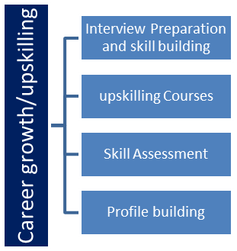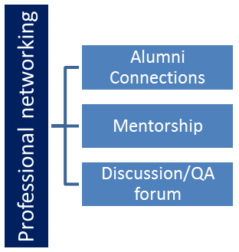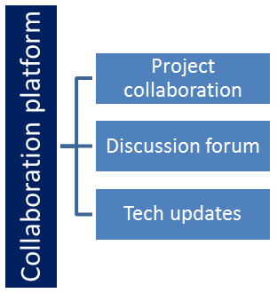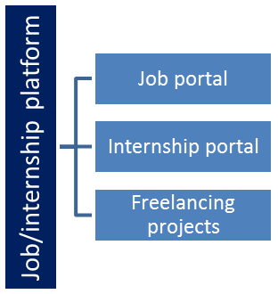

## The IoT Academy

The IoT academy is EdTech Division of UCT that is running long executive certification programs in collaboration with EICT Academy, IITK, IITR and IITG in multiple domains.

## Objectives of this Internship program

The objective for this internship program was to

 ☛ get practical experience of working in the industry.

 ☛ to solve real world problems.

 ☛ to have improved job prospects.

 ☛ to have Improved understanding of our field and its applications.

 ☛ to have Personal growth like better communication and problem solving.

## Reference

[1] Geeksforgeeks.com

[2] Javapoint.com

[3] Youtube.com

# Problem Statement

Traditional banking processes often rely on manual operations, leading to inefficiencies, errors, and delays in providing services to customers. There is a need for a modern Bank Management System that can automate and centralize various banking operations, including account management, transaction processing, loan management, and reporting. The current manual systems are prone to human errors, lack real-time data access, and may result in suboptimal customer experiences. To address these challenges, the proposed Bank Management System project aims to develop a robust and user-friendly software solution that enhances operational efficiency, accuracy, and customer satisfaction in the banking sector.

# Existing and Proposed solution

The developed Bank Management System is a comprehensive software solution designed to address the inefficiencies and challenges associated with traditional banking processes. This system offers a user-friendly interface for both customers and bank staff, streamlining various operations and enhancing overall efficiency. Key features include:

Account Management: Customers can easily create and manage their accounts, view transaction history, and update personal information through a secure and intuitive portal.

Transaction Processing: The system ensures swift and accurate processing of transactions, including deposits, withdrawals, and fund transfers, providing real-time updates to customers.

Security Measures: Robust security protocols safeguard customer data and transactions, instilling trust and confidence in the system.

User-Friendly Interface: The intuitive design ensures that customers can easily navigate the system, promoting a positive user experience.

Automation: Manual errors are minimized through automated workflows, reducing processing times and enhancing overall operational efficiency.

## Code submission (Github link)

https://github.com/AryaPatel793/BankSystem.git

## Report submission (Github link) : first make placeholder, copy the link.

https://github.com/AryaPatel793/BankSystem.git

# Proposed Design/ Model

Given more details about design flow of your solution. This is applicable for all domains. DS/ML Students can cover it after they have their algorithm implementation. There is always a start, intermediate stages and then final outcome.

## High Level Diagram (if applicable)

+-----------------------------------------------+

| Bank Management System |

+-----------------------------------------------+

| User Interface |

| +---------------------------+ |

| | Customer Portal | |

| +---------------------------+ |

| |

+-----------------------------------------------+

| Core Modules |

| +---------------------------+ |

| | Account Management | |

| | Transaction Processing | |

| | Deposit and Withdraw money | |

| | Account summary| |

| +---------------------------+ |

| |

+-----------------------------------------------+

| Backend Services |

| +---------------------------+ |

| | Database Management | |

| | Security Services | |

| +---------------------------+ |

Figure 1: HIGH LEVEL DIAGRAM OF THE SYSTEM

## Low Level Diagram (if applicable)

## Interfaces (if applicable)

# Performance Test

## Test Plan/ Test Cases

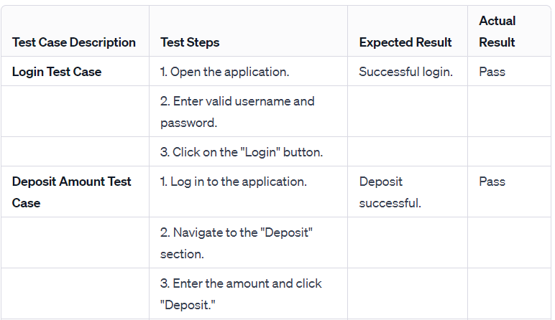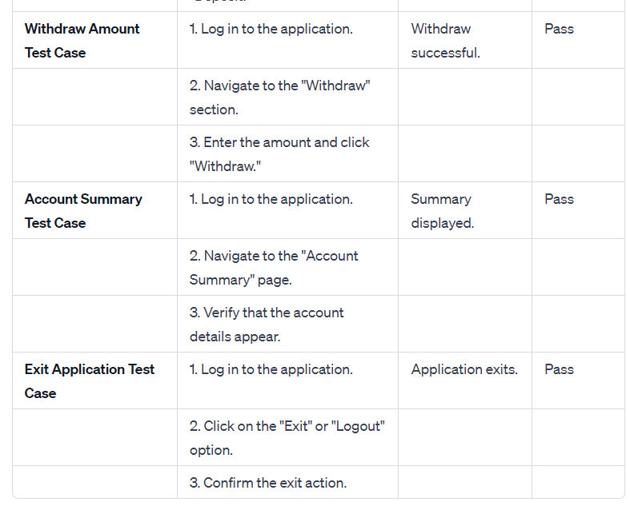

## Performance Outcome

The performance outcome of a Bank Management System project can be evaluated based on several key criteria. Here are some performance indicators and their expected outcomes:

Response Time:

Expected Outcome: The system should respond promptly to user inputs, providing quick feedback for actions such as login, deposit, withdrawal, and account summary inquiries.

Desired Result: Response times are within acceptable limits, ensuring a smooth user experience.

Transaction Throughput:

Expected Outcome: The system should be capable of handling a high volume of transactions concurrently without significant delays or performance degradation.

Desired Result: The system maintains optimal transaction throughput under varying loads.

Scalability:

Expected Outcome: The system should scale efficiently to accommodate an increasing number of users, accounts, and transactions.

Desired Result: Scalability is demonstrated, and the system performs well as the user base grows.

Reliability:

Expected Outcome: The system should be reliable, ensuring that transactions are accurately processed, and data integrity is maintained.

Desired Result: Minimal system downtime or disruptions, and accurate recording of all financial transactions.

Security:

Expected Outcome: The system should implement robust security measures to protect sensitive customer information and financial data.

Desired Result: No security breaches, unauthorized access, or data compromises.

Usability:

Expected Outcome: The user interface should be intuitive and user-friendly, minimizing the learning curve for both customers and bank staff.

Desired Result: Positive feedback from users regarding the ease of navigation and overall usability.

# My learnings

Understanding Banking Processes:

Learned: Gain insights into various banking operations, including account management, transactions, loans, and reporting.

Significance: Understanding the intricacies of banking processes is crucial for developing a system that meets the industry's specific needs.

Database Design and Management:

Learned: Acquired skills in designing and managing databases to store and retrieve financial data accurately and securely.

Significance: Efficient database management is essential for the reliability and performance of a financial system.

User-Centric Design:

Learned: Explored principles of user interface design to create an intuitive and user-friendly system for both customers and bank staff.

Significance: Prioritizing user experience contributes to higher adoption rates and customer satisfaction.

Security Implementation:

Learned: Implemented robust security measures to safeguard sensitive customer information and financial data.

Significance: Understanding security protocols is critical in maintaining trust and compliance with industry regulations.

Agile Development Methodology:

Learned: Embraced an iterative and agile development approach, allowing for flexibility and continuous improvement.

Significance: Agile methodologies facilitate adaptability to changing requirements and promote collaboration within development teams.

# Future work scope

The future work scope for this Bank Management System project could involve:

Enhanced Security Measures:

Exploring and implementing advanced security measures to stay ahead of evolving cybersecurity threats.

Integration with Emerging Technologies:

Investigating opportunities to integrate emerging technologies such as blockchain or artificial intelligence for improved efficiency and innovation.

Mobile Banking Applications:

Developing mobile applications to extend banking services to a wider range of customers through smartphones and tablets.

Internationalization and Localization:

Adapting the system to cater to international markets by incorporating features for multiple currencies, languages, and compliance with global banking standards.

Continuous Performance Optimization:

Ongoing efforts to optimize system performance, ensuring scalability and responsiveness as the user base and transaction volume grow.